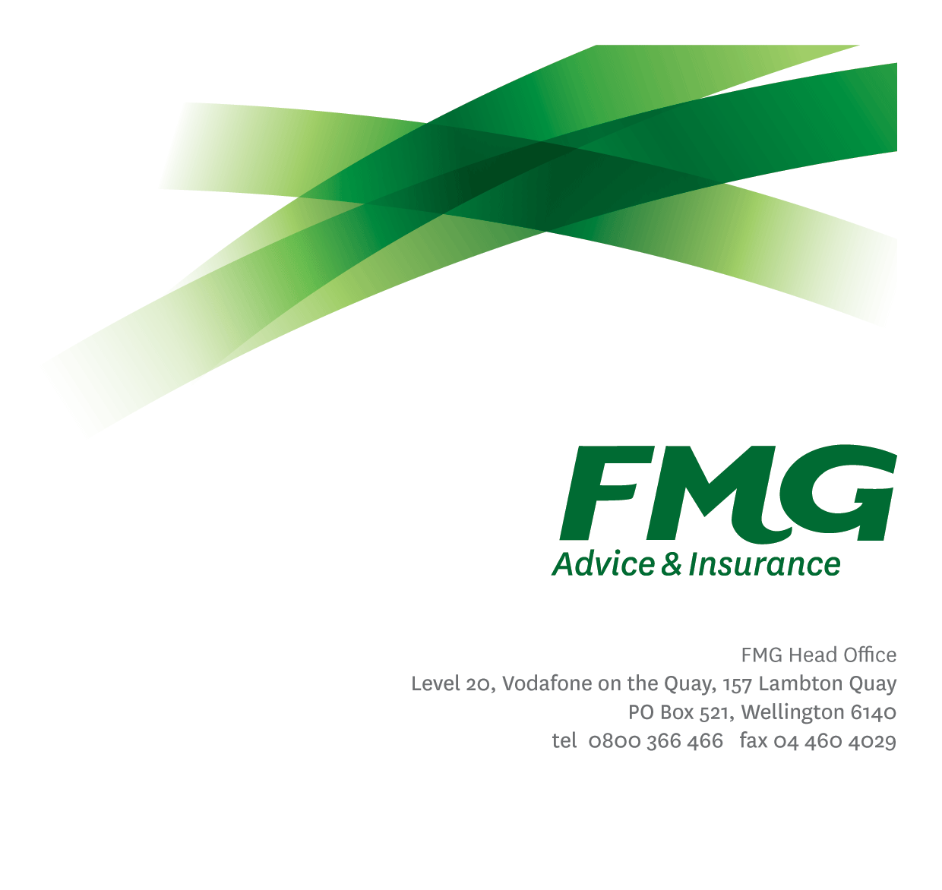
Project Manager
Position Description

Location: As per Personal Terms
Reporting to: Manager Projects & Improvement
Business Unit: Business Information Services
Direct Reports: Nil
Date Last Reviewed: May 2013

About FMG
Formed by farmers for farmers over a century ago, FMG is New Zealand’s leading rural insurer providing risk advice and insurance solutions for farmers, growers, commercial businesses, the lifestyle sector and domestic clients.
We’re proudly 100% New Zealand owned and operated and our focus is on helping our clients to achieve their goals. As a mutual organisation, we’re all about giving rural New Zealanders a better deal, and part of this involves reinvesting all profits back into the business to keep premiums low and ensure the future sustainability of the organisation.

FMG’s Values
The FMG brand represents promises about what customers can expect from us and each of us is responsible for delivering on these promises. Living our company values means we deliver the best brand experience for our customers. Our company values are:
- Do what’s right | - Make it happen
- We’re in it together | - Proud of who we are

Work Environment
We strive to provide an environment that promotes and fosters achievement. We place importance on career development and training to give our people the tools they need to succeed.
The Information Services team culture is based on open and honest communication, where authority and accountability are clear. Both challenges and opportunities are shared to bring about delivering the best solution FMG, whilst improving FMG’s core capabilities in information management practices.

Purpose of the role
To manage on behalf of FMG, intended projects and/or associated activities to successful completion in accordance with agreed standards and behaviours while assisting the Programme Manager in the definition and promotion of professional project management practices.
Key Responsibilities

Area | Responsibilities
FMG Values | - To promote the “FMG Way” through displaying the values of FMG which are do what’s right, make it happen, we’re in it together and proud of who we are
Project Management | - Manages the delivery of full life cycle projects across the FMG Business and IS projects as identified in the Information Management and Systems Strategy (IMSSP)  - Projects are delivered to specification, within budgets and agreed timeframes  - Client signoff obtained  - Projects are managed in accordance with published management standards
Project Evaluation | - Administers and maintains a standard process which allows the investigation & evaluation of technical options for projects  - Evaluation criteria and report prepared
Project Requirements and Documentation | - Manages, in accordance with the documented SDLC, the development of business function requirements, technical specifications and documentation of any related new business functions within the development of new, and the enhancement of existing applications  - Technical Specification production does not require excessive translation between business and developer
Relationship Management | - Liaises with business units and Information Services and assists with the establishment of processes and procedures for the administration of any new or enhanced systems  - Documented Service Level Agreement negotiated with, and signed by customer and appropriate Information Services management or their representative.
Information Technology Advice and Consultancy | - Assists or initiates investigation of alternative solutions  - Client signoff obtained
Vendor Management | - Manages relevant external supplier relationships  - Vendor and FMG responsibilities clearly defined  - Vendor understands FMG’s requirements
Information Management and Systems Strategy (IMSSP) Development | - Contributes in discussion with management & operating units and represents their view in the development of the IMSSP and/or Information Services Operational Plan
Championing & Promotion | - Promotes and champions the approved concepts, projects and communication channels in IMSSP
Service Support | - Demonstrates a customer centred approach by ensuring work is completed on time and to a high standard. Given the nature of services provided by Business Information Services, this may require working outside of normal business hours or working additional hours particularly in respect to regular out-of-hours maintenance activity, operator activity and project work.
Other Duties | - Completes tasks in agreed timeframe and provision of appropriate progress reports to the satisfaction of the Programme Manager and/or General Manager Business Information Systems.
Health and Safety | - Complies with safety and wellbeing policy and procedures, including accident and incident reporting and hazard management requirements  - Works in a safe manner at all times and does not undertake activities without appropriate training

COMPETENCIES
*see competency framework for behaviours expected at each level | Expected Level
Customer Driven (Internal & External)  A commitment to understanding the needs and best interests of both internal and external customers, in order to provide them with outstanding customer service and help them to make informed decisions. | Intermediate*
Accountability  Taking personal ownership of decisions, behaviour, and development, and being responsible for how these actions impact on the wider organisation and customers. | Intermediate*
Adaptability  Demonstrating a willingness to engage in a changing environment and being flexible and comfortable working with change. | Intermediate*
Motivation and Drive  The determination to achieve goals and strive for excellence. | Intermediate*
Relationship Building  Developing and maintaining positive, professional relationships that are built on mutual trust and respect. | Intermediate*
Team Work  Making a positive contribution to the FMG team and collaborating effectively with others to achieve objectives. | Intermediate*

KNOWLEDGE
Qualifications | Relevant Tertiary Qualification required
Business Awareness | Understands the internal workings of FMG and how business works; understands FMG's position in the advice and insurance market and knows the competition.
Systems Knowledge | Knowledge of the following systems is required: Genisys, Finance1
Specialist Knowledge | An understanding of a Financial Management function. i.e. how financial statements are put together, dealing with auditors.

SKILLS
Written Communication Skills | Able to write clear, concise and persuasive proposals and reports.
Verbal Communications Skills | Effectively presents information to others, both informally and in meetings.
Financial Skills | Able to calculate and understand financial information e.g. profit & loss, forecasts.
Technology Skills | Can expertly use relevant software and technology to its full capacity e.g. MS Word, Excel and PowerPoint.

Relationship
External | Internal | Committees/Groups
- Suppliers  - Contractors  - Consultant Organisations | - Project Sponsors, Stakeholders, steering group members  - Divisional/Regional/Senior Managers/Board | - Working Groups

Financial Authority Levels
- Managing identified project budget and associated expenditures (in some cases of approximately $1 million)

Human Resources Authority Levels
- May select team members for projects.
- No authority to dismiss staff, unless delegated by the Chief Executive and in consultation with manager and Human Resources

Agreement
I agree to the outline of the role as contained in this document and recognise that the contents may need to be amended from time to time to reflect changing business requirements.

I as Job holder, allow my Manager to gather information from third parties where necessary for the purposes of performance management.

Agreement will be via electronic signature as evidenced on the acceptance form.

