Job description
Title | Electrician
Location | Waikato - Hamilton
Start Date | May, 2026
Reports To | Jonty Jones
 | Operations Manager – Hamilton
Reviewed By | Jonty Jones | Date: | May, 2026
Last Updated By | People & Culture | Date: | May, 2026
Purpose:
To be responsible for the installation, maintenance, and repair of electrical systems and equipment.
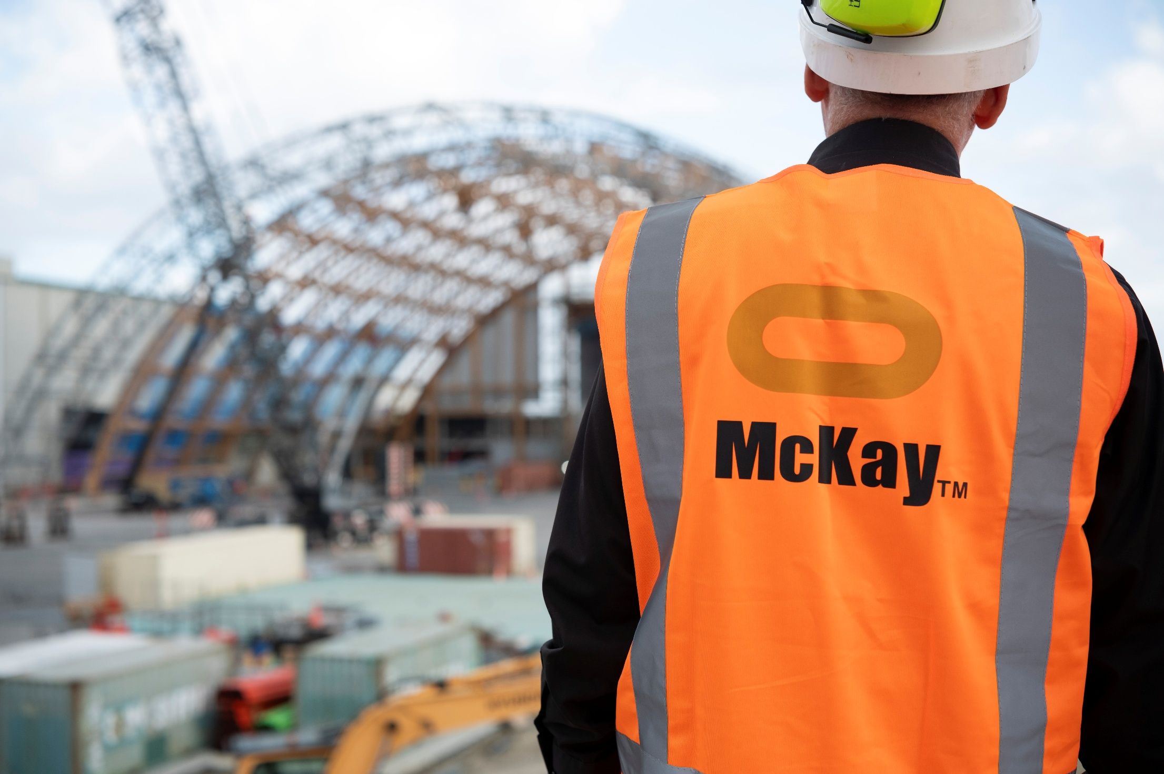



Role Summary
McKay is proud to stand as Aotearoa, New Zealand’s largest privately owned electrotechnology provider, offering innovative electrical engineering and construction services nationwide.
Having started providing electrotechnology services in 1936, McKay is a historic New Zealand electrical company with a depth of experience in providing end to end electrical solutions for a wide range of industries and sectors. McKay is the parent brand and has acquired and started a range of companies under the McKay Group name to serve all electrical needs.
As an Electrician at McKay Electrical Ltd., you are a skilled tradesperson responsible for the installation, maintenance, and repair of electrical systems and equipment. You will work in a variety of settings, from residential homes and commercial buildings to industrial facilities. They ensure that electrical systems are safe, reliable, and in compliance with relevant codes and regulations.

Responsibilities

Electrical Installation
  - Install wiring, electrical panels, outlets, and fixtures in new construction and renovation projects.
  - Determine the appropriate placement and layout of electrical components.
  - Connect wiring to transformers, circuit breakers, or other components.

Maintenance and Repair
  - Troubleshoot electrical problems to identify faults and issues.
  - Repair or replace damaged or outdated electrical components, such as switches, outlets, and fixtures.
  - Perform routine maintenance to prevent electrical system failures.

Compliance and Safety
  - Ensure all electrical work adheres to local, state, and national electrical codes.
  - Inspect electrical systems to identify potential safety hazards and rectify them.
  - Follow safety protocols and guidelines to minimise electrical risks.

Reading Blueprints and Technical Documents
  - Interpret blueprints, technical diagrams, and schematics to plan and execute electrical installations.
  - Review specifications to ensure compliance with project requirements.

Equipment and Tool Management
  - Maintain and repair tools and equipment used in electrical work.
  - Keep tools and equipment in good working condition, following safety guidelines.

Customer Communication
  - Communicate with customers to understand their electrical needs and provide cost estimates for projects.
  - Explain the work performed and educate customers about electrical safety.

Up-to-Date Knowledge
  - Stay informed about advancements in electrical technology, regulations, and safety standards.
  - Participate in ongoing training and professional development to enhance skills.

Documentation
  - Create and maintain records of electrical work performed, including wiring diagrams, maintenance logs, and repair reports.
  - Submit necessary documentation for permits and inspections.

Qualifications & Knowledge
- Create and maintain records of electrical work performed, including wiring diagrams, maintenance logs, and repair reports.
- Submit necessary documentation for permits and inspections.

Role Profile
As an Electrician at McKay Electrical Ltd., you must hold the following capabilities;
- Strong knowledge of electrical codes and regulations.
- Proficiency in reading blueprints and technical diagrams.
- Excellent problem-solving and troubleshooting skills.
- Physical stamina and the ability to work in various environments, including confined spaces.
- Strong attention to detail and safety-conscious.
- Good communication and customer service skills.
- Basic computer skills for recordkeeping and communication.

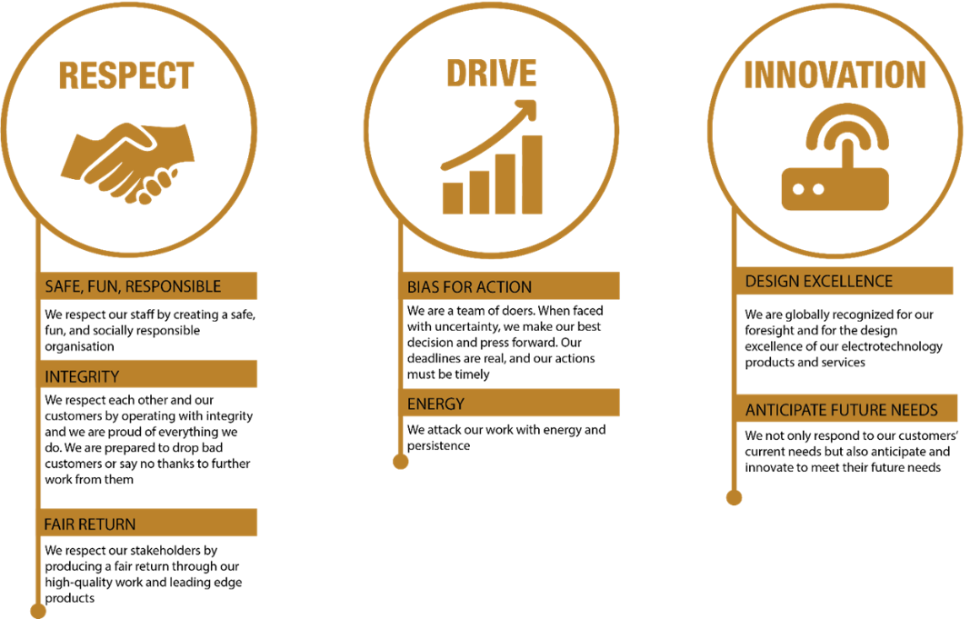
McKay Guiding Values

