*Position Description*

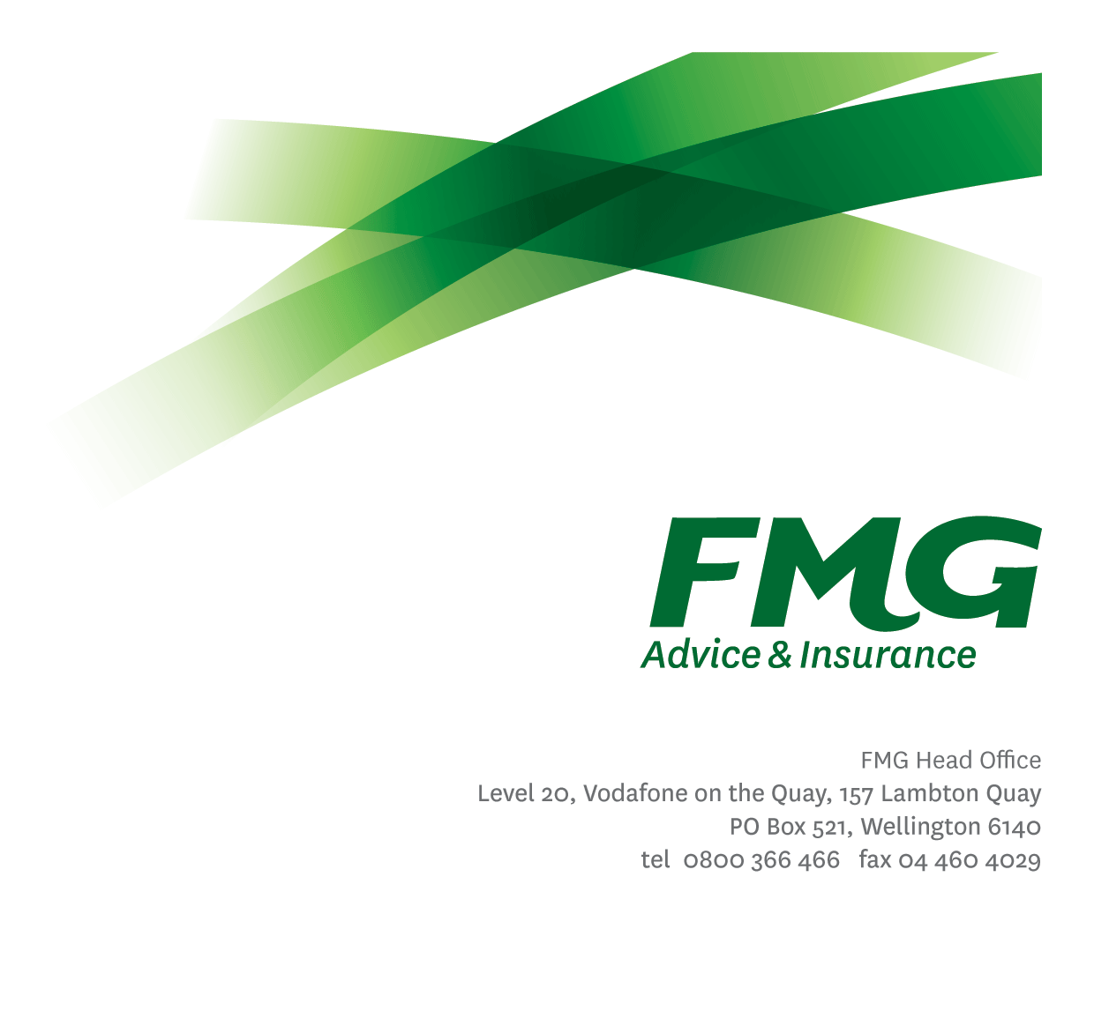

Sales & Development Manager –

Life & Health

*Location:* Upper North Island



*Reporting to:* National Sales Manager Life & Health

*Business Unit:* Sales, Advice & Service

*Direct Reports:* Nil

*Date Last Reviewed:* February 2021

### *About FMG*

***Formed by farmers for farmers over a century ago, FMG is New Zealand’s leading rural insurer providing risk advice and insurance solutions for farmers, growers, commercial businesses, the lifestyle sector and domestic clients.***

***We’re proudly 100% New Zealand owned and operated and our focus is on helping our clients to achieve their goals.  As a mutual organisation, we’re all about giving rural New Zealanders a better deal, and part of this involves reinvesting all profits back into the business to keep premiums low and ensure the future sustainability of the organisation.***

### *FMG’s Values*

The FMG brand represents promises about what clients can expect from us and each of us is responsible for delivering on these promises. Living our values means we deliver the best brand experience for our clients. Our organisational values are:

|  |  |
| --- | --- |
| * Do what’s right | * Make it happen |
| * We’re in it together | * Proud of who we are |

### *Work Environment*

We strive to provide an environment that promotes and fosters achievement. We place importance on career development and training to give our people the tools they need to succeed.

### *Purpose of the role*

The role has responsibility for achievement of results for the Life & Health Adviser channel. This includes but is not limited to the achievement of new business API growth, ensuring good client risk conversations, maintaining the agreed level of client retention and service, we provide good client outcomes and ensuring that all LHAs work in accordance with legislative standards and FMG best practice.

The role works collaboratively with the Area Managers, Heartland Managers, Life & Health Centre Manager, other Sales Leaders and is expected to build strong relationships across the North and South Island sales teams.

### *Key Responsibilities*

| Area |  |
| --- | --- |
| Sales Leadership and Coaching | * Provides one on one technical and sales coaching to LHAs through joint client visits, phone support and review of business development plans * Provides coaching and mentoring to LHAs in relation to best practice delivery of advice, report writing, new business acquisition and compliance. * Contributes to the half year and full year performance reviews for PRAs in conjunction with the Area Manager. * Support delivery of the sales development framework including facilitating sales and/or product training, ensuring follow through on training requirements and compliance work ons. |
| Business Growth & Profitability | * Facilitates acquisition of profitable ‘new to FMG’ business, through the execution and application of our Life & Health insurance proposition via the LHA and LHA Centre teams. * Supports direct marketing and advertising campaigns, through targeted initiatives where required. * Supports the generation of leads for other parts of the business, including General Insurance and Strategic Partners. * Achieves team sales results through maximising both quality and quantity of new business, while maintaining existing business. * Provides industry leading service to FMG clients and potential clients, through the provision of effective Life & Health risk advice and having a thorough practical knowledge of FMG Life & Health risk solutions. |
| Client Retention & Advocacy | * Actively monitor client retention and take steps to raise and/or address areas of concern * Actively monitors client advocacy outcomes as measured by NPS and takes actions to maintain and improve NPS. * Acts with urgency to resolve client complaints and ensure service recovery actions are taken |
| Networking | * Attend relevant events to enhance FMG’s profile. * Uses business, social networking occasions and industry contacts to identify business opportunities for FMG. |
| FMG Values | * Promotes the “FMG Way” through displaying the values of FMG which are: Do what’s right, Make it happen, We’re in it together, Proud of who we are. |
| Reporting | * In conjunction with Area Manager, develop and implement regional/channel business development plans. * All reports to meet agreed FMG service standards including but not limited to the quality of content, writing style, grammatical correctness, visual presentation and timeliness of delivery. |
| Risk Quality | * Develops a thorough knowledge of all FMG Life & Health insurance products and services and relevant industry topics through attending internal training sessions, external seminars and study programs. * Ensure all business written is within delegated authority (DA) levels. |
| Wellbeing & Safety | * Complies with safety and wellbeing policy and procedures, including accident and incident reporting and hazard management requirements * Works in a safe manner at all times and does not undertake activities without appropriate training |
| Compliance | * Complies with company policies, guidelines and procedures |

|  |  |
| --- | --- |
| **COMPETENCIES** | |
| *\*see competency framework for behaviours expected at each level* | *Expected Level* |
| **Advice & Sales Acumen**  Using appropriate interpersonal styles and communication methods to gain client acceptance of advice, which incorporates a product, service or idea. | Advanced* |
| **Client Driven (Internal & External)**  A commitment to understanding the needs and best interests of both internal and external clients, in order to provide them with outstanding client service and help them to make informed decisions. | Advanced* |
| **Accountability**  Taking personal ownership of decisions, behaviour, and development, and being responsible for how these actions impact on the wider organisation and clients. | Intermediate* |
| **Adaptability**  Demonstrating a willingness to engage in a changing environment and being flexible and comfortable working with change. | Intermediate* |
| **Motivation and Drive**  The determination to achieve goals and strive for excellence. | Advanced* |
| **Relationship Building**  Developing and maintaining positive, professional relationships that are built on mutual trust and respect. | Intermediate* |
| **Team Work**  Making a positive contribution to the FMG team and collaborating effectively with others to achieve objectives. | Intermediate* |
| **Problem Solving**  The ability to understand information from a variety of sources and think quickly on one’s feet. The ability to effectively combine verbal and numeric data into a coherent whole. | Advanced* |
| **Critical Analysis**  The capability to identify key issues, trends, or important facts from information and to question and probe. | Advanced* |
| **Influencing/Persuading**  Using rational argument and reasoning to convince others. To not be afraid to take a stand and to sell a position while keeping the relationship intact. | Advanced* |
| **Motivating and Developing Others**  A commitment to getting the best out of people and motivating them to reach their full potential. | Advanced* |

|  |  |
| --- | --- |
| **KNOWLEDGE** | |
| **Qualifications** | Relevant Tertiary Qualification essential  NZ Certificate in Financial Services Level 5 |
| **Experience** | Proven experience operating in a sales leadership role within Life & Health Insurance industry |
| **Business Awareness** | Develops and understands the internal workings of FMG and how business works; understands FMG's position in the advice and insurance market and knows the competition. |
| **Agribusiness Knowledge** | Understands the agribusiness sector and keeps up to date with the economic, political, and environmental issues affecting our clients. |
| **Legal Knowledge** | Has legal knowledge e.g. indemnity, liability, the Privacy Act etc. |
| **Product Knowledge** | Is knowledgeable about Life & Health insurance policies and packages, the differences between them, and the appropriateness of each in different situations. |
| **Risk/Insurance Knowledge** | Understands risk and how to apply FMG's policies to situations; is knowledgeable about compliance requirements; understands the insurance process and how claims are managed; knows industry partners and competitors. |

|  |  |
| --- | --- |
| **SKILLS** | |
| **Written Communication Skills** | Able to write clear, concise and persuasive proposals and reports. |
| **Verbal Communications Skills** | Communicates clearly in order to present information to persuade and influence others. |
| **Listening Skills** | Demonstrates active listening skills through eye contact, paraphrasing, appropriate body language and checking understanding. |
| **Risk Assessment Skills** | Identifies, understands and mitigates the risks that may impact on FMG's strategy, initiatives and reputation. |
| **Driving Skills** | Has full driver’s license. |

### *Key Relationships*

|  |  |  |
| --- | --- | --- |
| External | Internal | Committees/Groups |
| * Preferred Product Providers * Regulatory bodies * Training providers | * Area Managers * Heartland Managers * L&H Sales Managers * L&H Business Development Manager * L&H Centre Manager * Life & Health Risk Advisors * L & H Insurance Operations Specialist * Team leader Report Planners |  |

### *Financial Authority Levels*

* As per delegated authority manual

### *Human Resources Authority Levels*

* Not applicable

### *Delegated Authority Levels*

* Delegated authority levels for the individual role-holder will be advised following assessment, training and approval as per the requirements of the FMG Delegated Authority Policy.

### *Agreement*

I agree to the outline of the role as contained in this document and recognise that the contents may need to be amended from time to time to reflect changing business requirements.

I as Job holder, allow my Manager to gather information from third parties where necessary for the purposes of performance management.

|  |  |
| --- | --- |
| Sales & Development Manager – Life & Health’s Name: |  |
| Signature: |  |
| Date: |  |

|  |  |
| --- | --- |
| National Sales Manager – Life & Health’s Name: |  |
| Signature: |  |
| Date: |  |