Job description
Title | Project Coordinator
Location | Wellington
Start Date | August 2025
Reports To | Branch Manager
Reviewed By | Firstname Lastname | Date: | Month, 2025
Last Updated By | People & Culture | Date: | August 2025
Purpose:
To support the successful execution of electrical projects, from small installations to large-scale electrical infrastructure developments.




Role Summary
McKay is proud to stand as Aotearoa, New Zealand’s largest privately owned electrotechnology provider, offering innovative electrical engineering and construction services nationwide.
Having started providing electrotechnology services in 1936, McKay is a historic New Zealand electrical company with a depth of experience in providing end to end electrical solutions for a wide range of industries and sectors. McKay is the parent brand and has acquired and started a range of companies under the McKay Group name to serve all electrical needs.
As a Project Administrator at McKay Ltd., you will play a crucial role in ensuring that electrical projects are executed efficiently, on time, and within budget. You will help to streamline project management processes and contribute to the overall success of electrical installations and infrastructure developments.

Responsibilities

Documentation Management:
  - Maintain and organise project documents, including electrical plans, specifications, permits, and contracts. Specifically for :
    - RAMM
    - Submittica
    - Sharepoint
    - Procore
  - Prepare and distribute project reports, progress updates, and meeting minutes.
  - Ensure compliance with document control procedures.

Communication and Coordination:
  - Facilitate communication between project team members, subcontractors, and stakeholders.
  - Schedule and coordinate project team meetings, including kick-off meetings, progress reviews, and closeout meetings.
  - Manage correspondence and inquiries related to the project.

Budget and Financial Support:
  - Assist in tracking project expenses and budgets.
  - Process invoices, purchase orders, and expense reports.
  - Assist with cost tracking and financial reporting including preparing monthly project claims

Scheduling and Planning:
- Assist in developing project schedules and timelines.
- Monitor project progress and report on potential delays or issues.
- Coordinate logistics and resources for the project.

Quality Assurance and Compliance:
- Ensure that the project complies with electrical codes, regulations, and safety standards.
- Assist in maintaining quality control documentation.
- Support the preparation of project closeout documentation.

Data Entry and Record Keeping:
- Maintain accurate records of project activities and milestones.
- Enter data into project management software and databases.
- Generate reports and analytics as required.

Administrative Report:
- Provide general administrative assistance to project managers and team members.
- Assist with travel arrangements, equipment procurement, and resource coordination.
- Manage other tasks as needed to support project success.

Qualifications & Knowledge
- Proven experience as a Project Administrator in a related sector.

Role Profile
As the Project Administrator at McKay Ltd., you must hold the following capabilities;
- Strong organisational and time-management skills.
- Proficiency in using project management software and Microsoft Office applications.
- Excellent communication and interpersonal skills.
- Basic understanding of electrical systems and construction processes is a plus.
- Ability to work in a fast-paced environment and handle multiple tasks simultaneously.
- Attention to detail and a commitment to accuracy.
- Willingness to learn and adapt to changing project requirements.

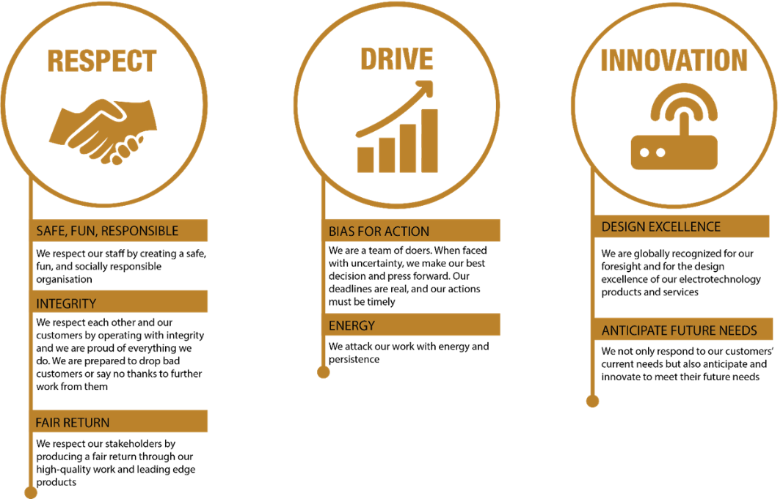
McKay Guiding Values

