JOB TITLE: | Business Development Manager
Location: | Auckland or Wellington |  | Date: | April 2026
Reports to: | EGM Business Development & Marketing
Purpose: | To support client growth and acquisition for McKay Limited.
ROLE SUMMARY:
McKay is proud to stand as New Zealand’s largest privately owned electrotechnology provider, offering innovative electrical engineering, construction and maintenance services nationwide. McKay is recognised as a sought-after specialist in the electrical industry, with a reputation for delivering collaborative, high-quality and innovative electrical solutions across a range of sectors including Infrastructure, Industrial, Construction, Renewables and Marine.
This role requires a proactive and collaborative Business Development Manager to strengthen our client engagement and business growth efforts. This role works alongside business units, supporting them to identify prospects, plan for growth, and provide client relationship management support. The Business Development Manager will play a pivotal role in building a sustainable pipeline of opportunities, ensuring long-term client relationships, and supporting teams to win and retain work.
The Business Development Manager will be assigned a portfolio of Regional, Business Unit and Sector teams.

RESPONSIBILITIES:

- Client & Relationship Management
- Establish and implement a Client Relationship Management (CRM) Programme to set up and maintain structured prospecting and relationship management.
- Support teams to manage existing client relationships and co-ordinate relationship teams for high-value clients.
- Conduct regular internal reviews and reporting to strengthen account management and ensure client satisfaction.

- Business Development Planning
- Support assigned teams to develop and implement tailored business development plans aligned with regional and sector strategies.
- Help maintain current revenue streams while creating a future work pipeline to sustain staff resourcing beyond major project milestones.
- Prepare compelling capability statements, testimonials, and thought leadership material to strengthen market positioning.

- Market Research & Insight
- Conduct market research to establish benchmarks (e.g. NPS / CSAT), identify trends, and provide insight reporting to assigned teams.
- Proactively gather information to support forward pipeline planning and recommend opportunities for pursuit.

- CRM & Systems Leadership
- Act as the company’s go-to CRM HubSpot expert, driving adoption and embedding best practice.
- Support regular CRM training programmes to build capability across the business.
- Identify opportunities for ongoing system improvements and ensure data integrity.

- Reporting & Measurement
- Monitor relationship management metrics (e.g. NPS, client feedback, and pipeline health).
- Provide clear reporting to leadership and business unit teams on business development activity, client health, and market opportunities.

QUALIFICATIONS & KNOWLEDGE:

- Proven experience in business development, client relationship management roles ideally within a professional services or electrical sector or engineering consulting background.
- Strong ability to collaborate with teams and influence.
- Excellent communication and stakeholder engagement skills.
- Experienced user of CRM platforms, preferably HubSpot, with a track record of driving adoption and improvement.
- Proficiency in Microsoft Office and adaptability to new tools and systems.

ROLE PROFILE:

As Business Development Manager at McKay Ltd, you should hold the following capabilities.
- Strong organisational skills, with the ability to manage multiple priorities and meet tight deadlines.
- Strong written and verbal communication skills; a credible and persuasive communicator with good influencing skills.
- Analytical mindset with the ability to translate market insights into practical recommendations.
- Organised, proactive, and able to balance both immediate and long-term business development priorities.
- Excellent attention to detail.
- Project management and problem-solving skills.

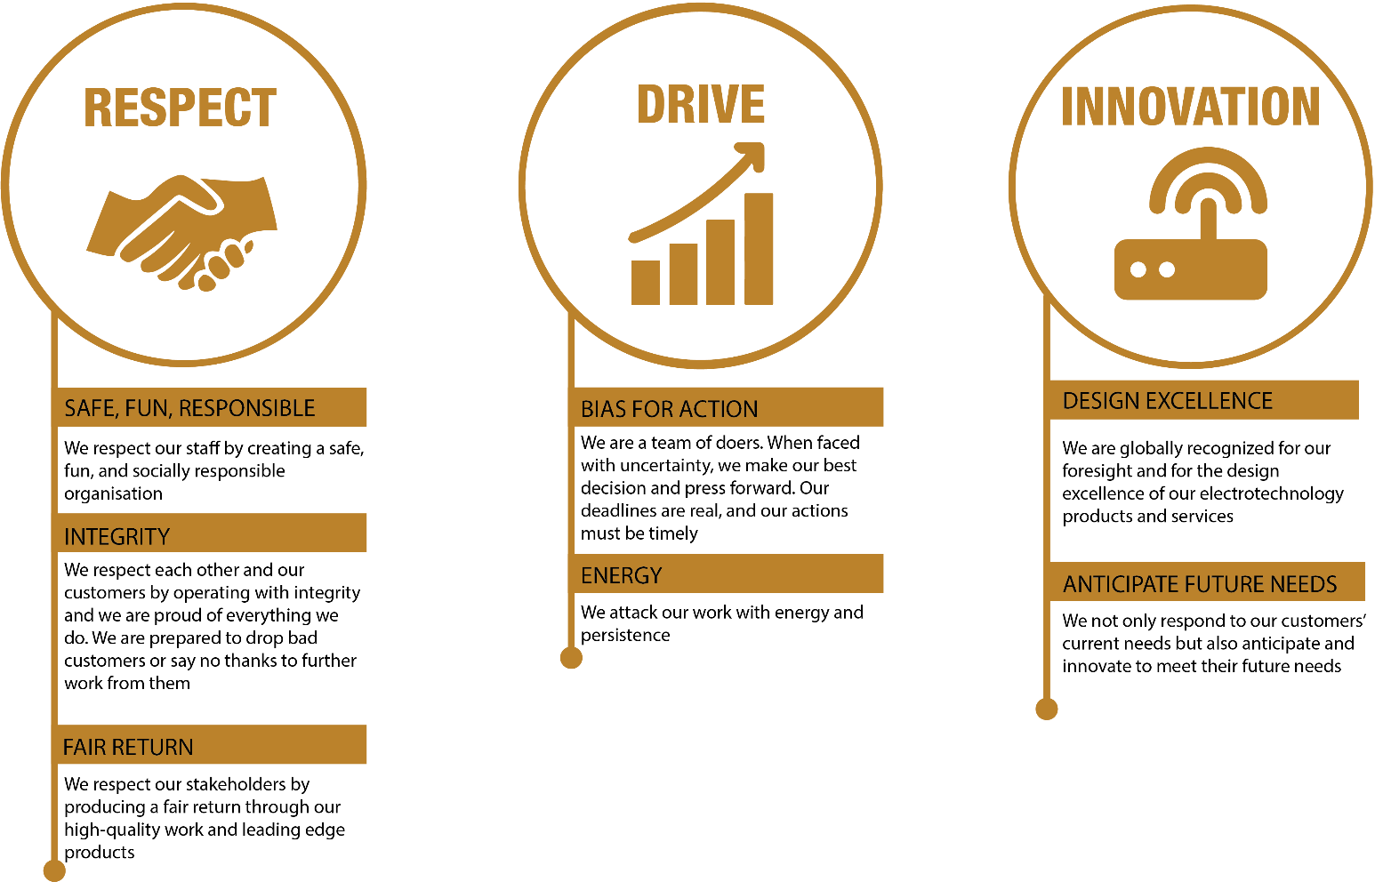
McKay GUIDING VALUES:

REVIEWED BY: |  |  | DATE:
Last updated by: | Business Development & Marketing |  | Date/Time: | April 2026

