Nohoanga l Position Description
Title | People & Wellbeing Senior Advisor
Team: | People & Wellbeing
Reporting to: | People & Wellbeing Business Partner
Location: | Wellington

Aronga Nui | Our Purpose
Ko te hāngai ki te whakatakanga ngātahi, a, ko te aronga tōtika ki ngā tini kaupēhipēhi me te hoe ngātahi i tā rātou kōkiri whakamua.
Manaaki Tāngata | Victim Support is here 24/7 for people directly affected by crime and traumatic events, including their whānau and witnesses. We support people to feel informed, empowered, safe and able to cope with the impact.
We are committed to upholding the principles of Te Tiriti o Waitangi to ensure equitable access and outcomes for Māori clients and that kaimahi Māori can thrive within our organisation.

Ngā Uara | Our Values
At our core of how we work are our values:
Manaakitanga | Whanaungatanga | Kotahitanga | Rangatiratanga | Kaitiakitanga

Kaupapa |Purpose
As a senior member of our People & Wellbeing (P&W) team, you will provide consistent support and advice to our people across the organisation, ensuring that we are providing a fantastic workplace, focused on wellbeing.
You will co-ordinate and implement P&W processes and activities to ensure the skills, capability and capacity of our workforce continues to meet organisational needs and support the achievement of organisation outcomes.
A key part of the role of a Senior Advisor is to provide support and advice to our people leaders across the organisation. The role will hold specific districts across the organisation, where you will provide guidance on everything P&W related, from recruitment & onboarding to performance support.
Role Structure
The People & Wellbeing (P&W) Group is a diverse and supportive team with a big portfolio of work and a clear focus on ensuring a great experience for our people. The P&W Group provides strategic and operational oversight of all People & Wellbeing functions, Safety and Wellbeing, Risk Management, and Change Management.
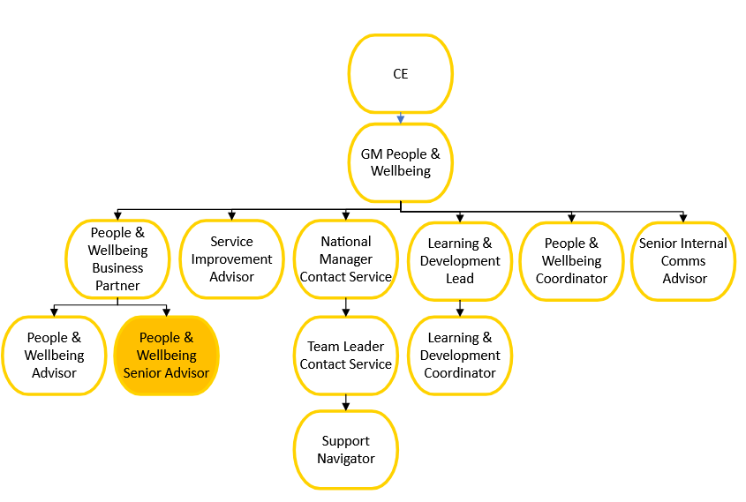

Ngā Mahi |Do
P&W Operations
- Provides timely, consistent coaching, advice, and support on all aspects of P&W to our people, at a senior level.
- Builds positive and effective working partnerships with Managers, providing advice and supporting them to achieve business goals in a way that is timely and consistent with our values and policies, improving management skills and lifting their capability in engaging team members and dealing effectively with people-related issues that arise.
- Assist in the resolution of employee grievances and complaints, in a procedurally fair and timely manner.
- Responds to employee queries, complaints, and feedback, escalating as appropriate.
- Assist with the monitoring and coordination of recurring P&W related activities and processes.
- Contributes to creating a learning and continuous improvement orientated workplace, building a highly capable, engaged and performing workforce.
- Promotes wellbeing and safety of all our people and stakeholders engaged with Maanaki Tāngata and follows/models our health and safety policies and procedures.
- Contribute to data and information for Board Report
- Be a collaborative and supportive senior member of the P&W team
Recruitment & Induction
- Complete end-to-end recruitment (this may include drafting and posting job ads through to supporting hiring managers with interviewing, shortlisting, pre-screening reference checking, and offers of employment) activities, as required.
- Work closely with hiring managers throughout the process, to support outcomes of recruitment activities of great candidates.
- Contribute to the continuous improvement of our recruitment and induction processes.
- Provide all applicants with a positive recruitment experience.

Note: The above responsibilities are not exclusive – the employee may be asked to perform other reasonable duties and accept additional reasonable responsibilities at their manager’s discretion. Depending on the region, some travel may be required.

Pūkenga |Key Skills

- Minimum of 3 years’ People & Wellbeing experience, with a recruitment and organisational development focus.
- A people person with strong relationship management skills (internally & externally).
- Excellent verbal and written communication skills.
- Able to prioritise conflicting tasks/expectations.
- A clear understanding and execution of HR/employment-related legislation in NZ and the importance of confidentiality and privacy.
The ideal person should be able to demonstrate:
- Provision of a diverse range of P&W services and activities including recruitment and selection, employee relations and change management.
- Collaborative team member, that supports the achievement of team and wider organisation outcomes.
- Great coaching and advice to managers in relation to P&W activities, assisting them to develop and implement innovative solutions to address complex organisational issues.
- Supports organisational vision and values
- Ability to present information to groups in a way that is confident, clear, and compelling.
- Demonstrated ability to self-manage and to practice self-care strategies, ability to respond to complex and pressured situations, resilient with a sense of humour and well-developed time management skills.
- Although the role will be based in an assigned Police Station(s) with an assigned geographical area to support, travel may be required from time to time to provide support and for business reasons.

