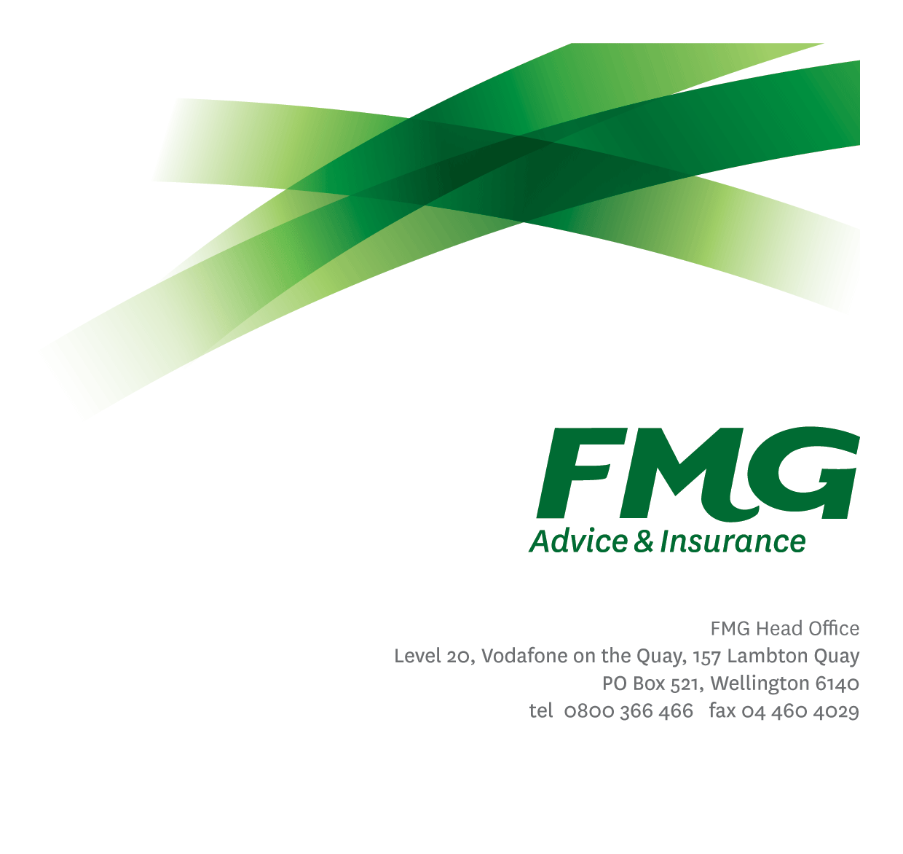
Senior Internal Auditor
Position Description

Location: Wellington
Reporting to: Chief Risk Officer
Business Unit: Financial Investment and Risk
Direct Reports: Nil
Date Last Reviewed: January 2025

About FMG
Formed by farmers for farmers over a century ago, FMG is New Zealand’s leading rural insurer providing risk advice and insurance solutions for farmers, growers, commercial businesses, the lifestyle sector and domestic clients.
We’re proudly 100% New Zealand owned and operated and our focus is on helping our clients to achieve their goals. As a mutual organisation, we’re all about giving rural New Zealanders a better deal, and part of this involves reinvesting all profits back into the business to keep premiums low and ensure the future sustainability of the organisation.

FMG’s Values
The FMG brand represents promises about what customers can expect from us and each of us is responsible for delivering on these promises. Living our company values means we deliver the best brand experience for our customers. Our values are:
- Do what’s right - Whāia te ara tika | - Make it happen - Whakatutukitia
- We’re in it together - Ko tātau tātau | - Proud of who we are Whakahīhī i te whakapapa

Work Environment
We strive to provide an environment that promotes and fosters achievement. We place importance on career development and training to give our people the tools they need to succeed.
FMG’s Head Office is located in Wellington and accommodates FMG’s Executive Leadership Team (ELT), Client Propositions & Online Services, People & Culture and Communications, Financial Management, Product & Pricing and Underwriting, Reinsurance, Business Information and Analysis, Legal and Compliance.
FMG’s largest regional office is in Palmerston North accommodating our National Sales & Advice Centre, Information Technology, Claims, Operations and Payments functions. In addition to the offices in Wellington, Palmerston North and Christchurch FMG has offices in 30 regional locations throughout New Zealand.

Purpose of the role
This role leads and oversees FMG's Internal Audit Programme. The Senior Internal Auditor leads the Third Line of Defence (3LoD) and ensures the effectiveness and efficiency of FMG's internal controls, risk management, and governance processes such that they are maintained, and fit for purpose.

Key Responsibilities
Area | Responsibilities
Internal Audit | - Responsible for ensuring that a robust and effective internal audit process is in place in conjunction with our co-source partners that enables the Mutual to make good use of the management and business information that quality internal audits are able to produce.  - Develop and deliver an internal audit approach which is consistent with leading global practice.  - Provide assurance and insights to ELT and the Board on the effectiveness and efficiency of key FMG activities and outputs including trends and systemic failures in audits and report on management actions to address findings or areas of concern.  - Respond to requests for reviews of areas of concern (via ELT, ERCC or the Board).  - Ensure the delivery of high-quality internal audit reports focused on the key risks and opportunities within FMG’s strategic and operational context, and practical recommendations that support meaningful change and improvement.  - Deliver continuous improvement by keeping up to date with developments in their field, demonstrating a willingness to change and use new approaches as well as learning from experiences by examining what didn’t go well, and why, and sharing this information with the team.  - Completes work as assigned by the Chief Risk Officer or relevant stakeholders, as required.  - Researches, analyses, and makes recommendations on project work and process improvements, as required.
Stakeholder Management |  | - Ensure effective stakeholder management and engagement at an operational level to ensure effective embedding of internal audit frameworks and processes.  - Maintains an effective level of communication with all stakeholders, ensuring expectations are appropriately set and required communications are effective and reach the desired audiences.  - Proactively builds, monitors, and manages a wide-ranging network of relationships related to the role; both internal and external.  - Proactively assists and supports other FMG colleagues and stakeholders.
Personal Proficiency |  | - Proactively acquire and develop appropriate skills, knowledge and techniques in relation to fulfilling the core functions of the role.
Team Membership |  | - Report regularly to the Risk Leadership Team and wider stakeholders as required.  - Contribute to the development of Risk’s strategic direction and Business Plan (Roadmap).  - Proactively assist and support Risk’s team colleagues and other stakeholders to identify opportunities and celebrate successes.
Compliance |  | - To ensure compliance with applicable legislation, regulations, accounting standards and internal FMG policies through the implementation and monitoring of systems, processes and improvements.
Wellbeing and Safety | - Complies with safety and wellbeing policy and procedures, including accident and incident reporting and hazard management requirements.  - Works in a safe manner at all times and does not undertake activities without appropriate training.
FMG Values | - To promote the “FMG Way” through displaying the values of FMG which are do what’s right; make it happen; we’re in it together and proud of who we are.

COMPETENCIES
*see competency framework for behaviours expected at each level | Expected Level
Client Driven (Internal & External)  A commitment to understanding the needs and best interests of both internal and external clients, in order to provide them with outstanding customer service and help them to make informed decisions. | Advanced*
Accountability  Taking personal ownership of decisions, behaviour, and development, and being responsible for how these actions impact on the wider organisation and customers. | Advanced*
Adaptability  Demonstrating a willingness to engage in a changing environment and being flexible and comfortable working with change. | Advanced*
Motivation and Drive  The determination to achieve goals and strive for excellence. | Advanced*
Relationship Building  Developing and maintaining positive, professional relationships that are built on mutual trust and respect. | Advanced*
Team Work  Making a positive contribution to the FMG team and collaborating effectively with others to achieve objectives. | Advanced*
Critical Analysis  The capability to identify key issues, trends, or important facts from information and to question and probe. | Advanced*
Change Leadership  The drive to initiate opportunities to address FMG’s organisational needs and to communicate change in a way that gains buy-in and support from others | Intermediate*
Strategic Thinking  The capacity to stand apart from the day-to-day and take a long-term, big picture view of the business. | Advanced*

KNOWLEDGE
Qualifications & Experience | Relevant Tertiary Qualification is essential  Minimum 10 years’ Experience in financial services, preferably in insurance  Specialist knowledge and experience working in a regulated environment.  Extensive legislative and compliance knowledge, including the Financial Markets Conduct Act and the Insurance (Prudential Supervision) Act (and the licensing regimes relevant to that legislation).
Business Awareness |  | Understands the internal workings of FMG and how business works; understands FMG's position in the advice and insurance market and knows the competition.
Rural Knowledge |  | Understands the rural community and keep up to date with the economic, political, and environmental issues affecting our customers.
Product Knowledge |  | Is knowledgeable about FMG's insurance policies and packages, the differences between them, and the appropriateness of each in different situations.
Risk/Insurance Knowledge |  | Understands risk and how to apply FMG's policies to situations; is knowledgeable about compliance requirements; understands the insurance process and how claims are managed; knows industry partners and competitors.
Legal Knowledge |  | Has legal knowledge e.g. indemnity, liability, the Privacy Act etc.
Specialist Knowledge |  | Legislative and compliance knowledge, including Farmers Mutual Act and Financial Advisers Act.

SKILLS
Written Communication Skills | Able to write clear, concise and persuasive proposals and reports.
Verbal Communications Skills | Communicates clearly in order to present information to persuade and influence others.
Listening Skills | Demonstrates active listening skills through eye contact, paraphrasing, appropriate body language and checking understanding.
Technology Skills | Can expertly use relevant software and technology to its full capacity e.g. MS Word, Excel and PowerPoint.
Audit Skills | Able to undertake audits in accordance with auditing standards.
Risk Assessment Skills | Can put in place plans to mitigate risks and manage issues.

Relationships
External | Internal | Committees/Groups
- Co-source Internal Auditors  - Government Relations Consultants  - Regulators  - External Auditors | - Senior management  - All business areas  - Board of Directors | - Audit and Risk Management Committee  - Enterprise Risk and Compliance

Financial Authority Levels
- As per delegated authorities

People Advisory Authority Levels
- Not applicable

Delegated Authority Levels
- Delegated authority levels for the individual role-holder will be advised following assessment, training and approval as per the requirements of the FMG Delegated Authority Policy.

Agreement
I agree to the outline of the role as contained in this document and recognise that the contents may need to be amended from time to time to reflect changing business requirements.

I as Job holder, allow my Manager to gather information from third parties where necessary for the purposes of performance management.

Senior Internal Auditor Name:
Signature:
Date:

