|  |  |  |  |  |
| --- | --- | --- | --- | --- |
|  | | | | |
| **JOB TITLE:** | Line Mechanic | | | |
|  |  |  |  |  |
| Location: |  |  | Date: |  |
|  |  |  |  |  |
| Reports to: |  | | | |
|  |  |  |  |  |
| Purpose: | To install, maintain, and repair electrical power systems, including overhead and underground power lines. | | | |
|  |  |  |  |  |
| **ROLE SUMMARY:** | | | | |
| Having started providing electrotechnology services in 1936, McKay is a historic New Zealand electrical company with a depth of experience in providing end to end electrical solutions for a wide range of industries and sectors. McKay is the parent brand and has acquired and started a range of companies under the McKay Group name in order to serve all electrical needs.  The role of Line Mechanic at McKay Electrical Ltd., plays a crucial role in installing, maintaining, and repairing electrical power systems, including overhead and underground power lines. This role is critical for ensuring the safe and reliable distribution of electricity to homes, businesses, and other facilities. | | | | |

|  |
| --- |
| RESPONSIBILITIES: |

1. **Installation and Maintenance:**
   * Install, repair, and maintain overhead and underground power lines.
   * Inspect and test power lines and equipment to ensure compliance with safety standards.
   * Replace or repair defective components, such as insulators, transformers, and switches.
2. **Troubleshooting:**
   * Diagnose and troubleshoot electrical issues in power distribution systems.
   * Respond to service calls and outages promptly, working efficiently to restore power.
3. **Safety Compliance:**
   * Adhere to safety protocols and guidelines to ensure a safe working environment.
   * Use personal protective equipment (PPE) and follow safety procedures when working with high-voltage equipment.
4. **Equipment Operation:**
   * Operate and maintain various tools and equipment, including bucket trucks, power drills, and hydraulic tools.
   * Use specialised equipment for climbing utility poles and working at heights.
5. **Documentation:**
   * Maintain accurate records of work performed, including inspections, repairs, and equipment replacements.
   * Complete and submit work orders, reports, and documentation as required.
6. **Team Collaboration:**
   * Collaborate with other line mechanics, engineers, and support staff to efficiently complete projects and resolve issues.
   * Communicate effectively with team members and supervisors.
7. **Emergency Response:**
   * Participate in on-call rotations to respond to emergency situations and power outages.
   * Work during inclement weather conditions to restore power in a timely manner.

|  |
| --- |
| QUALIFICATIONS & KNOWLEDGE: |

* Completion of a recognised Line worker apprenticeship program is preferred.
* Valid driver's license and the ability to obtain a Class 2 licence.

|  |
| --- |
| ROLE PROFILE: |

As a Line Mechanic at McKay Electrical Ltd., you must hold the following capabilities;

* Knowledge of electrical systems, safety procedures, and industry regulations.
* Ability to climb utility poles, work at heights, and perform physically demanding tasks.
* Experience operating and maintaining power line equipment and tools.
* Strong problem-solving and troubleshooting skills.
* Excellent communication and teamwork skills.
* Willingness to work flexible hours, including evenings, weekends, and on-call rotations.

|  |
| --- |
| McKay GUIDING VALUES: |

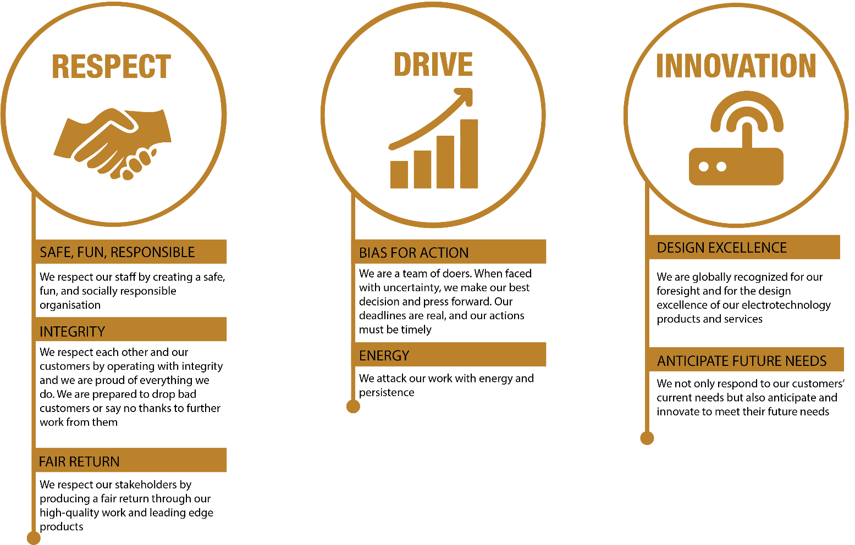

|  |  |  |  |  |
| --- | --- | --- | --- | --- |
| **REVIEWED BY:** |  |  | **DATE:** |  |
|  |  |  |  |  |
| **Last updated by:** | People and Culture |  | **Date/Time:** | Nov 23 |