Job description
Title | Performance Analyst & Estimator
Location | Auckland
Start Date | February 2026
Reports To | Renewables Manager
 | Strategy & Innovation/Renewables
Reviewed By | Andrew Lancaster | Date: | January 2026
Last Updated By | People & Culture | Date: | January 2026
Purpose:
To play a key role in strengthening our renewable energy delivery capability. Providing front-end project estimating with post-project performance analysis, ensuring our tenders are competitive and our execution continues to improve over time.




Role Summary
McKay is proud to stand as Aotearoa, New Zealand’s largest privately owned electrotechnology provider, offering innovative electrical engineering and construction services nationwide.
Having started providing electrotechnology services in 1936, McKay is a historic New Zealand electrical company with a depth of experience in providing end to end electrical solutions for a wide range of industries and sectors. McKay is the parent brand and has acquired and started a range of companies under the McKay Group name to serve all electrical needs.
This hybrid role is essential to our competitive strategy, bridging the gap between detailed electrical construction costs and operational efficiency. The Analyst is responsible for producing accurate and competitive cost estimates for all tenders and subsequently analysing project execution data to drive continuous improvement, directly supporting the strategic goals set by the Renewable Energy Sector Lead.

Responsibilities

Cost Estimation & Pre-Construction Data
  - Detailed Estimating: Execute comprehensive material take-offs, labour unit development, and full cost estimates for electrical scopes in solar, BESS, and grid-tie projects.
  - Tender Preparation: Work under the guidance of the Renewable Energy Sector Lead to develop and finalize proposal documents, including pricing sheets, scope clarifications, and commercial assumption summaries.
  - Supply Chain Costing: Solicit, analyse, and normalize quotes from key vendors and subcontractors to ensure the most competitive and accurate pricing is reflected in the final bid.

Operational Performance Analysis
  - Bid-to-Actual Variance Tracking: Conduct deep-dive analysis on completed projects, comparing the estimated costs (labour hours, material quantities) against the actual costs incurred in the field. Identify and report the root causes of all significant variances.
  - Productivity Reporting: Develop and maintain dashboards (e.g., in Power BI or Excel) to track and report key operational performance metrics, such as crew productivity (hours per kW installed), equipment utilization, and schedule adherence.
  - Model Refinement: Use performance data from completed projects to continuously refine and update the company’s internal estimation standards and cost models, ensuring future bids are more accurate and competitive.

Strategic Support & Tool Development
  - Strategic Input: Provide the Renewable Energy Sector Lead with timely, accurate data on cost trends, historical performance, and risk analysis to inform strategic decision-making and innovation initiatives.
  - Process Improvement: Assist in mapping and optimizing internal workflows related to project cost tracking, procurement data integration, and transition from estimating to project management.

Qualifications & Knowledge
  - 3+ years of experience in construction estimation, project engineering, or business analysis.
  - Experience in Electrical Construction or Renewables is highly preferred.

Role Profile
As a Performance Analyst & Estimator at McKay Ltd., you must hold the following capabilities;
- Strong understanding of electrical systems, codes, and standards.
- Expert level proficiency in Microsoft Excel (advanced modelling, pivot tables).
- Experience with a construction estimating software platform.
- Proficiency in data visualisation tools (Power BI, Tableau) is highly desirable.
- Demonstrated ability to handle large data sets.
- Excellent analytical and mathematical skills.
- Effective communication and negotiation skills.
- Ability to communicate complex findings clearly.
- Ability to work independently and as part of a collaborative team.

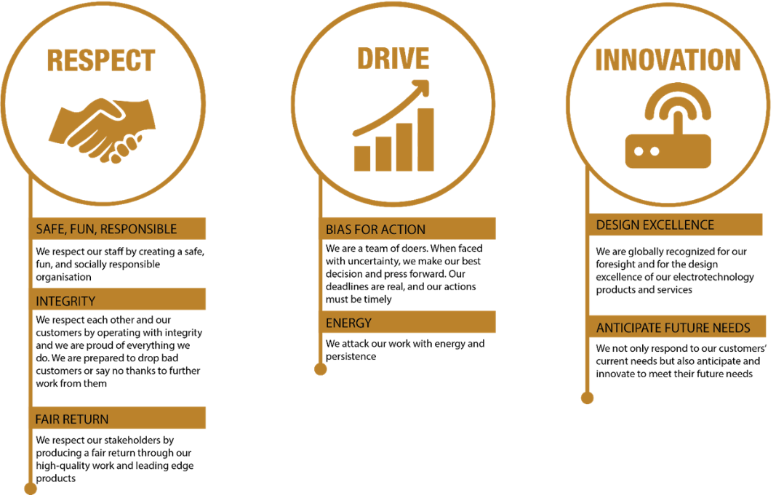
McKay Guiding Values

