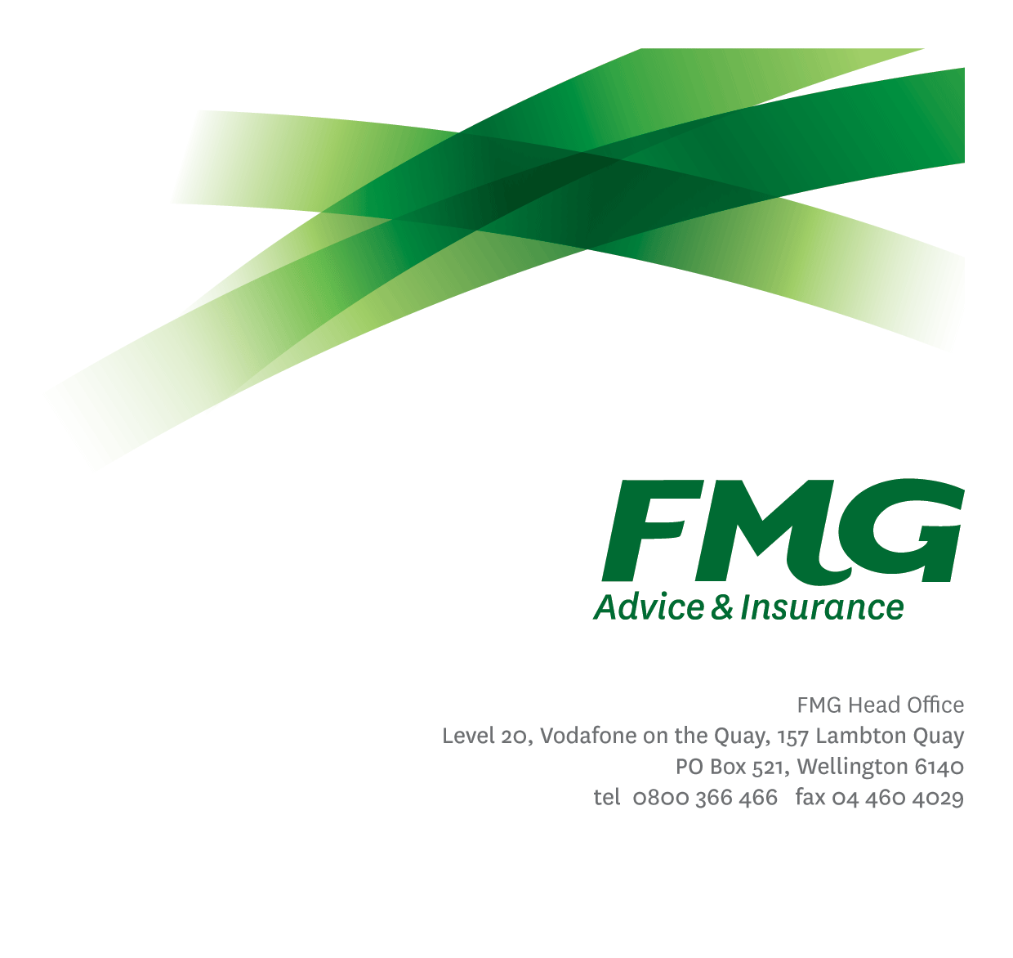
Digital Workplace Specialist
Position Description

Location: Palmerston North
Reporting to: Head of Information Management
Business Unit: Business Information Services
Direct Reports: 0
Date Last Reviewed: January 2026

About FMG
Formed by farmers for farmers over a century ago, FMG is New Zealand’s leading rural insurer providing risk advice and insurance solutions for farmers, growers, commercial businesses, the lifestyle sector and domestic clients.
We’re proudly 100% New Zealand owned and operated and our focus is on helping our clients to achieve their goals. As a mutual organisation, we’re all about giving rural New Zealanders a better deal, and part of this involves reinvesting all profits back into the business to keep premiums low and ensure the future sustainability of the organisation.

FMG’s Values
The FMG brand represents promises about what customers can expect from us and each of us is responsible for delivering on these promises. Living our company values means we deliver the best brand experience for our customers. Our company values are:
- Do what’s right | - Make it happen
- We’re in it together | - Proud of who we are

Work Environment
We strive to provide an environment that promotes and fosters achievement. We place importance on career development and training to give our people the tools they need to succeed.
The Business Information Services team culture is based on open and honest communication, where authority and accountability are clear. Both challenges and opportunities are shared to bring about delivering the best solution FMG, whilst improving FMG’s core capabilities in information management practices.

Purpose of the role
The primary purpose of this position is supporting the use, and adoption of the productivity and collaboration tools within M365 to enable FMG’s Digital and Data vision—empowering smarter decisions, operational excellence, and an engaged employee experience through technology, information and knowledge.
As part of the Information Management team, you will be required to work closely with different business units across the Mutual to ensure we are managing FMG’s knowledge and information though-out its life cycle.

Key Responsibilities

Area | Responsibilities
Corporate Knowledge Base (Intranet) | - Contribute to strategy and best practice approach for managing FMG’s intranet  - Delivering on-going enhancements and monitoring to ensure the integrity of our intranet is maintained  - Deliver training and ongoing support to content administrators and owners to ensure consistent and best practice approach is followed
Digital Work Practices | - Contribute to strategy and best practice approach for managing FMG’s unstructured electronic information through the use of M365 Teams, OneDrive, Outlook, etc  - Maintain, monitor and enhance the use of M365 Teams and associated collaboration tools i.e. Support our M365 products in ‘run state’.​  - Champion the adoption of new digital workplace technologies, including Copilot and other AI tools, to drive productivity and innovation.  - Identify and implement practical solutions that simplify work and enhance the employee experience.  - Provide expertise and advice to business units to ensure best practice approach followed  - Provide ongoing training and support to our employees on the use of these tools
Process Improvement | - Contribute best practice approach for automating process improvements  - Identify opportunities to utilise the M365 tools to provide productivity gains (e.g. automating processes)  - Liaise with business units to ensure best practice approach followed
Planning | - Input into information management strategy and vision for FMG
FMG Values | - To promote the “FMG Way” through displaying the values of FMG which are do what’s right, make it happen, we’re in it together and proud of who we are
Compliance | - Ensures compliance with legislative regulations and FMG policies through the monitoring of systems, processes and improvements.
Customer Satisfaction and Service Delivery | - Provides excellent customer service by demonstrating FMG values.  - Ensures all communication is to a high standard.  - Exceeds customer service satisfaction levels both externally and internal through the delivery of accurate and timely information and advice, by being recognised as an expert, building rapport; and getting the job done in a timely manner with minimal disruption to the customer.
Relationship Management | - Establishing effective working relationships with managers and employees throughout the Mutual  - Maintaining effective working relationships with third parties as required.
Personal Development | - Proactively acquires and develops skills, knowledge and techniques.  - Attends coaching sessions and personal development as agreed with management.
Team Participation | - Living the FMG team values and encouraging others to do the same.  - Assisting and supporting other team members, including training and peer review work as required.  - Supporting the team by sharing information and resources and providing feedback in a positive and constructive manner.  - Undertaking additional duties and providing assistance relevant to the Claims team as allocated by management.
Wellbeing & Safety | - Complies with wellbeing and safety policy and procedures, including accident and incident reporting and hazard management requirements  - Works in a safe manner at all times and does not undertake activities without appropriate training
Other Duties | - Support wider Business Information Services team as and when required.  - Other tasks may be delegated as and when required.

COMPETENCIES
*see competency framework for behaviours expected at each level | Expected Level
Customer Driven (Internal & External)  A commitment to understanding the needs and best interests of both internal and external customers, in order to provide them with outstanding customer service and help them to make informed decisions. | Advanced*
Accountability  Taking personal ownership of decisions, behaviour, and development, and being responsible for how these actions impact on the wider organisation and customers. | Intermediate*
Adaptability  Demonstrating a willingness to engage in a changing environment and being flexible and comfortable working with change. | Intermediate*
Motivation and Drive  The determination to achieve goals and strive for excellence. | Intermediate*
Relationship Building  Developing and maintaining positive, professional relationships that are built on mutual trust and respect. | Intermediate*
Team Work  Making a positive contribution to the FMG team and collaborating effectively with others to achieve objectives. | Intermediate*

KNOWLEDGE
Qualifications | Relevant business qualification in information management related subjects is desirable.
Experience & Specialist Knowledge | Experience in M365 Product Suite – particular emphasis on productivity and collaboration  Information Management and Knowledge Management
Business Awareness | Understands the internal workings of FMG and how business works; understands FMG's position in the advice and insurance market and knows the competition.
Rural Knowledge | Appreciates the rural community and keep up to date with the economic, political, and environmental issues affecting our customers.
Legal Knowledge | Has appropriate level of awareness of relevant legislation e.g. the Privacy Act, Records Management Act etc.

SKILLS
Written Communication Skills | Able to write clear and concise documentation.
Verbal Communication | Communicates clearly in order to present information to persuade and influence others.
Listening Skills | Demonstrates active listening skills through eye contact, paraphrasing, appropriate body language and checking understanding.
Technology Skills | Demonstrates advanced proficiency in leveraging digital workplace technologies, including the full Microsoft 365 suite (e.g., Teams, SharePoint, Copilot), to drive productivity, collaboration, and innovation.
Risk Assessment Skills | Can identify risks and escalate awareness.

Relationship
External | Internal | Committees/Groups
- External service providers | - All business units  - Technical and Product Owners  - Content Administrators  - Content Owners  - MS Team Owners | - Specialist User Groups

Financial Authority Levels
- No authority to commit or approve expenditure

Delegated Authority Levels
- Delegated authority levels for the individual role-holder will be advised following assessment, training and approval as per the requirements of the FMG Delegated Authority Policy.

Agreement
I agree to the outline of the role as contained in this document and recognise that the contents may need to be amended from time to time to reflect changing business requirements.

I as Job holder, allow my Manager to gather information from third parties where necessary for the purposes of performance management.

Agreement will be via electronic signature as evidenced on the acceptance form.

