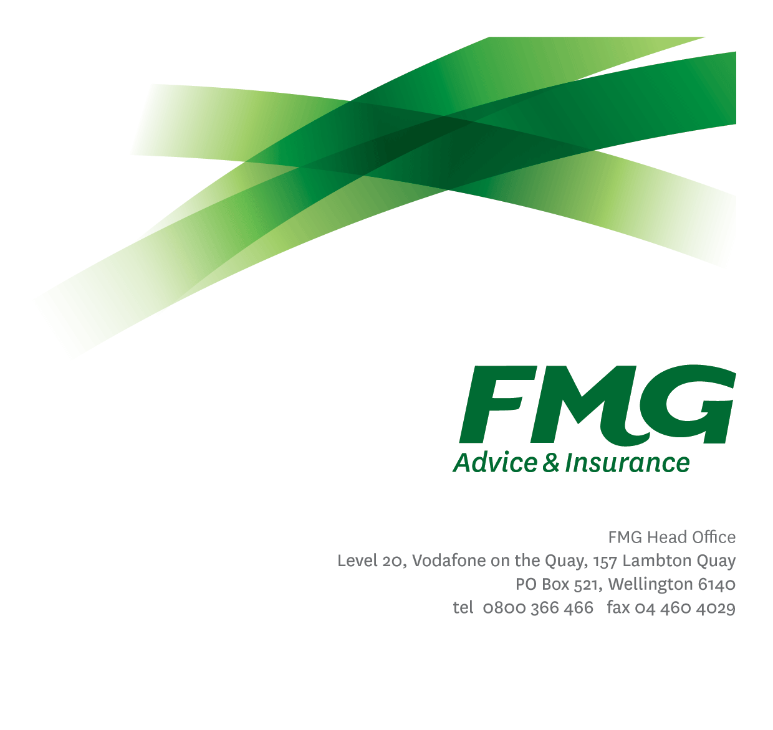
Compliance Specialist
Position Description

Location: As per Personal Terms
Reporting to: Head of Compliance
Business Unit: Risk & Compliance
Direct Reports: 0
Date Last Reviewed: February 2024

About FMG
Formed by farmers for farmers over a century ago, FMG is New Zealand’s leading rural insurer providing risk advice and insurance solutions for farmers, growers, commercial businesses, the lifestyle sector and residential clients.
We’re proudly 100% New Zealand owned and operated, and our focus is on helping our clients to achieve their goals. As a mutual organisation, we’re all about giving rural New Zealanders a better deal, and part of this involves reinvesting all profits back into the business to keep premiums low and ensure the future sustainability of the organisation.

FMG’s Values
The FMG brand represents promises about what customers can expect from us and each of us is responsible for delivering on these promises. Living our company values means we deliver the best brand experience for our customers. Our company values are:
- Do what's right - Whāia te ara tika | - Make it happen – Whakatutukitia
- We're in it together - Ko tātau tātau | - Proud of who we are - Whakahīhī i te whakapapa

Work Environment
We strive to provide an environment that promotes and fosters achievement. We place importance on career development and training to give our people the tools they need to succeed.
FMG’s Head Office is located in Wellington and accommodates FMG’s Executive Leadership Team (ELT), Client Propositions & Online Services, People & Culture and Communications, Financial Management, Product & Pricing and Underwriting, Reinsurance, Business Information and Analysis, Legal and Compliance.
FMG’s largest regional office is located in Palmerston North accommodating our National Sales & Advice Centre, Information Technology, Claims, Operations and Payments functions. In addition to the offices in Wellington, Palmerston North and Christchurch FMG has offices in 30 regional locations throughout New Zealand.

Purpose of the role
The Compliance Specialist is responsible for administering compliance management at FMG and the development and execution of processes for the identifying, measuring and management of compliance obligations and risks in relation to legislative, regulatory and industry code requirements. This position also provides recommendations and supports the implementation of improvements to internal controls and business processes.

Key Responsibilities

Area | Responsibilities
Compliance Framework | - To contribute to the development, implementation, and on-going function of FMG’s Compliance framework ensuring we have the policies, processes and procedures to support a robust framework and culture at FMG, including the policies, processes and procedures required to support FMG’s compliance with its license obligations under the Financial Markets Conduct Act.  - To contribute to the development, implementation, and on-going function of the Delegated Authorities framework to ensure a robust framework is in place.  - Ensure FMG Compliance Obligations Register is maintained.  - Ensure the FMG Breach Register is maintained, including working with internal stakeholders to remedy the consequences of any breach and address the root cause.  - Ensure all breaches and obligations are documented, uploaded and updated on the GRC tool Resolver.  - Develop and conduct testing of FMG’s internal controls in accordance with the testing plans and provide reporting of results to measure and report on the effectiveness of FMG’s internal controls used to satisfy compliance requirements.  - Support any reporting requirements as requested by the Head of Compliance.  - Contribute to the effective management of FMG’s Internal Audit program as required.  - Provide recommendations on improvements to internal controls and business processes.  - Acts as a subject matter expert for any wider business change that impacts compliance or have implications on compliance.
Stakeholder Management | - Maintains a high level of communication with all stakeholders, ensuring expectations are appropriately set and required communications are effective and reach the desired audiences.  - Proactively assists and supports other FMG colleagues and stakeholders
Personal Development | - Maintain own knowledge base of best practice and act as an expert resource in compliance across FMG.
Team Participation | - Contribute broadly to strategic and operational discussions and decisions as a member of the wider Risk & Compliance Team.  - Undertake additional duties as directed by the Head of Compliance or Chief Risk Officer.
Wellbeing & Safety | - Promote and support initiatives that contribute to a healthy and safe working environment for employees, visitors, and contractors.  - Ensure compliance with Wellbeing & Safety policy and procedures, including accident and incident reporting and investigation, hazard management, induction, training and supervision, employee participation and contractor management.  - Works in a safe manner at all times and does not undertake activities without appropriate training

COMPETENCIES
*see competency framework for behaviours expected at each level | Expected Level
Customer Driven (Internal & External)  A commitment to understanding the needs and best interests of both internal and external customers, in order to provide them with outstanding customer service and help them to make informed decisions. | Intermediate*
Accountability  Taking personal ownership of decisions, behaviour, and development, and being responsible for how these actions impact on the wider organisation and customers. | Intermediate*
Adaptability  Demonstrating a willingness to engage in a changing environment and being flexible and comfortable working with change. | Intermediate*
Motivation and Drive  The determination to achieve goals and strive for excellence. | Intermediate*
Relationship Building  Developing and maintaining positive, professional relationships that are built on mutual trust and respect. | Intermediate*
Team Work  Making a positive contribution to the FMG team and collaborating effectively with others to achieve objectives. | Intermediate*
Problem Solving  The ability to understand information from a variety of sources and think quickly on one’s feet. The ability to effectively combine and numeric data into a coherent whole. | Competent*
Critical Analysis  Identifies trends in data at an individual, group or operational level. Asks the right questions to gain an understanding of the bigger picture. | Intermediate*

KNOWLEDGE
Qualifications | Relevant Tertiary Qualification is preferred, but not required
Business Awareness | Understands the internal workings of FMG and how business works; understands FMG's position in the advice and insurance market and knows the competition.  Is knowledgeable about compliance requirements; understands the insurance process and how claims are managed; knows industry partners and competitors.
Specialist Knowledge | Ability to develop compliance validation testing in accordance with auditing principles.  Knowledge of the following systems is required: Genisys, Guidewire, Microsoft Office, XPlan and Gateway

SKILLS
Verbal Communications Skills | Communicates clearly in order to present information to persuade and influence others.  Able to articulate information in a way that matches the skills and capabilities of the audience
Listening Skills | Demonstrates active listening skills through eye contact, paraphrasing, appropriate body language and checking understanding.
Written Communication Skills | Able to write clear, concise, and persuasive proposals and reports.
Technology Skills | Can expertly use relevant software and technology to its full capacity e.g. MS Word, Excel and PowerPoint.

Relationship
External | Internal | Committees/Groups
- Head of Compliance
- Compliance Team
- Legal Counsel
- Risk Quality Team
- FMG Employees

Financial Authority Levels
- N/A

Human Resources Authority Levels
- N/A

Delegated Authority Levels
- Delegated authority levels for the individual role-holder will be advised following assessment, training and approval as per the requirements of the FMG Delegated Authority Policy.

Agreement
I agree to the outline of the role as contained in this document and recognise that the contents may need to be amended from time to time to reflect changing business requirements.

I as Job holder, allow my Manager to gather information from third parties where necessary for the purposes of performance management.

Compliance Specialist’s Name:
Signature:
Date:

