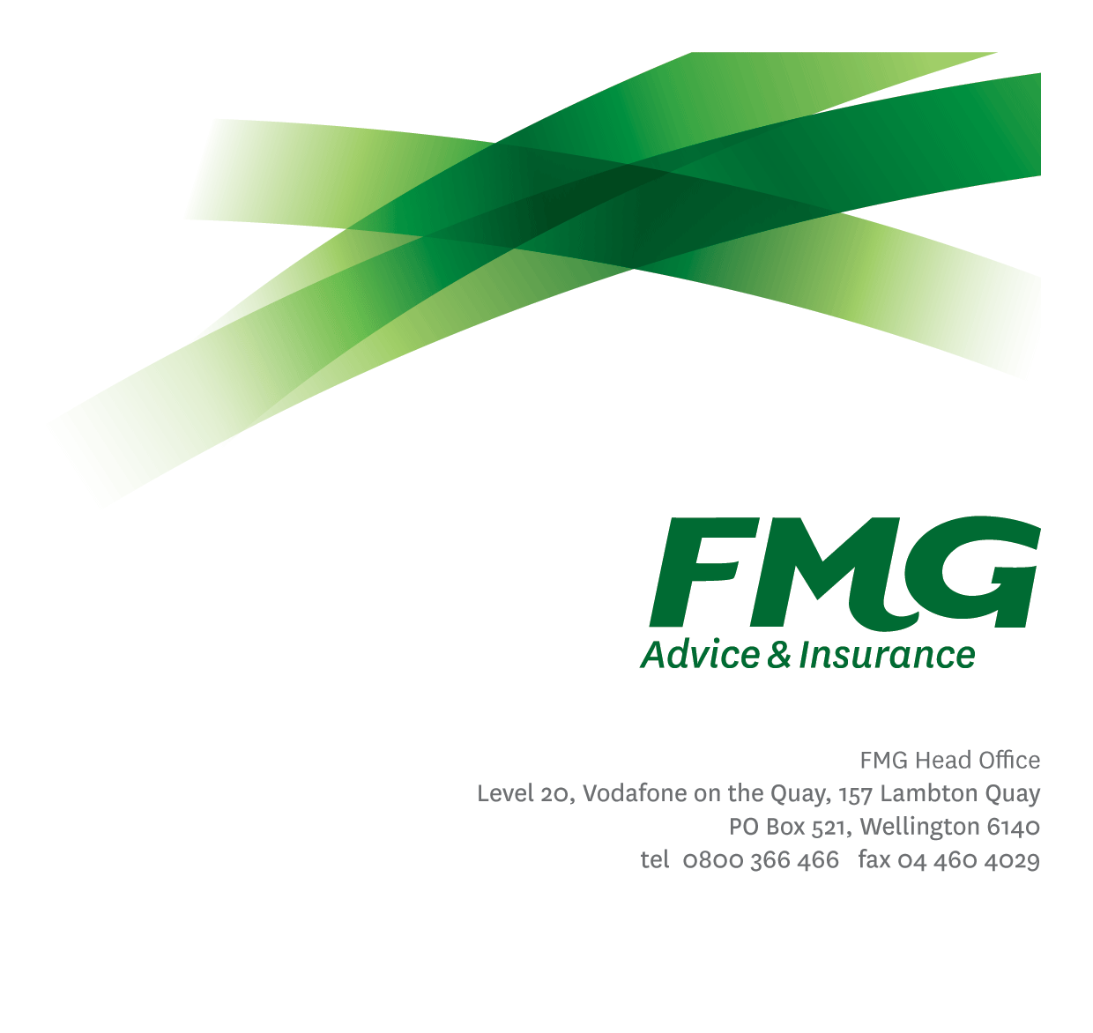
Position Description

Team Leader Inbound

Location: Palmerston North
Reporting to: National Claims & Service Manager
Business Unit: Advice & Insurance
Direct Reports: Variable (8+)
Date Last Reviewed: April 2016

About FMG
Formed by farmers for farmers over a century ago, FMG is New Zealand’s leading rural insurer providing risk advice and insurance solutions for farmers, growers, commercial businesses, the lifestyle sector and domestic clients.
We’re proudly 100% New Zealand owned and operated and our focus is on helping our clients to achieve their goals. As a mutual organisation, we’re all about giving rural New Zealanders a better deal, and part of this involves reinvesting all profits back into the business to keep premiums low and ensure the future sustainability of the organisation.

FMG’s Values
The FMG brand represents promises about what customers can expect from us and each of us is responsible for delivering on these promises. Living our company values means we deliver the best brand experience for our customers. Our company values are:
- Do what’s right | - Make it happen
- We’re in it together | - Proud of who we are

Work Environment
We strive to provide an environment that promotes and fosters achievement. We place importance on career development and training to give our people the tools they need to succeed.
The National Service Centre (NSSC) team operates within a busy, lively service centre environment. Located in Palmerston North the team is committed to delivering a world class customer service experience.
The National Service Centre has a fun, open work environment where we support our colleagues in enjoying what do while providing FMG customers with the highest level of service.

Purpose of the role
To ensure the National Service Centre team deliver a world class level of quality customer service to FMG customers through effective leadership and daily supervision of team members, while adding value to FMG.
The role of the Team Leader Inbound is to provide team members with the support, development and tools they require to deliver a high quality of customer service. The Team Leader will understand and analyse their team’s performance in the key metrics and offer support and recognition where appropriate.
As an integral member of the National Service Centre Leadership team another major component of the role is the requirement to continually identify ways to improve the level and scope of service provided by the overall National Service Centre to FMG’s customer base.

Key Responsibilities

Area | Responsibilities
Team Work Flow | - Ensure regional team achieves quality results through effective planning, management and monitoring of team activities.  - Utilises team resources to meet objectives.
Queue Management | - Manages resources to ensure Service Standards are exceeded.  - Ensure when team members require time outside the ‘call queue; that there is appropriate resource to handle expected call flow.
Customer Satisfaction | - Where appropriate assists with the answering and processing of inbound calls to ensure telephone service standards are exceeded.  - Seeks to improve NPS.  - Provides superior service to all customers and internal customers by demonstrating the FMG values.  - Exceeds customer service satisfaction levels both external and internal through the delivery of accurate and timely information and advice, by being recognized as an expert, building rapport; and getting the job done in a timely manner with minimal disruption to the customer.
People & Service Delivery Management | - Recruits, manages, develops & coaches their team into a highly skilled and performance orientated team.  - Assists with the development and training of the National Service Centre team members.  - When required, provide technical expertise for other team members.
Operational Planning | - Ensures operational business plans are developed and implemented.  - Assists with the implementation of change processes.
Reporting | - Identified key metrics are reported in a timely and accurate manner.  - All reports to meet agreed FMG service standards including but not limited to the quality of content, writing style, grammatical correctness, visual presentation and timeliness of delivery.
FMG Values | - Promotes the “FMG Way” through displaying the values of FMG which are: Do what’s right, Make it happen, We’re in it together, Proud of who we are.
Compliance | - Ensures compliance with legislative, regulations and FMG policies through the monitoring of systems, processes and improvement.
Risk Quality | - Develops a thorough knowledge of all FMG products and services and rural industry topics through attending internal training sessions, external seminars and study programs.  - Business written is within delegated authority (DA) levels.  - Meets targeted Gross Claims Ratios.
Relationship Management | - Maintains effective working relationships with third parties as required.  - Establishing effective working relationships with Managers and employees within the other business units of FMG.
Business Improvement | - Assist in identifying opportunities for process, service and sales improvements.  - Participate in projects or new initiatives as required.
Leadership Team | - Proactively assists and supports Service team colleagues and works closely with other leadership roles in the Service team to continue the culture of high achievement and performance.  - Shares information and resources and provides feedback in a positive and collaborative manner.
Personal Development | - Proactively acquires and develops skills, knowledge and techniques.  - Attends coaching sessions and personal development as agreed with management.
Team Participation | - Living the FMG team values and encouraging other to do the same.  - Assisting and supporting other team members, including training and peer review work as required.  - Supporting the team by sharing information and resources and providing feedback in a positive manner.
Other Duties | - Undertakes tasks as directed by the National Claims & Service Manager & the GM Advice & Insurance as and when required.
Risk Management | - Discusses with customers their approach to risk and examine their appetite and tolerance to risk. Puts risk in a positive context and discusses the “upside” and opportunities that arise out of their risk positions they take. In broad terms identifies customer’s financial ability to tolerate losses from adverse events and their willingness to fund losses themselves through equity or debt.  - Achieves a win/win risk environment with the customer, where the customer better manages risks including the transfer of appropriate portions to FMG through FMG’s insurance products.
Wellbeing & Safety | - Demonstrates commitment to workplace safety and wellbeing practices.  - Promotes and support initiatives that contribute to a healthy and safe working environment for employees, visitors and contractors.  - Ensures compliance with Wellbeing and Safety policy and procedures, including accident and incident reporting and investigation. hazard management, induction, training and supervision, employee participation and contractor management.  - Works in a safe manner at all times and does not undertake activities without appropriate training

COMPETENCIES
*see competency framework for behaviours expected at each level | Expected Level
Customer Driven (Internal & External)  A commitment to understanding the needs and best interests of both internal and external customers, in order to provide them with outstanding customer service and help them to make informed decisions. | Advanced*
Accountability  Taking personal ownership of decisions, behaviour, and development, and being responsible for how these actions impact on the wider organisation and customers. | Advanced*
Adaptability  Demonstrating a willingness to engage in a changing environment and being flexible and comfortable working with change. | Intermediate*
Motivation and Drive  The determination to achieve goals and strive for excellence. | Intermediate*
Relationship Building  Developing and maintaining positive, professional relationships that are built on mutual trust and respect. | Intermediate*
Team Work  Making a positive contribution to the FMG team and collaborating effectively with others to achieve objectives. | Intermediate*
Motivating and Developing Others  A commitment to getting the best out of people and motivating them to reach their full potential. | Intermediate*
Change Leadership  The drive to initiate opportunities to address FMG’s organisational needs and to communicate change in a way that gains buy-in and support from others. | Competent*
Strategic Thinking  The capacity to stand apart from the day-to-day and take a long-term, big picture view of the business. | Competent*

KNOWLEDGE
Qualifications | Relevant qualification is desirable.
Business Awareness | Understands the internal workings of FMG and how business works; understands FMG's position in the advice and insurance market and knows the competition.
Product Knowledge | Is knowledgeable about FMG's insurance policies and packages, the differences between them, and the appropriateness of each in different situations.
Rural Knowledge | Understands the rural community and keeps up to date with the economic, political, and environmental issues affecting our customers.
Risk/Insurance Knowledge | Understands risk and how to apply FMG's policies to situations; is knowledgeable about compliance requirements; understands the insurance process and how claims are managed; knows industry partners and competitors.
Legal Knowledge | Has appropriate level of legal knowledge e.g. the Privacy Act etc.  Can read and interpret legal agreements.

SKILLS
Written Communication Skills | Able to write clear, concise and persuasive proposals and reports.
Verbal Communications Skills | Communicates clearly in order to present information to persuade and influence others.
Listening Skills | Demonstrates active listening skills through eye contact, paraphrasing, appropriate body language and checking understanding.
Risk Assessment Skills | Can put in place plans to mitigate risks and manage issues.
Financial Skills | Able to calculate premiums, and able to accurately check data entry and system output.
Technology Skills | Can expertly use relevant software and technology to its full capacity.

Relationship
External | Internal | Committees/Groups
- Customers | - Wider Service Team  - Training & Development  - Underwriting  - FMG Employees  - Human Resources | - Service Leadership Team

Financial Authority Levels
- No authority to approve or commit expenditure

Human Resources Authority Levels
- May hire direct and indirect reports within approved FTE headcounts.
- May discipline direct and indirect reports in consultation with manager and Human Resources.
- No authority to dismiss staff, unless delegated by the Chief Executive and in consultation with manager and Human Resources.

Delegated Authority Levels
- Delegated authority levels for the individual role-holder will be advised following assessment, training and approval as per the requirements of the FMG Delegated Authority Policy.

Agreement
I agree to the outline of the role as contained in this document and recognise that the contents may need to be amended from time to time to reflect changing business requirements.

I as Job holder, allow my Manager to gather information from third parties where necessary for the purposes of performance management.

Team Leader Inbound’s Name:
Signature:
Date:

