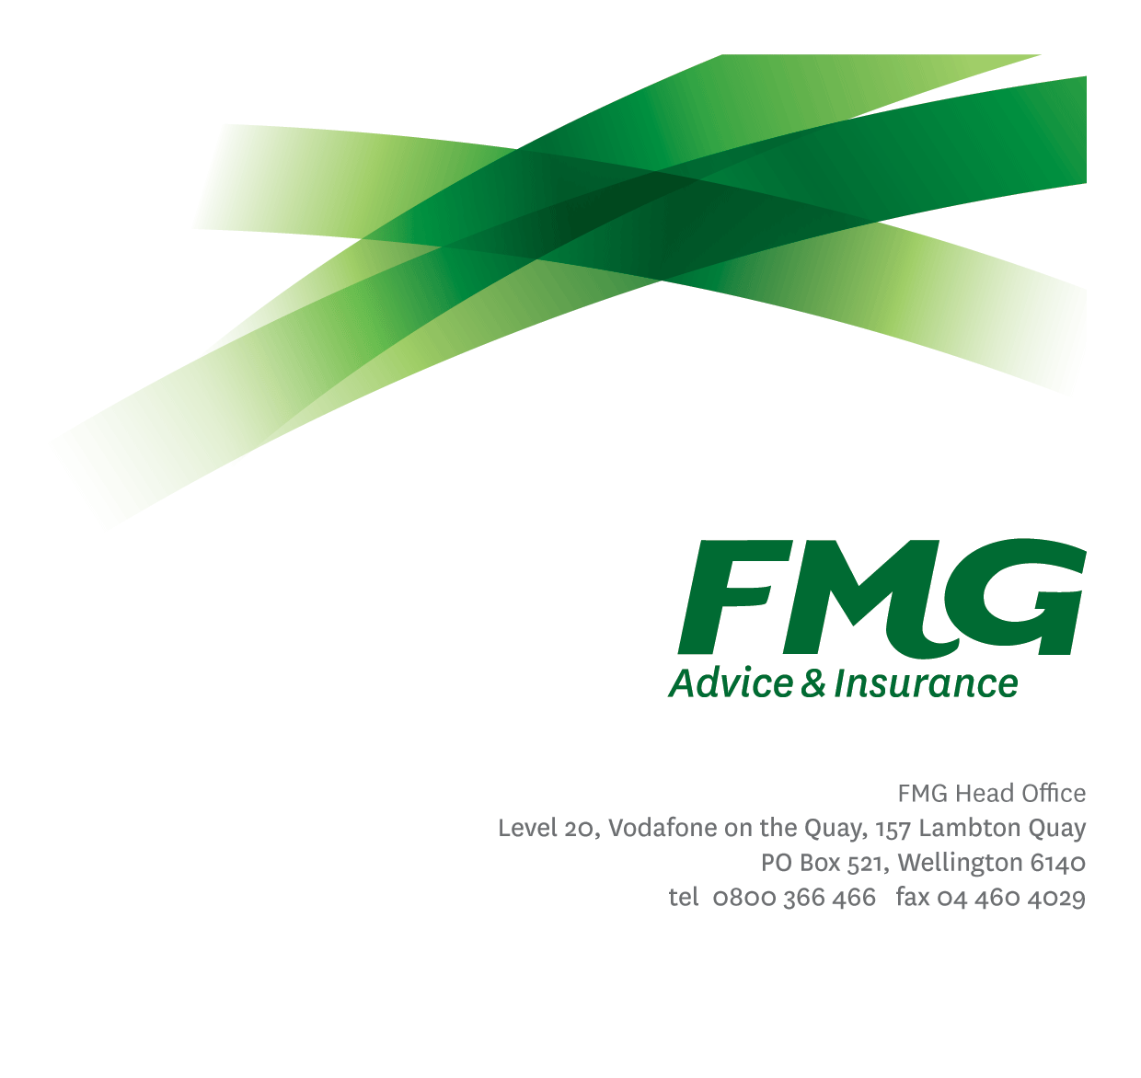
Information Management Specialist
Position Description
Location: Palmerston North
Reporting to: Head of Information Management
Business Unit: Business Information Services
Direct Reports: 0
Date Last Reviewed: January 2026

About FMG
Formed by farmers for farmers over a century ago, FMG is New Zealand’s leading rural insurer providing risk advice and insurance solutions for farmers, growers, commercial businesses, the lifestyle sector and domestic clients.
We’re proudly 100% New Zealand owned and operated and our focus is on helping our clients to achieve their goals. As a mutual organisation, we’re all about giving rural New Zealanders a better deal, and part of this involves reinvesting all profits back into the business to keep premiums low and ensure the future sustainability of the organisation.

FMG’s Values
The FMG brand represents promises about what customers can expect from us and each of us is responsible for delivering on these promises. Living our company values means we deliver the best brand experience for our customers. Our company values are:
- Do what's right - Whāia te ara tika | - Make it happen - Whakatutukitia
- We're in it together - Ko tātau tātau | - Proud of who we are - Whakahīhī i te whakapapa

Work Environment
We strive to provide an environment that promotes and fosters achievement. We place importance on career development and training to give our people the tools they need to succeed.
The Business Information Services team culture is based on open and honest communication, where authority and accountability are clear. Both challenges and opportunities are shared to bring about delivering the best solutions for FMG.

Purpose of the role
To facilitate and support the effective and efficient operation of FMG’s information management practices. You will utilise best practice, innovation and technical expertise in all areas of information management.

Key Responsibilities

Area | Responsibilities
Information Management | - Collaborate with business units and stakeholders to promote and support best practice information management across FMG, regardless of system of record or format  - Participate in the development, implementation and review of information management needs and solutions  - Consult and advise on the development of information management systems  - Document and maintain information management, records retention and archiving processes and procedures including the training and support to employees  - Development and application of business and security classification standards  - Contribute to strategy and best practice approach for managing FMG’s knowledgebases, paper-based files and digital workplace tools  - Development of policies, standards, and procedures to support information management practices  - Liaise with business units to ensure consistent adoption of IM practices across all information systems and repositories
Business Change Improvement | - Coordinate any execution of the identified change strategies, and ensure all key deliverables meet the agreed quality standard and agreed milestones  - Contribute to risk and issue management
Planning | - Input into information management strategy and vision for FMG  - Assists with the implementation of change processes and operational plans.
Reporting | - Identified key metrics are reported on in a timely and accurate manner.
FMG Values | - To promote the “FMG Way” through displaying the values of FMG which are do what’s right, make it happen, we’re in it together and proud of who we are
Compliance | - Ensures compliance with legislative, regulations and FMG policies through the monitoring of systems, processes and improvements.
Customer Satisfaction and Service Delivery | - Provides excellent customer service by demonstrating FMG values.  - Ensures all communication is to a high standard.  - Meets customer service satisfaction levels both external and internal through the delivery of accurate and timely information and advice, by being recognised as an expert, building rapport; and getting the job done in a timely manner with minimal disruption to the customer.
Relationship Management | - Establish and maintain effective working relationships both internally and third as required.
Personal Development | - Proactively acquires and develops skills, knowledge and techniques relevant to the role.  - Attends coaching sessions and personal development as agreed with management.
Team Participation | - Living the FMG team values and encouraging others to do the same.  - Assisting and supporting other team members, including training and peer review work as required.  - Supporting the team by sharing information and resources and providing feedback in a positive and constructive manner.
Wellbeing & Safety | - Complies with safety and wellbeing policy and procedures, including accident and incident reporting and hazard management requirements  - Works in a safe manner at all times and does not undertake activities without appropriate training
Other Duties | - Completes other tasks as requested in agreed timeframes and provision of appropriate progress reports to the satisfaction of the Head of Information Management

COMPETENCIES
*see competency framework for behaviours expected at each level | Expected Level
Customer Driven (Internal & External)  A commitment to understanding the needs and best interests of both internal and external customers, in order to provide them with outstanding customer service and help them to make informed decisions. | Advanced*
Accountability  Taking personal ownership of decisions, behaviour, and development, and being responsible for how these actions impact on the wider organisation and customers. | Advanced*
Adaptability  Demonstrating a willingness to engage in a changing environment and being flexible and comfortable working with change. | Intermediate*
Motivation and Drive  The determination to achieve goals and strive for excellence. | Intermediate*
Relationship Building  Developing and maintaining positive, professional relationships that are built on mutual trust and respect. | Intermediate*
Team Work  Making a positive contribution to the FMG team and collaborating effectively with others to achieve objectives. | Intermediate*

KNOWLEDGE
Qualifications | Relevant business qualification in information management related subjects is desirable.
Experience | Proven experience in developing information management architecture and advanced experience in the application of Microsoft 365, Microsoft Purview Compliance and Enterprise Content Management tools.
Specialist Knowledge | Policies and procedures relating to the lifecycle of information and implementation and maintenance of information management systems
Business Awareness | Understands the internal workings of FMG and how business works; understands FMG's position in the advice and insurance market and knows the competition.
Legal Knowledge | Has appropriate level of legal knowledge e.g. the Privacy Act, Records Management Act etc. Can read and interpret legal agreements.
Rural Knowledge | Understands the rural community and keep up to date with the economic, political, and environmental issues affecting our customers.

SKILLS
Written Communication Skills | Able to write clear and concise reports.
Verbal Communication | Communicates clearly in order to present information to persuade and influence others.
Listening Skills | Demonstrates active listening skills through eye contact, paraphrasing, appropriate body language and checking understanding.
Technology Skills | Can expertly use relevant software and technology to its full capacity
Risk Assessment Skills | Can identify risks and escalate awareness.

Relationship
External | Internal | Committees/Groups
- External Information Management providers and vendors (e.g. Microsoft, Fujitsu) | - Enterprise Architect  - Data Solution Architect  - Data Governance Manager  - Privacy Officer  - Information Custodians & Owners  - Product Owners  - Key Stakeholders | - Information & Data Governance Committee

Financial Authority Levels
- No authority to commit or approve expenditure

Delegated Authority Levels
- Delegated authority levels for the individual role-holder will be advised following assessment, training and approval as per the requirements of the FMG Delegated Authority Policy.

Agreement
I agree to the outline of the role as contained in this document and recognise that the contents may need to be amended from time to time to reflect changing business requirements.

I as Job holder, allow my Manager to gather information from third parties where necessary for the purposes of performance management.

