Te Tūranga l Position Description
Title: | Senior Finance Officer
Team: | Finance
Reporting to: | GM Finance

Aronga Nui | Our Purpose
Ko te hāngai ki te whakatakanga ngātahi, a, ko te aronga tōtika ki ngā tini kaupēhipēhi me te hoe ngātahi i tā rātou kōkiri whakamua.
Manaaki Tāngata Victim Support is here 24/7 for people directly affected by crime, and traumatic events, including their whānau and witnesses. We support people to feel informed, empowered, safe and able to cope with the impact.
We are committed to upholding the principles of Te Tiriti o Waitangi to ensure equitable access and outcomes for Māori clients and that kaimahi Māori can thrive within our organisation.
Ngā Uara | Our Values
At our core of how we work are our values:
Maanakitanga | Whanaungatanga | Kotahitanga | Rangatiratanga | Kaitiakitanga
Te Kaupapa |Role Purpose
The finance team enable the work that Manaaki Tāngata Victim Support do. There are three main components to this role, payroll, accounts receivable and general financial administration. This role is responsible for timely and accurate financial processing as well as maintaining positive relationships with internal and external stakeholders.

Te Rārangi Tūranga/Role Structure
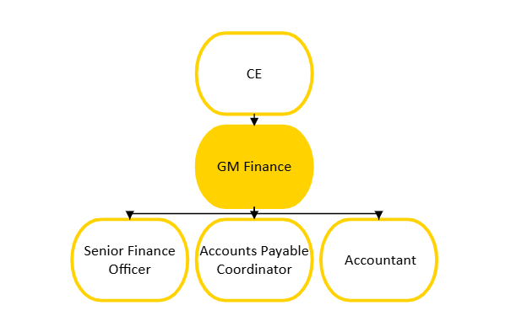

Ngā Mahi |Do
The key responsibilities for this position are:

Bank reconciliations
- Timely and accurate bank and credit card reconciliations
- Ensuring correct treatment of GST on receipts and payments.
- Prepare banking for authoriser approval by collating Victim Assistant Scheme (VAS) payments and creditor pay runs
- Verify VAS client bank accounts to satisfy MOJ verification requirements.

End to end payroll
- Accurate and compliant end to end processing of fortnightly pay runs (and one-off pays as required)
- Process PAYE and filing to meet IRD requirements
- Providing customer focused responses to payroll related enquiries from employees and queries from external stakeholders, e.g. ACC, IRD / Kiwisaver, etc.
- Maintain Payroll records and system information, ensuring all records are accurate and current and that appropriate supporting documentation for all transactions is held and maintained
- Preparing and filing payroll related reports and required Payroll compliance activities such as PAYE returns, etc.
- Providing or assisting with ad hoc reports as required.

Accounts receivable
- Prepare invoices in a timely and accurate manner
- Monitor debtor balances, including seeking recovery of outstanding amounts as agreed with Accountant.

Youth Justice reparation programme
- Monitoring and recording receipts at least weekly. Follow up and identify any receipts which are not clearly identified
- Maintain complete and accurate records of youth justice receipts and payments and other records
- Reconcile youth justice balances and assist in resolving matters relating to client balances
- Prepare and distribute reports in a timely and accurate manner
- Make approved payments as instructed by Oranga Tamariki
- Respond to enquiries from authorised people
- Liaise with Oranga Tamariki as required.

Systems and processes
- Demonstrate and support adherence to agreed internal controls, processes systems and/or policies
- Recommend enhancements to internal controls, processes and systems and participate in agreed enhancements to processes/systems
- Respond to authorised requests for information (financial and/or non-financial)
- Preparation of accountability information for funders as required
- Participate in audit related activities

Relationship management
- Maintain a positive relationship with Manaaki Tāngata Victim Support staff and key external stakeholders
- Keep colleagues informed of any issues, risks and trends emerging in their areas
- Manage and respond to complaints in accordance with Manaaki Tāngata Victim Supports policy to ensure issues are appropriately resolved and positive relationships maintained.

Pūkenga |Key Skills
- 3+ years’ experience in financial administration, GST, payroll and the preparation of bank reconciliations, in a medium/large organisation
- Strong experience in using financial information systems including payroll systems (experience using Datacom would be advantageous)
- Microsoft Office expertise, particularly Excel
- Effective analytical and problem-solving skills with the ability to take initiative
within role expectations
- Highly organised and capable of managing competing priorities while maintaining attention to detail and accuracy and meeting deadlines during peak periods
- Able to present information including explanations and requirement in a clear and professional manner, both written and orally
- Commitment to our organisational values and culture, including Victims’ Rights and advocacy
- Ability to develop good relationships and rapport with people internally and externally
- Able to contribute to an inclusive, respectful and collaborative workplace including working with people with diverse backgrounds and experience.

