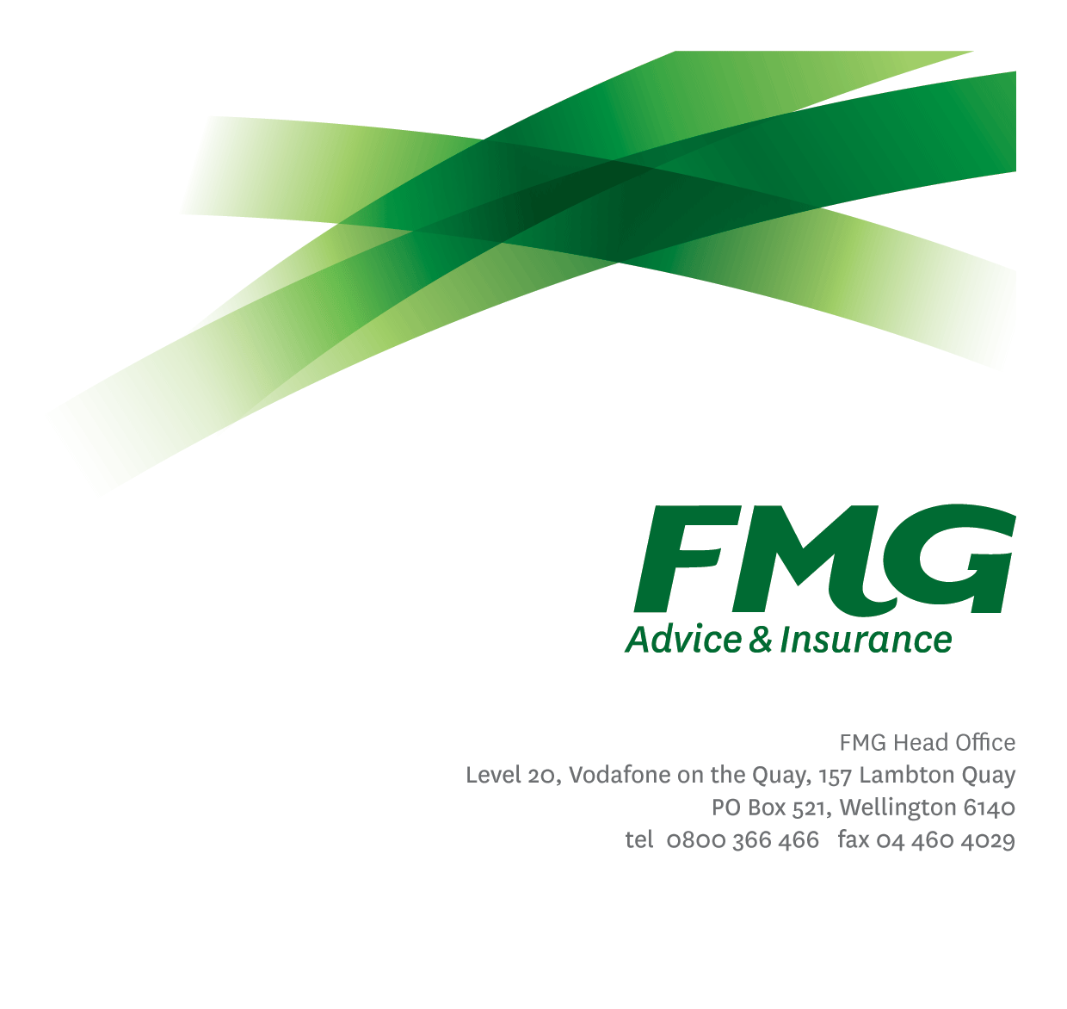
Position Description
Inbound Consultant

Location: As per Personal Terms
Reporting to: Team Leader
Business Unit: Sales, Advice & Service
Direct Reports: Nil
Date Last Reviewed: April 2021

About FMG
Formed by farmers for farmers over a century ago, FMG is New Zealand’s leading rural insurer providing risk advice and insurance solutions for farmers, growers, commercial businesses, the lifestyle sector and domestic clients.
We’re proudly 100% New Zealand owned and operated and our focus is on helping our clients to achieve their goals. As a mutual organisation, we’re all about giving rural New Zealanders a better deal, and part of this involves reinvesting all profits back into the business to keep premiums low and ensure the future sustainability of the organisation.

FMG’s Values
The FMG brand represents promises about what customers can expect from us and each of us is responsible for delivering on these promises. Living our company values means we deliver the best brand experience for our customers. Our company values are:
- Do what’s right | - Make it happen
- We’re in it together | - Proud of who we are

Work Environment
We strive to provide an environment that promotes and fosters achievement. We place importance on career development and training to give our people the tools they need to succeed.
The Service Centre teams operate within busy, lively service centre environment. Located in Palmerston North our team is committed to delivering outstanding customer service.
All inbound calls/queries to FMG come through the Service Centre and Consultants answer and respond to all general queries from customers, farmers, businesses and rural New Zealanders relating to insurance, products and services, claims and policy matters.

Purpose of the role
To be an active member of the Service Centre team and assist with the processing of inbound and outbound communication, through providing timely accurate information, support and advice with a Single Call Resolution focus. The role has a strong emphasis on providing a professional, world class, “value-add’ service for all FMG customers, where the customer receives advice appropriate to their needs.

Key Responsibilities

Area | Responsibilities
Sales & Acquisition | - Generate leads for other parts of the business, including our Investment & Strategic Partners and Life Risk Advisors.
Business Growth and Profitability | - Within agreed timeframe standards, follows up with the customer.  - Business written is of the highest quality and priced accordingly to minimise the risk to FMG’s long term profitability.  - Provides advice and information relevant to the client needs (e.g. product information, fact sheets, packs, etc).  - Identifies and clarifies the nature of the customer’s risk needs and uses initiative to up sell / cross-sell, in order to provide appropriate products, solutions and services to meet those needs.
Retention | - Talking to customers wishing to cancel and discussing options and benefits to retain business.  - Exceeds customer service satisfaction levels through the delivery of accurate and timely information and advice; recognised as an expert in risk management matters; and gets the job done in a timely manner with minimal disruption to the customer.
Customer Focus | - Seeks to improve FMG Net Promoter Score  - Provides superior service to all customers and internal customers by demonstrating the FMG values.  - Achieves a targeted % customer satisfaction score combined of excellent and/or very good, where the customer recognises FMG as providing strategically relevant advice in risk management.  - Engagement with the customer reflects a consultative approach where in-depth questioning and active listening is undertaken, and industry related information is discussed.  - Assisting to identify opportunities for process and service improvement.
Customer Interaction | - Achieves agreed Key Result Areas (KRAs).  - Answer inbound calls and take ownership for a single call resolution, within service level agreements.  - Identify and clarify the nature of the call and use initiative to take appropriate action.  - Ensure call information is correctly documented and updated within Genisys.  - Interpret and apply FMG product coverage, conditions, limitations and exceptions relevant to customer claims/ situations as necessary.  - Prepare clear and concise responses to written queries.  - Where required, seek additional information from customers to properly and fully respond to and resolve queries and claims.  - Ensure written correspondence sent is recorded within Genisys.
Self Development | - Actively identifies all areas for development.  - Attends company approved training and development programs in insurance, risk management and agribusiness.  - Uses newly gained knowledge and skills on the job.
FMG Values | - Promotes the “FMG Way” through displaying the values of FMG which are: Do what’s right, Make it happen, We’re in it together, Proud of who we are.
Team Participation | - Effectively contributes to a collegial and efficient FMG team dynamic.  - Assisting and supporting other team members, including training and peer review work as required.  - Supporting the team by sharing information and resources and providing feedback in a positive manner.
Reporting | - All reports to meet agreed FMG service standards including but not limited to the quality of content, writing style, grammatical correctness, visual presentation and timeliness of delivery.
Risk Management | - Discusses with customers their approach to risk and examine their appetite and tolerance to risk. Puts risk in a positive context and discusses the “upside” and opportunities that arise out of their risk positions they take. In broad terms identifies customer’s financial ability to tolerate losses from adverse events and their willingness to fund losses themselves through equity or debt.  - Achieves a win/win risk environment with the customer, where the customer better manages risks including the transfer of appropriate portions to FMG through FMG’s insurance products.
Risk Quality | - Develops a thorough knowledge of all FMG products and services and rural industry topics through attending internal training sessions, external seminars and study programs.  - Business written is within delegated authority (DA) levels.
Health and Safety | - Complies with safety and wellbeing policy and procedures, including accident and incident reporting and hazard management requirements  - Works in a safe manner at all times and does not undertake activities without appropriate training
Compliance | - Complies with company policies, guidelines and procedures

COMPETENCIES
*see competency framework for behaviours expected at each level | Expected Level
Customer Driven (Internal & External)  A commitment to understanding the needs and best interests of both internal and external customers, in order to provide them with outstanding customer service and help them to make informed decisions. | Competent*
Accountability  Taking personal ownership of decisions, behaviour, and development, and being responsible for how these actions impact on the wider organisation and customers. | Competent*
Adaptability  Demonstrating a willingness to engage in a changing environment and being flexible and comfortable working with change. | Competent*
Motivation and Drive  The determination to achieve goals and strive for excellence. | Competent*
Relationship Building  Developing and maintaining positive, professional relationships that are built on mutual trust and respect. | Competent*
Team Work  Making a positive contribution to the FMG team and collaborating effectively with others to achieve objectives. | Competent*

KNOWLEDGE
Qualifications | Relevant Tertiary Qualification desirable
Business Awareness | Understands the internal workings of FMG and how business works; understands FMG's position in the advice and insurance market and knows the competition.
Product Knowledge | Is knowledgeable about FMG's insurance policies and packages, the differences between them, and the appropriateness of each in different situations.
Risk/Insurance Knowledge | Understands risk and how to apply FMG's policies to situations; is knowledgeable about compliance requirements; understands the insurance process and how claims are managed; knows industry partners and competitors.

SKILLS
Verbal Communications Skills | Communicates clearly in order to present information to persuade and influence others.
Listening Skills | Demonstrates active listening skills through eye contact, paraphrasing, appropriate body language and checking understanding.
Financial Skills | Able to calculate premiums, and interpret budgets and forecasts.
Risk Assessment Skills | Can identify risks and escalate awareness.

Relationships
External |  | Internal |  | Committees/Groups
 | - Customers  - Business partners  - External service providers |  | - Underwriting  - FMG staff

Financial Authority Levels
- No authority to approve or commit expenditure

Human Resources Authority Levels
- Not applicable

Delegated Authority Levels
- Delegated authority levels for the individual role-holder will be advised following assessment, training and approval as per the requirements of the FMG Delegated Authority Policy.

Agreement
I agree to the outline of the role as contained in this document and recognise that the contents may need to be amended from time to time to reflect changing business requirements.

I as Job holder, allow my Manager to gather information from third parties where necessary for the purposes of performance management.

Agreement will be via electronic signature as evidenced on the acceptance form.

