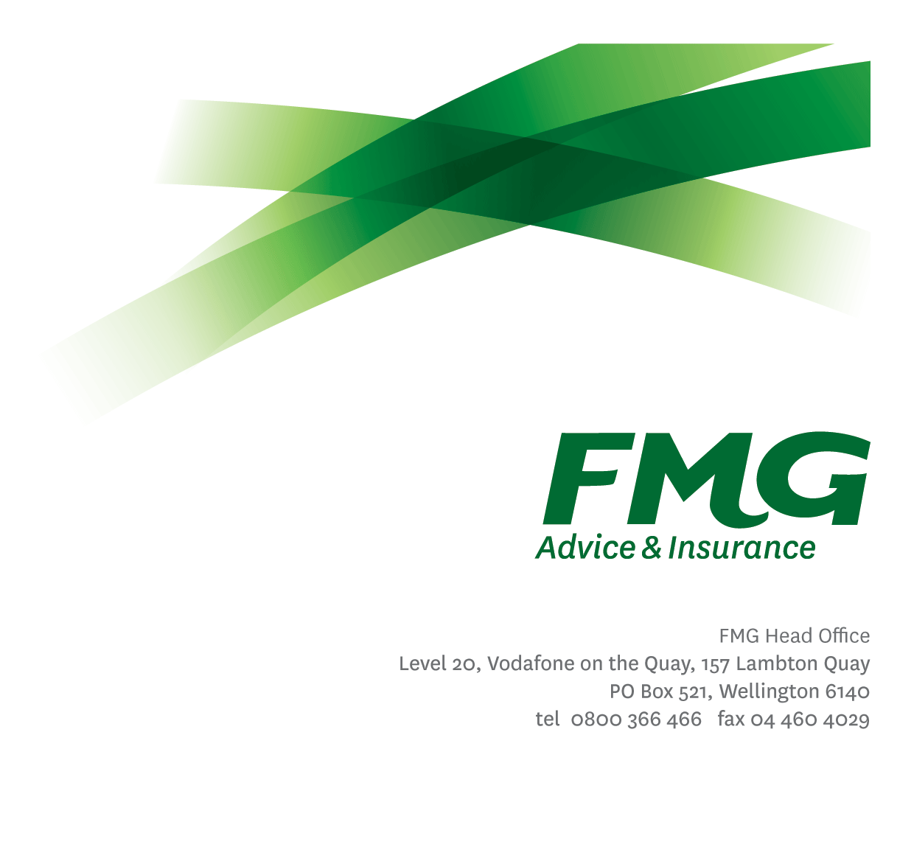  
Risk Specialist (1LoD)

*Position Description*

Location: Wellington/ Palmerston North (Hybrid)

Reporting to: Departmental Mutual Leader (as per Contract)

Business Unit: Sales, Advice & Service/ Claims/ Insurance Solutions

/ Business Information Services (delete as appropriate)

Direct Reports: Nil

Date Last Reviewed: April 2025

### *About FMG*

**Formed by farmers for farmers over a century ago, FMG is New Zealand’s leading rural insurer providing risk advice and insurance solutions for farmers, growers, commercial businesses, the lifestyle sector and domestic clients.**

**We’re proudly 100% New Zealand owned and operated, and our focus is on helping our clients to achieve their goals.  As a mutual organisation, we’re all about giving rural New Zealanders a better deal, and part of this involves reinvesting all profits back into the business to keep premiums low and ensure the future sustainability of the organisation.**

### *FMG’s Values*

The FMG brand represents promises about what customers can expect from us and each of us is responsible for delivering these promises. Living our company values means we deliver the best brand experience for our customers. Our company values are:

|  |  |
| --- | --- |
| **Do what's right - Whāia te ara tika** | **Make it happen - Whakatutukitia** |
| **We're in it together - Ko tātau tātau** | **Proud of who we are - Whakahīhī i te whakapapa** |

### *Work Environment*

We strive to provide an environment that promotes and fosters achievement. We place importance on career development and training to give our people the tools they need to succeed.

FMG’s Head Office is in Wellington and accommodates FMG’s Executive Leadership Team (ELT) and other teams including Risk, Client Strategy, People & Culture, Communications, Financial Management, Product & Pricing and Underwriting, Reinsurance and Business Information Services.

FMG’s largest regional office is in Palmerston North accommodating our National Sales & Advice Centre, Business Information Services, Claims, Operations and Payments functions. In addition to the offices in Wellington, Palmerston North and Christchurch FMG has offices in 28 regional locations throughout New Zealand.

### *Purpose of the role*

The purpose of this role is to ensure that all 1st Line of Defence (LoD) risk management activities for the associated Business Unit are conducted in alignment with FMG’s risk management framework.

Working in collaboration with the Risk Management function, this role will exercise a critical function to support uplifting FMG’s risk maturity by overseeing the programme of work across risk management within the Business Unit.

### *Key Responsibilities*

| Area | Responsibilities |
| --- | --- |
| 1st Line of Defence Implementation | * Educate and support the assigned Business Unit embed FMG’s Enterprise Risk Management Standard No.1 – Risk Management Process across all operational processes. * Support the assigned Business Unit to Identify, Measure, Manage, Monitor and Report on the risks that they own or influence. * Support the assigned Business Unit to manage the risks they are accountable for within FMG’s risk tool, Resolver. * Facilitate or assist in facilitating Risk Assessment workshops for the business units for which you are responsible. * Identify and periodically test the effectiveness of management controls * Undertake regular meetings with employees within their assigned Business Unit who are discharging 1st LoD responsibilities to review, update and / or manage the risks that they own or influence. |
| Risk Incident Management | * Support the assigned Business Unit to manage Risk Incidents for which they are responsible. Activities for example may include, but are not necessarily limited to, triage, root cause analysis and the management of the resolution or corrective actions. |
| Governance Risk and Compliance Tool | * Manage and administer FMG’s Risk tool ‘Resolver’ for the respective business unit. * Ensure the risks captured within the tool align with the appropriate standard and support processes for the identification, measurement, management, monitoring and reporting of risks. |
| Reporting | * Prepare risk reports to support leadership requirements such as Business Unit Leadership risk and performance management; Head of Risk for Enterprise Risk and Compliance Committee (ERCC) or Board Risk and Audit Committee (BRAC). |
| 1st Line of Defence Risk Working Group Team Membership | * Proactive and supportive membership of the 1st LoD risk team working group. * Effectively contribute to a collegial and efficient 1st LoD risk team working group dynamic. |
| Team Membership | | * Effectively contributes to a collegial and efficient FMG team dynamic. * Is a proactive and supportive team member of their team. * Undertake other tasks, when reasonable to do so, ensuring these do not conflict with the delivery of tasks described in this Position Description. |
| Relationship Management | * Proactively build and manage a network of relationships across FMG as necessary to support delivery of accountabilities. |
| Compliance & Risk Quality | * Ensure compliance with appropriate legislation, regulation and FMG policies. |
| Wellbeing & Safety | * Promote and support initiatives that contribute to a healthy and safe working environment for employees, visitors, and contractors. * Ensure compliance with Wellbeing & Safety policy and procedures, including accident and incident reporting and investigation, hazard management, induction, training and supervision, employee participation and contractor management. * Work in a safe manner, at all times, and do not undertake activities without appropriate training |

|  |  |
| --- | --- |
| **COMPETENCIES** | |
| *\*see competency framework for behaviours expected at each level* | *Expected Level* |
| **Customer Driven (Internal & External)**  A commitment to understanding both internal and external clients' needs and providing outstanding service to help them make informed decisions. | Intermediate* |
| **Accountability**  Taking personal ownership of decisions, behaviour, and development, and be responsible for how these actions impact on the wider organisation, clients, members and external partners. | Intermediate * |
| **Adaptability**  Demonstrating a willingness to engage proactively in a rapidly changing environment. | Advanced * |
| **Motivation and Drive**  The determination to achieve goals and strive for excellence. | Intermediate * |
| **Relationship Building**  Developing and maintaining positive, professional relationships that are built on mutual trust and respect. | Advanced * |
| **Teamwork**  Making a positive contribution to the Risk FMG team and collaborating effectively with others to achieve objectives. | Intermediate * |
| **Critical Analysis**  The capability to identify key issues, trends, or important facts from information and to question and probe where required. | Intermediate * |

|  |  |
| --- | --- |
| **TRAINING AND KNOWLEDGE** | |
| **Qualifications** | * Tertiary qualification preferred; risk qualifications advantageous |
| **Business Awareness** | * Understand the internal workings of FMG, how the business functions and how the assigned Business Unit operates to support that. Understands FMG's position in the advice and insurance market and understands the competition. |
| **Rural Knowledge** | * Understands the rural community and keeps up to date with the economic, political, and environmental issues affecting our customers. |
| **Legal Knowledge** | * Has appropriate level of legal knowledge e.g. the Privacy Act etc. Can read and interpret legal agreements. |
| **Risk / Insurance Knowledge** | * Understands the concept of risk management and how to apply FMG policies to diverse situations; is knowledgeable about compliance requirements; understands the insurance process and how claims are managed; knows industry partners and competitors. |

|  |  |
| --- | --- |
| **EXPERIENCE** | |
| **Work Experience** | * Experience within Financial Services sector, preferably Insurance. * ≥ 5 years work experience & clear demonstration of significant exposure to the operations of the respective Business Unit. * Experience with risk management is desired but not essential. * Ability to lead and influence change in a similar construct. * Interacting with people at all levels in the organisation |

|  |  |
| --- | --- |
| **SKILLS** | |
| **Written Communication Skills** | Able to write clear, concise and persuasive risk assessment summaries and reports. |
| **Verbal Communications Skills** | Communicates information clearly to persuade and influence others. Effectively presents information to others, both formally and informally. |
| **Listening Skills** | Demonstrates active listening skills through appropriate techniques, and checks understanding. |
| **Risk Assessment Skills** | Can put in place plans to manage risks and risk incidents. |
| **Leadership** | Lead colleagues in the understanding in the concepts of the Risk Management. |
| **Improvement Skills** | Able to identify and act on improvement opportunities. |
| **Driving Skills** | Full driver’s license required. |

### *Relationships*

|  |  |  |
| --- | --- | --- |
| External | Internal | Committees / Groups |
| * Risk NZ * Resolver (Wynyard Group) | * Assigned 1st Line of Defence Business Units * FMG Risk and Compliance functions | * 1st Line of Defence (embedded) Working Group ERCC |

### *Financial Authority Levels*

* No authority to approve or commit expenditure.

### *People Advisory Authority Levels*

* No People Advisory authority

### *Delegated Authority Levels*

* Delegated authority levels for the individual role-holder will be advised following assessment, training and approval as per the requirements of the FMG Delegated Authority Policy.

### *Agreement*

I agree to the outline of the role as contained in this document and recognise that the contents may need to be amended from time to time to reflect changing business requirements.

I as role holder, allow my manager to gather information from third parties where necessary for the purposes of performance management.

Name: _________________________

Signature: ______________________

Date: __________________________