JOB DESCRIPTION – Schedule B

Position: Luge Operator

Location: Skyline Rotorua

Department: Activities

Responsible to: Activities Manager

Key Tasks:

To assist visitors and guests on the Luge and Chairlifts as per required standards and process.

To ensure that the needs of the guests are given priority at all times and customer service is maintained to a high professional standard

To have the required product knowledge on the activities and services Skyline Rotorua offers.

To ensure that all daily duties are carried all activities are ready for service at the required times.

To assist Skyline Rotorua to achieve budgeted profitability in all areas of the operation, e.g. to promote other areas of our operation.

To maintain all standards of safety, security, hygiene and administration to all applicable legislation levels.

Main Duties & Responsibilities:

1. Responsible for quality guest service within the Activities Department.

- Demonstrate the use of Luge Carts to all riders and ensure they are attempting the track most suitable to their abilities.

- Operate the Chairlift at the Top and Bottom stations ensuring staff and customer safety, managing luge cart return and provide a high level of customer service at these stations.

- To operate all activities within departmental guidelines to a highly professional and motivated level.

- To ensure all Health and Safety requirements are attained to the highest level including Fire and Hygiene.

- To maintain and promote the standards of acceptable behavior at all times.

- To ensure adequate security awareness at all Activities Department outlets are maintained to the highest level.

- To assist in any other area as and when directed by the Duty Manager or direct supervisor.
- Daily preparation of the Activities Department for service, maintain resource stock levels, complete cleaning and end of service duties.

- Deal quickly and correctly with any guest complaint within established parameters.

- To act as the Photo booth Cashier and ensure competent cash/cheque/credit card handling procedures are strictly adhered to.

- To comply with all established workplace Health and Safety policies.

- To be responsible for meeting and promoting established Health and Safety policies and practices.

- To be responsible for the completion of approved workplace Health and Safety documentation.

- Ensuring delivery of service that support Skyline’s sustainability goals by:

- Ensuring recycling and waste management practices are carried out where possible.

Key Competencies

- Excellent Customer Service Skills
- Fit and able to handle heavy luge carts
- The ability to cope well under pressure in an outdoors environment
- Reliable and able to work unsupervised
- Able to strictly follow procedures
- Able to work in a team
- Attention to detail – particularly with regards to safety standards and procedural requirements

Living Our Values

Skyline Rotorua is a leader in the New Zealand travel and tourism sector. We are successful because of the commitment of our staff towards our company’s purpose; to share real fun with the world. We have three values that sum up how we communicate, behave, and work together to achieve our goals.

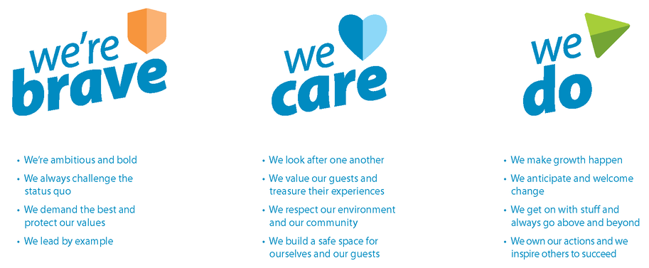
We’re Skyliners. We’re brave, we care, and we do everything we can to deliver real fun and make people smile.

General:

Any other duties that are related to and consistent with the above Job Description as directed by the Activities Manager.

Ensure full confidentiality is maintained at all times.

Attend staff training, induction and other professional development as directed.

Ensure all aspects of the Skyline Mission statement are upheld

Maintain a public image that is compatible with the highest possible standards whilst on the premises.

I accept the job description for the position of Luge Operator.

Name: Date:

