
Āpiha Oranga Taiao
Environmental Health Officer
Job Description

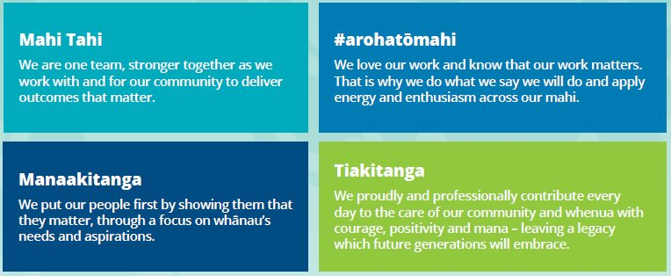
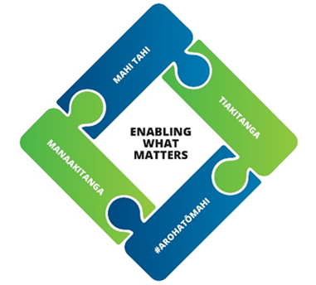

Details
Job Title | Āpiha Oranga Taiao || Environmental Health Officer
REPORTS TO | Licensing Team Lead
GROUP | Community Experience and Services
DIRECT REPORTS | Nil
FINANACIAL DELEGATIONS | TBC
WARRANTS REQUIRED | Yes
GRADE | 16

Purpose
The purpose of the Environmental Health Officer role is to promote and safeguard environmental health in the community by managing licensing requirements, facilitating and influencing proactive compliance, leading, educating and working with the public and industry locally, regionally and nationally to maintain compliance within the Horowhenua.

Key Responsibility and Expected Outcomes

Environmental Investigation, Monitoring, Compliance, and Enforcement
- Using the following legislation as a framework for compliance, monitoring, and enforcement action; Health Act, Food Act, RMA including the Horowhenua District Plan, Building Act, Local Government Act, Litter Act, HSNO; carry out licensing activities, compliance/enforcement/education activities in a timely, accurate, and professional manner.
- Registration and inspection of Health Premises, responding to noise complaints, health nuisances, HSNO and bylaw approvals and complaints
- Maintain high standards of health and safety, ensuring adherence to legislative standards and a healthy working environment for staff, contractors, and members of the community

Food Business Registrations and Verifications, and Alcohol Licencing Support
- Under the Food Act 2014 and associated regulations and legal instruments, manage the registration of and verification of food businesses in the Horowhenua, ensuring Council’s responsibilities as a co-regulator with MPI are met.
- Carry out the duties and functions of a food safety officer under the Food Act.
- Provide support to the alcohol licensing activity. This involves providing advice to customers, processing applications where necessary, and providing cover during periods of absence or when workloads are high.

Environmental Health Advice and Education
- Provide support and education, opinion, and advice to internal and external customers involved in the resource consent, building consent, or plan change process including response through detailed written argument/opinion, conclusions, and appropriate recommendations relating to environmental health matters when required.

Relationship Management
- Support the Community Experience and Services Group in strengthening Council’s strategic relationships by working collaboratively with Iwi and other cultural stakeholders.
- Establish and maintain a network of key contacts to enhance Council’s relationships across local government, government agencies, businesses, and the community.
- Coordinate the implementation of communication plans to ensure key stakeholders are kept informed of Council’s work programme.

Health Safety & Wellbeing
- Promote a strong health and safety culture by proactively modelling our values and hold self and others to account to Consistently follow all health and safety policies and legislative requirements.

Council Contribution
- Actively contribute to the Community Experience and Services Group by performing duties as required, promoting a positive workplace culture, and participating in Emergency Management activities.

CAPABILITY & COMPETENCIES REQUIRED
SkillS, knowledge & Experience | - Proven experience in building strong relationships and becoming a trusted advisor, keeping people up to date intuitively, and communicating to get the best outcome  - Demonstrated success in leading, supporting, and educating compliance across multiple avenues and industries.  - Tertiary qualification that is equivalent to Environmental Health Officer status under the Environmental Health Officer Qualifications Regulations 1993.  - Familiarity with local government or complex public sector environments preferred.
Drives Community Outcomes
Delivers impactful outcomes for the community by providing exceptional service, fostering meaningful Iwi relationships, integrating Te Reo Māori and tikanga, and continuously improving efficiency within the Horowhenua District Council landscape.
Delivery Focused
Delivers high-quality work with integrity, accountability, and efficiency, following through on commitments, engaging with Iwi where appropriate, and using digital tools effectively to achieve meaningful community outcomes.
Mana Enhancing
Builds trust by placing people at the heart of decisions, embracing diverse cultures, upholding high standards of professionalism, nurturing personal growth and self-care, and protecting the mana and integrity of relationships.
Connected
Builds strong, trust-based relationships across teams and the community through clear communication, collaboration, and cultural engagement, creating a connected and inclusive environment that drives better outcomes.
Resilient and Adaptable
Adapts to change with curiosity and resilience, maintaining focus under pressure, seeking diverse perspectives, and persevering to deliver the best outcomes for the community.

Alignment with our community outcomes
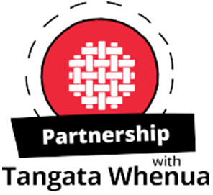 | We uphold Te Tiriti o Waitangi and its principles and recognise the role of Mana Whenua as kaitiaki of their rohe. We support them to maintain and enhance tikanga with their ancestral lands and waterways, wāhi tapu and other taonga, and build mutually respectful partnerships with tangata whenua, supporting whanau, marae, hapū and iwi in achieving their aspirations.
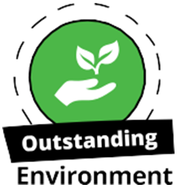 | We contribute to improving our natural environment for current and future generations to enjoy, and protect the important natural features in our district.  We ensure our built environment supports the wellbeing of our people and manage competing pressures on resources sustainably.
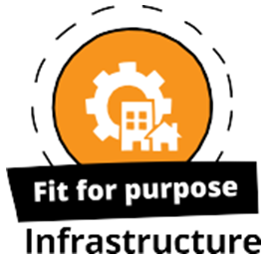 | We provide efficient, reliable and affordable infrastructure, developing and maintaining facilities and infrastructure to meet the needs of current and future generations. Our community facilities and infrastructure are resilient, helping us to respond to climate change and natural hazards, working with partners to develop infrastructure that enables growth.
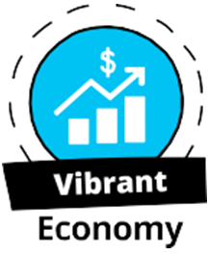 | We are business friendly, supporting diversity and resilience in our local economy and work with others to make our economy grow. We aspire for economic security for all of our people and seize growth opportunities for our district.
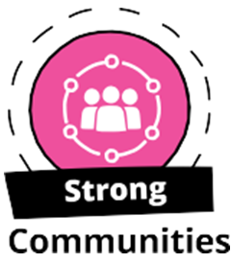 | We value the diversity of our people, and how our district’s heritage shapes our community’s sense of identity and pride.  We provide infrastructure, services, facilities and places to build resilient and connected communities where people of all ages and backgrounds feel included and safe. We are building collaborative relationships with service providers to enable all people to live positive and healthy lifestyles, encouraging our people to participate in local decision making.

