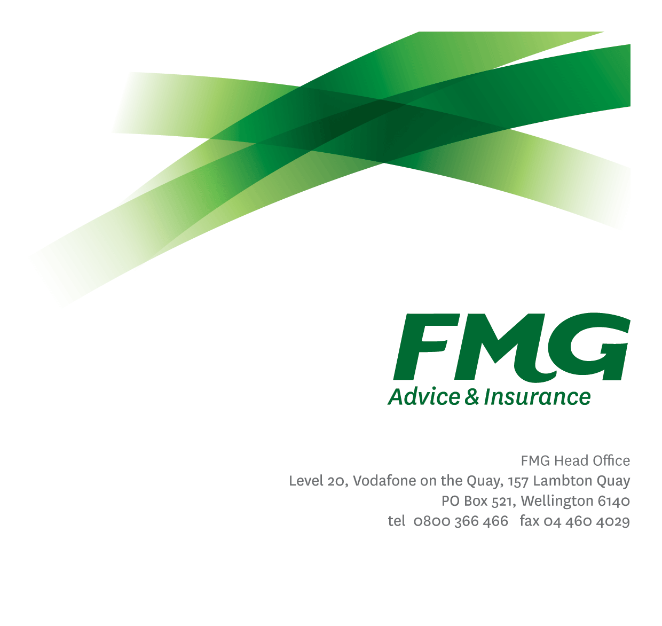
Business Support Consultant
Position Description

Location: Christchurch
Reporting to: Business Support Team Leader
Business Unit: Advice & Insurance
Direct Reports: Nil
Date Last Reviewed: August 2023

About FMG
Formed by farmers for farmers over a century ago, FMG is New Zealand’s leading rural insurer providing risk advice and insurance solutions for farmers, growers, commercial businesses, the lifestyle sector and domestic clients.
We’re proudly 100% New Zealand owned and operated and our focus is on helping our clients to achieve their goals. As a mutual organisation, we’re all about giving rural New Zealanders a better deal, and part of this involves reinvesting all profits back into the business to keep premiums low and ensure the future sustainability of the organisation.

FMG’s Values
The FMG brand represents promises about what customers can expect from us and each of us is responsible for delivering on these promises. Living our company values means we deliver the best brand experience for our customers. Our company values are:
- Do what's right - Whāia te ara tika | - Make it happen - Whakatutukitia
- We're in it together - Ko tātau tātau | - Proud of who we are - Whakahīhī i te whakapapa

Work Environment
We strive to provide an environment that promotes and fosters achievement. We place importance on career development and training to give our people the tools they need to succeed.
FMG’s Head Office is located in Wellington and accommodates FMG’s Executive Leadership Team (ELT), Client Propositions & Online Services, People & Culture and Communications, Financial Management, Product & Pricing and Underwriting, Reinsurance, Business Information and Analysis, Legal and Compliance.
FMG’s largest regional office is located in Palmerston North accommodating our National Sales & Advice Centre, Information Technology, Claims, Operations and Payments functions. In addition to the offices in Wellington, Palmerston North and Christchurch FMG has offices in 30 regional locations throughout New Zealand.

Purpose of the role
Business Support Consultants are responsible for the day-to-day administrative support for our Rural, Commercial and Life & Health Advisors to enable them to focus on providing quality risk advice and new business acquisition.
You may also be required to provide administrative support to other teams within FMG as required.

Key Responsibilities

Area | Responsibilities
Business Support | - Answer Business Support calls and take ownership, within service level agreements.  - Identify and clarify the nature of the call and use initiative to take appropriate action.  - Business written is of the highest quality and minimises the risk to FMG’s profitability.  - Provide appropriate and accurate information to clients as required.  - Ensure call information is correctly documented and updated within the relevant system/s.  - Interpret and apply relevant product coverage, conditions, limitations, and exceptions relevant to situations as necessary.  - Where required, seek additional information to properly, and fully respond to and resolve queries and claims.  - Ensure all written correspondence is recorded within the relevant system.
Client Focus | - All dealings on behalf of FMG promote FMG Values.  - Ensure all communication (including inwards processing, telephone calls and other communication) is completed accurately and within appropriate service levels.  - Ensure any complaints received from customers are fully resolved or escalated to the Team Leader or Manager as appropriate.  - Exceeds customer service satisfaction levels through the delivery of accurate and timely information and advice; building rapport, being recognised as an expert; and getting the job done in a timely manner with minimal disruption to the customer.
Team participation | - Assist and support other team members, including training and peer review work as required.  - Support the team by sharing information and resources and providing feedback in a positive manner.  - Participate in projects or new initiatives as required.  - Undertake additional duties and provide assistance relevant as allocated by the Team Leader or Manager.
Risk Quality | - Interpret and apply FMG product coverage, conditions, limitations, and exceptions as necessary.  - Prepare and provide clear and concise written information.  - Ensure business written is within relevant delegated authority (DA) levels.
Relationship Management | - Develop, manage and maintain effective working relationships.  - Establish effective working relationships with managers and employees throughout FMG.
Personal Development | - Undertake coaching sessions and attend to personal development as agreed with the Team Leader.
Business Improvement | - Assist in identifying opportunities for improving processes and services.
Policy and statutory compliance | - Comply with corporate policies, guidelines, and procedures.
Wellbeing and Safety | - Comply with safety and wellbeing policy and procedures, including accident and incident reporting and hazard management requirements.  - Work in a safe manner at all times and does not undertake activities without appropriate training.

COMPETENCIES
*see competency framework for behaviours expected at each level | Expected Level
Customer Driven (Internal & External)  A commitment to understanding the needs and best interests of both internal and external customers, to provide them with outstanding customer service and help them to make informed decisions. | Intermediate*
Accountability  Taking personal ownership of decisions, behaviour, and development, and being responsible for how these actions impact on the wider organisation and customers. | Intermediate*
Adaptability  Demonstrating a willingness to engage in a changing environment and being flexible and comfortable working with change. | Intermediate*
Motivation and Drive  The determination to achieve goals and strive for excellence. | Competent*
Relationship Building  Developing and maintaining positive, professional relationships that are built on mutual trust and respect. | Competent*
Team Work  Making a positive contribution to the FMG team and collaborating effectively with others to achieve objectives. | Competent*

KNOWLEDGE
Business Awareness | Understands the internal workings of FMG and how business works; understands FMG's position in the advice and insurance market and knows the competition.
Rural Knowledge | Understands the rural community and keep up to date with the economic, political, and environmental issues affecting our customers.
Product Knowledge | Is knowledgeable about FMG’s insurance products, the differences between them, and the appropriateness of each in different situations.

SKILLS
Written Communication Skills | Able to write clear, concise and persuasive proposals and reports.
Verbal Communications Skills | Communicates clearly in order to present information to persuade and influence others.
Listening Skills | Demonstrates active listening skills through eye contact, paraphrasing, appropriate body language and checking understanding.
Technology Skills | Can proficiently use relevant software and technology to its full capacity e.g. Microsoft 365, MS Outlook, OneDrive, Teams, MS Word, Excel and Sharepoint.
Risk Assessment Skills | Can put in place plans to mitigate risks and manage issues.

Relationship
External | Internal | Committees/Groups
- Rural/Commercial Managers
- Mobile Rural Consultants
- FMG employees

Financial Authority Levels
- No authority to approve or commit expenditure

Human Resources Authority Levels
- Not applicable

Delegated Authority Levels
Delegated authority levels for the individual role-holder will be advised following assessment, training and approval as per the requirements of the FMG Delegated Authority Policy.

Agreement
I agree to the outline of the role as contained in this document and recognise that the contents may need to be amended from time to time to reflect changing business requirements.

I as Job holder, allow my Manager to gather information from third parties where necessary for the purposes of performance management.

Agreement will be via electronic signature as evidenced on the acceptance form.

