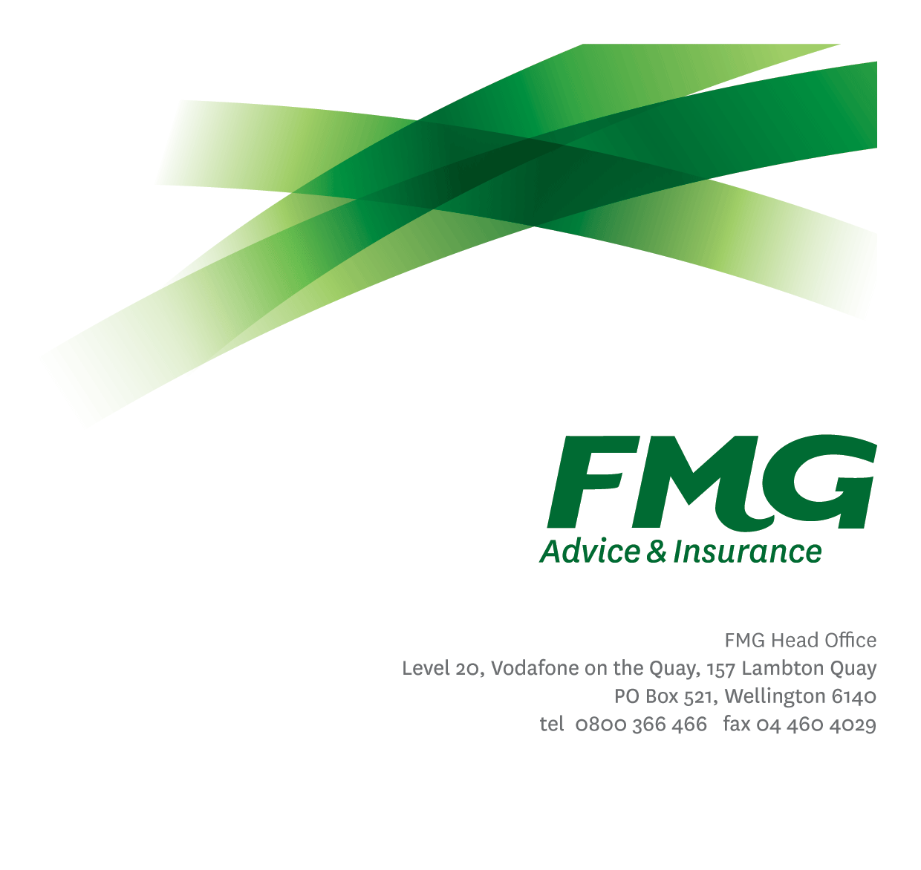
Client Proposition Manager
Position Description

Location: As per Personal Terms
Reporting to: Head of Client Propositions and Loss Prevention
Business Unit: Client Propositions and Loss Prevention
Direct Reports: Two
Date Last Reviewed: Mar 2026

About FMG
Formed by farmers for farmers over a century ago, FMG is New Zealand’s leading rural insurer providing risk advice and insurance solutions for farmers, growers, commercial businesses, the lifestyle sector and residential clients.
We’re proudly 100% New Zealand owned and operated and our focus is on helping our clients to achieve their goals. As a mutual organisation, we’re all about giving rural New Zealanders a better deal, and part of this involves reinvesting all profits back into the business to keep premiums stable and ensure the future sustainability of the organisation.

FMG’s Values
The FMG brand represents promises about what clients can expect from us and each of us is responsible for delivering on these promises. Living our company values means we deliver the best brand experience for our customers. Our company values are:
- Do what’s right - Whāia te ara tika | - Make it happen - Whakatutukitia
- We’re in it together - Ko tātau tātau | - Proud of who we are Whakahīhī i te whakapapa

Work Environment
We strive to provide an environment that promotes and fosters achievement. We place importance on career development and training to give our people the tools they need to succeed.
FMG’s Head Office is located in Wellington and accommodates FMG’s Executive Leadership Team (ELT), Client Propositions & Online Services, People & Culture and Communications, Financial Management, Product & Pricing and Underwriting, Reinsurance, Business Information and Analysis, Legal and Compliance.
FMG’s largest regional office is located in Palmerston North accommodating our National Sales & Advice Centre, Information Technology, Claims, Operations and Payments functions. In addition to the offices in Wellington, Palmerston North and Christchurch FMG has offices in 30 regional locations throughout New Zealand.

Purpose of the role
The Client Propositions Manager is responsible for defining, developing and delivering sector and segment playbooks to achieve long term growth aspirations and ensure alignment with other Mutual strategies.
In this role you will provide leadership and drive the improvement of FMG's Client Propositions across all segments to help contribute to the Mutual's strategic goals in the short, medium and long term and deliver on the strategic ambitions for agreed target markets.
You will lead the development of Client Proposition Playbooks and use your influencing skills to mobilise different teams to act on those strategies. You will use data supported by anecdote to influence and challenge the direction of FMG's Client Propositions. This role will provide leadership to the Proposition Leads.
Being a strong networker is a must both internally to drive collaboration and externally to gain intel within the industry. To do this does requires travel to FMG’s regional offices, to attend industry events, and be a strong team player in the Client Propositions and Loss Prevention team to gain intel from others.

Key Responsibilities

Area | Responsibilities
Client Proposition Strategy and Planning | - Drive the development and implementation of FMG’s Client Proposition Playbooks.  - Collaboration in the development, documentation and delivery of annual business plans.  - Develop strategies and plans to manage key relationships and partners aligned to advice for growth and risk mitigation.
Implementation | - Developing new and enhancing existing Client Propositions to drive sustainable growth through acquisition and retention plans and meeting more needs of existing clients. This will be supported by the Propositions Leads.  - Document key relationships with industry partners and establish a contact plan at both strategic and operational levels to ensure these relationships are proactively managed.  - Assist with planning, organising and monitoring of relevant marketing initiatives and customer events to explore new business sources, enhance brand awareness and establish customer relationships.
Report and Analyse (Insights) | - Analyse the client profile and develop client personas to propose relevant propositions and strategies for client acquisition, loyalty and retention on both a national and regional level.  - Ensure the achievement of overall profitability and growth for each segment.  - Proactively monitor performance to ensure client growth and profitability targets are being met.
People Leadership | - Provide clear leadership to direct reports to support achievement of results and ensuring that individual and team performance is managed and measured appropriately  - Manage the on-going coaching and professional development of the team to ensure full competence in their roles  - Communicate and share information with the team on a regular basis, both formally and informally  - Drive a culture which is underpinned by individual accountability, client/business focus and collaboration.  - Actively looks for and identifies areas for improvement within the team’s business processes.  - Identifies, understands and mitigates the risks that may impact on FMG's strategy, initiatives and reputation.  - Report regularly to the wider team and wider stakeholders to identify opportunities and to celebrate successes.
Broader Propositions Context | - Contribute broadly to strategic and operational discussions and decisions as a member of FMG’s Marketing & Propositions team.  - Work with the Head of Client Propositions and Loss Prevention to ensure alignment with FMG’s overall strategy and plans.  - Lead and contribute to projects as assigned from time to time by the Head of Client Propositions and Loss Prevention.
Relationship Management | - Maintain and manage effective relationships with key FMG stakeholders.  - Monitor the regional and local team’s progress towards segment strategy and provide insights and recommendations to relevant stakeholders eg. Area Managers.
External Networking | - Regularly attends events in local rural communities to promote FMG and enhance personal profile and network within segment.  - Use business and social networking occasions to identify business opportunities for FMG.
Business Requirements | - Document the team’s approved requests for development and improvement that enhance FMG’s proposition and/or client experience.
Team Membership | - Proactively assist the Client Propositions and Loss Prevention team colleagues and other stakeholders.  - Share information and resources and provide feedback in a positive and collaborative manner.
Self-Development | - Maintain own knowledge base of best practice and act as an expert resource
FMG Values | - Promotes the “FMG Way” through displaying the values of FMG which are: Do what’s right, Make it happen, We’re in it together, Proud of who we are.
Other Duties | - Undertakes tasks as directed by the Head of Client Propositions and Loss Prevention from time to time.
Compliance | - Ensure assigned products and overall work is compliant with legislation, regulations and FMG policies through the use of established systems.
Wellbeing & Safety | - Comply with the Safety & Wellbeing policy and procedures, including accident and incident reporting and hazard management requirements  - Work in a safe manner at all times and do not undertake activities without appropriate training

COMPETENCIES
*see competency framework for behaviours expected at each level | Expected Level
Client Driven (Internal & External)  A commitment to understanding the needs and best interests of both internal and external clients, in order to provide them with outstanding customer service and help them to make informed decisions. | Advanced*
Accountability  Taking personal ownership of decisions, behaviour, and development, and being responsible for how these actions impact on the wider organisation and customers. | Intermediate*
Adaptability  Demonstrating a willingness to engage in a changing environment and being flexible and comfortable working with change. | Advanced*
Motivation and Drive  The determination to achieve goals and strive for excellence. | Intermediate*
Relationship Building  Developing and maintaining positive, professional relationships that are built on mutual trust and respect. | Advanced*
Team Work  Making a positive contribution to the FMG team and collaborating effectively with others to achieve objectives. | Advanced*
Critical Analysis  The capability to identify key issues, trends, or important facts from information and to question and probe. | Advanced*

KNOWLEDGE
Qualifications | Relevant Tertiary Qualification required
Experience | 5+ years in a product management or agribusiness or commercial role ideally within the Financial Services Sector.  Experience relevant segment e.g. Rural and Provincial business, Farming.  Proven ability to navigate complex data and gain insights.  Business Development  Internal and External Stakeholder Management.
Business Awareness | Understands the internal workings of FMG and how business works; understands FMG's position in the advice and insurance market and knows the competition.
Market Knowledge | Understands the insurance industry. Maintains an active knowledge of competitors’ products benefits, features and pricing.
Rural Knowledge | Understands the rural community and keep up to date with the economic, political, and environmental issues affecting our customers.
Product Knowledge | Is knowledgeable about FMG's insurance policies and packages, the differences between them, and the appropriateness of each in different situations.
Risk/Insurance Knowledge | Understands risk and how to apply FMG's policies to situations; is knowledgeable about compliance requirements; understands the insurance process and how claims are managed; knows industry partners and competitors.
Specialist Knowledge | Understands the roles of underwriting, sales, claims etc and is able to use their viewpoint in analysing product performance

SKILLS
Written Communication Skills | Able to write clear, concise and persuasive proposals and reports.
Verbal Communications Skills | Communicates clearly in order to present information to persuade and influence others.
Listening Skills | Demonstrates active listening skills through eye contact, paraphrasing, appropriate body language and checking understanding.
Technology Skills | Can expertly use relevant software and technology to its full capacity e.g. MS Word, Excel and PowerPoint.
Project Management Skills | Can manage projects to deliver agreed outcomes across the business within agreed timeframes.

Relationships
External | Internal | Committees/Groups
- Relevant Industry Groups  - Insurance Industry Groups  - Outsourced Product Providers | - Head of Client Propositions and Loss Prevention  - Wider Client Propositions and Loss Prevention team  - Marketing and Propositions  - SAS Senior Leadership Team  - Area Managers  - Head of Underwriting  - Head of Product & Planning

Financial Authority Levels
- As per agreed Delegated Authority levels.

People and Culture Authority Levels
- Not applicable

Agreement
I agree to the outline of the role as contained in this document and I recognise that the contents may need to be amended from time to time to reflect changing business requirements.
I as Job holder, allow my Manager to gather information from third parties where necessary for the purposes of performance management.

Client Proposition Manager’s Name
Signature:
Date:

