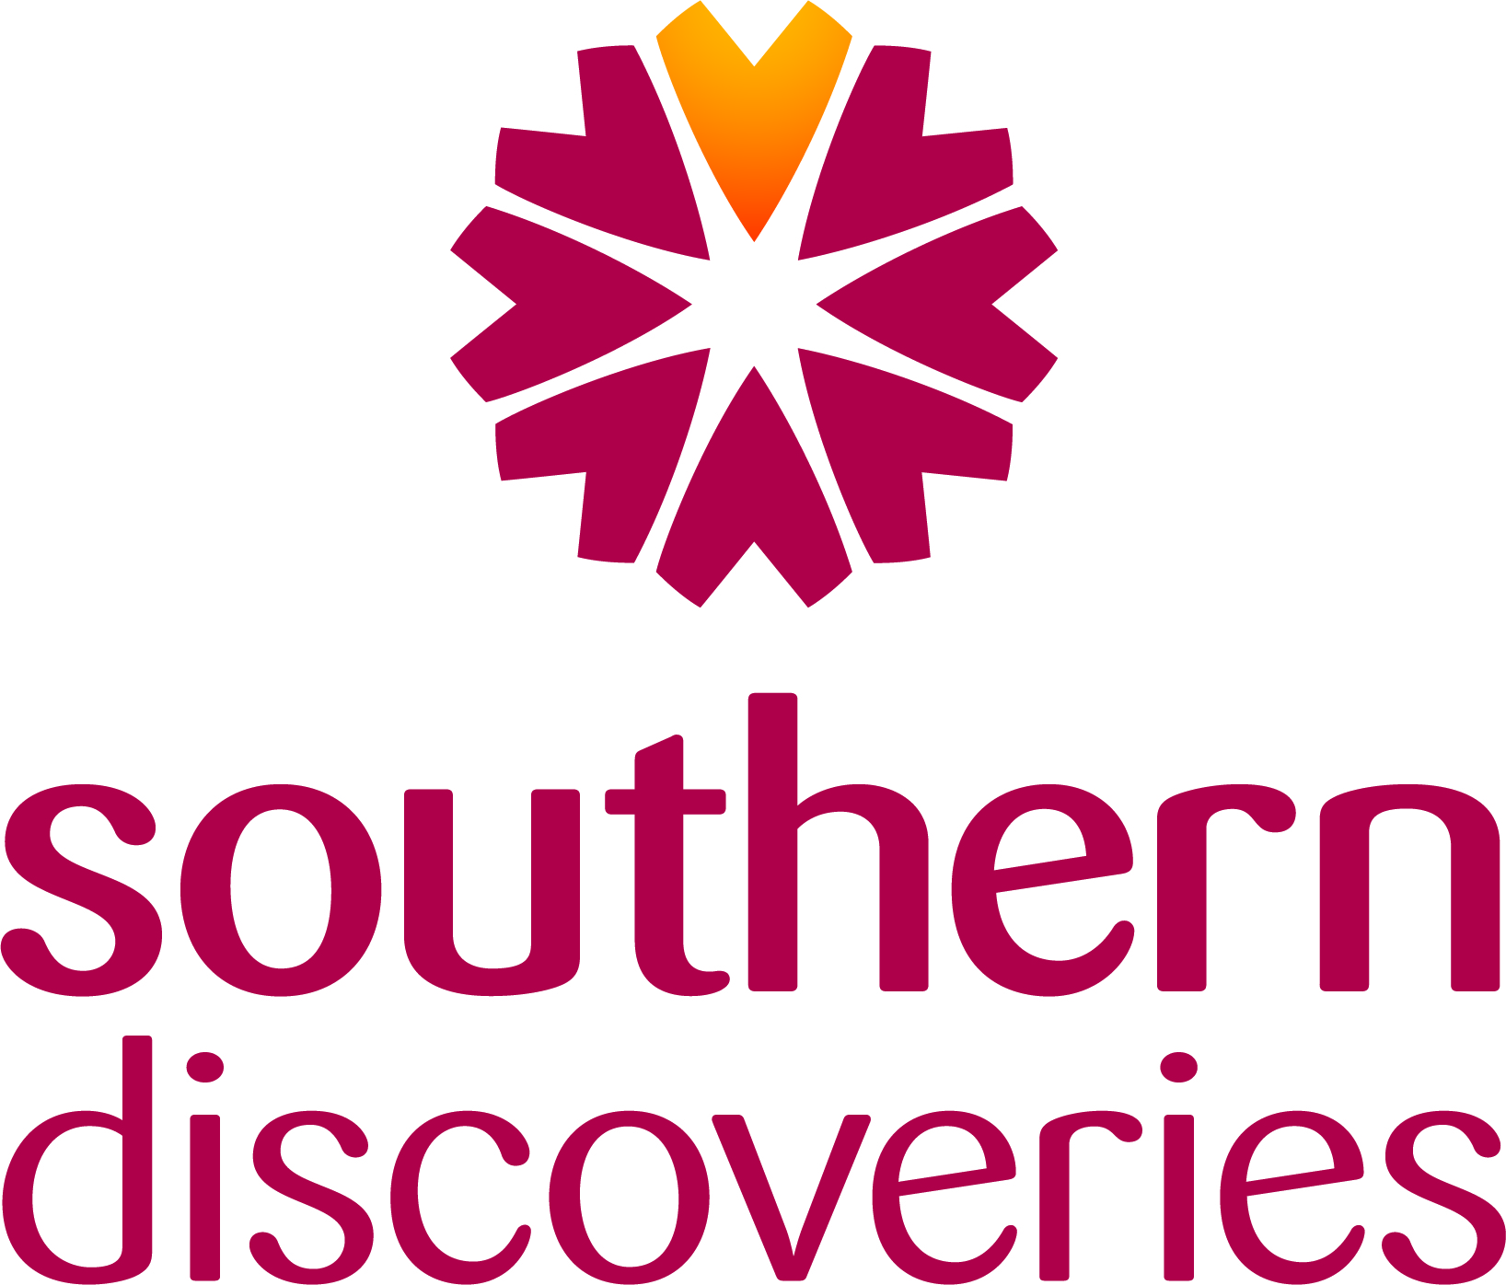

INTERNATIONAL SALES MANAGER
POSITION DESCRIPTION

BUSINESS UNIT: SALES AND MARKETING
LOCATION: Auckland Or Queenstown

Position Summary
The International Sales Manager is responsible for driving Southern Discoveries’ international and partnership sales performance through strong sales management, commercial acumen, and channel growth.

Reporting to the General Manager Sales, this role manages key trade and partnership channels — including international wholesalers, inbound tour operators, partners, and other distribution networks — to deliver sustainable revenue and yield growth.

The role combines traditional relationship-based trade engagement with modern, data-led channel management. It involves developing account plans, identifying growth opportunities, and maintaining pricing and brand consistency across all markets. The International Sales Manager works closely with the General Manager Marketing and marketing team to ensure alignment between trade activities, digital campaigns, and brand storytelling.

Frequent international and domestic travel is required to represent Southern Discoveries at sales calls, key trade events, strengthen partner relationships, and identify new market opportunities.

This is a strategic and hands-on position that plays a pivotal role in ensuring Southern Discoveries’ products are well represented globally, partnerships are nurtured and optimised, and commercial performance is delivered in line with company objectives.

Position Mission
To strengthen and grow Southern Discoveries’ trade and partnership channels through a balanced approach of relationship building, strategic planning, and commercial execution.

The mission of this role is to:

- Maximise revenue and yield across trade, wholesale, and partnership accounts, ensuring each channel performs to its full potential.
- Build and maintain strong partner relationships with key distributors, inbound operators, and partners — positioning Southern Discoveries as a trusted, high-value partner.
- Identify and secure new business opportunities through proactive market engagement, industry networking, and innovative partnership development.
- Enhance collaboration between Sales and Marketing, ensuring trade activities are fully integrated with marketing campaigns, brand communications, and digital visibility.
- Use data and insights to drive decisions on pricing, partner performance, and promotional investment, ensuring commercial targets are met sustainably.
- Represent Southern Discoveries internationally and domestically at trade events, conferences, and partner visits, demonstrating professionalism, product knowledge, and brand passion.
- Contribute to product and experience development, providing market feedback and insights that inform future product innovation and positioning.

Ultimately, the International Sales Manager ensures that Southern Discoveries’ trade and partnership channels are high-performing, well-supported, and aligned with the company’s vision to deliver world-class experiences in Fiordland and Queenstown.

Reporting Responsibility
This position reports to the General Manager Sales.

Health & Safety

- Under the Health and Safety at Work Act (HSWA) 2015, all staff must take responsibility for health and safety, and ensure wherever practicable and reasonable that they, or others, are not harmed by something they do, fail to do, or do incorrectly.
- Promptly report any accident, incident or near miss that occurs in the workplace using the appropriate procedure.
- Maintain a safe working environment by monitoring safety procedures and equipment.
- Understand how to use equipment effectively in accordance with manufacturers’ instructions.

- Be knowledgeable of procedures in the event of emergencies such as fire, earthquake, in line with company policy and legislation.

- Adhere to all operating procedures including identifying and acting upon any new hazards or risks.
- Suggest improvements and participate in Health & Safety matters.

- Attend and participate in Health & Safety meetings.

- Where appropriate assist passengers in case of emergency and be observant of guests to ensure general safety.

Sales & Market Management
- Manage and grow sales across assigned international trade, wholesale, and partnership channels, including inbound operators, wholesalers, partners, and other key distributors.
- Develop and maintain strong, long-term relationships with partners, agents, and relevant tourism bodies, positioning Southern Discoveries as a preferred operator.
- Undertake structured account management, combining in-person visits, virtual meetings, and data-led business reviews.
- Support the negotiation of trading terms and contract renewals as directed by the General Manager Sales, ensuring alignment with commercial strategy and yield targets.
- Deliver partner training and product updates through in-person sessions, webinars, and digital communications.
- Act as the primary point of contact for assigned partners, ensuring seamless communication between clients and internal teams.
- Work collaboratively with Operations, Reservations, and Marketing teams to ensure exceptional partner and guest experience.
- Coordinate and host familiarisations (FAMILs) and key partner experiences in line with company policy, showcasing product quality and value.
- Monitor account performance using CRM tools and analytics, identifying growth opportunities, and maintaining accurate partner records.
- Establish and achieve agreed revenue, yield, and engagement targets for each channel and key account.
- Prepare and implement an annual channel and account plan outlining sales objectives, marketing activity, and growth forecasts.
Market Representation and Business Development
- Represent Southern Discoveries at key trade events, roadshows, and familiarisations, both domestically and internationally, as approved by the General Manager Sales.
- Identify international events and roadshows that provide maximum ROI for the company
- Promote Southern Discoveries’ products and brand story to trade partners, tourism bodies, and industry representatives to strengthen market awareness.
- Undertake targeted travel both independently, and with the General Manager Sales, to engage with high-value partners and conduct strategic business reviews.
- Deliver engaging product presentations and updates to key industry stakeholders to drive advocacy and product knowledge.
- Identify and pursue new partnership opportunities and distribution agreements to expand reach and grow yield.
- Collaborate with the Marketing team on co-operative campaigns, digital visibility, and partner content to ensure brand consistency and campaign alignment.
- Provide post-event reports and insights following travel or trade events, including ROI and future recommendations.
Research, Technology, and Collaboration
- Monitor, analyse, and report on sales performance, revenue, and yield across all assigned accounts and channels.
- Maintain accurate and up-to-date CRM records for all partner interactions and account activity.
- Prepare monthly reports on sales performance, market trends, and partner engagement for management review.
- Use CRM, and analytics tools to identify trends, assess ROI, and support data-led decision-making.
- Collaborate with Marketing and Operations teams to share insights, coordinate campaigns, and ensure alignment between partner activity and company strategy.
- Contribute market feedback and partner insights to product development discussions to support innovation and future planning.
- Stay current with geo-political events that may influence market performance
Key Relationships
Internal
- Sales Team
- Marketing Manager and marketing department
- Reservations and Customer Services
- Accounts
- Operations Managers

External
- Allocated clients
- Partner organisations
- Industry bodies and RTOs.

Authorities
- No authority to represent the company, or partner companies in the media. Any media enquiries must be referred to the GM Sales, GM Marketing, or Chief Executive Officer.

Personal Attributes and Skills
- Commercially driven, able to balance relationship building and management with a strong focus on sales performance and yield improvement.
- Results-oriented, motivated by achieving targets, growing revenue, and delivering measurable outcomes.
- Strategic yet hands-on, with the confidence to negotiate, influence, and close opportunities.
- Ability to think on your feet and adapt presentations and sales calls to meet the needs of the client
- Analytical and data-informed, using insights to identify trends, gaps, and growth potential.
- Digitally capable, experienced in CRM/ IBIS/ BI systems and comfortable working with reporting tools and partner dashboards.
- Excellent communicator and presenter, skilled at building rapport and representing the brand with professionalism.
- Collaborative and proactive, working effectively across departments to align sales, marketing, and operational goals.
- Highly organised and adaptable, able to manage multiple accounts and priorities in a dynamic environment.
- Energetic, self-motivated, and driven by continuous improvement and success.

Qualifications and Experience
- Minimum five years’ experience in tourism, sales, or partnership management, ideally within the travel or experience sector.
- Proven success in driving revenue growth, improving yield, and managing key trade or partnership accounts.
- Strong understanding of commercial principles, including pricing strategy, ROI, contracting, and commission structures.
- Demonstrated ability to analyse performance data and translate insights into actionable sales strategies.
- Experience using CRM systems and reporting dashboards to track performance and manage client relationships.
- Confident negotiator with experience managing high-value partnerships and delivering measurable outcomes.
- Skilled collaborator, able to work effectively with marketing and operational teams to align activity and maximise results.
- Relevant tertiary qualification in tourism, business, or marketing preferred.
- Current driver’s licence and legal right to work in New Zealand.

