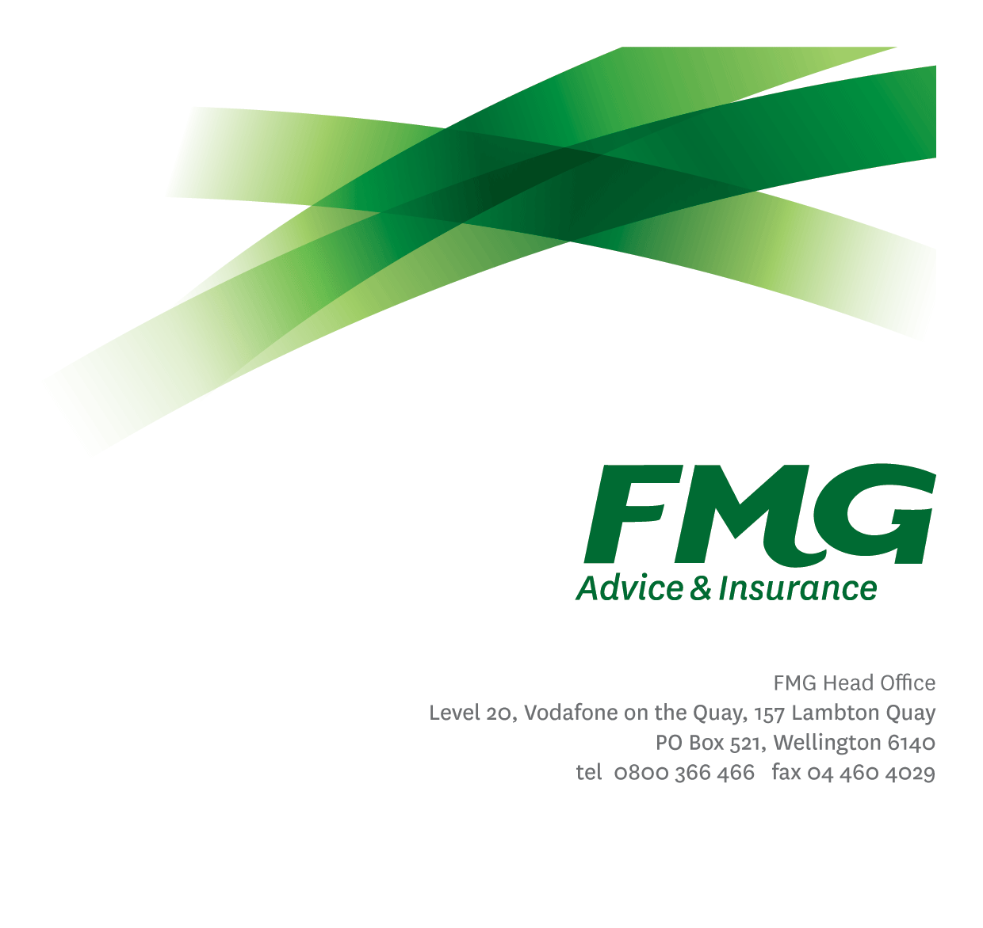Learning Designer
Position Description

Location: As per Personal Terms
Reporting to: Manager, Learning & Development
Business Unit: People & Culture
Date: April 2025

About FMG
Formed by farmers for farmers over a century ago, today’s FMG is New Zealand’s leading rural insurer providing business and personal risk advice and insurance solutions for farmers, growers, commercial businesses, the lifestyle sector and domestic customers.
We’re proudly 100% New Zealand owned and operated and our focus is on helping our customers achieve their goals. Our commitment to a mutual ownership structure guarantees that members’ and customers’ interests are preserved through working in partnership and reinvesting all profits in the business.

FMG’s Values
The FMG brand represents promises about what customers can expect from us and each of us is responsible for delivering on these promises. Living our company values means we deliver the best brand experience for our customers. Our company values are:
- Do what’s right | - Make it happen
- We’re in it together | - Proud of who we are

Work Environment
We strive to provide an environment that promotes and fosters achievement. We place importance on career development and learning to give our people the tools they need to succeed.

Purpose of the role
The purpose of this role is to provide learning design expertise to learning and capability initiatives, which will support delivery of FMG’s business and learning plan. The Learning Designer will use their expertise in program design, assessment and delivery methods (including e-learning, self-paced, classroom, virtual/dispersed and community/peer-to-peer learning) to deliver engaging learning activities, tools and programs that support FMG’s business and capability strategy.
This will be done by providing insights, applying best practice and embedding this knowledge to develop, effective, innovative and sustainable outcomes. The Learning Designer will also leverage subject matter expertise and resources across FMG to deliver on their plans.

KEY RESPONSIBILITIES
Instructional Design | - Contribute to the development of FMG’s learning strategy  - Provide instructional design expertise to capability building programs and initiatives and business change projects when required.  - Analyse, design, develop, evaluate and where necessary support implementations of key capability and learning initiatives.  - Introduce and develop best practice learning design for all capability and learning initiatives, including evaluating business results.
Learning and Capability Program/Initiative Design | - Lead or work with the Learning & Capability Lead, subject matter experts, Learning Architects and when required, external partners to analyse needs, design, develop and assess learning and capability programs and initiatives.  - Ensure programs/solutions developed are leveraged across FMG so that duplication of effort is eliminated.  - Produce materials which effectively aid learning.  - Ensures learning materials and programmes align with organisational messaging and compliance requirements.  - Designs learning and assessment strategies to determine whether desired learning and performance outcomes are achieved, including providing recommendations for future initiatives.
Collaboration,Teamwork and Personal Development | - Exceed client and business partnership standards.  - Act as a specialist advisor to P&C and the business on ‘best practice’ knowledge and innovative ways of designing and supporting learning.  - Collaborate closely with others within the P&C team and wider business to design and deliver fit for purpose solutions leveraging resources to the maximum organisational benefit.  - Support a culture which is underpinned by individual accountability, client/business focus and collaboration  - Take ownership for your personal development, seek guidance from your people leader and colleagues, seize and create opportunities in your work and identify areas that FMG should invest which will build your capability and that of others
Wellbeing and Safety, Policy and Statutory Compliance | - Align learning with wellbeing and Safety and statutory compliance requirements  - Comply with safety and wellbeing policy and procedures, including accident and incident reporting and hazard management requirements  - Work in a safe manner at all times and do not undertake activities without appropriate training  - Comply with organisational policies, guidelines and procedures  - Comply with all legislation governing employment

KNOWLEDGE
Qualifications | - NA
Experience and Knowledge | - A minimum of 3 years of experience in learning or equivalent experience, with a proven ability to develop original and innovative learning content.  - Working knowledge and experience using the ADDIE model and be aware of or willing to learn and operate in an agile design environment.  - Working knowledge and application of learning principles and learning models
Business Knowledge and Industry Awareness | - Understands how businesses work and the commercial nature of doing business (including appreciation for how a mutual operates)  - Understands FMG's position in the insurance market and has knowledge of the competitive landscape.  - Affinity with the rural community and maintain general knowledge of the industry in which we operate and the clients we service.
Skills | - Adult learning principles, learning & development practice, Instructional design, assessment, on the job training, evaluation, facilitation, social learning, eLearning, stakeholder management.

Relationships
External | Internal | Committees/Groups
- Learning and development partners | - Business SMEs  - Human Resources Team  - All Employees  - People Leaders

Authority Levels
- No authority to commit or approve expenditure
- No HR authority levels

Agreement
I agree to the outline of the role as contained in this document and recognise that the contents may need to be amended from time to time to reflect changing business requirements.

I as Job holder, allow my Manager to gather information from third parties where necessary for the purposes of performance management.

Name _____________________

Date _________________

Signature ___________________________

