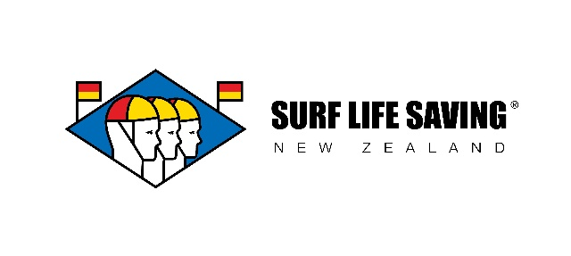

**SLSNZ Office and Team Support Lead**

**POSITION DESCRIPTION**



|  |  |
| --- | --- |
| **Reports To:** | SLSNZ GM – Northern Region |
| **Location:** | Auckland |
| **Position Status:** | Fixed Term, Part Time |
| **Direct Reports:** | None |
| **Key Relationships:** | SLSNZ ELT, NR SLT |
| **Date Prepared:** | September 2025 |

**ABOUT SURF LIFE SAVING NZ**

*As Aotearoa’s leading beach & coastal safety, drowning prevention and rescue authority, we are truly unique, delivering proactive lifeguarding & essential emergency rescue services, a range of public education beach safety programmes, member education, training & development as well as a highly respected sport. With New Zealand having one of the highest rates of drowning (per capita) in the OECD, we are committed to changing this with a vision to have zero preventable drownings on our beaches.*

*We do all this as a charity and rely on the generosity of the public, commercial partners, foundations and trusts for donations and financial contributions in order to lead and support our incredible front line volunteer lifeguarding services. SLSNZ is the national association and represents 74 surf lifesaving clubs with 18,000 + members, including more than 4500 volunteer Surf Lifeguards. Our lifeguards, patrol over 80 locations in summer as well as providing emergency call-out rescue services throughout Aotearoa - saving hundreds of lives each year and ensuring thousands return home safe, after a day at the beach.*

**OUR ORGANISATIONAL CULTURE STATEMENT**

Clubs are at the heart of everything we do.  We support our clubs, volunteers and each other through our values of:

Collaboration • Integrity • Respect • Wellbeing • Fun

We are an organisation that our People are proud to work for and our whanaungatanga (sense of kinship, connection, relationships through shared experiences and working together) provides our people with a sense of belonging.

**POSITION PURPOSE**

This role will provide Office Admin support to the organisation, ensuring high levels of productivity are maintained within the Auckland office site. The role will also fulfil Team Support and Event Coordination tasks and activities to ensure optimal delivery of the team within the Auckland office.

**KEY RESPONSIBILITIES**

|  |  |
| --- | --- |
| **Office Support** | * Manage day-to-day office operations, ensuring a clean, organised, and professional environment. * Maintain office supplies inventory and place orders as needed. * Oversee office equipment and liaise with vendors for maintenance or repairs. * Develop and implement office procedures to improve efficiency. * Attend AMRC User Group meetings as SLS delegate |
| **Team Support** | * Assist staff with administrative tasks, including scheduling meetings, preparing reports, and managing internal correspondence. * Coordinate on-boarding and training for new employees within the Auckland office. * Coordinate catering for internal events including staff welcomes & farewells. * Secretary for NR SLT meetings and NR Gaming & Grants meetings * Act as a liaison between departments to facilitate effective communication and collaboration, including drafting of weekly SLS AMRC Internal Communication |
| **Event Coordination** | * Plan and execute Auckland office events, team-building activities, or training sessions including the NR AOE event * Tasked to provide logistical support to any additional SLSNZ delivered events including: SLSNZ AGM & Leadership Forum, SLSNZ AGM and SLSNZ Staff Conference * Provide administrative and strategic support to the Board of Directors and its committees including:   + SLSNR Club Delegates   + SLSNR AGM’s |

**KEY PERFORMANCE INDICATORS**

* **Compliancy with regulatory deadlines and requirements**
  + Ensuring respective agendas are communicated in line with ToR/Constitutional requirements
  + Engagement with committee secretariat/Chair in advance to create effective agenda’s
* **Timeliness and quality of governance deliverables (e.g. Minutes)**
  + Ensuring minutes are completed for approval within 7 days of meeting occurring
* **Stakeholder satisfaction with support and communication**
  + Maintaining a high-level of written work and meeting administration

**PERSONAL ATTRIBUTES**

**THE APPOINTEE SHOULD HAVE AND BE ABLE TO DEMONSTRATE:**

* Currently Police Vetted in New Zealand
* A current driver’s license
* NZ citizenship or permanent residency
* Confident working with executives and Boards
* Organised, assertive and proactive
* Previous experience in an office support, EA, governance or similar role
* Previous experience with minute taking
* Strong written and verbal communication skills
* Discretion and integrity in handling confidential information
* Experience in developing and maintain office systems and procedures
* High degree of IT literacy, including document management and board portal software
* Ability to remain calm under pressure and think on your feet