|  |  |  |  |  |
| --- | --- | --- | --- | --- |
|  | | | | |
| **JOB TITLE:** | Electrical Technician | | | |
|  |  |  |  |  |
| Location: |  |  | Date: |  |
|  |  |  |  |  |
| Reports to: |  | | | |
|  |  |  |  |  |
| Purpose: | To install, maintain, repair, and troubleshoot electrical systems and equipment. | | | |
|  |  |  |  |  |
| **ROLE SUMMARY:** | | | | |
| Having started providing electrotechnology services in 1936, McKay is a historic New Zealand electrical company with a depth of experience in providing end to end electrical solutions for a wide range of industries and sectors. McKay is the parent brand and has acquired and started a range of companies under the McKay Group name in order to serve all electrical needs.  As an Electrical Technician at McKay Electrical Ltd., you are a skilled professional who is responsible for installing, maintaining, repairing, and troubleshooting electrical systems and equipment. | | | | |

|  |
| --- |
| RESPONSIBILITIES: |

1. **Installation:** Electrical Technicians install various electrical systems and components, such as wiring, circuit breakers, switches, outlets, lighting fixtures, and electrical panels in residential, commercial, or industrial settings.
2. **Maintenance:** They perform routine maintenance to ensure the ongoing functionality of electrical systems. This includes inspecting, cleaning, and replacing components as needed.
3. **Repair:** Electrical technicians diagnose and repair electrical malfunctions or damage. They may need to troubleshoot and fix issues in electrical equipment, circuits, or wiring.
4. **Safety Compliance:** Ensure that all electrical work adheres to safety codes and regulations. Electrical technicians must follow safety protocols to protect themselves and others from electrical hazards.
5. **Blueprints and Schematics:** Read and interpret electrical blueprints, diagrams, and technical documents to understand the layout and specifications of electrical systems.
6. **Testing and Calibration:** Use various tools and equipment to test, measure, and calibrate electrical systems to ensure they operate correctly and efficiently.
7. **Upgrades and Improvements:** Electrical technicians may be involved in upgrading or modifying existing electrical systems to improve efficiency, energy savings, or compliance with new regulations.
8. **Collaboration:** Work closely with other tradespeople, contractors, and engineers to coordinate electrical installations with other construction or maintenance projects.
9. **Documentation:** Maintain accurate records of all electrical work performed, including detailed notes, diagrams, and inspection reports.
10. **Customer Service:** For technicians working in the residential or commercial sectors, interacting with clients, addressing their concerns, and explaining the work performed is important.
11. **Troubleshooting:** Analyse electrical problems, identify their root causes, and develop solutions to resolve them.
12. **Knowledge of Codes and Regulations:** Stay up-to-date with electrical codes and regulations to ensure compliance in all electrical work.
13. **Upkeep of Tools and Equipment:** Maintain and care for tools and equipment, ensuring they are in good working condition and safe to use.
14. **Emergency Response:** Respond to electrical emergencies promptly, such as power outages, electrical fires, or other urgent issues.
15. **Continuous Learning:** Stay current with advancements in electrical technology and industry best practices through training and professional development.Top of Form

|  |
| --- |
| QUALIFICATIONS & KNOWLEDGE: |

* High school diploma or equivalent; an associate's degree or certification in electrical technology.
* Relevant electrical licensing.

|  |
| --- |
| ROLE PROFILE: |

As an Electrical Technician at McKay Electrical Ltd., you must hold the following capabilities;

* Strong knowledge of electrical systems, circuits, and components.
* Proficiency in reading and interpreting electrical blueprints and schematics.
* Familiarity with relevant electrical codes and regulations.
* Skill in using electrical tools and test equipment.
* Excellent troubleshooting and problem-solving skills.
* Strong attention to detail and safety.
* Effective communication and teamwork skills.
* Physical fitness and the ability to work in various conditions, including confined spaces and heights.

|  |
| --- |
| McKay GUIDING VALUES: |

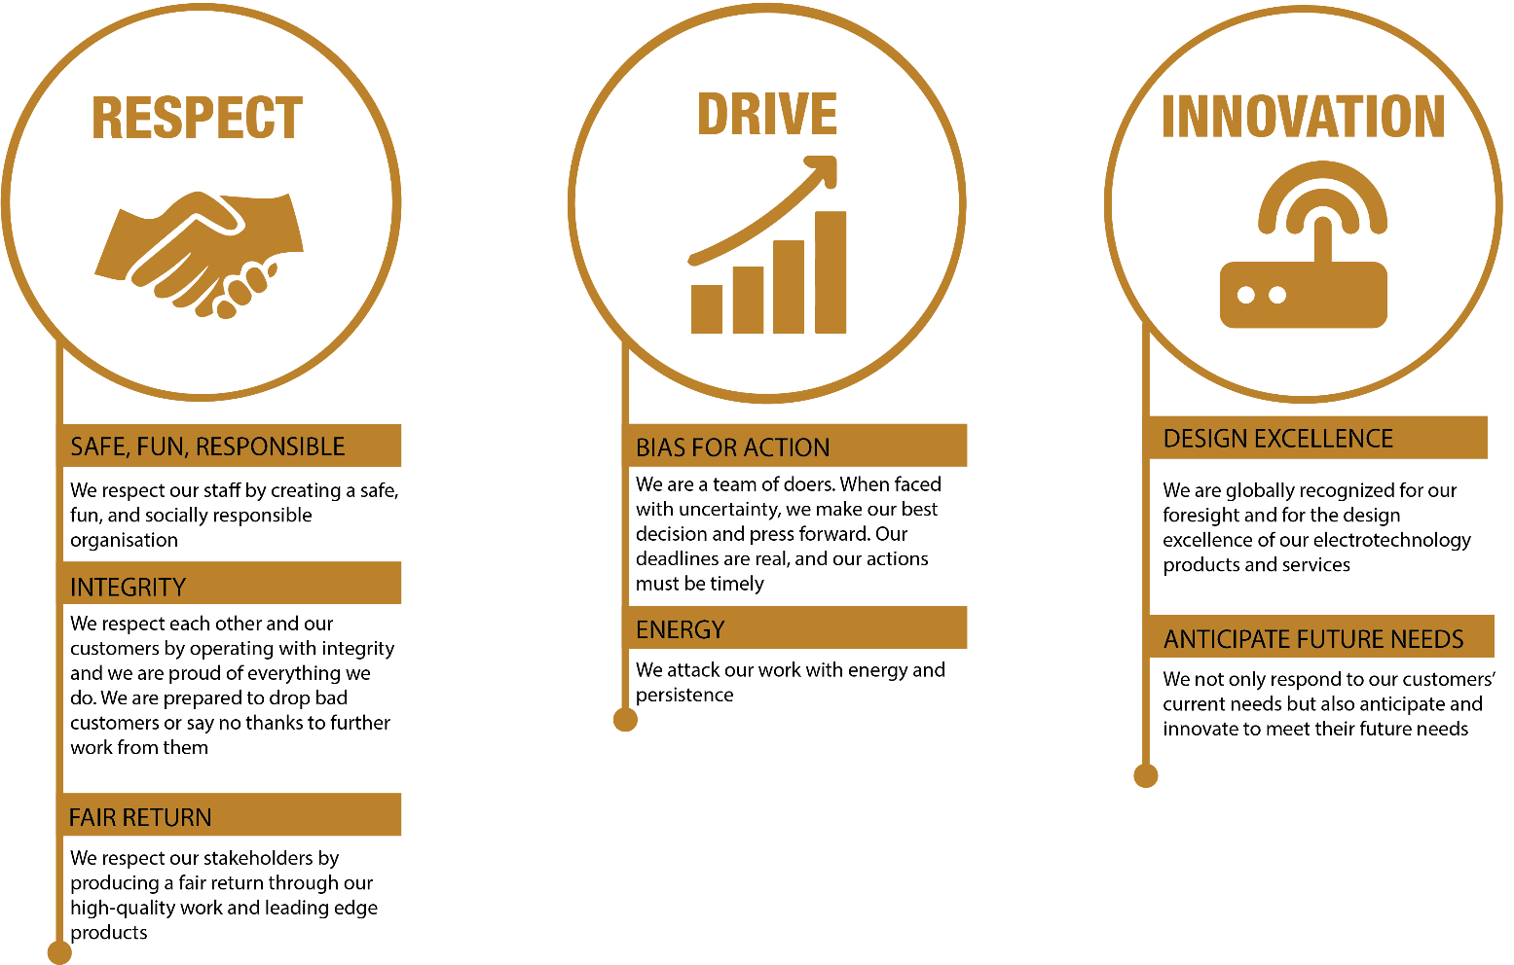

|  |  |  |  |  |
| --- | --- | --- | --- | --- |
| **REVIEWED BY:** |  |  | **DATE:** |  |
|  |  |  |  |  |
| **Last updated by:** | People and Culture |  | **Date/Time:** | Nov 23 |