Job description
Title | Projects – HS+Q Advisor
Location | Dannevirke, Manawatū
Start Date | January, 2026
Reports To | Matthew Beach
 | Renewables
Reviewed By | Matthew Beach | Date: | November, 2025
Last Updated By | People & Culture | Date: | November, 2025
Purpose:
To ensure that all project activities adhere to the highest standards of quality, health, safety, and environmental compliance.
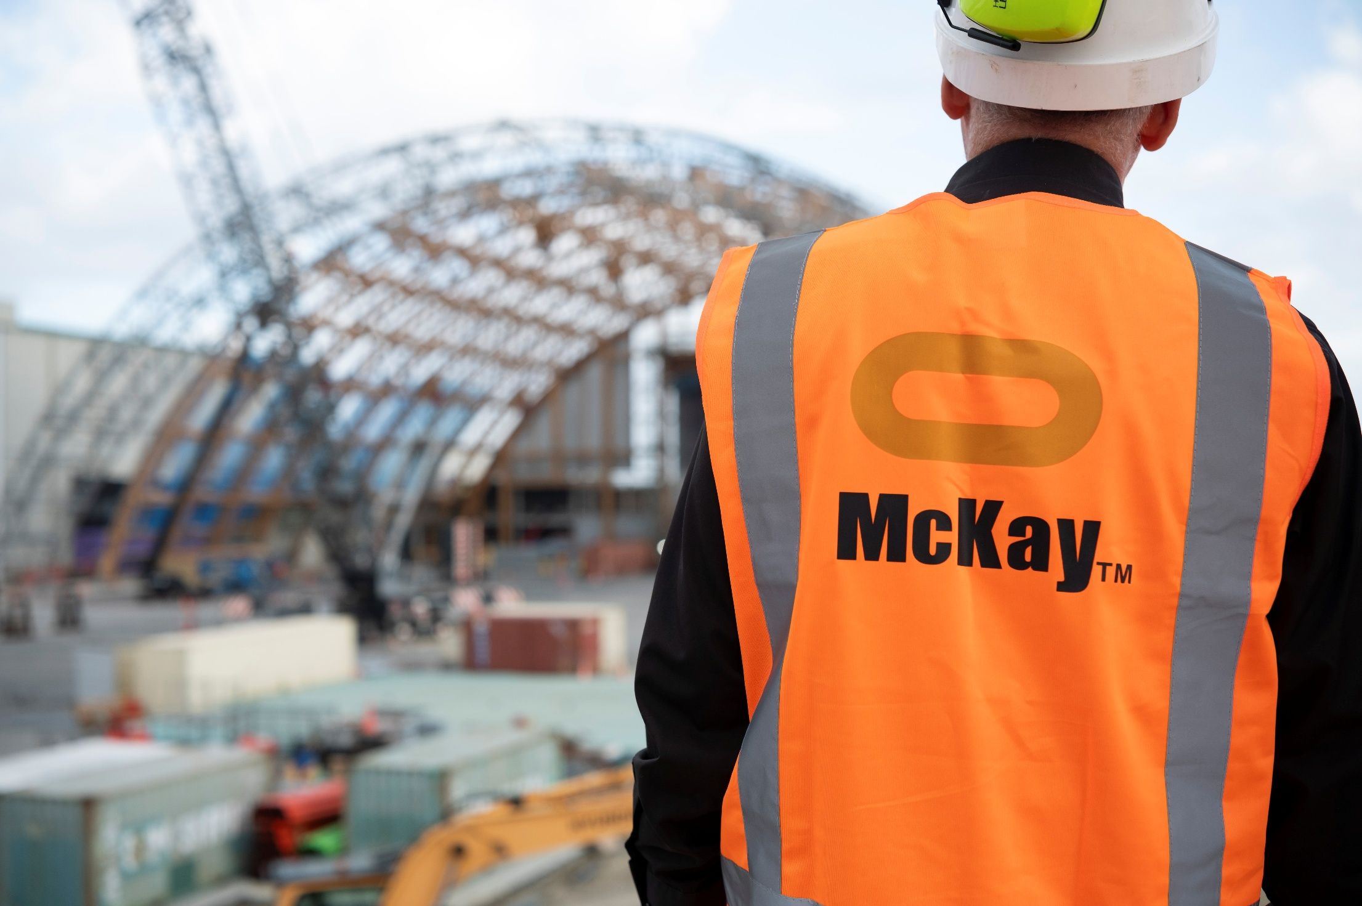

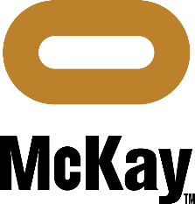

Role Summary
McKay is proud to stand as Aotearoa, New Zealand’s largest privately owned electrotechnology provider, offering innovative electrical engineering and construction services nationwide.
Having started providing electrotechnology services in 1936, McKay is a historic New Zealand electrical company with a depth of experience in providing end to end electrical solutions for a wide range of industries and sectors. McKay is the parent brand and has acquired and started a range of companies under the McKay Group name to serve all electrical needs.
As the Projects QHSE Advisor at McKay Electrical Ltd., you will play a crucial role in ensuring that all project activities adhere to the highest standards of quality, health, safety, and environmental compliance. Your primary responsibility will be to develop, implement, and maintain effective QHSE management systems for ongoing and upcoming projects. You will work closely with project teams, contractors, and other stakeholders to create a culture of safety, environmental responsibility, and quality excellence.

Responsibilities

HS+Q Management System
  - Develop, implement, and continuously improve QHSE management systems for projects in compliance with relevant regulations, industry standards, and company policies.
  - Conduct regular audits and inspections to assess the effectiveness of QHSE systems and identify areas for improvement.

Risk Assessment and Mitigation
  - Conduct risk assessments for project activities, identifying potential hazards and implementing effective control measures.
  - Work with project teams to develop and implement risk mitigation plans.

Safety Leadership
  - Provide guidance and leadership on safety matters to project teams, promoting a strong safety culture throughout all project phases.
  - Conduct safety training sessions and workshops for project staff and contractors.

Incident Management
  - Investigate incidents, accidents, and near misses, and provide recommendations for corrective and preventive actions.
  - Maintain incident records and analyse trends to proactively address potential issues.

Quality Assurance
  - Collaborate with project managers to establish and maintain quality assurance processes for project deliverables.
  - Monitor and report on project performance against quality objectives.

Environmental Compliance
  - Ensure projects comply with environmental regulations and standards.
  - Implement measures to minimize the environmental impact of project activities.

Documentation and Reporting
  - Maintain accurate and up-to-date QHSE documentation for projects.
  - Prepare regular reports on QHSE performance for project management and corporate leadership.

Stakeholder Engagement
  - Engage with internal and external stakeholders to promote QHSE awareness and collaboration.
  - Liaise with regulatory bodies and external auditors as needed.

Qualifications & Knowledge
- Bachelor’s degree in a relevant field (e.g., Environmental Science, Occupational Health and Safety, Engineering).
- Professional certification in QHSE is highly desirable.
  - Proven experience in a similar role within the electrical or construction industry.

Role Profile

As the Projects HS+Q Advisor at McKay Electrical Ltd., you must hold the following capabilities;
- Strong knowledge of QHSE regulations, standards, and best practices.
- Excellent communication and interpersonal skills.
- Ability to influence and engage others in HS+Q initiatives.
- Strong problem-solving and analytical skills.

McKay Guiding Values
