Job description
Title | Manager – NZDF Marine
Location | Auckland
Start Date | <TBC>
Reports To | Executive General Manager – Technology
Reviewed By | EGM Technology | Date: | November, 2025
Last Updated By | People & Culture | Date: | November, 2025
Purpose:
To drive the growth and expansion of the NZDF Marine team by overseeing daily operations, leading the team to achieve business objectives, and implementing strategies to enhance customer engagement and market presence.




Role Summary
McKay is proud to stand as Aotearoa, New Zealand’s largest privately owned electrotechnology provider, offering innovative electrical engineering and construction services nationwide.
Having started providing electrotechnology services in 1936, McKay is a historic New Zealand electrical company with a depth of experience in providing end to end electrical solutions for a wide range of industries and sectors. McKay is the parent brand and has acquired and started a range of companies under the McKay Group name to serve all electrical needs.
As the Manager – NZDF Marine at McKay Limited, you will play a crucial role in overseeing and managing all aspects of electrical projects within the NZDF Marine team. You will be required to bring a strong background in electrical engineering, project management, and a deep understanding of marine systems. You will lead a team of talented professionals, ensuring the successful execution of marine projects from conception to completion.

Responsibilities

Team Leadership and Management:
  - Lead, mentor, and motivate a team of Electricians, Electrical Apprentices, Technicians, Engineers and Project managers.
  - Foster a collaborative and innovative work environment and provide motivational leadership to the team, fostering a positive and collaborative work environment.
  - Conduct regular team meetings to ensure effective communication and project progress.
  - Identify training needs within the team and coordinate training programs accordingly, nurturing key talent and proactively manage poor performance as it occurs.
  - Conduct performance reviews and provide ongoing coaching, including creating individual development plans to support career growth and succession planning for McKay and the business unit.
  - Work alongside Project Managers to execute projects, including, monitor project progress and ensure adherence to the project plan and specified KPI’s, track project expenses and resources to stay within budget and resolve any project issues or conflicts that arise promptly.
  - Allocate resources efficiently, including personnel, equipment, and materials, to ensure team milestones are achieved.

Client Relationship Management:
  - Cultivate and maintain strong relationships with clients, ensuring their needs and expectations are met.
  - Establish and maintain effective communication channels with internal and external stakeholders, including clients, contractors, and regulatory authorities.
  - Serve as the primary point of contact for client communications and issue resolution.
  - Collaborate with the Business Development and Marketing team to identify new business opportunities and contribute to proposal development.

Operational Excellence:
  - Oversee the daily operations of the team, ensuring adherence to company policies and procedures.
  - Oversee the execution of projects, ensuring adherence to quality standards, safety regulations, and industry best practices.
  - Implement and maintain safety protocols to ensure a secure working environment.
  - Foster a culture where delivering projects to a high quality and safety standard are core team values.
  - Ensure that all documentation and processes are delivered to a high level and that this standard is achieved at all levels within your team.
  - Coordinate with cross-functional teams to ensure alignment with project goals and client expectations.
  - Collaborate with stakeholders to define project scope, objectives, and deliverables.

Sales and Business Development
  - Identify and pursue new business opportunities within the assigned sector and support broader business opportunities as required.
  - Closely collaborate with the Business Development and Marketing Team to develop annual business plans which you take ownership and accountability for.
  - You are responsible for a continuous flow of projects with an overall expectation that there will be revenue and profit growth year on year.
  - Use available research and analysis to identify potential opportunities.
  - Accountable for management of bid and tender process ensuring that bids and tenders are always to a highly professional and best practice standard.

Financial Management
  - Monitor and manage project and business unit budget, forecasting, expenses, and financial performance.
  - Implement cost-control measures to maximise profitability.
  - Prepare and analyse financial reports for senior management.

Risk Management:
  - Identify and assess potential risks and challenges associated with projects.
  - Develop and implement mitigation strategies to ensure successful project delivery.
  - Monitor and report on project risks and provide solutions as needed.

Qualifications & Knowledge
- Proven experience in management or leadership roles (essential) and preferably experience with electrical projects within the marine and/or defence industry.
- Bachelor's or Masters degree in relevant field. – Preferable

Role Profile
As Manager – NZDF Marine at McKay, you must hold the following capabilities.
- High level of professionalism
- Strong knowledge of the defence, naval and marine sector and industry trends
- High level of emotional intelligence
- Excellent and proactive leadership, communication, customer and interpersonal skills
- Experience of business to business sales and business development
- Ability to make sound decisions under pressure and adapt to changing circumstance.
- Budget and financial management
- High level of knowledge of application of project management methodologies and systems
- Proficient in Microsoft Office Suite and other relevant business software.
- Knowledge of marine electrical systems and industry standards.

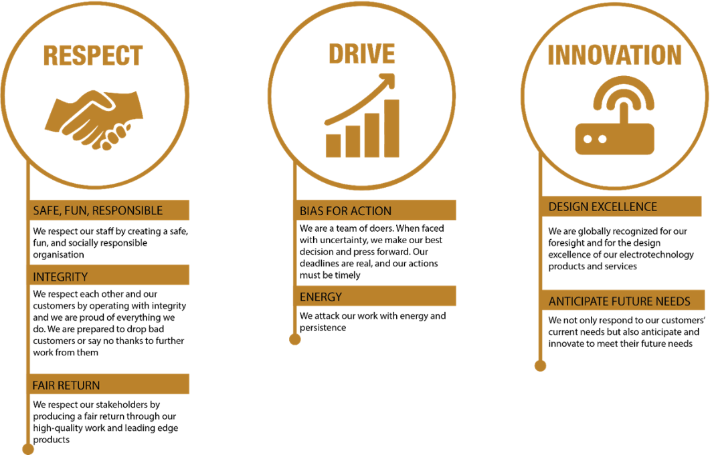
McKay Guiding Values

