- Organised, efficient and productive, autonomous / Independent.

Position Description
Project Manager



Our purpose
Our long-term aspirations are to develop more long-term value-based relationships with our customers, and for our people to grow and develop so that they are better off working at the Co-operative.

Our values
Our values represent who we are, how we think, and how we behave to bring these to life every day. You’ll demonstrate behaviours that define our core values and support an inclusive culture with a strong teamwork spirit.
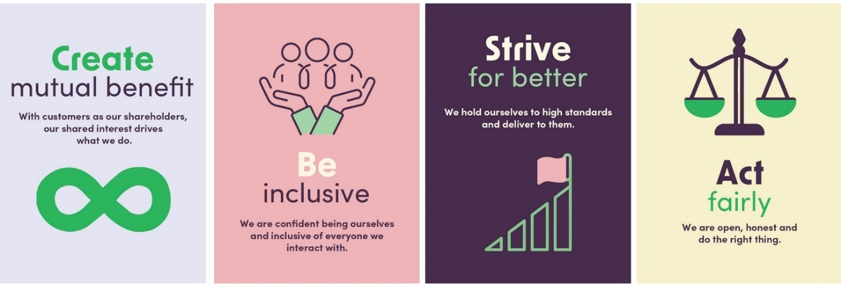

About the team

The Enterprise Portfolio and Change Management team is responsible for leading the consistent use of a standardised set of skills, tools, and processes to support the delivery and execution of enterprise-wide business and regulatory change. Within the team are centralised project resources that lead and manage the Bank’s bigger delivery and change projects and programmes of work, and specialist capability resources providing leadership, coaching, co-ordination of, and advice on our project, programme and change capabilities, frameworks and practices. Together, the team are focussed on uplifting programme and change management capability and practices to enable the Bank to respond quickly to market and regulatory changes, customer needs, and adoption of new technology, all whilst minimising unnecessary impact on its people and its customers.

Purpose of this position
The purpose of the Project Manager role is to lead the delivery design and implementation of critical technology projects that support the execution of key parts of the Bank’s strategy and business plan.

They’ll achieve this by leading project team(s) that could be specialist or cross-functional, ensuring that customer and staff needs are fulfilled, strategic outcomes are met, and risks are managed effectively. Many projects will involve co-ordinating external business partners and specialist technical vendors.

This role will work directly with the team’s Programme Lead and will engage with the Bank’s broader business and technology delivery plans to ensure the execution and sequencing on technology project delivery is aligned with this plan and other strategic priorities. This will mean working with other leaders, internal delivery teams and collaboratively with 3rd Party vendors, to deliver each project.

The Project Manager will adopt a variety of project delivery methodologies as needed and escalate risks, actions, issues and decisions in a timely manner. This will ensure projects are delivered to the desired quality, within the agreed restraints of time and cost and ensuring what gets delivered is embedded/adopted by our customers and our people to realise maximum benefit.

Position reports to: Programme Lead

Challenges and opportunities of this role
This area is to focus on the key areas that are the most challenging to navigate but also most important to get right for this position, within our operating environment.

- Balancing our desire to ‘deliver great people and customer experiences’ with the Co-operative Bank’s risk appetite and compliance obligations.
- Ensuring that the quality assurance applied during the project stages deliver the intended experience and outcomes for our people, our customers and the Bank.
- This role will include both a project overview and governance component as well as a hands-on component to ensure that projects achieve the agreed outcomes.
- Achieving delivery at a sufficient rate to enable the Bank to achieve strategic business goals. The main constraints will be resource availability and cost.
- Adopting robust project management methodologies in an environment with low project and change management maturity.
- Championing and leading project management disciplines across the business for all projects.

How you will contribute:
What you’ll do | Success will mean

Technology Project & Change Management
Lead cross-functional teams to successfully scope, design and deliver technology projects across the business alongside other key stakeholders and change roles at the Co-operative Bank.  Deliver assigned technology projects using robust best practice project management methodologies that are right sized for the organisation and scope /type of project.  Development of clear business and technical requirements and management of project scope.  Manage complex dependencies (including technology) involving multiple teams, organisations and change approval processes.  Clearly define internal and third-party accountabilities and responsibilities.  Identify and track benefits from delivery and communicate impact.  Create, manage and share project status updates, reports and presentations as required to manage stakeholders and drive project outcomes.  Inclusion of robust change management practices within each project to ensure change is prioritised and sequenced effectively.  Support development of project planning and delivery methods and approaches that align and enable better execution of the Co-operative’s strategy and operating rhythms. | - Sponsor and key stakeholder relationships, including to a Board level, are built and maintained.  - People and customers buy-in to change.  - Targeted results from technology project and change initiatives are delivered.  - Methodologies are appropriate for the simplicity or complexity of projects that may involve software development, infrastructure, networking or data.  - Projects are delivered on time, within scope, quality and cost.  - Accountabilities and responsibilities are clearly understood across all teams and organsations involved.  - Change is well implemented, planned and supported and considers the impact on our people, our customers and the Co-operative.  - Reports and presentations are on time and fit for purpose to meet the need of the project and organisation.  - Other business change is considered within delivery plan and approaches.  - Balancing the art and science to transformation management.

Effective Leadership
Lead business and technology delivery resources to deliver change and solutions for the Co-operative Bank’s customers and our people.  Deliver quality solutions that are strategically aligned, deliver great customer and business outcomes and support the team to deliver within allocated budgets and timelines.  Leverage your understanding of common practices for the design, implementation and testing of software development, traditional infrastructure and cloud systems to apply appropriate methodologies  Champion agile delivery disciplines where relevant and beneficial.  Provide advice and coaching where needed on best practice project management disciplines. | - Create a high performing, engaged and motivated technology project team.  - Encourage a culture of customer focus and continuous improvement.  - Project methodologies and approach are credible to business and technology delivery teams and third parties.  - Guide the business and technical delivery team members to define what they can realistically achieve.  - Right-size the approach for the scale of work and the organisation.

Finance and Risk Management
Tracking and reporting project progress against milestones, activities and deliverables.  Reporting progress against budget.  Identifying, tracking and managing project risks and issues.  Manage third party delivery by co-ordinating procurement, contract negotiation and management.  Leading for a healthy risk management mind-set in the team. | - Each project’s financial situation is well understood by key stakeholders/senior leadership.  - Management of salary transfer to CAPEX is captured where relevant (i.e. technology teams with capitalisable salaries).  - We get value for money from delivery by third parties.  - Risks are mitigated or managed within appetite.  - Risk is considered within a customer lens.

Stakeholder Management
Build and maintain strong relationships with technology project team and key stakeholders.  Work collaboratively with other members of the team.  Provide leadership, mentoring, and coaching to other members of the project team and the business as required.  Ensure regular meetings are held with clearly defined agendas. | - Stakeholders and teams are kept on task.  - Wider business is aware of and understands delivery and implementation planning at the right time.  - Teamwork is well integrated, and team goals are achieved.  - An uplift in project and change management maturity across the Bank.

Other Accountabilities
Have self-awareness, influence and leads in ways that uphold our beliefs.  Complies with Health & Safety requirements, including practicing safe work methods, and helping management eliminate workplace hazards. | - Demonstration of behaviours that define our core beliefs.  - H&S good practice and compliance supports a safe workplace.

Healthy and safe work environments
Follow all health and safety policies, standards, emergency procedures and plans.  Participate in health and safety activities, training and meetings as required.  Reports hazards, near misses, injuries, incidents, and ideas for continuous improvement.  Cease work if an unsafe situation arises and seek assistance. | - Having healthy and safe ways of working.  - All workers feel empowered to and aware of opportunities to participate in health and safety activities.  - Our people can easily report hazards, near misses, injuries, incidents, and ideas for continuous improvement.  - Workers stop work if they feel unsafe and connect with their people leader or other workers for assistance.

Decision making and responsibilities
- Decisions and/or financial accountabilities:
- Make all project decisions as defined in governance structure for projects (including technology) that fall within scope and budget, through building clear understanding of the consequences of those decisions by engaging deeply with project teams.
- Make all project delivery related decisions for 3rd parties as defined in the SOW for each technology project.

- Actions and decisions that are recommended to a higher level of management for approval:
- Advise Sponsors and Business Owners of appropriate decision making as they arise during each project.
- Hiring of additional temporary or permanent resource.

Qualifications and experience

Tertiary level degree or equivalent experience

Certification in project management and change management essential

Role requires 7-10 years’ experience in project management and delivery environments

Experienced in multi-project management, including being an Agile practitioner

Experience delivering change across a broad range of people, process and systems preferable

Skills and attributes

Technical Skills

Analytical: Excellent analytical, organisational, time management and co-ordination skills with a focus on detail. Ability to identify and manage risks and issues.

Financial: Cost analysis experience to contribute to business cases and optimal use of resources. Financial planning, management and reporting expertise.

Acumen: Expertise in planning at both the high and detailed levels.

Team dynamics: Proven ability to manage and co-ordinate teams which include members at all levels and with disparate skills, experience and objectives.

Tools: Proficient in Microsoft Office Suite and Atlassian suite experience.

Methodology: Proficient in common project management methodologies, along with analysis, reporting, risk management and collaboration tools and techniques used to successfully deliver change.

Personality Attributes

Communication: Comfortable having difficult conversations. Uses interpersonal skills (including listening skills) to achieve effective two-way information exchange, including writing clearly and concisely.

Innovation: Can think outside the box when problem solving.

Adaptability: Has good learning agility and can adapt to the changing needs of their business.

Results focused: Takes personal responsibility for achieving results.

Values based: Demonstrates personal commitment to the established beliefs of The Co-operative Bank.

Judgement: Knows when and how to resolve issues, how to manage conflict and when to escalate issues.

Empathy: Emotional intelligence and communication skills necessary to effectively and empathetically organise and manage people related change alongside technology, process and business change.

Resilience: Ability to deliver in an environment that can be high pressure, challenging and rapidly changing.

Leadership Skills
You will be expected to demonstrate behaviours from our Leadership skills framework through your actions, the way you work and how you work with others.

