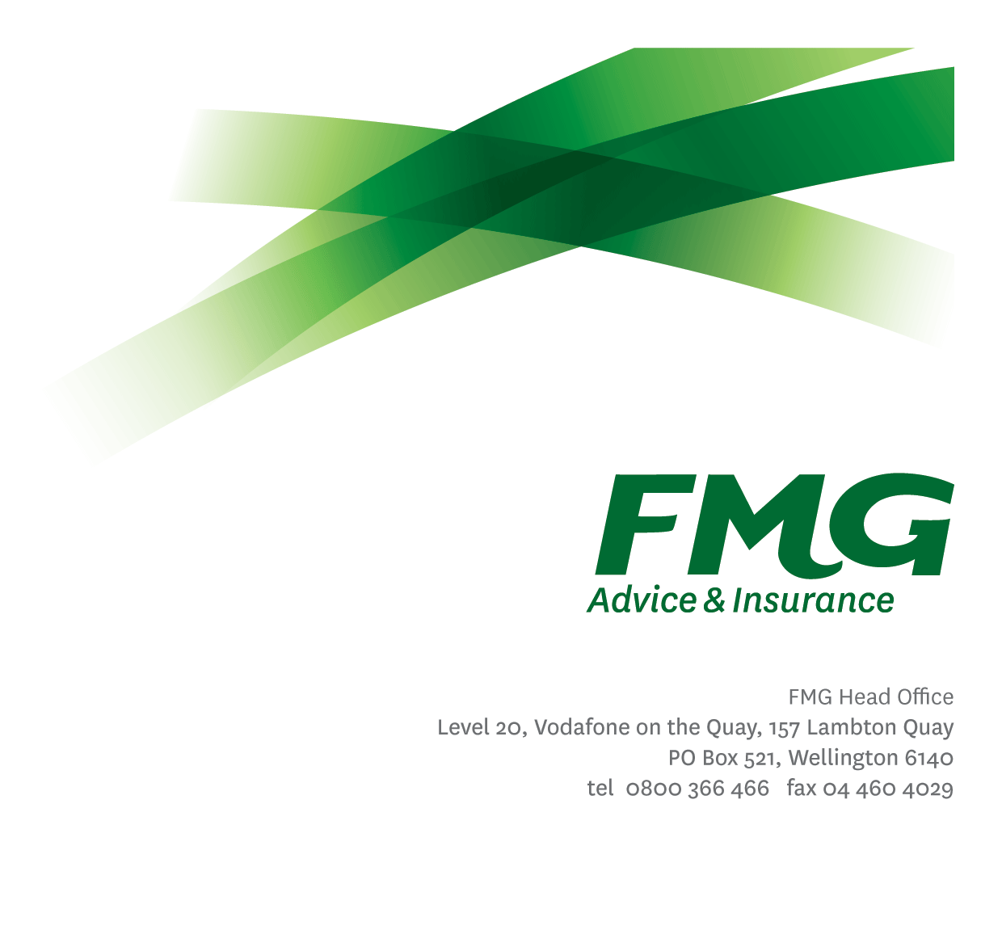  
Risk Specialist ( 2 LoD Business Partner )

*Position Description*

*Location:* As per Personal Terms

Reporting to: Head of Risk

*Business Unit:* Risk

*Direct Reports:* Nil

*Date Last Reviewed:* April 2025

### *About FMG*

**Formed by farmers for farmers over a century ago, FMG is New Zealand’s leading rural insurer providing risk advice and insurance solutions for farmers, growers, commercial businesses, the lifestyle sector and domestic clients.**

**We’re proudly 100% New Zealand owned and operated, and our focus is on helping our clients to achieve their goals.  As a mutual organisation, we’re all about giving rural New Zealanders a better deal, and part of this involves reinvesting all profits back into the business to keep premiums low and ensure the future sustainability of the organisation.**

### *FMG’s Values*

The FMG brand represents promises about what customers can expect from us and each of us is responsible for delivering these promises. Living our company values means we deliver the best brand experience for our customers. Our company values are:

|  |  |
| --- | --- |
| * Do what's right - Whāia te ara tika | * Make it happen - Whakatutukitia |
| * We're in it together - Ko tātau tātau | * Proud of who we are - Whakahīhī i te whakapapa |

### *Work Environment*

We strive to provide an environment that promotes and fosters achievement. We place importance on career development and training to give our people the tools they need to succeed.

FMG’s Head Office is located in Wellington and accommodates FMG’s Executive Leadership Team (ELT) and other teams including Risk, Client Strategy, People & Culture, Communications, Financial Management, Product & Pricing and Underwriting, Reinsurance and Business Information and Analysis.

FMG’s largest regional office is located in Palmerston North accommodating our National Sales & Advice Centre, Information Technology, Claims, Operations and Payments functions. In addition to the offices in Wellington, Palmerston North and Christchurch FMG has offices in 28 regional locations throughout New Zealand.

### *Purpose of the role*

Overall purpose is accountability for the support of FMG’s ‘Three Lines of Defense’ risk framework. The role of Risk Specialist supports this purpose by conducting Risk Assessments and managing Risk Incidents across the Mutual in line with FMG’s Enterprise Risk Management Standard No. 1 – Risk Management Process and Enterprise Risk Management Standard No. 2 – Risk and Compliance Incidents.

This role will exercise a critical function to support FMG’s risk maturity by partnering across the business to help FMG’s 1st line of defence roles **Identify, Measure, Manage, Monitor and Report** risks.

### *Key Responsibilities*

| Area | Responsibilities |
| --- | --- |
| Risk Management – 1st Line of Defence Oversight and Support | * Support First Line of Defence Teams (1st LoD) to understand and apply, in their day-to-day activities, FMG’s Enterprise Risk Management Standard No.1 – Risk Management Process. * Partner with FMG’s front line teams to help them Identify, Measure, Manage, Monitor and Report the risks that they own or influence. * Support FMG’s front line teams to manage the risk they are accountable for within FMG’s risk tool, Resolver. * Facilitate or assist in facilitating Risk Assessment workshops for the business units for which you are responsible. * Undertake regular meetings with 1st LoD teams to review, update and / or manage the risks that they own or influence. |
| Risk Incident Management | * Provide Second Line of Defence (2nd LoD) support assisting the 1st LoD to manage Risk Incidents. Activities for example may include, but are not necessarily limited to, triage, root cause analysis and the resolution of Corrective Actions. |
| 1st Line of Defence Support | * Assist FMG’s 1st LOD teams to complete activities by supporting them with risk thinking or providing them with risk tools and/or advice on how to use/apply them, where necessary. |
| Governance & Risk Compliance Tool | * Oversee the functioning (including administration) of FMG’s Risk tool, Resolver, for the business units for which you are responsible, with a view to ensuring robust processes are in place for the identification, measurement, management, monitoring and reporting of risks including the processes and controls related to that risk. |
| Risk Governance Committees | * Provide secretarial support for FMG’s Goveranance Committees as requested (Enterprise Risk and Compliance Committee (ERCC) or Operational Risk and Compliance Committee (ORCC) ). |
| Reporting | * Support Risk Leadership (including the Enterprise Risk Manager) in the preparation of reports required for each ERCC or ORCC. |
| Other Team Responsibilities | * Undertake other tasks, when reasonable to do so, that are the responsibility of FMG’s Risk Team. Such tasks may include * Responsibility for the Business Continuity Recovery Management Programme * Oversight administration function for the GRC tool. |
| Team Membership | * Effectively contributes to a collegial and efficient FMG team dynamic. * Is a proactive and supportive team member of the Risk team. * Undertaking additional duties and providing assistance relevant to the Risk function as determined by management. |
| Relationship Management | * Proactively builds, monitors, and manages a wide network of relationships both internally (and externally) as necessary to deliver the roles accountabilities. |
| Compliance & Risk Quality | * Ensure compliance with legislative regulations and FMG policies. |
| FMG Values | * To promote the “FMG Way” through displaying the values of FMG which are “do what’s right”, “make it happen”, “we’re in it together” and “proud of who we are”. |
| Wellbeing & Safety | * Promote and support initiatives that contribute to a healthy and safe working environment for employees, visitors, and contractors. * Ensure compliance with Wellbeing & Safety policy and procedures, including accident and incident reporting and investigation, hazard management, induction, training and supervision, employee participation and contractor management. * Works in a safe manner, at all times, and does not undertake activities without appropriate training |

|  |  |
| --- | --- |
| **COMPETENCIES** | |
| *\*see competency framework for behaviours expected at each level* | *Expected Level* |
| **Customer Driven (Internal & External)**  A commitment to understanding the needs and best interests of both internal and external clients in order to provide them with outstanding customer service and help them to make informed decisions. | Intermediate* |
| **Accountability**  Taking personal ownership of decisions, behaviour, and development, and be responsible for how these actions impact on the wider organisation and customers. | Intermediate * |
| **Adaptability**  Demonstrating a willingness to engage in a changing environment and being flexible and comfortable working with change. | Advanced * |
| **Motivation and Drive**  The determination to achieve goals and strive for excellence. | Intermediate * |
| **Relationship Building**  Developing and maintaining positive, professional relationships that are built on mutual trust and respect. | Advanced * |
| **Teamwork**  Making a positive contribution to the Risk FMG team and collaborating effectively with others to achieve objectives. | Intermediate * |
| **Critical Analysis**  The capability to identify key issues, trends, or important facts from information and to question and probe where required. | Intermediate * |

|  |  |
| --- | --- |
| **TRAINING AND KNOWLEDGE** | |
| **Qualifications** | * Tertiary qualification preferred, risk qualifications advantageous |
| **Business Awareness** | * Understand the internal workings of FMG and how the business functions; understands FMG's position in the advice and insurance market and understands the competition. |
| **Rural Knowledge** | * Understands the rural community and keeps up to date with the economic, political, and environmental issues affecting our customers. |
| **Legal Knowledge** | * Has appropriate level of legal knowledge e.g. the Privacy Act etc. Can read and interpret legal agreements. |
| **Risk / Insurance Knowledge** | * Understands the concept of risk and how to apply FMG policies to diverse situations; is knowledgeable about compliance requirements; understands the insurance process and how claims are managed; knows industry partners and competitors. |

|  |  |
| --- | --- |
| **EXPERIENCE** | |
| **Work Experience** | * Experience within Financial Services sector, preferably Insurance. * Experience with risk management is advantageous * Growing ability to lead and influence change. * Interacting with people at all levels in the organisation |

|  |  |
| --- | --- |
| **SKILLS** | |
| **Written Communication Skills** | Able to write clear, concise and persuasive risk assessment summaries and reports. |
| **Verbal Communications Skills** | Communicates clearly in order to present information to persuade and influence others. Effectively presents information to others, both informally and in meetings. |
| **Listening Skills** | Demonstrates active listening skills through eye contact, paraphrasing, appropriate body language and checking understanding. |
| **Risk Assessment Skills** | Can put in place plans to manage risks and risk incidents. |
| **Improvement Skills** | Able to identify and act on improvement opportunities. |
| **Driving Skills** | Full driver’s license required. |

### *Relationships*

|  |  |  |
| --- | --- | --- |
| External | Internal | Committees/Groups |
| * Risk NZ * Resolver (Wynyard Group) | * Assigned 1st Line of Defence Business Units * 1st Line of Defence (embedded) Working Group | * ERCC or ORCC |

### *Financial Authority Levels*

* No authority to approve or commit expenditure.

### *People Advisory Authority Levels*

* No People Advisory authority

### *Delegated Authority Levels*

* Delegated authority levels for the individual role-holder will be advised following assessment, training and approval as per the requirements of the FMG Delegated Authority Policy.

### *Agreement*

I agree to the outline of the role as contained in this document and recognise that the contents may need to be amended from time to time to reflect changing business requirements.

I as role holder, allow my Manager to gather information from third parties where necessary for the purposes of performance management.

Name: _________________________

Signature: ______________________

Date: __________________________