Position Description

Position title: | First Aider | Date: | February 2026
Reports to: | Clinical & Operations Manager | Department: | Clinical
Number of reports: | Direct: N/A  Total (include indirect): N/A | Location: | Nationwide
Delegated financial authority: | N/A | Budget ownership: | No
Level of influence: | Leading self  Leading others  Leading leaders  Leading the Organisation

Our Organisation
At Southern Cross Healthcare, our vision is to help people live their best lives by reimagining healthcare.

Across our nationwide network, we combine the skills of more than 4,000 people including nurses and anaesthetic technicians, working with specialists, surgeons, anaesthetists, and allied health practitioners.

As New Zealand’s largest private provider of healthcare, our strong “for purpose ethos” and through being recognised as one of New Zealand’s leading and most trusted brands, we are poised to amplify the delivery of healthcare services like no other.

Vision | Purpose
Our vision is for what we aspire.  To help people live their best lives by reimagining healthcare. | Our purpose is why we exist.  To advance the provision of quality healthcare in Aotearoa New Zealand.
Values and Behaviours
Care First: Care is at our heart. It’s the foundation of who we are and how we approach our mahi. Through genuine manaakitanga, we deliver a quality of care that makes healthcare more human.

Better Together: Our strength comes from connection and collaboration – we bring together our diverse skills, perspectives, and experiences in the spirit of partnership and kotahitanga. We all play our part creating better outcomes for everyone.

Pursue Excellence: Every day brings a new opportunity to improve, innovate, and excel. We don’t settle for ‘good enough’. We’re here to do our best work, delivering our best care for the people and communities we serve.

Role Purpose
This role provides onsite first aid and support to nursing teams delivering workplace flu vaccination clinics. The First Aider helps ensure clinics run safely, efficiently, and professionally for all participants.

Key Relationships
Internal  - Service Delivery Team  - Clinical Team – Nursing Staff | External  - Registered Nurses  - Client Representatives and Employees

Key Accountabilities
Onsite Support
- Assist nurses with transporting, setting up, and packing down required equipment.
- A friendly face to meet and greet individuals on arrival and cross checking off individuals against the appointment list.
- Provide clear guidance on the vaccination process and direct individuals through each step.
- Distribute after-care information and answer basic queries within scope.
- Monitor attendees during the post vaccination observation period and escalate concerns to the nurse.
- Complete required data entry accurately and in a timely manner.
- Help troubleshoot minor onsite issues to support smooth clinic operations.
- Provide general reception and customer service duties as needed.
- Support nurses with effective use of onsite IT systems (e.g., iPads).
- Contribute to maintaining an organised, professional flu vaccination environment.

Observing Individuals Post-Vaccination:
- Actively observe individuals in the waiting area post-vaccination.
  - The wait time will vary between 5 minutes and 15 minutes, and individuals will be advised of this by their nurse. For reference wait times are as follows:
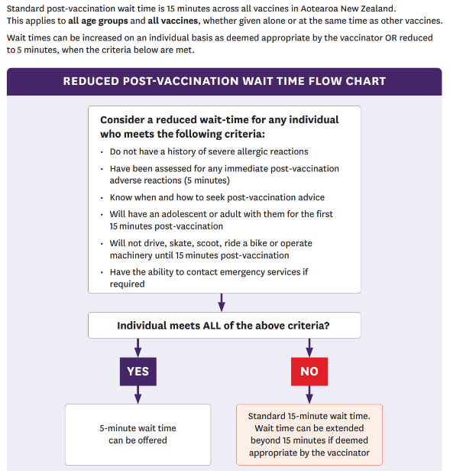
  - In the initial 5-minute wait period, individuals should stay with you in the waiting area for observation.
  - In the 20 minutes following vaccination, the individual should not be alone regardless of the 5- or 20-minute wait period. This includes waiting 20 minutes before going anywhere alone such as the bathroom.
  - We are working with adults in the workplace, and on occasion adults will make their own decision to leave early. If this occurs, please advise your nurse.
- Escalate any reported or observed issues immediately to your nurse. N.B. Report any concerns or questions of a clinical nature to your nurse (even if considered minor)

Emergency Support
- Working with the nurse to assist in emergency situations.
  - Follow the instructions of the nurse.
  - You must have access to your cell phone to dial 111 in an emergency.

Responsibilities may change from time to time depending on business need.

Health, Safety and Wellbeing
- All employees are responsible for complying with health and safety policies and procedures.
- You are responsible for your own health and safety while at work and ensuring that your actions or inactions do not put others at risk.
- Identify, report and self-manage hazards where appropriate.
- Ensure that you complete early and accurate reporting of incidents at work.
- Participate and co-operate for shared health and safety responsibilities
- Actively participate where improvements to health and safety at SCHL can be made

Commitment to the principles of Te Tiriti o Waitangi
- Demonstrate awareness and understanding of Te Tiriti o Waitangi obligations through manaakitanga (respect) and kawa whakaruruhau (cultural safety) as evidenced in interpersonal relationships.

Commitment to Diversity, Equity and Inclusion (DEI)
- Honour diversity by acknowledging and respecting others’ spiritual beliefs, cultural practices and lifestyle choices as evidenced in interpersonal relationships.
- Seek opportunities to include diversity, equity and inclusion practices in everyday work.

Commitment to Environment, Social and Governance (ESG)
- Engage in sustainable practices whenever possible. Try to reduce the environmental impact of your work and take an active role to initiate change to meet Southern Cross' ESG (Environmental, Social and Governance) commitments.
- Actively engage to improve your knowledge regarding sustainable practices whenever possible.

Role Requirements
Experience and skills required:  - Own Transport / Car  - Excellent customer service  - Ability to be agile and multi-task  - Attention to detail  - Excellent time management  - Clear Communication  - Calm manner  - Ability to problem solve  - Work well with a team | Education and qualifications required:  - Current NZ First Aid Certificate  - NZ Driver’s License

Leadership Attributes
Human Centred Leadership  - Empathy  - Adaptability  - Connection  Performance Coach  - Accountability  - Engagement  - Collaboration | Change Enabler  - Execution  - Energy  - Contribution

