Underwriter - Technical

*Position Description*

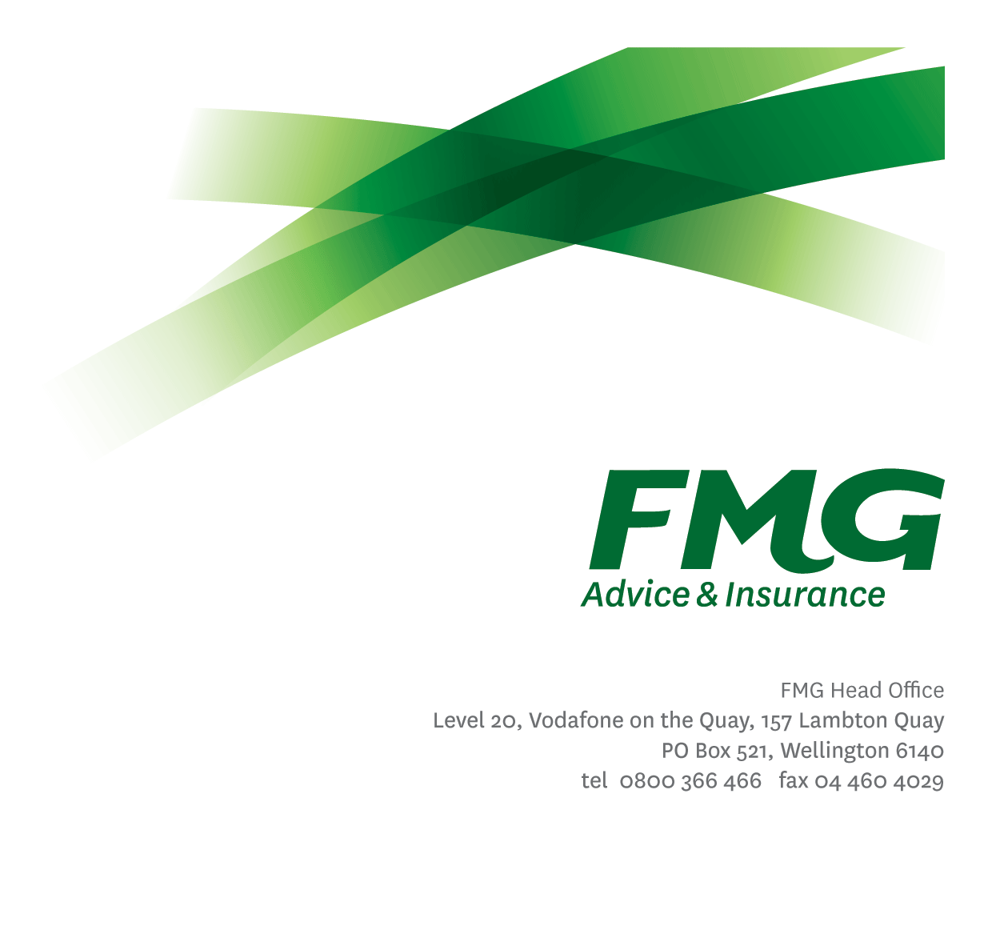

*Location:* Wellington



*Reporting to:* Underwriting Team Manager

*Business Unit:* Underwriting

*Direct Reports:* Nil

*Date Last Reviewed:* June 2024

### *About FMG*

***Formed by farmers for farmers over a century ago, FMG is New Zealand’s leading rural insurer providing risk advice and insurance solutions for farmers, growers, commercial businesses, the lifestyle sector and domestic clients.***

***We’re proudly 100% New Zealand owned and operated, and our focus is on helping our clients to achieve their goals.  As a mutual organisation, we’re all about giving rural New Zealanders a better deal, and part of this involves reinvesting all profits back into the business to keep premiums low and ensure the future sustainability of the organisation.***

### *FMG’s Values*

The FMG brand represents promises about what customers can expect from us and each of us is responsible for delivering on these promises. Living our company values means we deliver the best brand experience for our customers. Our company values are:

|  |  |
| --- | --- |
| * Do what’s right | * Make it happen |
| * We’re in it together | * Proud of who we are |

### *Work Environment*

We strive to provide an environment that promotes and fosters achievement. We place importance on career development and training to give our people the tools they need to succeed.

Being a part of the underwriting team, you’ll be surrounded by people with technical smarts, who share their ideas and create a learning environment. So, you’ll be sure to get off to a great start.

### *Purpose of the role*

### To be part of a centralised Underwriting Team providing technical underwriting advice and guidance to support and enable the acceptance of quality business. To carry out detailed portfolio management, by providing technical advice on improving and maintaining the profitability of relevant FMG portfolios.

### *Key Responsibilities*

| Area | Responsibilities |
| --- | --- |
| Underwriting | * Evaluate risks and exposures for specific clients and prospects * Provide rates, terms and conditions of cover, answer queries and provide quotes for all lines of business * Generate various reports toward improving the underwriting results for FMG * Assist field staff and consultant teams in providing a ‘best-fit’ for client’s insurance needs * Ensure business written is within delegated authority levels * Identify and assist with the updating and maintenance of policies database to ensure that up-to-date policy information and archived information is available |
| Risk Management | * Assess and determine a client’s risk profile through undertaking strategic analysis in conjunction with the SAS teams. * Achieve a win/win risk environment with internal stakeholders, where their client better manages the risks identified. * Carry out risk assessments in accordance with FMG standards including making reasoned judgements about the profitability and consequences of loss occurring. |
| Portfolio Management | * Carry out detailed portfolio management in conjunction with our Product & Pricing teams by providing technical advice on improving and maintaining the profitability of relevant FMG portfolios. |
| Process Improvement | * Establish, review and update agreed underwriting guidelines. * Continually look for process and efficiency improvements in our approach to underwriting, ensuring that at all times our approach to underwriting is sales enabling, consistent and objective, and based on robust analysis. * Play an active part in research and develop new lines of business in accordance with FMG strategy. |
| Relationship Management | * Establish and maintain professional relationships with relevant stakeholders. |
| Policy Maintenance | * Accurately update and maintain client policy information in both electronic and paper-based form to be readily archived and retrieved. |
| Underwriting Team | * Contribute to FMG through participation in operational activities including pricing reviews and policy wording changes to enable better portfolio performance, or other duties as delegated by Head of Underwriting or Underwriting Team Manager. |
| FMG Company Values | * Promote the “FMG Way” through displaying the values of FMG which are do what’s right, make it happen, we’re in it together and proud of who we are |
| Wellbeing and Safety | * Complies with safety and wellbeing policy and procedures, including accident and incident reporting and hazard management requirements * Works in a safe manner at all times and does not undertake activities without appropriate training |

|  |  |
| --- | --- |
| **COMPETENCIES** | |
| *\*see competency framework for behaviours expected at each level* | *Expected Level* |
| **Customer Driven (Internal & External)**  A commitment to understanding the needs and best interests of both internal and external customers, in order to provide them with outstanding customer service and help them to make informed decisions. | Intermediate* |
| **Accountability**  Taking personal ownership of decisions, behaviour, and development, and being responsible for how these actions impact on the wider organisation and customers. | Intermediate* |
| **Adaptability**  Demonstrating a willingness to engage in a changing environment and being flexible and comfortable working with change. | Intermediate* |
| **Motivation and Drive**  The determination to achieve goals and strive for excellence. | Intermediate* |
| **Relationship Building**  Developing and maintaining positive, professional relationships that are built on mutual trust and respect. | Intermediate* |
| **Team Work**  Making a positive contribution to the FMG team and collaborating effectively with others to achieve objectives. | Intermediate* |
| **Critical Analysis**  The capability to identify key issues, trends, or important facts from information and to question and probe. | Advanced* |

|  |  |
| --- | --- |
| **KNOWLEDGE** | |
| **Qualifications** | * ANZIIF Diploma of General Insurance or equivalent qualification (or working towards) |
| **Business Awareness** | * Understands the internal workings of FMG and how business works; understands FMG's position in the advice and insurance market and knows the competition. |
| **Rural Knowledge** | * Understands the rural community and keep up to date with the economic, political, and environmental issues affecting our customers. |
| **Legal Knowledge** | * Has legal knowledge e.g. indemnity, liability, the Privacy Act etc. |
| **Product Knowledge** | * Is knowledgeable about FMG's insurance policies and packages, the differences between them, and the appropriateness of each in different situations. |
| **Risk/Insurance Knowledge** | * Understands risk and how to apply FMG's policies to situations; is knowledgeable about compliance requirements; understands the insurance process and how claims are managed; knows industry partners and competitors. |
| **Specialist Knowledge** | * Know how to correctly rate policies and know what the current market price for a policy is. * General underwriting and product knowledge |

|  |  |
| --- | --- |
| **SKILLS** | |
| **Written Communication Skills** | Able to write clear, concise and persuasive proposals and reports. |
| **Verbal Communications Skills** | Communicates clearly in order to present information to persuade and influence others. |
| **Listening Skills** | Demonstrates active listening skills through eye contact, paraphrasing, appropriate body language and checking understanding. |
| **Risk Assessment Skills** | Identifies, understands and mitigates the risks that may impact on FMG's strategy, initiatives and reputation. |

### *Relationship*

|  |  |  |
| --- | --- | --- |
| External | Internal | Committees/Groups |
| * Third Party Brokers & Suppliers (including Outsourced Partners) | * Underwriting Team * Reinsurance & Risk Quality Team * Product & Pricing Teams * BIAS Team * SAS Teams * Claims & Assessing Teams * Marketing Team * Head Office Staff | * ICNZ Committees, Sub Committees & Working Groups |

### *Financial Authority Levels*

* No authority to approve or commit expenditure

### *Human Resources Authority Levels*

* Not applicable

### *Agreement*

I agree to the outline of the role as contained in this document and recognise that the contents may need to be amended from time to time to reflect changing business requirements.

I as Job holder, allow my Manager to gather information from third parties where necessary for the purposes of performance management.

*Name: ______________________*

*Date: _______________________*

*Signature: _______________________*