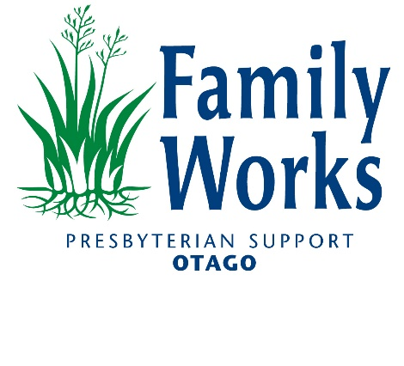

**Financial Mentor - Dunedin**

If you are looking for a role that makes a REAL difference to your community, here is your opportunity to join the Building Financial Capability team at Family Works, Presbyterian Support Otago.

**About the Role**

This is a permanent part-time position based in our Dunedin office working 20 hours a week as a Financial Mentor.

You will work with clients to identify their needs, provide immediate support where required and empower them to make good financial decisions for the future.

As a member of the Financial Capability service within our Family Works team at Presbyterian Support Otago, you will be surrounded by colleagues doing the same. This role will give you the opportunity to make a real difference in your community.

**About You**

We would love you to:

* Understand the social and economic complexities that exist in the community.
* Have highly developed interpersonal skills including relationship skills and advocacy skills.
* Understand core budgeting concepts and the wider impact for individuals/families.
* Skills and experience in online banking, computer systems and databases to maximise the use of technology for improved service provision.
* Be able to work independently and as part of a small team.
* A full driver’s license is essential for this role.

**About Us**

Family Works is a service within Presbyterian Support Otago (PSO) that that works to ensure every person is valued and grows in a safe and strong community. PSO is a Charitable Trust established in 1906, and is a leading provider of aged care, retirement living and social services to the people of Otago and the wider South Island. With over 800 staff and 500 volunteers, we operate a highly regarded network of 8 care homes across Otago and we provide many other community-based social support programmes.

**Join the Family Works Team -** To apply click "Apply Now".

Applications close on Friday 23 May 2024.

For further information contact Jollene Warrington on 021595136

Please note applications will be reviewed as they are received, and this job vacancy could close prior to the closing date.

If you have difficulty applying, please email recruitment@psotago.org.nz