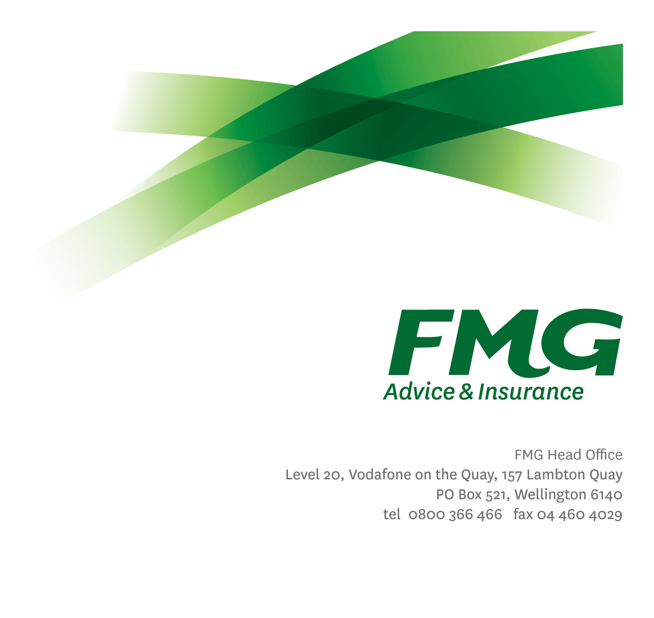

*Position Description*

Area Manager

*Location:* [Variable]

*Reporting to:* Head of Advice & Sales

*Business Unit:* SAS

*Direct Reports:* Variable

*Date Last Reviewed:* January 2017

### *About FMG*

***Formed by farmers for farmers over a century ago, FMG is New Zealand’s leading rural insurer providing risk advice and insurance solutions for farmers, growers, commercial businesses, the lifestyle sector and domestic clients.***

***We’re proudly 100% New Zealand owned and operated and our focus is on helping our clients to achieve their goals.  As a mutual organisation, we’re all about giving rural New Zealanders a better deal, and part of this involves reinvesting all profits back into the business to keep premiums low and ensure the future sustainability of the organisation.***

### *FMG’s Values*

The FMG brand represents promises about what clients can expect from us and each of us is responsible for delivering on these promises. Living our company values means we deliver the best brand experience for our clients. Our company values are:

|  |  |
| --- | --- |
| * Do what's right - Whāia te ara tika | * Make it happen - Whakatutukitia |
| * We're in it together - Ko tātau tātau | * Proud of who we are - Whakahīhī i te whakapapa |

### *Work Environment*

We strive to provide an environment that promotes and fosters achievement. We place importance on career development and training to give our people the tools they need to succeed.

FMG’s Head Office is located in Wellington and accommodates FMG’s Executive Leadership Team (ELT), Client Propositions & Online Services, People & Culture and Communications, Financial Management, Product & Pricing and Underwriting, Reinsurance, Business Information and Analysis, Legal and Compliance.

FMG’s largest regional office is located in Palmerston North accommodating our National Sales & Advice Centre, Information Technology, Claims, Operations and Payments functions. In addition to the offices in Wellington, Palmerston North and Christchurch FMG has offices in 30 regional locations throughout New Zealand.

### 

### *Purpose of the role*

### To provide leadership, direction and coaching to a geographically spread sales team in order to build and maintain a high performance culture that retains existing business and continues to grow FMG’s market share.

### *Key Responsibilities*

| Area |  |
| --- | --- |
| Sales Leadership – Client Retention & Acquisition | * Generates leads for the General Insurance and Personal Insurance businesses and for FMG’s Investment and Strategic Partners. * Agrees and communicates the sales and service direction for the local team and how the local sales campaigns contribute to the National objectives, * Leads and Motivates the team towards the goals through regular coaching, expectations setting, acknowledging success and recognizing best practice contributions and monitors the local team’s progress towards goals and removes barriers that impede frontline confidence. * Completes half year and full year performance reviews and final ratings. * Leadership of a sales development framework (CPD), including compliance requirement which encompass DA and QA for General Insurance and meeting best practice standards and/or associated compliance related requirements for Personal Insurance. * Follows through on training requirements and provides recommendations on training to the Head of Advice & Sales for the wider team. * In conjunction with the Head of Advice & Sales ensures acquisition, retention and referral targets are accurately established and met. |
| Coaching | * Coaches and provides one on one professional development encompassing technical and sales support through monthly coaching sessions and quarterly joint client visits * Leads and coaches to the FMG “Client Conversation Framework” to grow the mindset, skillset and structure of client interactions to lift sales advice and service delivery * Leads and coaches to a high-performing level of in-field activity by each individual, encompassing client servicing on farm and on-site, prospecting, risk and insurance advice and administration * Recruits, manages, develops & coaches employees into a highly skilled and performance oriented team. |
| Professional Relationship Management | * Identifies and evaluates third party organisations that would provide profitable business openings for FMG. * Establishes and maintains professional relationships with these third party organisations to provide FMG with business gains and referrals. * Holds regular meetings with third parties to establish business oriented opportunities that include cross-selling and referrals. * Re-evaluates the value of the third party relationship in terms of quality of business referrals. |
| Networking | * Regularly attends field days, instigates and attends risk management seminars and events in the local rural community to enhance FMG’s profile and personal profile. * Uses business and social networking occasions to identify business opportunities for FMG. |
| Business Growth & Profitability | * Achieves agreed Key Result Areas (KRAs). * Identifies opportunities for new business risk management and insurance opportunities through networking activities, market research and business referrals from internal and external third parties. * Within agreed timeframe standards, follows up with the client. * Business written is of the highest quality and priced accordingly to minimise the risk to FMG’s long term profitability. * Provides advice and information relevant to the client needs (e.g. product information, fact sheets, packs, etc.). |
| Retention | * Achieves retention objectives for the group’s business portfolios. |
| Client Focus | * Seeks to improve FMG Net Promoter Score * Provides superior service to all clients and internal clients by demonstrating the FMG values. * Achieves a targeted % client satisfaction score combined of excellent and/or very good, where the client recognises FMG as providing strategically relevant advice in risk management. * Engagement with the client reflects a consultative approach where in-depth questioning and active listening is undertaken, and industry related information is discussed. * Assisting to identify opportunities for process and service improvement. |
| Self Development | * Pro-Actively identifies all areas for development. * Attends company approved training and development programs in insurance, risk management and agribusiness. * Uses newly gained knowledge and skills on the job. |
| FMG Values | * Promotes the “FMG Way” through displaying the values of FMG which are: Do what’s right, Make it happen, We’re in it together, Proud of who we are. |
| Team Participation | * Effectively contributes to a collegial and efficient FMG team dynamic. * Assisting and supporting other team members, including training and peer review work as required. * Supporting the team by sharing information and resources and providing feedback in a positive manner. |
| Reporting | * All reports to meet agreed FMG service standards including but not limited to the quality of content, writing style, grammatical correctness, visual presentation and timeliness of delivery. |
| Risk Quality | * Develops a thorough knowledge of all FMG products and services and rural industry topics through attending internal training sessions, external seminars and study programs. * Business written is within delegated authority (DA) levels. * Meets targeted Gross Claims Ratios. |
| Wellbeing & Safety | * Leads and develops a team culture of a safety, inclusiveness and wellbeing * Complies with safety and wellbeing policy and procedures, including accident and incident reporting and hazard management requirements * Works in a safe manner at all times and does not undertake activities without appropriate training |
| Compliance | * Complies with company policies, guidelines and procedures |
| Operational Management | * Achieves quality client service results through the effective planning, management and monitoring of team activities. |
| Planning & Analysis | * Assists in the operational direction for risk management services through the participation in and implementation of strategic, business and operational plans which support FMG’s critical strategies and strategic focus. * Monitors, analyses and interprets data for planning purposes. |
| Business & Financial Management | * Assists in the provision of prudent financial management by operating within FMG parameters, planning and operational guidelines for the effective management of revenue, costs and assets. * Manages and controls the business unit’s operational budget. |

|  |  |
| --- | --- |
| **COMPETENCIES** | |
| *\*see competency framework for behaviours expected at each level* | *Expected Level* |
| **Advice & Sales Acumen**  Using appropriate interpersonal styles and communication methods to gain client acceptance of advice, which incorporates a product, service or idea. | Advanced* |
| **Customer Driven (Internal & External)**  A commitment to understanding the needs and best interests of both internal and external customers, in order to provide them with outstanding customer service and help them to make informed decisions. | Advanced* |
| **Accountability**  Taking personal ownership of decisions, behaviour, and development, and being responsible for how these actions impact on the wider organisation and clients. | Advanced* |
| **Adaptability**  Demonstrating a willingness to engage in a changing environment and being flexible and comfortable working with change. | Advanced* |
| **Motivation and Drive**  The determination to achieve goals and strive for excellence. | Advanced* |
| **Relationship Building**  Developing and maintaining positive, professional relationships that are built on mutual trust and respect. | Advanced* |
| **Team Work**  Making a positive contribution to the FMG team and collaborating effectively with others to achieve objectives. | Advanced* |
| **Problem Solving**  The ability to understand information from a variety of sources and think quickly on one’s feet. The ability to effectively combine verbal and numeric data into a coherent whole. | Advanced* |
| **Critical Analysis**  The capability to identify key issues, trends, or important facts from information and to question and probe. | Intermediate* |
| **Motivating and Developing Others**  A commitment to getting the best out of people and motivating them to reach their full potential. | Advanced* |
| **Change Leadership**  The drive to initiate opportunities to address FMG’s organisational needs and to communicate change in a way that gains buy-in and support from others. | Intermediate* |
| **Strategic Thinking**  The capacity to stand apart from the day-to-day and take a long-term, big picture view of the business. | Intermediate* |

|  |  |
| --- | --- |
| **KNOWLEDGE** | |
| **Business Awareness** | Understands the internal workings of FMG and how business works; understands FMG's position in the advice and insurance market and knows the competition. |
| **Rural Knowledge** | Understands the rural community and keep up to date with the economic, political, and environmental issues affecting our clients. |
| **Legal Knowledge** | Has legal knowledge e.g. indemnity, liability, the Privacy Act etc. |
| **Product Knowledge** | Is knowledgeable about FMG's insurance policies and packages, the differences between them, and the appropriateness of each in different situations. |
| **Risk/Insurance Knowledge** | Understands risk and how to apply FMG's policies to situations; is knowledgeable about compliance requirements; understands the insurance process and how claims are managed; knows industry partners and competitors. |

|  |  |
| --- | --- |
| **SKILLS** | |
| **Written Communication Skills** | Able to write clear, concise and persuasive proposals & reports. |
| **Verbal Communications Skills** | Communicates clearly in order to present information to persuade and influence others. |
| **Listening Skills** | Demonstrates active listening skills through eye contact, paraphrasing, appropriate body language and checking understanding. |
| **Financial Skills** | Able to calculate and understand financial information e.g. profit & loss, forecasts. |
| **Risk Assessment Skills** | Identifies, understands and mitigates the risks that may impact on FMG's strategy, initiatives and reputation. |
| **Driving Skills** | Has full driver’s license. |

### *Relationship*

|  |  |  |
| --- | --- | --- |
| External | Internal | Committees/Groups |
| * Agency Representatives * Brokers (where applicable) * Other referral sources | * SAS Leadership Team * Rural Managers * Life & Health Advisers * Service & Sales Centres * FMG Business Unit managers * Key Account Managers | * As required |

### *Financial Authority Levels*

* May approve routine expenditure within budgetary limits.

### *Human Resources Authority Levels*

* May hire direct and indirect reports within approved FTE headcounts.
* May discipline direct and indirect reports in consultation with manager and Human Resources.
* No authority to dismiss staff, unless delegated by the Chief Executive and in consultation with manager and Human Resources.

### *Delegated Authority Levels*

* Delegated authority levels for the individual role-holder will be advised following assessment, training and approval as per the requirements of the FMG Delegated Authority Policy.

### *Agreement*

I agree to the outline of the role as contained in this document and recognise that the contents may need to be amended from time to time to reflect changing business requirements.

I as Job holder, allow my Manager to gather information from third parties where necessary for the purposes of performance management.

*Name: ____________________________*

*Signature: _________________________*

*Date: _____________________________*