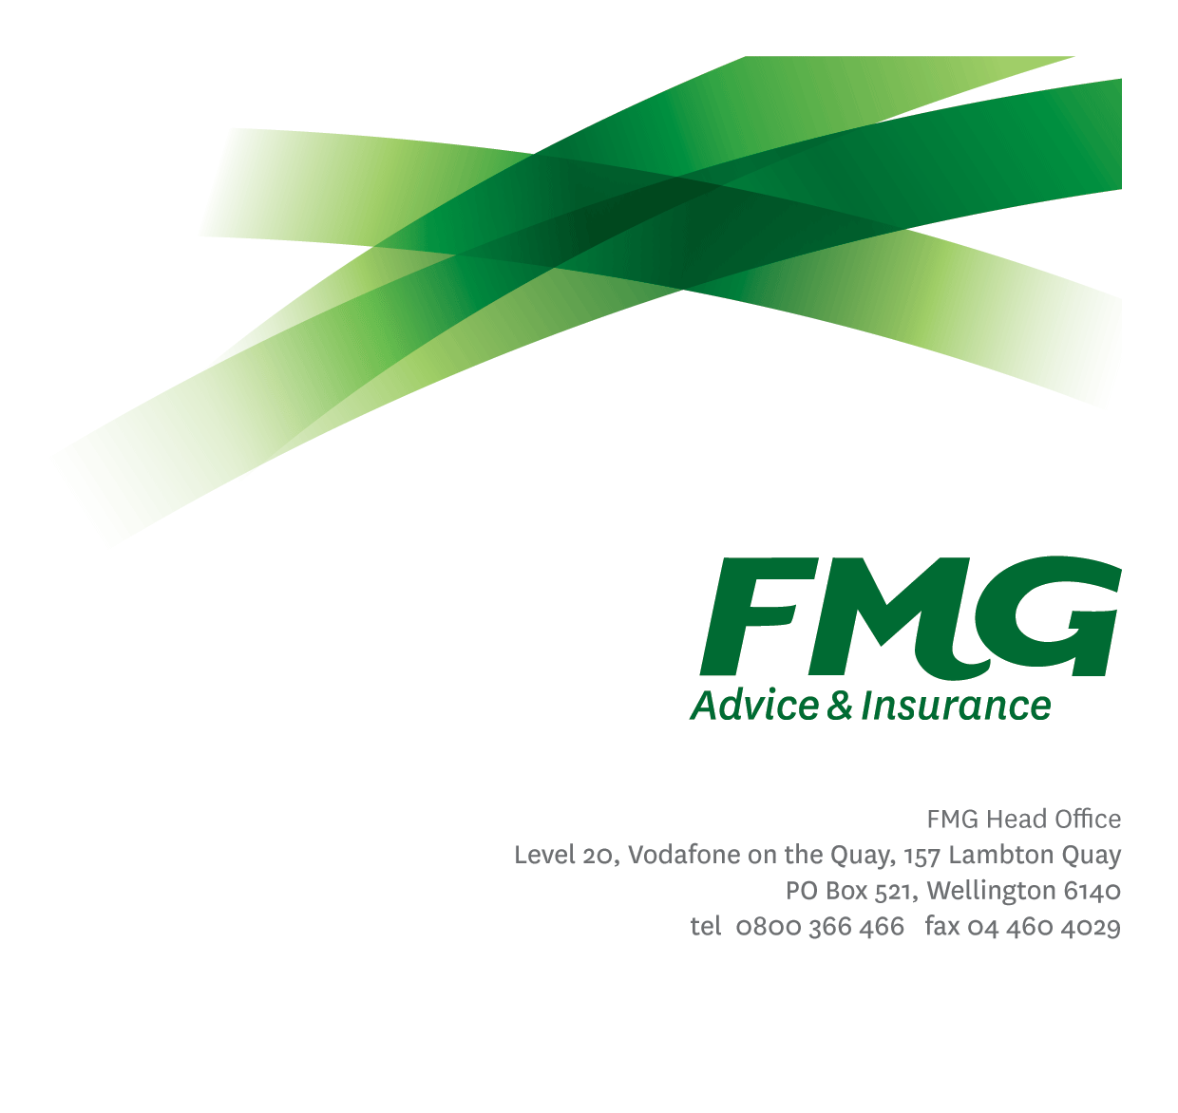
Manager Insurance Conduct
Position Description

Location: Wellington
Reporting to: Chief Insurance Officer
Business Unit: Insurance Solutions [Client Remediation Programme]
Direct Reports: Nil
Date Last Reviewed: June 2024

About FMG
Formed by farmers for farmers over a century ago, FMG is New Zealand’s leading rural insurer providing risk advice and insurance solutions for farmers, growers, commercial businesses, the lifestyle sector and domestic clients.
We’re proudly 100% New Zealand owned and operated and our focus is on helping our clients to achieve their goals. As a mutual organisation, we’re all about giving rural New Zealanders a better deal, and part of this involves reinvesting all profits back into the business to keep premiums low and ensure the future sustainability of the organisation.

FMG’s Values
The FMG brand represents promises about what clients can expect from us and each of us is responsible for delivering on these promises. Living our company values means we deliver the best brand experience for our clients. Our company values are:
- Do what's right - Whāia te ara tika | - Make it happen - Whakatutukitia
- We're in it together - Ko tātau tātau | - Proud of who we are - Whakahīhī i te whakapapa

Work Environment
We strive to provide an environment that promotes and fosters achievement. We place importance on career development and training to give our people the tools they need to succeed.
FMG’s Head Office is in Wellington and accommodates FMG’s Executive Leadership Team (ELT), Sales, Advice & Services, Claims, Marketing & Propositions, People & Culture, Finance & Investment, Insurance Solutions, Business Information Systems, Risk & Compliance and Strategy & Enablement.
FMG’s largest regional office is in Palmerston North accommodating our National Sales & Advice Centre, People and Culture, Information Technology, Claims, Operations and Payments functions. In addition to the offices in Wellington, Palmerston North and Christchurch FMG has offices in 30 regional locations throughout New Zealand.

Purpose of the role
The Manager Insurance Conduct will undertake the role of Business Owner leading a programme of work to ensure the successful and timely delivery of identified Client Remediation Projects (as outlined in the Client Remediation Policy and Standard) with responsibility for ensuring adherence to the Policy and Standard is achieved operationally, and regulatory expectations are met in conducting remediation activities.
This role will work closely with the Client Remediation Programme Manager, Head of Regulation, Client Resolutions and General Counsel and the Head of Compliance while also engaging with stakeholders and SMEs across the business (including Insurance Solutions, Finance, Legal, Risk, Communications and Business Information Systems).
The Manager Insurance Conduct will apply insurance, regulatory compliance and legal knowledge to inform and deliver the Project Plan for each Client Remediation Issue. They will take a lead role in standing up new client remediation workstreams and progressing the Analyse and Plan, Execute and Close phases within them, while supporting the responsible Business Units to address and resolve the root cause(s) (as applicable), as set out in the Client Remediation Standard.
They will also take a lead role:
- in developing proposals for the resolution of non-client remediation issues (e.g. with NHC and/or FENZ), including day-to-day relationship management responsibility in respect of such issues
- with the Head of Compliance, in recommending any reporting of an issue to the FMA, ICNZ, NHC and/or FENZ
- with the Client Remediation Programme Manager, in reporting to the Client Remediation Programme Steering Group, and
- with the Business Solutions Consultant – Conduct, in reporting to the Enterprise Risk and Compliance Committee (ERCC) and Board regarding FMG’s client remediation activities.

Key Responsibilities

Area | Responsibilities
Insurance Conduct Leadership | - Lead and manage FMG’s overall remediation activities to bring any identified Client Remediation Projects to a successful conclusion, in line with the Client Remediation Policy and Standard.  - Work closely with stakeholders and SMEs across the business to undertake remediation activities for each Client Remediation Project, including Analyse and Plan, Execute and Close phases with the development of supporting artefacts (e.g. website content).  - Communicate with and inform all relevant stakeholders, internal and external, regarding Client Remediation issues. Work with Communications and Business Change to develop and agree upon an approach to internal and external (client) communication.  - Provide regular reporting on Client Remediation activities and progress to the relevant FMG Committees.  - Work with the Product Manager – Conduct and Business Solutions Consultant – Conduct, on any potential issues that may require future Client Remediation activity.  - Continually improve and share knowledge in agreed specialist areas including relevant legal, regulatory, competitor, regulator and industry developments, both in NZ and relevant countries offshore.
Risk and Quality | - Ensure assigned Projects and associated work are compliant with legislation, regulations and FMG policies and standards.  - Ensure documentation is in place for critical processes.
Change Management | - Lead effective change management for employees and clients to ensure the successful embedding of product, process and system changes as part of Client Remediation activity.
Other Duties | - Undertake tasks as directed by the Chief Insurance Officer.
Wellbeing & Safety | - Comply with safety and wellbeing policy and procedures, including accident and incident reporting and hazard management requirements.  - Work in a safe manner at all times and do not undertake activities without appropriate training.

COMPETENCIES
*see competency framework for behaviours expected at each level | Expected Level
Client Driven (Internal & External)  A commitment to understanding the needs and best interests of both internal and external clients, in order to provide them with outstanding customer service and help them to make informed decisions. | Advanced*
Accountability  Taking personal ownership of decisions, behaviour, and development, and being responsible for how these actions impact on the wider organisation and clients. | Advanced*
Adaptability  Demonstrating a willingness to engage in a changing environment and being flexible and comfortable working with change. | Advanced*
Motivation and Drive  The determination to achieve goals and strive for excellence. | Advanced*
Relationship Building  Developing and maintaining positive, professional relationships that are built on mutual trust and respect. | Advanced*
Team Work  Making a positive contribution to the FMG team and collaborating effectively with others to achieve objectives. | Advanced *
Critical Analysis  The capability to identify key issues, trends, or important facts from information and to question and probe. | Advanced*

KNOWLEDGE
Qualifications | Law Degree or Relevant Tertiary Qualification
Experience |  | 10+ years Insurance/Legal or Compliance Industry experience  Demonstrated Insurance Product Management and Client Remediation experience.
Business Awareness | Understands the internal workings of FMG and the Insurance Value Chain; understands FMG's position in the advice and insurance market and knows the competition.
Legal Awareness | Experience and understanding of the current and emerging legal and regulatory environment applicable to the NZ insurance market, including international developments where applicable.
Market Knowledge | Understands the insurance industry. Maintains an active knowledge of competitors’ products benefits, features and pricing.
Rural Knowledge | Understands the rural community and keeps up to date with the economic, political, and environmental issues affecting our customers.
Product Knowledge | Is knowledgeable about FMG's insurance policies and packages, the differences between them, and the appropriateness of each in different situations.
Risk/Insurance Knowledge | Understands risk and how to apply FMG's policies to situations; is knowledgeable and experienced in compliance requirements; understands the insurance process and how claims are managed; knows industry partners and competitors.
Specialist Knowledge | Understands the roles of Underwriting, Sales, Claims etc and is able to use their viewpoint in analysing product performance including Fair Conduct requirements.

SKILLS
Written Communication Skills | Able to write clear, concise and persuasive proposals and reports.
Verbal Communications Skills | Communicates clearly in order to present information to persuade and influence others.
Listening Skills | Demonstrates active listening skills through eye contact, paraphrasing, appropriate body language and checking understanding.
Technology Skills | Can expertly use relevant software and technology to its full capacity e.g. MS Word, Excel and PowerPoint.
Project Management | Can autonomously drive and manage projects to deliver agreed outcomes across the business within agreed timeframes.

Relationships
External | Internal | Committees/Groups
 | - Client Remediation Programme  - Wider Insurance Solutions team  - Finance & Risk, Legal, Compliance & Risk Quality  - BIS / BIAS  - Claims  - Sales, Advice & Service  - Communications, Marketing & Propositions | - Client Remediation Programme Steering Group  - Enterprise Risk and Compliance Committee (ERCC)  - Enterprise Portfolio Management Committee (EPMC)

Financial Authority Levels
- No authority to approve or commit expenditure.

Human Resources Authority Levels
- Not applicable.

Agreement

I agree to the outline of the role as contained in this document and recognise that the contents may need to be amended from time to time to reflect changing business requirements.
I as Job holder, allow my Manager to gather information from third parties where necessary for the purposes of performance management.

Manager Insurance Conduct’s Name
Signature:
Date:

