JOB TITLE: | Information and Technology Systems Engineer
Location: | Whangarei |  | Date: | 26/09/2025
Reports to: | IT Manager
Purpose: | To be responsible for the upkeep and maintenance of McKay’s IT Systems and Services
ROLE SUMMARY:
Having started providing electrotechnology services in 1936, McKay is a historic New Zealand electrical company with a depth of experience in providing end to end electrical solutions for a wide range of industries and sectors. McKay is the parent brand and has acquired and started a range of companies under the McKay Group name in order to serve all electrical needs.
As McKay continues to grow so does our dependence on reliable and secure IT infrastructure and services. Aligned to this growth is the needs for a Systems Engineer to join the IT Team to help maintain and grow the IT ecosystem as well as support our IT and Security objectives

RESPONSIBILITIES:

- Assist the IT Manager in planning, implementing, and maintaining the technical aspects of the organisation’s IT environment.
- Maintain and manage identity management systems including Microsoft Active Directory and Azure Active Directory.
- Involved in the administration and optimisation of the Microsoft 365 environment.
- Manage and monitor Sophos Security solutions to ensure robust cyber security across all endpoints and network segments.
- Handle procurement of IT products and services, including evaluating options, liaising with vendors, and ensuring cost-effective solutions meet organisational requirements.
- Act as a technical liaison to external IT Managed Services Providers, coordinating support and project delivery to align with business objectives.
- Conduct regular system audits and implement improvements as needed to maintain high standards of performance and security.
- Provide technical support and troubleshooting for end users and Line of Business systems, ensuring timely resolution of issues.
- Travel to Mckay office location as well as project remote site to maintain and support the IT requirements on-site sites.
- Assist in the upkeep and compliance to the organisations elected cyber security frameworks.
QUALIFICATIONS & KNOWLEDGE:

Required Skills and Experience
- Demonstrated experience with Microsoft Active Directory and Azure Active Directory administration.
- Proficiency in managing Microsoft 365 environments (Admin Center), including user accounts, licensing, and security settings
- Proficiency in IT documentation and compliance management including ticketing systems, change control and maintaining service levels.
- Proficiency in Administration of Microsoft Services such as SharePoint, Teams, One Drive and Microsoft Intune (MDM)
- Strong knowledge of Sophos Security products and general cybersecurity practices.
- Experience with Server & Network configuration, procurement, installation, and lifecycle management.
- Excellent communication skills, with the ability to liaise effectively with external IT providers and internal stakeholders.
- Solid troubleshooting skills and a methodical approach to problem-solving.
- Ability to work independently as well as collaboratively within a team.

Desirable Qualifications

- Relevant IT certifications (e.g., Microsoft Certified: Azure Administrator Associate, Microsoft 365 Certified, Sophos Certified Engineer, Comptia N+ A+).
- Experience working in a multi-site or cloud-integrated environment.
- Previous involvement in IT project delivery or technical rollouts.

ROLE PROFILE:

As an IT Systems Engineer at McKay Electrical Ltd., you must hold the following capabilities.
- Strong knowledge of IT systems, infrastructure, and security.
- Excellent communication and interpersonal abilities.
- Knowledge of industry best practices and emerging technologies.
- Ability to prioritise tasks and manage time effectively in a dynamic environment.
- Strong analytical and troubleshooting abilities
- Adaptability and a commitment to staying updated on industry trends

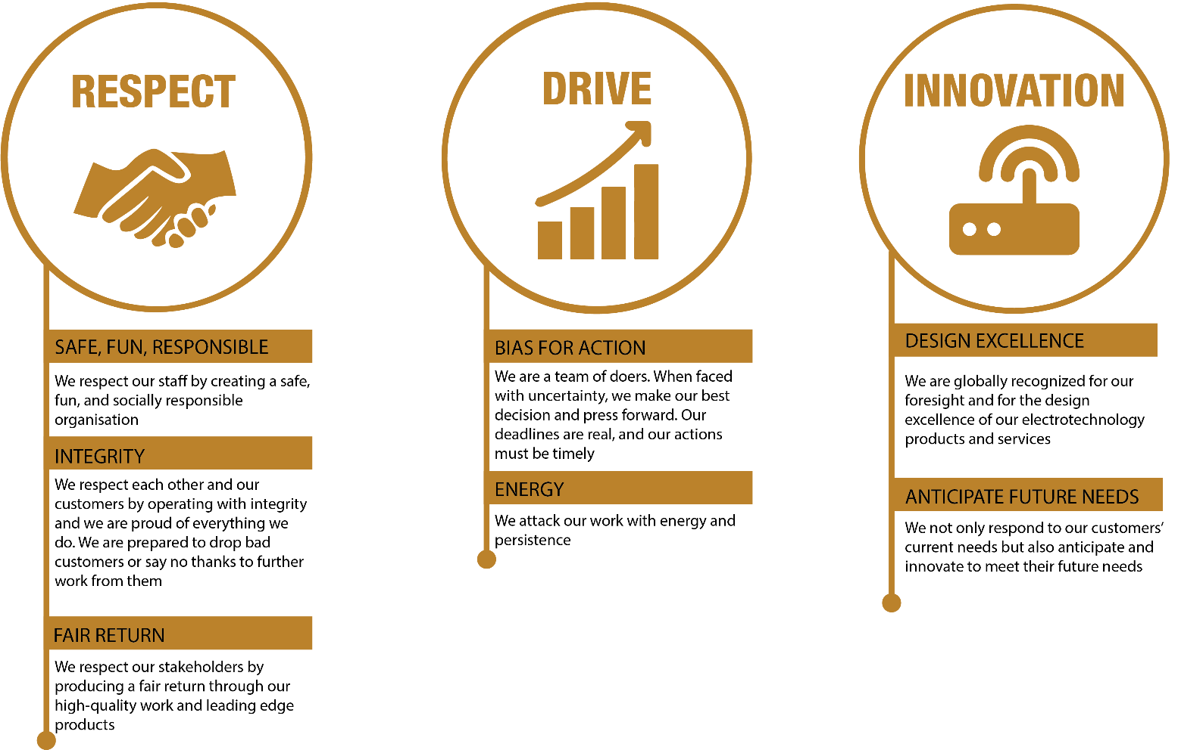
McKay GUIDING VALUES:

REVIEWED BY: |  |  | DATE:
Last updated by: | People and Culture |  | Date/Time: | Nov 23

