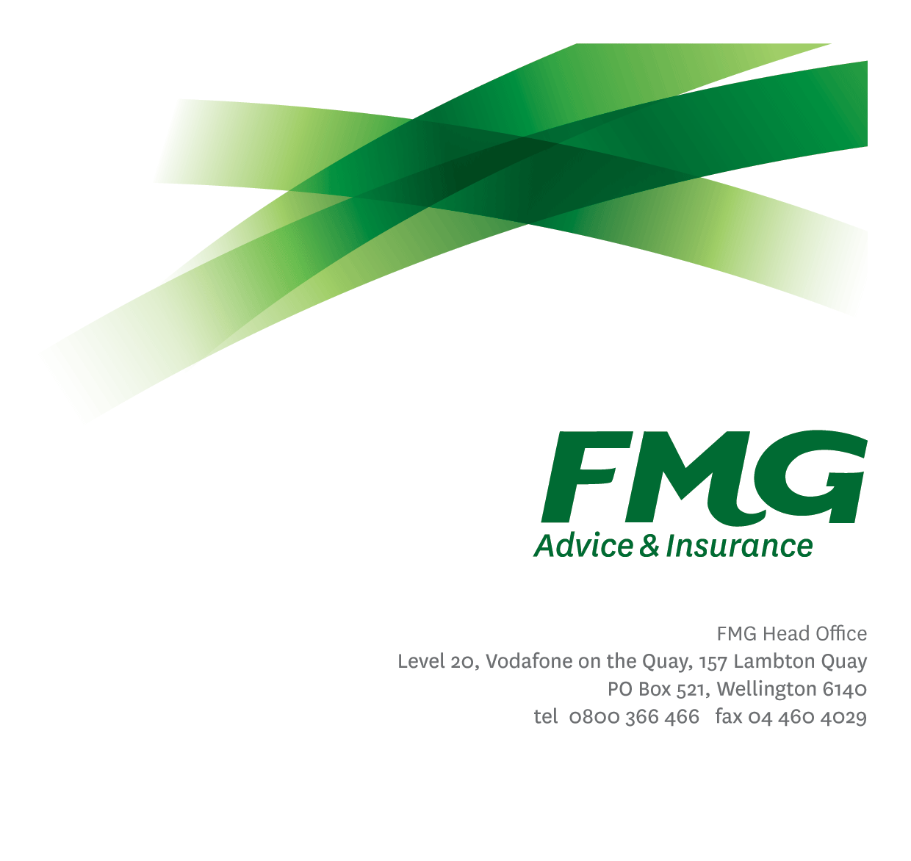
Assistant Accountant
Position Description

Location: Wellington
Reporting to: Finance Manager
Business Unit: Finance
Direct Reports: Nil
Date Last Reviewed: April 2025

About FMG
Formed by farmers for farmers over a century ago, FMG is New Zealand’s leading rural insurer providing risk advice and insurance solutions for farmers, growers, commercial businesses, the lifestyle sector and domestic clients.
We’re proudly 100% New Zealand owned and operated and our focus is on helping our clients to achieve their goals. As a mutual organisation, we’re all about giving rural New Zealanders a better deal, and part of this involves reinvesting all profits back into the business to keep premiums low and ensure the future sustainability of the organisation.

FMG’s Values
The FMG brand represents promises about what customers can expect from us and each of us is responsible for delivering on these promises. Living our company values means we deliver the best brand experience for our customers. Our company values are:
- Do what’s right | - Make it happen
- We’re in it together | - Proud of who we are

Work Environment
We strive to provide an environment that promotes and fosters achievement. We place importance on career development and training to give our people the tools they need to succeed.

Purpose of the role
To provide generalist financial expertise and support across financial accounting and management accounting fields, enabling critical business decisions to be made and strategies adopted for organisational growth and wellbeing.

Key Responsibilities

Area | Responsibilities
Bank Reconciliations | - To ensure the accurate and timely processing of bank statement information, and the reconciliation thereof to the General Ledger using our FMIS (TechnologyOne).
Miscellaneous Banking | - To ensure the timely processing of miscellaneous banking.
Customer Service | - To provide superior service to both internal and external clients through the provision of financial information where appropriate and the accurate and timely recognition of premium revenue against clients’ accounts within our insurance software suite.  - To ensure the successful processing and authorisation of daily banking, including claim payments and premium refunds.  - Maintain the Financial Management Group email inbox, responding to queries on a timely basis.
General Accounting | - Maintain the Accounts Receivable sub ledger and completing timely invoicing as and when required.  - To ensure timely settlement of Accounts Receivable invoices.
Financial Accounting | - To ensure the accuracy and timely provision of financial reports, both for management and for statutory reporting, through the efficient processing of financial cash transactions.  - Support the Financial Accountants in collating information for statutory reporting and any ad hoc queries as required.
Team Work | - Contributes to the effective functioning of the Financial Management Team through assisting other team members with any work required.  - Share information and resources and provide feedback in a positive and collaborative manner.
FMG Values | - To promote the “FMG Way” through displaying the values of FMG which are do what’s right, make it happen, we’re in it together and proud of who we are.
Wellbeing and Safety | - Complies with safety and wellbeing policy and procedures, including accident and incident reporting and hazard management requirements.  - Works in a safe manner at all times and does not undertake activities without appropriate training.

COMPETENCIES
*see competency framework for behaviours expected at each level | Expected Level
Client Driven (Internal & External)  A commitment to understanding the needs and best interests of both internal and external clients, in order to provide them with outstanding service and help them to make informed decisions. | Intermediate*
Accountability  Taking personal ownership of decisions, behaviour, and development, and being responsible for how these actions impact on the wider organisation and clients. | Intermediate*
Adaptability  Demonstrating a willingness to engage in a changing environment and being flexible and comfortable working with change. | Intermediate*
Motivation and Drive  The determination to achieve goals and strive for excellence. | Intermediate*
Relationship Building  Developing and maintaining positive, professional relationships that are built on mutual trust and respect. | Competent*
Team Work  Making a positive contribution to the FMG team and collaborating effectively with others to achieve objectives. | Intermediate*

KNOWLEDGE
Qualifications | Relevant Accounting Qualification essential
Experience | Basic knowledge and understanding of contemporary financial management, and management accounting concepts in a commercial environment.
Business Awareness | Understands the internal workings of FMG and how business works; understands FMG's position in the advice and insurance market and knows the competition.
Systems Knowledge | Knowledge of the following systems is preferred: TechnologyOne, SAS Visual Analytics

SKILLS
Financial Skills | Able to calculate and understand financial information e.g. profit & loss, forecasts.
Listening Skills | Demonstrates active listening skills through eye contact, paraphrasing, appropriate body language and checking understanding.
Technology Skills | Can expertly use relevant software and technology to its full capacity e.g. MS Word, Excel and PowerPoint.
Verbal Communications Skills | Effectively presents information to others, both informally and in meetings.
Written Communication Skills | Able to write clear and concise emails, proposals and reports.

Relationship
External | Internal | Committees/Groups
- External Auditors  - Government Departments (IRD, Earthquake Commission, Fire Service)  - Bank Personnel | - Financial Management team  - Executive team  - All FMG Managers  - Payment Services Team  - Claims Team

Financial Authority Levels
- No authority to commit or approve expenditure

Human Resources Authority Levels
- Not applicable

Agreement
I agree to the outline of the role as contained in this document and recognise that the contents may need to be amended from time to time to reflect changing business requirements.

I as Job holder, allow my Manager to gather information from third parties where necessary for the purposes of performance management.

Assistant Accountant’s Name:
Signature:
Date:

