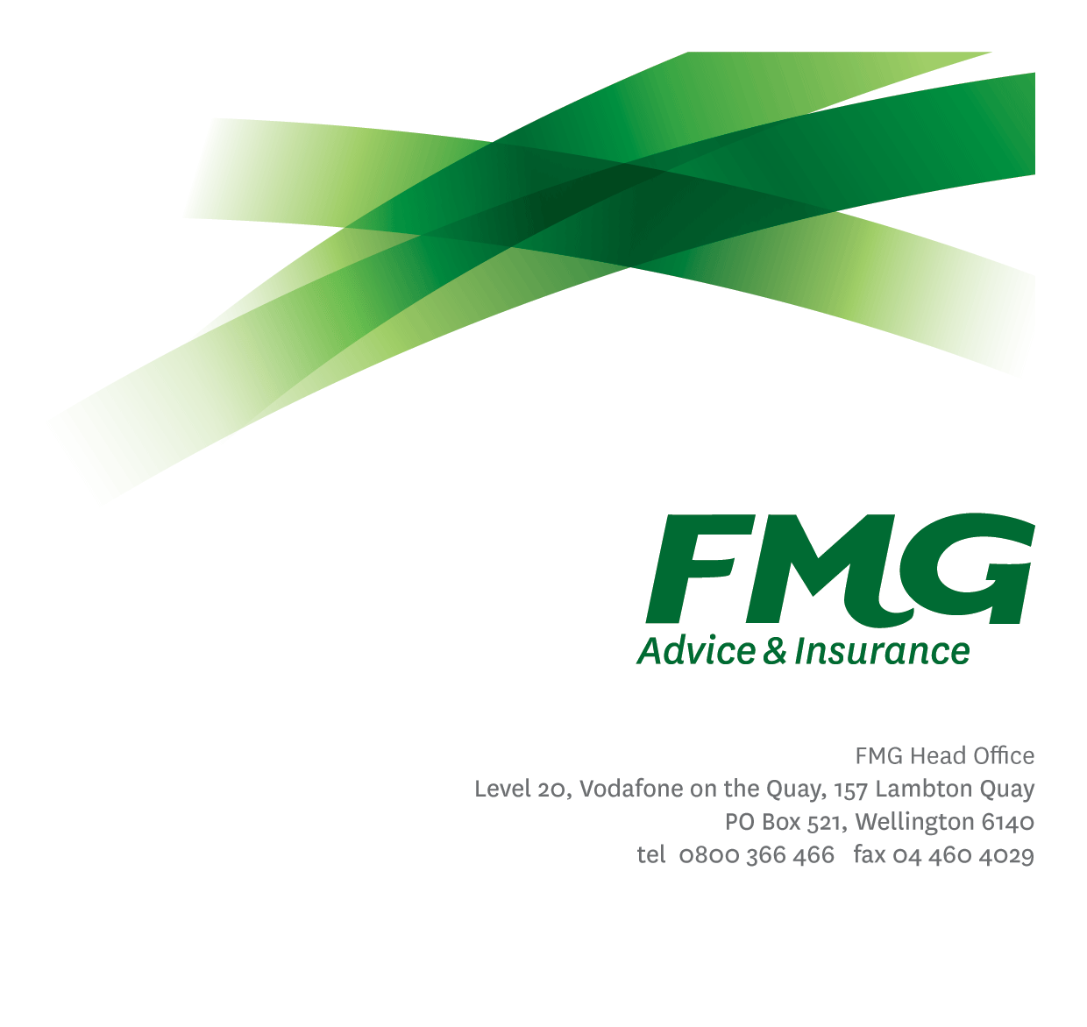
Risk Consultant
Position Description

Location: As per Personal Terms
Reporting to: Head of Underwriting
Business Unit: Insurance Solutions
Direct Reports: Nil
Date Last Reviewed: February 2023

About FMG
Formed by farmers for farmers over a century ago, FMG is New Zealand’s leading rural insurer providing risk advice and insurance solutions for farmers, growers, commercial businesses, the lifestyle sector and domestic clients.
We’re proudly 100% New Zealand owned and operated and our focus is on helping our clients to achieve their goals. As a mutual organisation, we’re all about giving rural New Zealanders a better deal, and part of this involves reinvesting all profits back into the business to keep premiums stable and ensure the future sustainability of the organisation.

FMG’s Values
The FMG brand represents promises about what clients can expect from us and each of us is responsible for delivering on these promises. Living our company values means we deliver the best brand experience for our customers. Our company values are:
- Do what’s right - Whāia te ara tika | - Make it happen - Whakatutukitia
- We’re in it together - Ko tātau tātau | - Proud of who we are Whakahīhī i te whakapapa

Work Environment
We strive to provide an environment that promotes and fosters achievement. We place importance on career development and training to give our people the tools they need to succeed. Fostering a culture of Wellbeing and Safety is also a critical element.
FMG’s Head Office is in Wellington and accommodates FMG’s Leadership Team, Marketing & Risk Services, Human Resources, Client Propositions, Financial Management, Underwriting and Risk Quality, Reinsurance, Business Information and Analysis, and Legal and Compliance.

FMG’s largest regional office is in Palmerston North accommodating our National Service Centre, Insurance Consultants, Information Technology, Claims, Operations and Payment functions. Approximately 200 employees are located there. FMG’s largest office in the South Island is Christchurch. In addition to the offices in Wellington, Palmerston North and Christchurch – FMG has smaller offices in 30 regional locations throughout New Zealand.

Purpose of the role
In this role you will be responsible for helping identified FMG clients identify, understand and manage risk to improve their insurable risk profile, prevent avoidable loss and minimise disruption. This will include going onsite to client’s premises to undertake risk management assessments and provide actionable insights to help build resilience.

Key Responsibilities

Area | Responsibilities
Risk Surveying & Consulting | - Undertake risk surveys for identified clients over a variety of risks including physical risks, operational risks, and key person.  - Analyse the information collected from risk surveys to provide approaches and recommendations to help clients improve their risk management practices.  - Develop Risk Management plans that provide clients with concrete advice and action plans to improve their insurable risk profile and build resilience.  - Build and maintain risk management frameworks and processes that will be used with clients alongside the Underwriting team.  - Participate in the development and evolution of the Risk Consulting capability at FMG
Internal Customer Service | - Work with FMG Sales and Service teams to support and follow up clients in embedding their risk management plans  - Provide field intelligence and insight to internal underwriting teams to assist in the underwriting/pricing of new or existing risks  - Maintain strong communication with the FMG employees who service the clients that risk management recommendations are made to.  - Share risk management insights and knowledge with FMG employees to lift FMG’s risk management capability.
External Relationship and Network Management | - Proactively builds and maintains a network of relationships in order to strengthen FMG’s risk management capability and contribute to developing new risk transfer and financing mechanisms.

Broader Insurance Solutions Context | - Contribute broadly to strategic and operational discussions and decisions as a member of FMG’s Insurance Solutions team.  - Work with the Head of Underwriting to ensure alignment with FMG’s overall strategy and plans.  - Lead and contribute to other pieces of work as assigned from time to time by the Head of Underwriting.
Relationship Management | - Maintain and manage effective relationships with key FMG stakeholders  - Create relationships with third party providers that are in the interest of FMG and its clients.  - Build rapport and understanding with FMG clients.
Team Membership | - Proactively assist to the Underwriting team colleagues and other stakeholders.  - Share information and resources and provide feedback in a positive and collaborative manner.  - Completes and coordinates necessary administrative duties in a timely manner through efficient and effective self-management
Self-Development | - Maintain own knowledge base of established and emerging industry best practice to act as an expert resource, both ICNZ and relevant client industry bodies.
FMG Values | - Promotes the “FMG Way” through displaying the values of FMG which are: Do what’s right, Make it happen, We’re in it together, Proud of who we are.
Other Duties | - Undertakes tasks as directed by the Head of Underwriting from time to time.
Compliance | - Ensure assigned products and overall work is compliant with legislation, regulations and FMG policies through the use of established systems.
Wellbeing & Safety | - Comply with the Safety & Wellbeing policy and procedures, including accident and incident reporting and hazard management requirements  - Work in a safe manner at all times and do not undertake activities without appropriate training

COMPETENCIES
*see competency framework for behaviours expected at each level | Expected Level
Client Driven (Internal & External)  A commitment to understanding the needs and best interests of both internal and external clients, in order to provide them with outstanding customer service and help them to make informed decisions. | Advanced*
Accountability  Taking personal ownership of decisions, behaviour, and development, and being responsible for how these actions impact on the wider organisation and customers. | Advanced*
Adaptability  Demonstrating a willingness to engage in a changing environment and being flexible and comfortable working with change. | Advanced*
Motivation and Drive  The determination to achieve goals and strive for excellence. | Advanced*
Relationship Building  Developing and maintaining positive, professional relationships that are built on mutual trust and respect. | Advanced*
Team Work  Making a positive contribution to the FMG team and collaborating effectively with others to achieve objectives. | Advanced*
Critical Analysis  The capability to identify key issues, trends, or important facts from information and to question and probe. | Advanced*

KNOWLEDGE
Qualifications | Relevant Tertiary Qualification required
Experience | 5+ years’ experience in risk management services or associated services.  Experience within the agriculture/horticulture industry.
Business Awareness | Understands the internal workings of FMG and how business works; understands FMG's position in the advice and insurance market and knows the competition.
Rural Knowledge | Understands the rural community and keep up to date with the economic, political, and environmental issues affecting our customers.
Risk/Insurance Knowledge | Understands risk and how FMG's policies respond to insurable risks; is knowledgeable about compliance requirements; understands the insurance process and how claims are managed; knows industry partners and competitors.
Specialist Knowledge | Risk surveying and risk management skills relevant to primary sector and affiliated industries.

SKILLS
Written Communication Skills | Able to write clear, concise and persuasive proposals and reports.
Verbal Communications Skills | Communicates clearly in order to present information to persuade and influence others.
Listening Skills | Demonstrates active listening skills through eye contact, paraphrasing, appropriate body language and checking understanding.
Technology Skills | Can expertly use relevant software and technology to its full capacity e.g. MS Word, Excel and PowerPoint.
Project Management Skills | Can manage projects to deliver agreed outcomes across the business within agreed timeframes.
Risk Assessment Skills | Can put in place plans to mitigate risks and manage issues.
Driving Skills | Full driver’s license required.

Relationship
External | Internal | Committees/Groups
- FMG Clients  - Relevant industry groups | - Underwriting team  - Insurance Solutions team  - Chief Insurance Officer  - Sales and Service team  - Client Strategy & Advice Services team  - Claims and Assessing teams | - Future of Advice steering group

Financial Authority Levels
- As per agreed Delegated Authority levels.

Human Resources Authority Levels
- Not applicable

Agreement
I agree to the outline of the role as contained in this document and I recognise that the contents may need to be amended from time to time to reflect changing business requirements.
I as Job holder, allow my Manager to gather information from third parties where necessary for the purposes of performance management.

