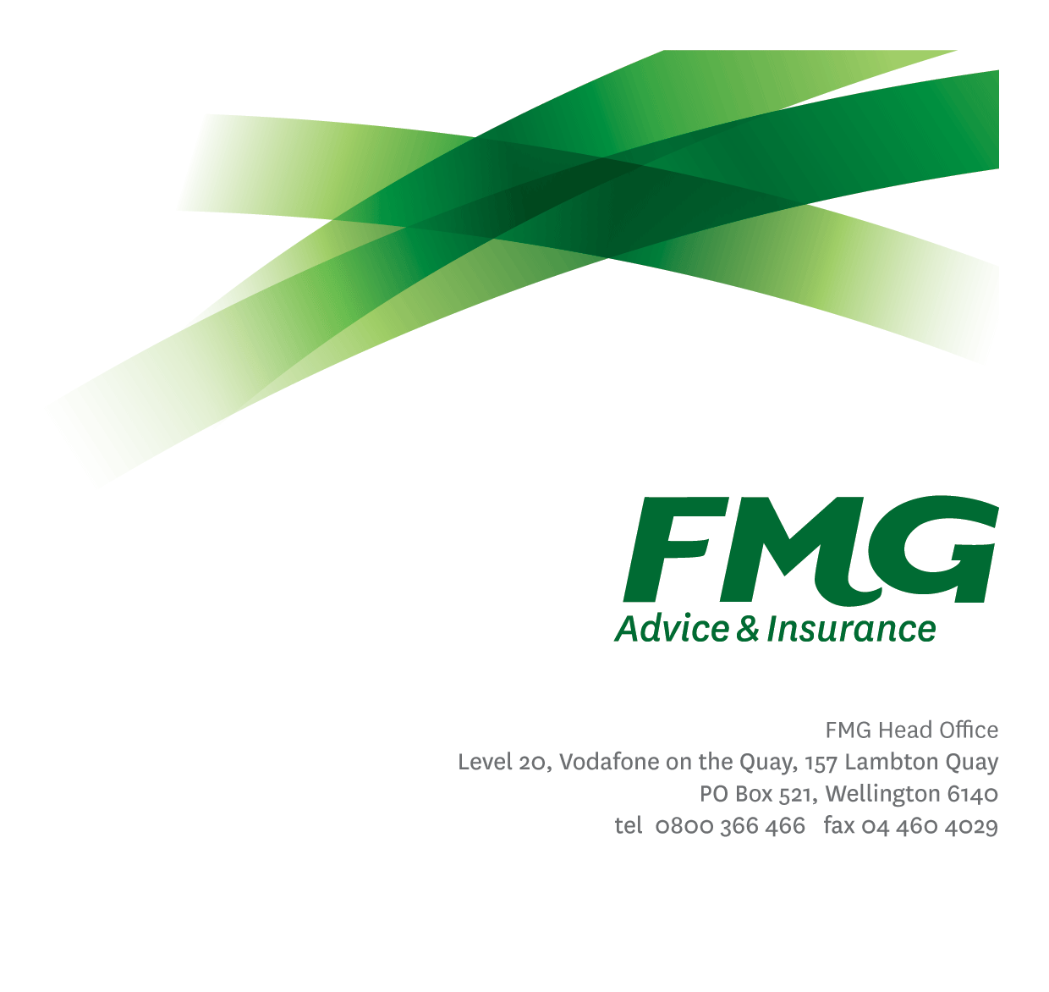
Team Leader, Claims Advisers
Position Description

Location: As per Personal Terms
Reporting to: Manager, Transactional Claims
Business Unit: Claims
Direct Reports: Various
Date Last Reviewed: July 2024

About FMG
Formed by farmers for farmers over a century ago, FMG is New Zealand’s leading rural insurer providing risk advice and insurance solutions for farmers, growers, commercial businesses, the lifestyle sector and residential clients.
We’re proudly 100% New Zealand owned and operated and our focus is on helping our clients to achieve their goals. As a mutual organisation, we’re all about giving rural New Zealanders a better deal, and part of this involves reinvesting all profits back into the business to keep premiums low and ensure the future sustainability of the organisation.

FMG’s Values
The FMG brand represents promises about what clients can expect from us and each of us is responsible for delivering on these promises. Living our company values means we deliver the best brand experience for our clients. Our company values are:
- Do what's right - Whāia te ara tika | - Make it happen - Whakatutukitia
- We're in it together - Ko tātau tātau | - Proud of who we are - Whakahīhī i te whakapapa

Work Environment
We strive to provide an environment that promotes and fosters achievement. We place importance on career development and training to give our people the tools they need to succeed.
FMG’s Corporate Office is in Wellington and accommodates FMG’s Executive Leadership Team (ELT), Client Propositions & Online Services, People & Culture and Communications, Financial Management, Product & Pricing and Underwriting, Reinsurance, Business Information and Analysis, Legal and Compliance.
FMG’s largest regional office is in Palmerston North accommodating our National Sales & Advice Centre, Information Technology, Claims, Operations and Payments functions. In addition to the offices in Wellington, Palmerston North and Christchurch FMG has offices in 30 regional locations throughout New Zealand.

Purpose of the role
The Team Leader, Claims Adviser is responsible for ensuring a team of Claims Advisers deliver a consistent, professional and client focused claims service.
The role of the Team Leader, Claims Adviser, is to provide our Claims Advisers with the support, development, and tools to ensure a consistent, professional and client focused claims service. The Team Leader will understand and analyse their team’s performance and offer support and recognition where appropriate.
This role is also required to work supportively and collaboratively across the Claims team, as well as across the wider organisation, to deliver world-class claims service to our clients.

Key Responsibilities

Area | Responsibilities
Team-Work Flow & Management | - Holds accountability for ensuring that all claims assigned to a Claims Adviser are assessed in an efficient and consistent manner while maintaining high quality for both our clients and FMG.  - Responsible for planning, management, and monitoring of workflow.  - Takes proactive ownership and accountability for the monitoring of progress against key operating metrics, identifies issues or trends and removes or escalates barriers.  - Ensure that documentation and processes are well managed.  - Create, implement, and maintain a culture of continuous improvement in operational workflows that enhance the provision of excellent service for FMG clients and employees.  - Key role in leading effective change management for teams as and when required and assists with the implementation of change processes.  - Ensure that client expectations are met or exceeded and act as the first point of escalation for all transactional claims client complaints.
Leadership | - Provide clear leadership for direct reports to support achievement of results. Ensures individual and team performance is managed and measured appropriately and provides feedback.  - Manage the ongoing recruitment, coaching and professional development of individual team members to ensure full competence in their roles.  - Ensure talent and succession plans are in place for key positions.  - Communicate and share information with a range of audiences including direct reports on a regular basis, both formally and informally.  - Ensure performance is managed and measured appropriately.  - Communicates effectively with the team by sharing information and resources and providing feedback in a positive and constructive manner
Team Participation | - Is a proactive and supportive team member of the Claims team and works closely with other leadership peers across the wider business to ensure a seamless, professional, and quality client experience.  - Participating in projects or new initiatives as required.  - Undertakes tasks as directed by the Manager, Claims Advisers, Head of Claims – Transactional or Chief Claims Officer
Customer Satisfaction & Service Delivery | - Provides excellent customer service by demonstrating FMG values.  - Ensure all communication is of a high standard.  - Exceeds customer service satisfaction levels both external and internal through the delivery of accurate and timely information and advice, by being recognised as an expert, building rapport; and getting the job done in a timely manner with minimal disruption to the customer.
Personal Proficiency | - Proactively acquire and develop appropriate skills, knowledge and techniques in relation to fulfilling the core functions of the role.
Relationship Management | - Supporting cross-team collaboration within the whole of Claims to ensure all team members have access to information and resources as required and all clients receive consistent, quality and professional claims service.  - Establishing effective working relationships with other employees and business units of FMG.
FMG Values | - To promote the “FMG Way” through displaying the values of FMG which are do what’s right, make it happen, we’re in it together and proud of who we are
Risk Quality & Compliance | - Ensures compliance with legislative, regulations and FMG policies through the monitoring of systems, processes and improvements.  - Understands, interprets and applies FMG product coverage, conditions, limitations and exceptions relevant to each customer’s circumstances.  - Writes all business within the delegated authority levels.  - Prepares concise and accurate information for clients.  - Ensures all records of call and data entry in ClaimsCentre and other related software / databases are correct; with a focus on data quality is maintained.
Wellbeing & Safety | - Complies with Wellbeing & Safety policy and procedures, including accident and incident reporting and hazard management requirements.  - Works in a safe manner at all times and does not undertake activities without appropriate training.

COMPETENCIES
*see competency framework for behaviours expected at each level | Expected Level
Client Driven (Internal & External)  A commitment to understanding the needs and best interests of both internal and external clients, in order to provide them with outstanding client service and help them to make informed decisions. | Advanced*
Accountability  Taking personal ownership of decisions, behaviour, and development, and being responsible for how these actions impact on the wider organisation and clients. | Advanced*
Adaptability  Demonstrating a willingness to engage in a changing environment and being flexible and comfortable working with change. | Advanced*
Motivation and Drive  The determination to achieve goals and strive for excellence. | Advanced*
Relationship Building  Developing and maintaining positive, professional relationships that are built on mutual trust and respect. | Advanced*
Team Work  Making a positive contribution to the FMG team and collaborating effectively with others to achieve objectives. | Advanced*
Motivating and Developing Others  A commitment to getting the best out of people and motivating them to reach their full potential. | Competent*
Change Leadership  The drive to initiate opportunities to address FMG’s organisational needs and to communicate change in a way that gains buy-in and support from others. | Competent*
Strategic Thinking  The capacity to stand apart from the day-to-day and take a long-term, big picture view of the business. | Competent*
Leadership Courage  A dedication to leading the FMG team toward their vision and values and communicating FMG’s future direction with clarity and enthusiasm. The awareness and courage to front up to difficult situations with sensitivity and integrity. | Competent*

KNOWLEDGE
Business Awareness | Understands the internal workings of FMG and how business works; understands FMG's position in the advice and insurance market and knows the competition.
Rural Knowledge | Understands the rural community and keep up to date with the economic, political, and environmental issues affecting our clients.
Legal Knowledge | Has appropriate level of legal knowledge e.g. the Privacy Act etc.
Insurance Knowledge | Understands risk and how to apply FMG's policies to situations; is knowledgeable about compliance requirements; understands the insurance process and how claims are managed; knows industry partners and competitors.
Claims Management | Understands how the Claims processes operate.
Product & Service Knowledge | Is knowledgeable about FMG's insurance policies and packages and services, the differences between them, and the appropriateness of each in different situations.

EXPERIENCE
Work Experience | At least 4 years leadership experience within the financial services sector, preferably insurance.  Proven experience in insurance / claims  Specialist knowledge in Motor & Machinery

SKILLS
Written Communication Skills | Able to write clear and concise content.
Listening Skills | Demonstrates active listening skills through eye contact, paraphrasing, appropriate body language and checking understanding.
Verbal Communications Skills | Communicates clearly in order to present information to persuade and influence others.
Technology Skills | Broad systems knowledge including experience in programming software and/or insurance modelling tools. Can expertly use relevant software and technology to its full capacity.
Risk Assessment Skills | Can identify risks and escalate awareness.

Relationship
External | Internal | Committees/Groups
- Clients  - External Service Providers | - Claims Team  - Underwriting  - Sales, Advice & Service Team  - Risk Quality Team  - People & Culture

Financial Authority Levels
- No authority to commit or approve expenditure

People & Culture Authority Levels
- May hire direct and indirect reports within approved FTE headcounts in consultation with Manager and People & Culture
- May discipline direct and indirect reports in consultation with manager and Human Resources.
- No authority to dismiss staff, unless delegated by the Chief Executive and in consultation with manager and Human Resources.

Delegated Authority Levels
- Delegated authority levels for the individual role-holder will be advised following assessment, training and approval as per the requirements of the FMG Delegated Authority Policy.

Agreement
I agree to the outline of the role as contained in this document and recognise that the contents may need to be amended from time to time to reflect changing business requirements.

I as Job holder, allow my Manager to gather information from third parties where necessary for the purposes of performance management.

Name: ______________________

Signature: ____________________

Date: ________________________

