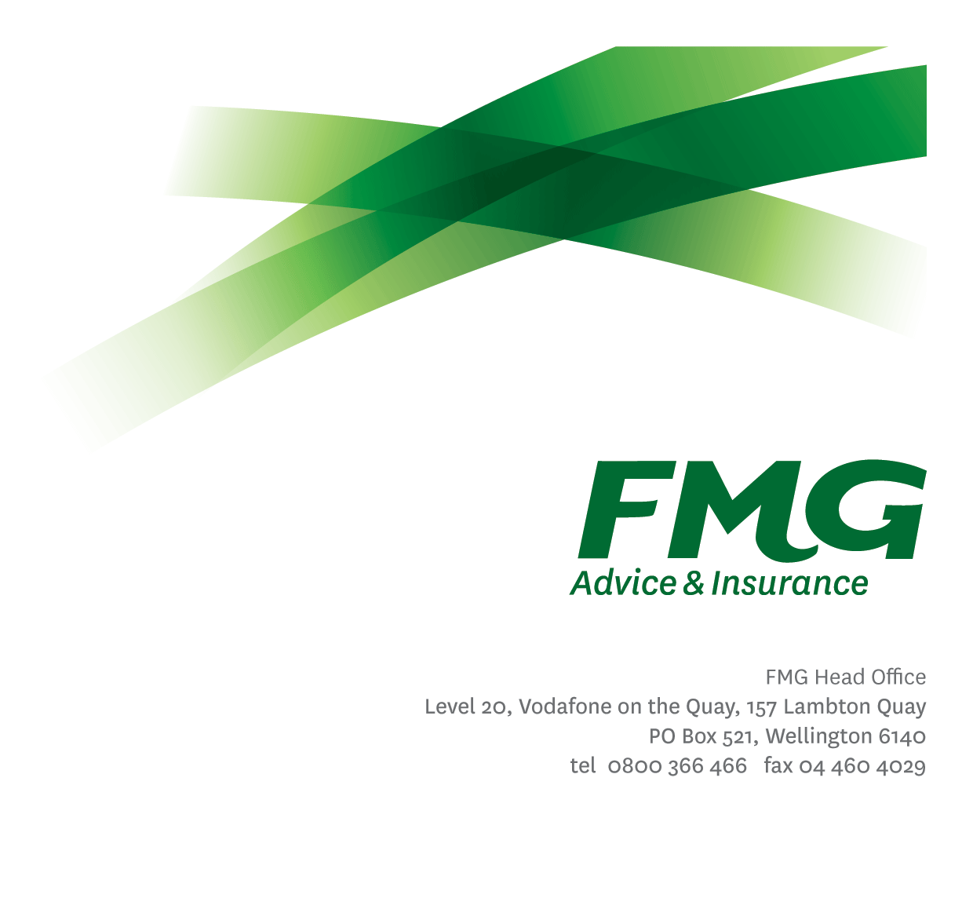Manager Agribusiness Centre

*Position Description*

*Location:* Palmerston North

*Reporting to:* Head of National Advice & Service Centre

*Business Unit:* Sales, Advice & Service

*Direct Reports:* Variable

*Date Last Reviewed:* May 2024

### *About FMG*

***Formed by farmers for farmers over a century ago, FMG is New Zealand’s leading rural insurer providing risk advice and insurance solutions for farmers, growers, commercial businesses, the lifestyle sector and residential clients.***

***We’re proudly 100% New Zealand owned and operated and our focus is on helping our clients to achieve their goals.  As a mutual organisation, we’re all about giving rural New Zealanders a better deal, and part of this involves reinvesting all profits back into the business to keep premiums low and ensure the future sustainability of the organisation.***

### *FMG’s Values*

The FMG brand represents promises about what customers can expect from us and each of us is responsible for delivering on these promises. Living our company values means we deliver the best brand experience for our customers. Our company values are:

|  |  |
| --- | --- |
| * Do what’s right | * Make it happen |
| * We’re in it together | * Proud of who we are |

### *Work Environment*

We strive to provide an environment that promotes and fosters achievement. We place importance on career development and training to give our people the tools they need to succeed.

FMG’s largest office is located in Palmerston North accommodating our Service Centre, Insurance Consultants, Information Technology, Claims, Operations and Payments functions. The Agribusiness Centre is located in Feilding. FMG’s largest office in the South Island is in Christchurch. In addition to the offices in Wellington, Palmerston North and Christchurch FMG have 27 smaller offices in regional locations throughout NZ.

### *Purpose of the role*

### The Manager Agribusiness & Commercial Centre is accountable for providing operational direction and leadership to FMG’s phone-based Rural and Commercial Insurance Consultants. This role will also be tasked with operationalizing FMG relevant Rural and C0mmercial strategies with a view to increase acquisition, retention and NPS.

This role will play a core role in driving FMG’s growth agenda in respect of market share by ensuring consistent delivery of the client value proposition for our new clients, along with improving the organizational efficiency, effectiveness, engagement, and experience of employees.

### *Key Responsibilities*

| Area | Responsibilities |
| --- | --- |
| Leadership / Operational Planning | * Implements and leads the operational plans for the Agribusiness & Commercial Centre, in the context of FMG’s growth strategy, retention targets and distribution model. * In conjunction with the Head of National Advice & Service Centre, participates in the development of the overall NASC strategic and operational plans. * Ensure the Agribusiness & Commercial Centre has plans in place to deliver on the agreed distribution/operating model (including alignment with the broader Rural & Commercial strategy and model) and support the achievement of broader organisational objectives. * Proactively identifies and acts upon business gaps and growth and retention opportunities for clients serviced out of the Agribusiness & Commercial Centre, as well as removing barriers to closing or taking advantage of these opportunities. * Ensures the effective utilisation of client systems and processes (i.e. CIC, CRM, Policy Centre) including ensuring teams understand the importance of client data and data integrity. * Manages and controls the unit’s operational budget. * Participates in projects or new initiatives as required. * Monitors, analyses and interprets data for planning purposes and reports as and when required to relevant stakeholders. * Proactively builds monitors and manages a wide-ranging network of relationships related to the role in order to maximize sales and growth opportunities within the Centre |
| People Leadership, Talent & Succession Planning | * Drives a high performance and coaching culture by ensuring team members meet or exceed agreed KRAs, along with coaching leaders to implement and drive performance plans as appropriate. Including managing on-going coaching and professional development of direct reports to ensure they are successful in their roles. * Recruits, manages, develops & coaches individuals to create a high performing team environment with a focus across the whole of NASC. * Ensures appropriate advice, sales and service training is in place and operating in line with the agreed standards. * Works with People & Culture to implement an internal talent management process and a documented succession plan for key positions. * Rewards and recognises employees who contribute to FMG’s success through informal and formal methods. * Implements service standards & objectives for the Agribusiness & Commercial Centre and contributes to the overall service standards & objectives for all of NASC. |
| Process improvement, Performance and efficiency | * Ensure appropriate performance and process standards are established and systems established to monitor and report on these. * Leadership and management of enhancing the client and employee experience through standardizing, streamlining and simplifying business processes, including through leveraging digital channels. * Investigating technology and championing a continuous improvement focus when it comes to efficiency of the Centre |
| Personal Proficiency | * Proactively acquires and develops skills, knowledge and techniques. * Attends coaching sessions and personal development as agreed with management. |
| Leadership Team | * Proactively assists and supports the Advice & Service Centre Leadership Team colleagues and works closely with other leadership roles in the Team to continue the culture of high achievement and performance * Shares information, resources and provides feedback in a positive and collaborative manner. * Undertakes tasks as directed by the Head of Advice & Service Centre as and when required. |
| Wellbeing and Safety | * Demonstrates commitment to workplace safety and wellbeing practices. * Promotes and supports initiatives that contribute to a healthy and safe working environment for employees, visitors and contractors. * Ensures compliance with safety and wellbeing policy and procedures, including accident and incident reporting and investigation, hazard management, induction, training and supervision, employee participation and contractor management. |
| Risk Quality & Compliance | * Ensures internal and external compliance with legislative, regulations and FMG policies through the implementation and monitoring of systems, processes and improvements. |

|  |  |  |
| --- | --- | --- |
| **COMPETENCIES** | | |
| *\*see competency framework for behaviours expected at each level* | | *Expected Level* |
| **Client Driven (Internal & External)**  A commitment to understanding the needs and best interests of both internal and external customers, in order to provide them with outstanding customer service and help them to make informed decisions. | | Advanced* |
| **Accountability**  Taking personal ownership of decisions, behaviour, and development, and being responsible for how these actions impact on the wider organisation and customers. | | Advanced* |
| **Adaptability**  Demonstrating a willingness to engage in a changing environment and being flexible and comfortable working with change. | | Advanced* |
| **Motivation and Drive**  The determination to achieve goals and strive for excellence. | | Advanced* |
| **Relationship Building**  Developing and maintaining positive, professional relationships that are built on mutual trust and respect. | | Advanced* |
| **Team Work**  Making a positive contribution to the FMG team and collaborating effectively with others to achieve objectives. | | Advanced* |
| **Critical Analysis**  The capability to identify key issues, trends, or important facts from information and to question and probe. | Intermediate* | |
| **Motivating and Developing Others**  A commitment to getting the best out of people and motivating them to reach their full potential. | | Advanced* |
| **Change Leadership**  The drive to initiate opportunities to address FMG’s organisational needs and to communicate change in a way that gains buy-in and support from others. | | Intermediate* |
| **Strategic Thinking**  The capacity to stand apart from the day-to-day and take a long-term, big picture view of the business. | | Intermediate* |
| **Leadership Courage**  A dedication to leading the FMG team toward their vision and values, and communicating FMG’s future direction with clarity and enthusiasm. The awareness and courage to front up to difficult situations with sensitivity and integrity. | | Advanced* |

|  |  |
| --- | --- |
| **KNOWLEDGE** | |
| **Qualifications** | Tertiary qualified, preferably in an agri-business, commerce or business discipline. |
| **Work Experience** | 3+ years’ experience working in a Sales or Service Centre Leadership role  A commercially savvy leader with a successful track record in leading and motivating teams and achieving results  Experience in building and executing successful sales and service strategies, ideally in a phone-based/inside sales environment.  Experience in working with and in a multi-channel distribution model  Experience in leading change initiatives at a strategic and operational level. |
| **Business Awareness** | Understands the internal workings of FMG and how business works; understands FMG's position in the advice and insurance market and knows the competition. |
| **Rural Knowledge** | Understands the rural community and keep up to date with the economic, political, and environmental issues affecting our customers. |
| **Legal Knowledge** | Has legal knowledge e.g. indemnity, liability, the Privacy Act etc. |
| **Product Knowledge** | Is knowledgeable about FMG’s insurance policies and packages, the differences between them, and the appropriateness of each in different situations. |
| **Specialist Knowledge** | Financial Advisers Act working knowledge of personal insurance best practice advice and compliance. |
| **Risk/Insurance Knowledge** | Understands risk and how to apply FMG's policies to situations; is knowledgeable about compliance requirements; understands the insurance process and how claims are managed; knows industry partners and competitors. |

|  |  |
| --- | --- |
| **SKILLS** | |
| **Written Communication Skills** | Able to write clear, concise and persuasive proposals and reports. |
| **Verbal Communications Skills** | Communicates clearly in order to present information to persuade and influence others. |
| **Listening Skills** | Demonstrates active listening skills through eye contact, paraphrasing, appropriate body language and checking understanding. |
| **Financial Skills** | Able to calculate and understand financial information e.g. profit & loss, forecasts. |
| **Technology Skills** | Can expertly use relevant software and technology to its full capacity |
| **Risk Assessment Skills** | Can put in place plans to mitigate risks and manage issues |
| **Conflict Resolution Skills** | Able to effectively respond to and satisfactorily resolve conflicts and customer complaints |

### *Relationship*

|  |  |  |
| --- | --- | --- |
| External | Internal | Committees/Groups |
| * Clients | * Head of Advice & Service Centre * Agribusiness and Commercial Centre Team Leaders * Area Managers * New Client Centre * Commercial and Rural Managers * NASC Managers * All FMG employees |  |

### *Financial Authority Levels*

### May approve routine expenditure within budgetary limits.

### *Human Resources Authority Levels*

* May hire direct and indirect reports within approved FTE headcounts.
* May discipline direct and indirect reports in consultation with Manager and People & Culture
* No authority to dismiss staff, unless delegated by the Chief Executive and in consultation with manager and Human Resources.

### *Delegated Authority Levels*

* Delegated authority levels for the individual role-holder will be advised following assessment, training and approval as per the requirements of the FMG Delegated Authority Policy.

### *Agreement*

I agree to the outline of the role as contained in this document and recognise that the contents may need to be amended from time to time to reflect changing business requirements.

I as Job holder, allow my Manager to gather information from third parties where necessary for the purposes of performance management.

|  |  |
| --- | --- |
| Manager Agribusiness & Commercial Centre’s Name: |  |
| Signature: |  |
| Date: |  |