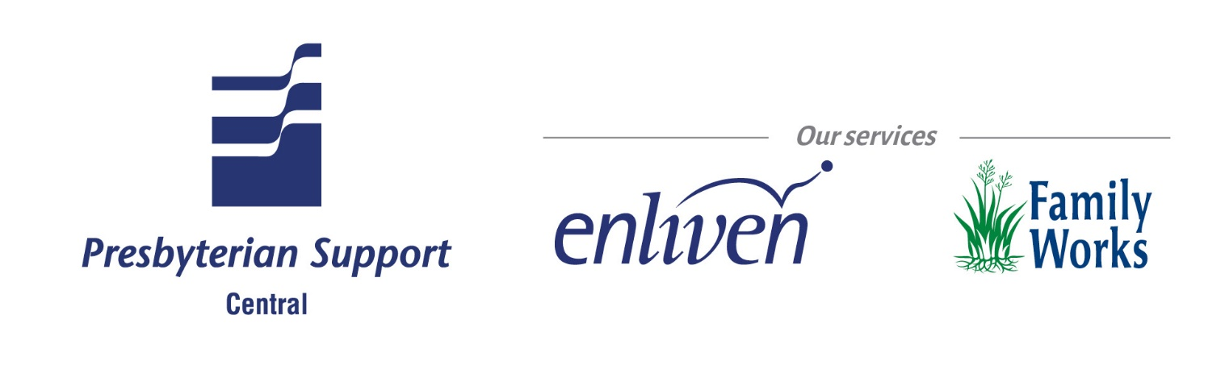

Position Description
Role Specification

Role Title: | Cleaner
Business Unit: | Enliven Residential | Location: | Enliven Home

Reports to: (role title) | Facility manager / Service’s team leader
Direct reports (role titles) | Nil

Purpose of the role (What the role does; how the role contributes to the organisation goals)
As a member of the cleaning team you will assist In maintaining a clean, warm, caring, safe and secure environment for our resident in line with our mission statement. You are to provide a
standard of cleanliness that meets requirements in the areas designated in the work schedule.

Key Accountabilities (Key activities, tasks and outcomes to be achieved)
Supporting Residents independence
- Is familiar with Eden philosophy
- Helps residents maintain their individuality by allowing and helping them to do safe cleaning practices if they wish to.
Cleaning/Quality
- Follows Enliven policies and procedures.
- Provide quality cleaning and hygiene services for residents and staff that is maintained to a consistent standard.
- Responds to residents or managers requests for additional cleaning assistance. Is respectful of Enliven property
- Understand and carry out cleaning services programme as written in the work schedule.
- Understand and follows infection control procedures in the cleaners manual
Professional Development
- Completes the National Certificate in Cleaning level 2
- Participates in mandatory training
Health and Safety
- Has read and understood the Enliven Health and Safety protocols.
- Reports all hazards and potential hazards seen during the cleaning process
- Reports all accidents, incidents and near misses for residents, visitors, staff and self.
- Reports any early signs of personal pain or discomfort to their manager.
Core competencies
Competent performance in the role requires demonstration of the following competencies. These competencies provide a framework for selection and development.
Teamwork
- Works as part of the team, has a friendly manner and sense of humour and is polite to residents and staff.
- Shows flexibility
- Is reliable
- Is a good listener.
- Answer’s question and concerns raised by others in a non defensive way.
- Deals effectively with conflict.
Quality
- Provides quality service, looks for ways to improve work processes and shows commitment to continuous learning and performance development.
- Plans and organises work completing tasks in a timely manner. Consistently performs tasks correctly.
Key job requirements
Qualifications
National certificate in cleaning and care taking level 2 – 3 (or working towards)
Experience
- Demonstrate a high standard of personal hygiene and appearance
- Experience working with the elderly is preferred
- Effective communication skills
- Cleaning experience and knowledge of correct use of products and equipment preferred.
Person Specification

Treaty of Waitangi

Enliven, Presbyterian Support Central is committed to working in a multi-cultural way and affirms the place of Maori as Tangata Whenua and seeks to actively promote the spirit of equality and partnership inherent in the Treaty of Waitangi.
The role description will be reviewed regularly in order for it to continue to reflect the changing needs of the organisation. Any changes will be discussed with the position holder before being made. Annual objectives and performance measures will be set each year during the annual performance planning and development meeting.
I have read this job description and accept it.
Signed:
………………………………………
Date: ………………..
Employee’s Name:
………………………………………

Prepared by: (Name and position) | Matthew Gutschlag HR Director | Date:
Approved by: (Name and position) | Nicola Turner  GM – Enliven Residual | Date:

