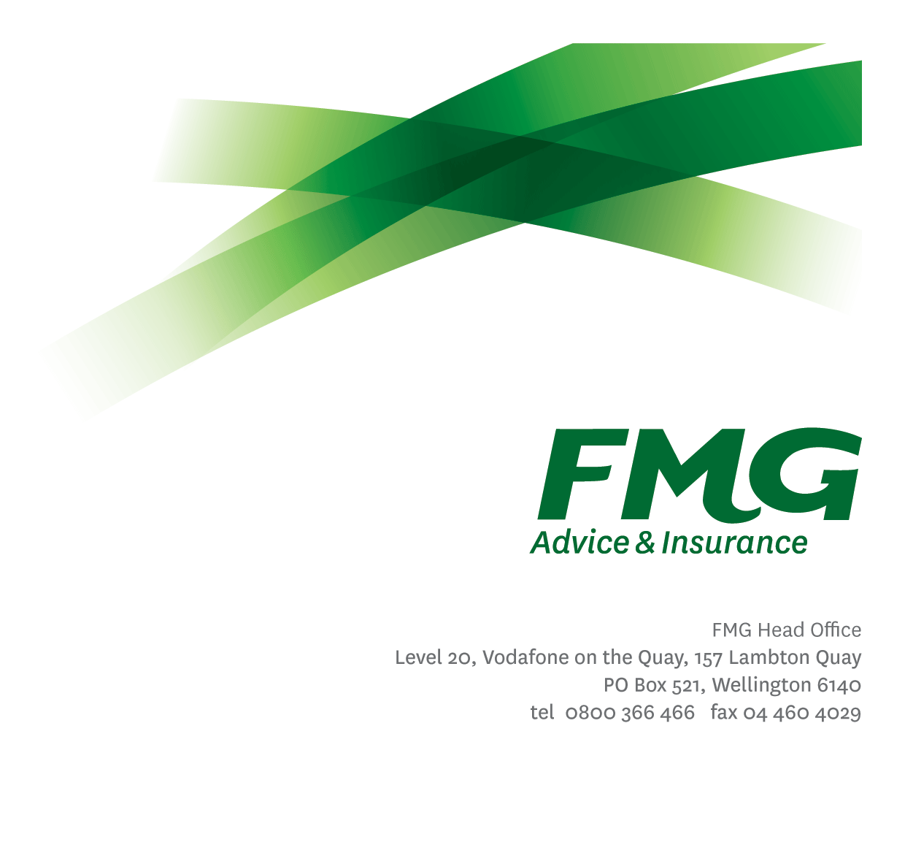Underwriting and Claims Coordinator

*Position Description*

*Location:* Palmerston North, Feilding, Various

*Reporting to:* Life & Health Centre Manager

*Business Unit:* Sales, Advice & Service

*Direct Reports:* 0

### *Date Last Reviewed:* January 2025

### *About FMG*

***Formed by farmers for farmers over a century ago, FMG is New Zealand’s leading rural insurer providing risk advice and insurance solutions for farmers, growers, commercial businesses, the lifestyle sector and domestic clients.***

***We’re proudly 100% New Zealand owned and operated, and our focus is on helping our clients to achieve their goals.  As a mutual organisation, we’re all about giving rural New Zealanders a better deal, and part of this involves reinvesting all profits back into the business to keep premiums low and ensure the future sustainability of the organisation.***

### *FMG’s Values*

The FMG brand represents promises about what customers can expect from us and each of us is responsible for delivering on these promises. Living our company values means we deliver the best brand experience for our customers. Our company values are:

|  |  |
| --- | --- |
| * Do what’s right - Whāia te ara tika | * Make it happen - Whakatutukitia |
| * We’re in it together - Ko tātau tātau | * Proud of who we are Whakahīhī i te whakapapa |

### *Work Environment*

We strive to provide an environment that promotes and fosters achievement. We place importance on career development and training to give our people the tools they need to succeed. Fostering a culture of Wellbeing and Safety is also a critical element.

FMG’s Head Office is located in Wellington and accommodates FMG’s Leadership Team, Marketing & Risk Services, Human Resources, Client Propositions, Financial Management, Underwriting and Risk Quality, Reinsurance, Business Information and Analysis, and Legal and Compliance.

FMG’s largest regional office is located in Palmerston North accommodating our National Service Centre, Insurance Consultants, Information Technology, Claims, Operations and Payment functions. Approximately 300 employees are located there. FMG’s largest office in the South Island is Christchurch. In addition to the offices in Wellington, Palmerston North and Christchurch – FMG has smaller offices in 30 regional locations throughout New Zealand.

### *Purpose of the role*

To provide efficient, high quality, proactive underwriting and claims administration support to the Life & Health Team. This role also supports the L&H communication, ensuring excellent customer service to FMG clients is being delivered.

### *Key Responsibilities*

| Area | Responsibilities |
| --- | --- |
| Underwriting pipeline management | Provide confidential, effective and efficient service Life & Health clients and advisers and wider business (where required) including but not limited to the following –   * Pipeline management through calling / contacting clients and following up on underwriting requirements. * Working collaboratively with L&H advisers - including following up any adviser-required underwriting actions. * Contacting medical providers/specialists directly to obtain required client files/notes for underwriting purposes. * Meeting regularly with provider underwriters to manage the pipeline across both organisations (including providing feedback to providers on consistency of underwriting requirements for clients). * Providing any relevant feedback to leadership regarding underwriting practices at FMG and providers. |
| Claims collation management | * Working collaboratively with advisers and/or with clients directly to fill in required claims documents/forms. * Liaising with providers to ensure claims are progressed in a timely manner. * Updating channel leadership and L&H advisers regularly on the status of client claims. * Working collaboratively with advisers to provide timely information to clients regarding the status of their claim. |
| Team Membership | * Participate fully as a member FMG and the wider L&H channel team through the effective and efficient performing of other duties as may be required from time to time. |
| Relationship Management | * Establishes and maintains professional relationships with internal and external stakeholders. * Works collaboratively with providers and establishes sound working relationships with both underwriting and claims teams. |
| Risk and Quality | * Ensure overall compliance with legislation regulations and FMG policies through the use of established systems and adherence to approved FMG processes. * Provides feedback on adherence to procedure to channel leadership in the event an adviser has not followed the correct FMG underwriting processes. |
| Wellbeing & Safety | * Complies with safety and wellbeing policy and procedures, including accident and incident reporting and hazard management requirements * Works in a safe manner at all times and does not undertake activities without appropriate training |
| FMG Values | * To promote the “FMG Way” through displaying the values of FMG which are do what’s right, make it happen, we’re in it together and proud of who we are |

|  |  |
| --- | --- |
| **COMPETENCIES** | |
| *\*see competency framework for behaviours expected at each level* | *Expected Level* |
| **Customer Driven (Internal & External)**  A commitment to understanding the needs and best interests of both internal and external customers, in order to provide them with outstanding customer service and help them to make informed decisions. | Competent* |
| **Accountability**  Taking personal ownership of decisions, behaviour, and development, and being responsible for how these actions impact on the wider organisation and customers. | Intermediate* |
| **Adaptability**  Demonstrating a willingness to engage in a changing environment and being flexible and comfortable working with change. | Intermediate* |
| **Motivation and Drive**  The determination to achieve goals and strive for excellence. | Competent* |
| **Relationship Building**  Developing and maintaining positive, professional relationships that are built on mutual trust and respect. | Competent* |
| **Team Work**  Making a positive contribution to the FMG team and collaborating effectively with others to achieve objectives. | Intermediate* |

|  |  |
| --- | --- |
| **KNOWLEDGE** | |
| **Systems Knowledge** | Knowledge of the following systems is required:  ClaimCenter, ContactManager |
| **Legal Knowledge** | Has legal knowledge e.g. indemnity, liability, the Privacy Act etc. |
| **Business Awareness** | Understands the internal workings of FMG and how business works; understands FMG's position in the advice and insurance market and knows the competition. |
| **Administrative Knowledge** | Knowledge of basic administration activities and processes. |
| **Other Knowledge** | Knowledge of Office Administrator role as a backup. |

|  |  |
| --- | --- |
| **SKILLS** | |
| **Qualification** | Not required. |
| **Experience** | A minimum of one years of experience in an office environment. |
| **Written Communication Skills** | Spell words correctly and use grammar appropriately in everyday written communication e.g. emails. |
| **Verbal Communications Skills** | Effectively presents information to others, both informally and in meetings. |
| **Listening Skills** | Gives others full attention when listening i.e. stops what they are doing. |
| **Financial Skills** | Has a basic understanding of maths e.g. can use a calculator for addition and subtraction. |
| **Technology Skills** | Able to use technology for everyday work e.g. PC (word processing, saving documents etc.) |
| **Risk Assessment Skills** | Can identify risks and escalate awareness. |
| **Problem Solving** | Uses initiative to gather, analyse and evaluate options and develop innovative working solutions.  Uses a common sense approach to make sound, well-informed decisions which are mutually agreeable. |

### *Relationship*

|  |  |  |
| --- | --- | --- |
| External | Internal | Committees/Groups |
| * Vendors * Other insurance providers | * L&H team * Claims team * Underwriting team * SAS teams * Other FMG Employees | * As required |

### *Financial Authority Levels*

* No authority to commit or approve expenditure

### *Human Resources Authority Levels*

* Not applicable

### *Agreement*

I agree to the outline of the role as contained in this document and recognise that the contents may need to be amended from time to time to reflect changing business requirements.

I as job holder, allow my Manager to gather information from third parties where necessary for the purposes of performance management.

*Name: ____________________________*

*Signature: _________________________*

*Date: _____________________________*