Job description
Title | Mechanical Supervisor
Location | Tasman Mill
Start Date
Reports To | Site Manager
Reviewed By | Don Grainger | Date: | January 2026
Last Updated By | People & Culture | Date: | January 2026
Purpose:
To supervise machinery maintenance (Routine and Corrective), machinery condition monitoring and reporting, to best practice standards. To improve overall equipment efficiency and ensure machinery maintenance activities are carried out to directed specifications and standards. Improve asset data quality (SAP) and PM and SOP document improvement recommendations
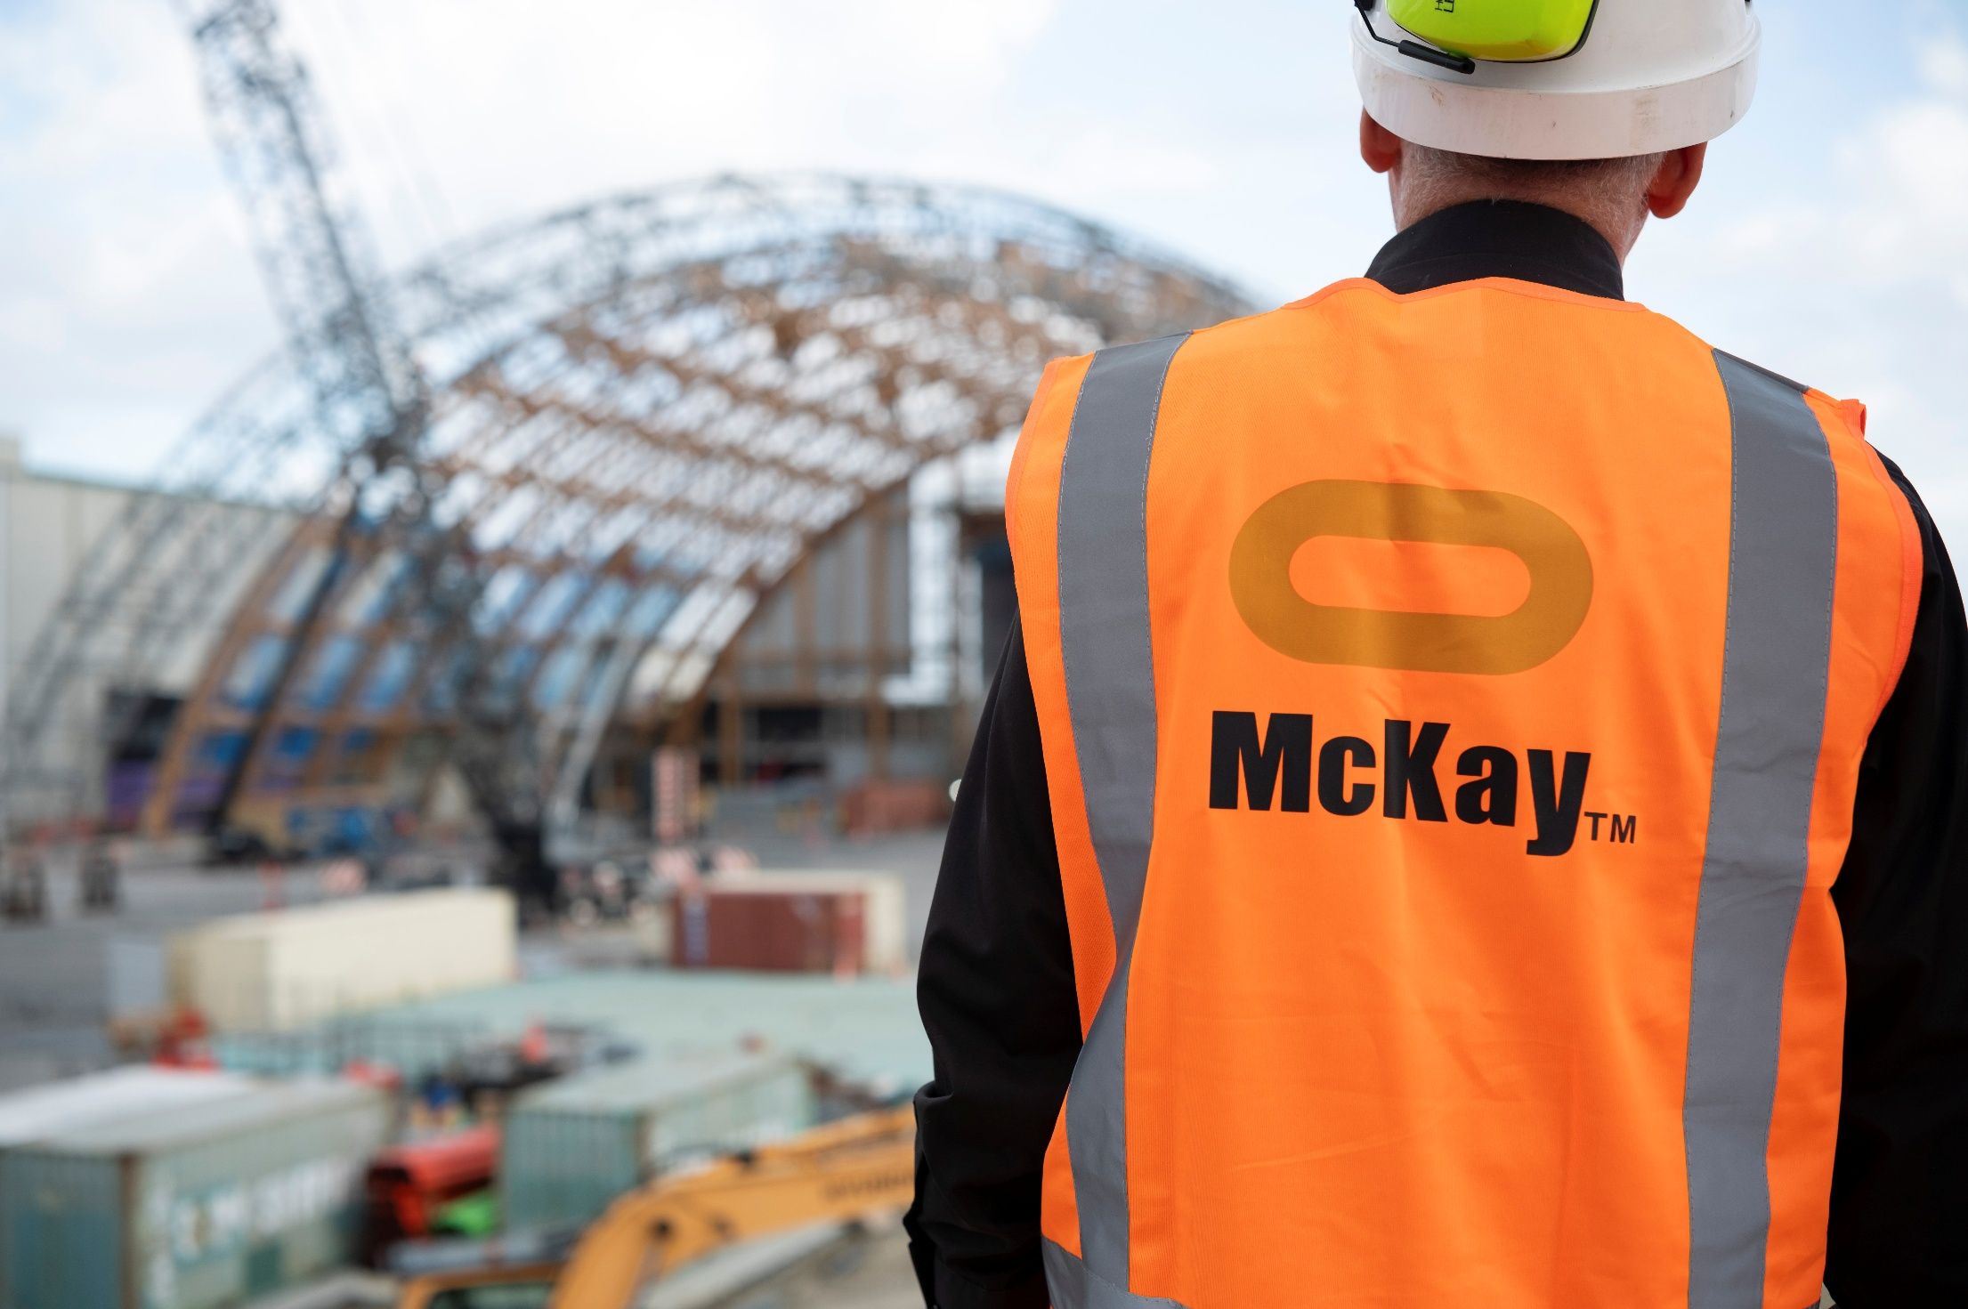

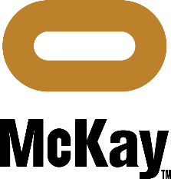

Role Summary
McKay is proud to stand as Aotearoa, New Zealand’s largest privately owned electrotechnology provider, offering innovative engineering and construction services nationwide
Having started providing electrotechnology services in 1936, McKay is a historic New Zealand company with a depth of experience in providing end to end electrical solutions for a wide range of industries and sectors. McKay is the parent brand and has acquired and started a range of companies under the McKay Group name to serve a broad range of industrial site maintenance needs.
As part of our engagement with our key customer OJI Fibre Solutions at the Kinleith and Tasman mills we offer a full range of maintenance services both electrical and mechanical as one combined and coordinated team.
As a Mechanical Technician Maintenance (Shift Worker) at McKay Ltd., you are a skilled professional who is responsible for: -
- Day to day machinery maintenance and condition monitoring, reporting and analysis
- Update SAP/ CMMS data, online data and records.
- Provide job status reporting
- Revise and markup hard copy information systems. I.E Drawings, Data sheets, Bills of material, installation drawings E.T.C.
- Participate in equipment maintenance practice review.
- Preparation and completion of equipment work plans and packs.
- Oversee machinery maintenance
- Review and improvement recommendation to equipment spares and asset data.

Responsibilities
Technical Knowledge
- High level understanding of machinery maintenance best practice.
- Understand equipment lubrication and condition monitoring requirements
- Metal component machining to the specifications required by the OEM or other directive.
- Understand technical drawing and specification data
- Ensure mechanical equipment maintenance is carried out to required regulations, industry best practice, OEM specifications and Customer practice.
- (OEM Original Equipment manufacturer)

Communication & Customer Service
- Able to communicate confidently to one level up within the organisation.
- Written and digital communication skills, including ability to compile reports and other correspondence. Complete forms and communicate through digital platforms.
- Be cordial and cooperative with customer representatives.
- Deliver services (the Job, or Job lot) in the time allowance agreed.
- Notify of any emerging risk to agreed deliverables.
- Maintain cohesive relationships with all appropriate customer stake holders.
- Embrace the concept of overall plant reliability. “It is my job’ ‘’I can make a difference’’
Safety Compliance
- Engage with our health and safety process, be a proactive H&S leader.
- Not knowingly breach any Act, Regulation or code of practice or allow others to do so.
- Adhere to all applicable health and safety systems, procedures and requirements
- Ensure operational procedures are adopted and practiced
- Actively participate in regular pre-start, toolbox, health and safety and safety committee meetings as required
- Participate in any incident investigation as required
Upgrades and Improvements
- Technicians may be involved in upgrading or modifying existing systems to improve efficiency, energy savings, or compliance with new regulations.
Collaboration
- Provide effective leadership to the assigned maintenance team
- Participate as a positive member of the maintenance team and in the wider McKay.
- Actively participate in designated maintenance teams and provide a positive contribution as required
Documentation
- Maintain accurate records of all mechanical work performed, including detailed notes, diagrams, and inspection reports.
Upkeep of Tools and Equipment
- Maintain and care for tools and equipment, ensuring they are in good working condition and safe to use.

Continuous Learning
- Participate in training as required
- Take a proactive approach to ensuring all required competencies are current
- Achieve required training outcomes
- Provide mentoring to other staff
- Assist in the growth of maintenance techniques and knowledge within the team

Qualifications & Knowledge
- NZ Cert Mechanical Engineering Trade / Level 4, Maintenance Engineering or, Fitting and Machining strand. Or equivalent.
OR
- Apprenticed in Mechanical or Allied trade, unqualified. Extensive Relevant Industry and machinery experience, or equivalent.
- 5 years’ experience in industrial manufacturing environments preferred.
- Ability to diagnose mechanical equipment faults and analyse equipment failure.
- Familiarity and understanding of digital alignment tools, diagnostic and configuration devices and systems is desirable.
- Perform alignment including complex alignment on rotating equipment, in a range of equipment configurations.
- Strong English language and numeracy
- Office software, Word, Excel preferred.
- Have the ability to operate smart devices and data collection systems or be prepared to upskill with them.

Role Profile
As a Mechanical Technician Maintenance at McKay Ltd., you must hold the following capabilities:-
- Understands mechanical maintenance best practice and can interpret technical drawings and machine components accurately.
- Confidently provides clear updates and technical information to supervisors or managers.
- Produces accurate maintenance documentation, reports, and digital records.
- Identifies customer needs and engages professionally to clarify technical issues and support operational outcomes.
- Builds strong, respectful working relationships with colleagues, contractors, and customers.
- Takes ownership of assigned tasks and consistently delivers safe, high-quality work on time.
- Maintains high accuracy in maintenance tasks and contributes to quality and root-cause investigations.
- Supports apprentices and trainees with coaching and shares knowledge to build team capability.

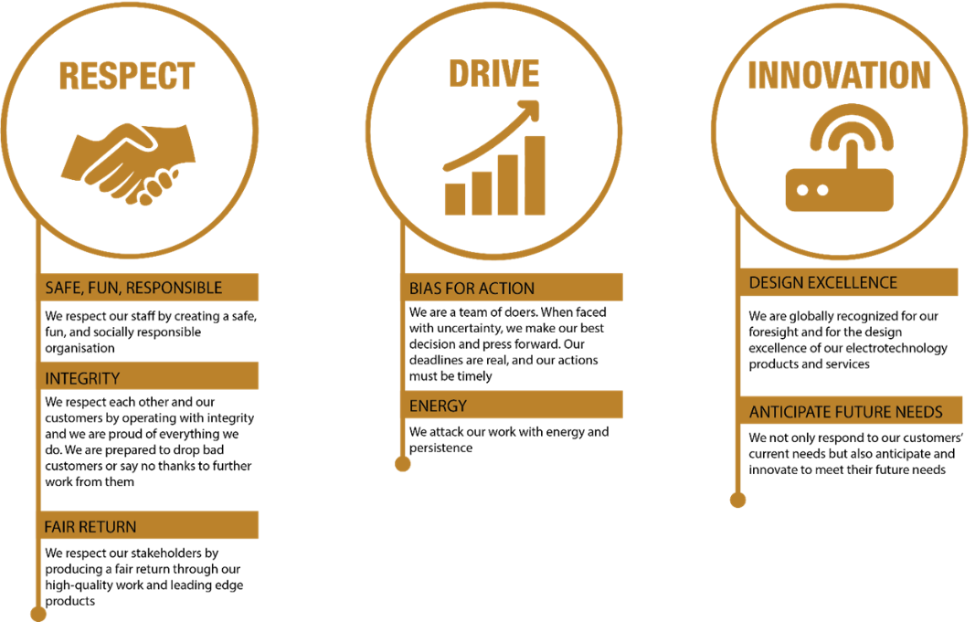
McKay Guiding Values

