JOB TITLE: | Supervisor (Electrical Projects)
Location: |  |  | Date:
Reports to:
Purpose: | To oversee and coordinate the electrical activities within the company’s electrical projects division.
ROLE SUMMARY:
Having started providing electrotechnology services in 1936, McKay is a historic New Zealand electrical company with a depth of experience in providing end to end electrical solutions for a wide range of industries and sectors. McKay is the parent brand and has acquired and started a range of companies under the McKay Group name in order to serve all electrical needs.
As a Supervisor (Electrical Projects) at McKay Electrical Ltd., you will play a crucial role in overseeing and coordinating the electrical activities with the company’s electrical projects division. This role involves supervising a team of electricians, ensuring that electrical systems and equipment are installed, maintained, and repaired efficiently and in compliance with safety and regulatory standards.

RESPONSIBILITIES:

- Supervision and Leadership:
  - Lead and manage a team of electricians, providing guidance, direction, and support.
  - Assign tasks, set priorities, and ensure that team members adhere to schedules and deadlines.
  - Conduct regular team meetings to communicate goals, expectations, and updates.
- Project Planning and Coordination:
  - Collaborate with project managers to plan and coordinate electrical work in line with project timelines.
  - Review project specifications and blueprints to determine electrical requirements.
  - Develop work schedules and allocate resources effectively.
- Installation and Maintenance:
  - Oversee the installation, maintenance, and repair of electrical systems, equipment, and components.
  - Ensure that work is carried out in compliance with relevant codes, regulations, and safety standards.
  - Troubleshoot electrical issues and provide technical expertise to resolve problems.
- Quality Assurance:
  - Conduct regular inspections to ensure the quality of electrical workmanship.
  - Implement and enforce quality control measures to meet industry standards.
  - Address and rectify any deviations from established standards.
- Budget Management:
  - Assist in the development of electrical project budgets.
  - Monitor expenses, control costs, and ensure that projects are completed within budgetary constraints.
- Training and Development:
  - Identify training needs for team members and coordinate relevant training programs.
  - Foster a culture of continuous learning and skill development within the electrical team.
- Documentation and Reporting:
  - Maintain accurate records of electrical work, including project documentation and reports.
  - Provide regular progress reports to management and stakeholders.
- Safety Compliance:
  - Enforce and promote a strong safety culture among the electrical team.
  - Ensure that all electrical work is conducted in accordance with safety regulations and best practices.

QUALIFICATIONS & KNOWLEDGE:

- Bachelor’s degree in Electrical Engineering or a related field.
- Proven experience in electrical supervision.

ROLE PROFILE:

As a Supervisor (Electrical Projects) at McKay Electrical Ltd., you must hold the following capabilities;
- Knowledge of electrical codes, regulations, and industry best practices.
- Strong leadership and communication skills.
- Ability to read and interpret blueprints and technical drawings.
- Proficient in the use of relevant electrical tools and equipment.

McKay GUIDING VALUES:

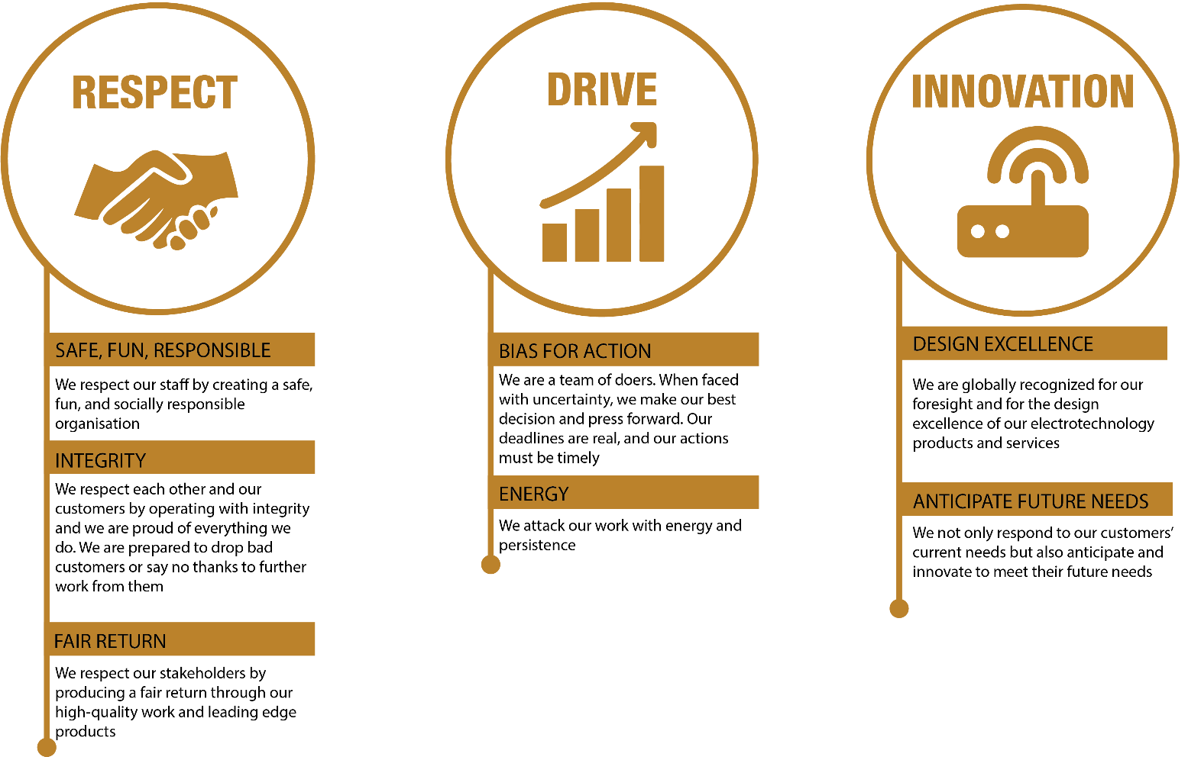

REVIEWED BY: |  |  | DATE:
Last updated by: | People and Culture |  | Date/Time: | Nov 23

