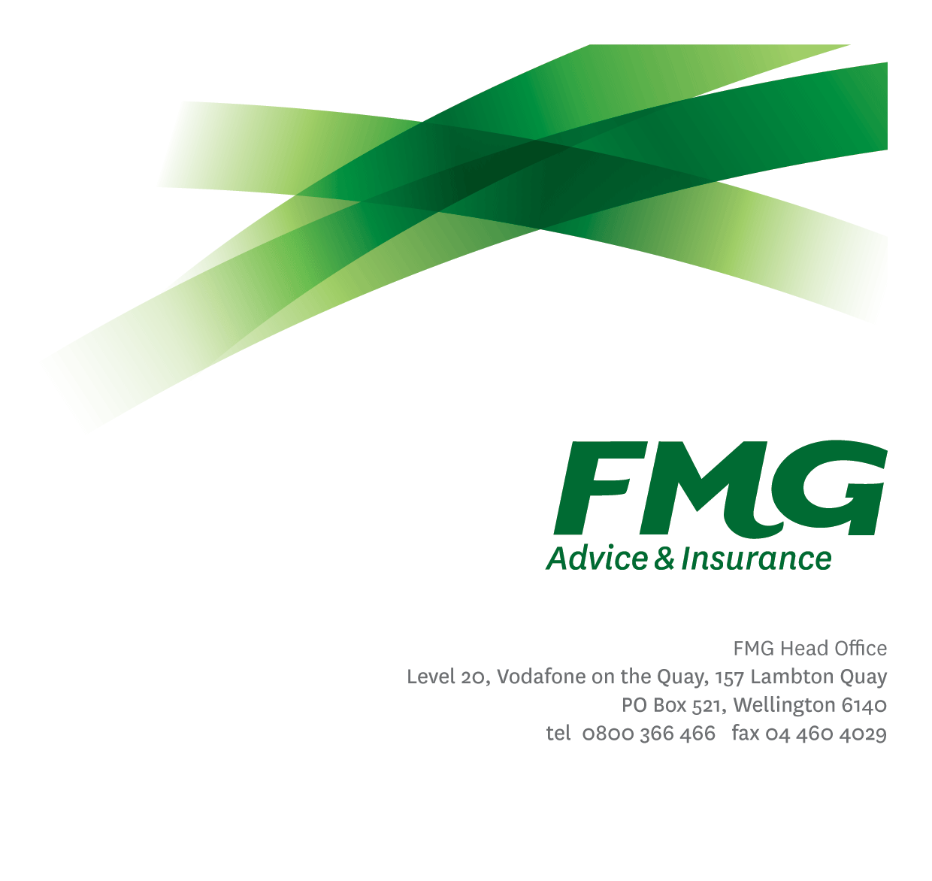
Programme Coordinator
Position Description

Location: Palmerston North or Wellington
Reporting to: Manager Projects and Improvement
Business Unit: Business Information Services
Direct Reports: Nil
Date Last Reviewed: July 2021

About FMG
Formed by farmers for farmers over a century ago, FMG is New Zealand’s leading rural insurer providing risk advice and insurance solutions for farmers, growers, commercial businesses, the lifestyle sector and domestic clients.
We’re proudly 100% New Zealand owned and operated and our focus is on helping our clients to achieve their goals. As a mutual organisation, we’re all about giving rural New Zealanders a better deal, and part of this involves reinvesting all profits back into the business to keep premiums low and ensure the future sustainability of the organisation.

FMG’s Values
The FMG brand represents promises about what customers can expect from us and each of us is responsible for delivering on these promises. Living our company values means we deliver the best brand experience for our customers. Our company values are:
- Do what’s right | - Make it happen
- We’re in it together | - Proud of who we are

Work Environment
We strive to provide an environment that promotes and fosters achievement. We place importance on career development and training to give our people the tools they need to succeed.
The Business Information Services team culture is based on open and honest communication, where authority and accountability are clear. Both challenges and opportunities are shared to bring about delivering the best solution FMG, whilst improving FMG’s core capabilities in information management practices.

Purpose of the role
To provide programme coordination for multiple projects to assist the Programme Management Office and Project Managers to effectively deliver the FMG change programme to achieve organisational business objectives.

Key Responsibilities

Area | Responsibilities
Programme Coordination (including Administration) | - Assist project managers to manage project plans and budgets to ensure projects are delivered on time and on budget.  - Assist with preparation of the monthly Programme Committee and/or Project Steering Group (PSG) reports; organize PSG meetings, distribute papers, record minutes and actions.  - In conjunction with project managers, monitor project schedules and progress against what is planned by utilizing relevant programme delivery management tools, and prepare required updates for the Programme Management Office.  - Assist with producing, coordinating and maintaining (including following up on actions) of project management deliverables such as initiation documentation, project schedule, RAID register and other key programme activities.  - Schedule and organize regular project team meetings; including regular iteration planning days and project ’show & tells’.  - Perform Project Manager duties on projects as and when required.
Financial Management | - Receive, validate and code vendor invoices and follow up any issues.  - Monitor actual spend against budget for projects in coordination with the Finance Business Partner, maintain project financial records including preparation of summary reporting for steering groups and/or committees.  - Regularly review financials with Programme Managers and/or Project Managers to ensure an up-to-date view and estimation of future projected costs against budget.  - Monitor and administer time recording and time reporting for projects.
Team Support | - Work with FMG’s Travel & Event coordinators to organise any project workshops or ‘whole team’ events to manage logistics for team members including travel, accommodation, and external venue hire, lunches etc.  - Organize minor team events from time to time as requested by Project Managers; this may include team fun events, coffee shouts etc.  - Monitor team member workloads identifying any stress points to be addressed in conjunction with project managers so as to take action and/or provide support where necessary.
Service Support | - Demonstrate a customer focused approach by ensuring work is completed on time and to a high standard. Given the nature of services provided by Business Information Services, this may require working outside of normal business hours or working additional hours particularly in respect to regular out-of-hours maintenance activity, operator activity and project work.  - Travel between the Palmerston North and Wellington offices will be required on a regular basis.
Health and Safety | - Complies with FMG safety and wellbeing policy and procedures, including accident and incident reporting and hazard management requirements.  - Works in a safe manner always and does not undertake activities without appropriate training.

COMPETENCIES
*see competency framework for behaviours expected at each level | Expected Level
Customer Driven (Internal & External)  A commitment to understanding the needs and best interests of both internal and external customers, in order to provide them with outstanding customer service and help them to make informed decisions. | Intermediate*
Accountability  Taking personal ownership of decisions, behaviour, and development, and being responsible for how these actions impact on the wider organisation and customers. | Intermediate*
Adaptability  Demonstrating a willingness to engage in a changing environment and being flexible and comfortable working with change. | Intermediate*
Motivation and Drive  The determination to achieve goals and strive for excellence. | Intermediate*
Relationship Building  Developing and maintaining positive, professional relationships that are built on mutual trust and respect. | Intermediate*
Team Work  Making a positive contribution to the FMG team and collaborating effectively with others to achieve objectives. | Intermediate*

KNOWLEDGE
Qualifications | Minimum of two years relevant experience.
Specialist Knowledge | Knowledge of project management methodologies.  Understanding of “agile” delivery methodology and practices.

SKILLS
Written Communication Skills | Able to write clear, concise and persuasive proposals and reports.
Verbal Communications Skills | Effectively presents information to others, both informally and in meetings.
Listening Skills | Demonstrates active listening skills through eye contact, paraphrasing, appropriate body language and checking understanding.
Technology Skills | High level of skill is needed in MS-Office, including Word, Excel, PowerPoint, and working knowledge of MS-Project is preferred but not critical.
Risk Assessment Skills | Can put in place plans to mitigate risks and manage issues.

Relationships
External | Internal | Committees/Groups
- Vendors | - Project Managers  - Programme Management Office  - Project Product Owners  - BIS Managers  - Other FMG Managers  - Project teams  - Change Managers | - Working Groups  - Project Steering Groups and Committees

Financial Authority Levels
- May approve project expenditure within budgetary limits.

Human Resources Authority Levels
- Not applicable

Agreement
I agree to the outline of the role as contained in this document and recognise that the contents may need to be amended from time to time to reflect changing business requirements.

I as Job holder, allow my Manager to gather information from third parties where necessary for the purposes of performance management.

Agreement will be via electronic signature as evidenced on the acceptance form.

