Cloud Engineer

*Position Description*

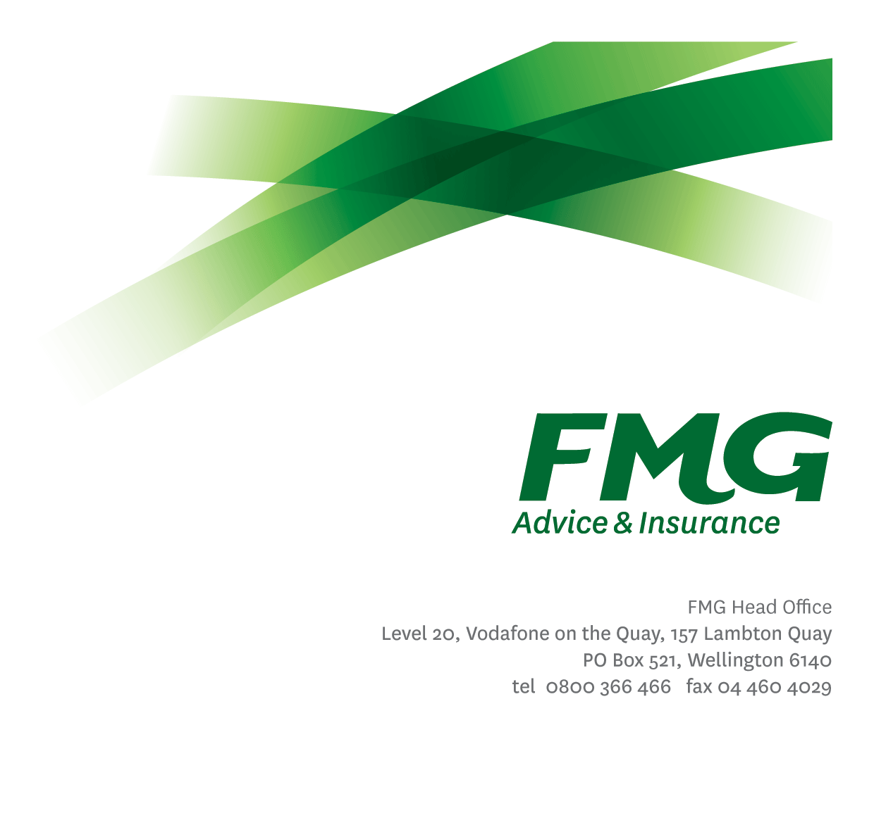

*Location:* Palmerston North



*Reporting to:* Cloud and Security Operations Manager

*Business Unit:* Business Information Services

*Direct Reports:* Nil

*Date Last Reviewed:* June 2024

### *About FMG*

***Formed by farmers for farmers over a century ago, FMG is New Zealand’s leading rural insurer providing risk advice and insurance solutions for farmers, growers, commercial businesses, the lifestyle sector and domestic clients.***

***We’re proudly 100% New Zealand owned and operated and our focus is on helping our clients to achieve their goals.  As a mutual organisation, we’re all about giving rural New Zealanders a better deal, and part of this involves reinvesting all profits back into the business to keep premiums low and ensure the future sustainability of the organisation.***

### *FMG’s Values*

The FMG brand represents promises about what customers can expect from us and each of us is responsible for delivering on these promises. Living our company values means we deliver the best brand experience for our customers. Our company values are:

|  |  |
| --- | --- |
| * Do what’s right | * Make it happen |
| * We’re in it together | * Proud of who we are |

### *Work Environment*

We strive to provide an environment that promotes and fosters achievement. We place importance on career development and training to give our people the tools they need to succeed.

The Business Information Services team culture is based on open and honest communication, where authority and accountability are clear. Both challenges and opportunities are shared to bring about delivering the best solution, whilst improving FMG’s core capabilities in information management practices.

### *Purpose of the role*

As a key member of the Operations and Security team, this Cloud specialized role will help design, deploy and manage our cloud infrastructure. This role ensures the security and efficiency of our services at all levels.

### *Key Responsibilities*

| Area | Responsibilities |
| --- | --- |
| FMG Company Values | * To promote the “FMG Way” through displaying the values of FMG which are: do what’s right; make it happen; we’re in it together; and proud of who we are. |
| Delivery Team Requirements | * Assist in sizing and planning of upcoming work. * Ensure work is completed within the agreed timeframes to the definition of done. * Collaborate with colleagues from other teams and disciplines when required. |
| Infrastructure Delivery | * Develop secure cloud-based solutions to meet business requirements. * Integrating solutions with other workloads, platforms or services * Monitor metrics and identify areas for improvement. * Build, maintain and enforce configuration standards in a secure manner. * Follow best practices and procedures while ensuring suitable documentation and code is created and maintained. * Demonstrate a security-first mindset when designing and building solutions. * Create and maintain resources using infrastructure as code. |
| Development | * Design and implement build, deployment, testing and configuration management * Develop implementation scripts and documentation with security considerations. * Deploy code across cloud environments while adhering to internal standards. * Provide technical guidance to team members and other delivery team members on Cloud development and operations. |
|  |  |
| Release Management | * Manage CICD tools for Azure with security controls. * Document and improve existing CICD process, emphasizing security practices. |
| Subject Matter Expert | * Expert opinion and knowledge shown in business or technical Subject Matter Expert areas * Opinion and specialist advice provided during evaluation of solutions. |
| Industry / Practice Awareness | * Stay informed about industry best practices, trends and strategies related to Azure, Security and other Cloud platforms. |
| Service Support | * Demonstrate a customer centered approach by ensuring work is completed on time and to a high standard. Given the nature of services provided by Business Information Services, this may require working outside of normal business hours or working additional hours particularly in respect to regular out-of-hours maintenance activity, operator activity and project work. |
|  |  |
| Wellbeing & Safety | * Complies with safety and wellbeing policy and procedures, including accident and incident reporting and hazard management requirements * Works in a safe manner at all times and does not undertake activities without appropriate training |

|  |  |
| --- | --- |
| **COMPETENCIES** | |
| *\*see competency framework for behaviours expected at each level* | *Expected Level* |
| **Customer Driven (Internal & External)**  A commitment to understanding the needs and best interests of both internal and external customers, in order to provide them with outstanding customer service and help them to make informed decisions. | Intermediate* |
| **Accountability**  Taking personal ownership of decisions, behaviour, and development, and being responsible for how these actions impact on the wider organisation and customers. | Intermediate* |
| **Adaptability**  Demonstrating a willingness to engage in a changing environment and being flexible and comfortable working with change. | Intermediate * |
| **Motivation and Drive**  The determination to achieve goals and strive for excellence. | Intermediate* |
| **Relationship Building**  Developing and maintaining positive, professional relationships that are built on mutual trust and respect. | Intermediate* |
| **Team Work**  Making a positive contribution to the FMG team and collaborating effectively with others to achieve objectives. | Intermediate* |
| **Critical Analysis**  The capability to identify key issues, trends, or important facts from information and to question and probe. | Intermediate* |
| **Problem Solving**  The ability to understand information from a variety of sources and think quickly on one’s feet. The ability to effectively combine verbal and numeric data into a coherent whole. | Advanced* |

|  |  |
| --- | --- |
| **KNOWLEDGE** | |
| **Qualifications** | Relevant Tertiary Qualification desirable |
| **Experience** | A minimum of three years of experience in supporting enterprise hardware and software solutions. |
| **System’s Knowledge** | Knowledge of FMG’s systems including SCCM, Cloud Services and cloud-based technologies.  Demonstrated Experience with MSSQL, CI/CD tools and scripting such as Python and PowerShell.  Knowledge of Identity Management, AD, OKTA, Azure AD, Federation and SSO, Security, Firewalls, Networking, IP and WAN  Knowledge and experience with Cloudflare, Github and Docker.  Knowledge of cloud concepts – IaaS, PaaS, SaaS  Knowledge of Infrastructure as code and related systems. |
| **Specialist Knowledge** | Knowledge of Continuous Integration practices, Container systems and AGILE development methodologies, Performance monitoring tools both Application and Infrastructure. |

|  |  |
| --- | --- |
| **SKILLS** | |
| **Written Communication Skills** | Able to write and maintain clear documentation and reports when required. |
| **Verbal Communications Skills** | Effectively presents information to others, both informally and in meetings. |
| **Technology Skills** | Proficient in Cloud infrastructure, networking and security with broad IT systems knowledge. |
| **Listening** | Demonstrates active listening skills through eye contact, paraphrasing, appropriate body language and checking understanding. |
| **Risk Assessment Skills** | Identifies, understands and mitigates the risks that may impact on FMG's strategy, initiatives and reputation. |

### *Relationship*

|  |  |  |
| --- | --- | --- |
| External | Internal | Committees/Groups |
| * Applications and BIS Partners * Software / Database Providers | * Business Information Services Team * Other FMG employees * Delivery Team Members |  |

### *Financial Authority Levels*

* No authority to approve or commit expenditure.

### *Human Resources Authority Levels*

* + Not applicable

### *Agreement*

I agree to the outline of the role as contained in this document and recognise that the contents may need to be amended from time to time to reflect changing business requirements.

I as Job holder, allow my Manager to gather information from third parties where necessary for the purposes of performance management.

Name:

Signature:

Date: