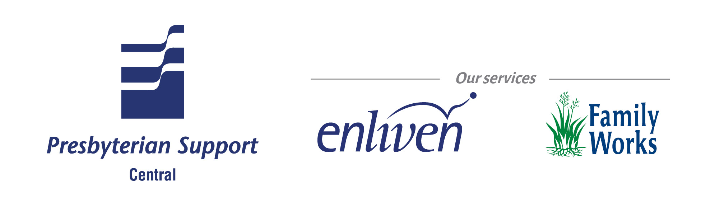

Position Description

Role Specification
Role Title: | Kitchen Hand
Business Unit: | Enliven Residential | Location: | Enliven Home
Collective:

Reports to: (role title) | Home Manager / Senior Cook
Direct reports (role titles) | NIL

Purpose of the role (What the role does; how the role contributes to the organisation goals)
To support the Home Manager in achieving a stimulating and enjoyable living environment, by assisting the cook to provide tasty nutritious meals, which meet the physical, social and cultural needs of the residents.

Key Accountabilities (Key activities, tasks and outcomes to be achieved)
Food Preparation
- Demonstrates the ability to assist preparing food under the direction of the senior cook, as per menu.
- Assist the cook preparing morning and afternoon tea.

Food service
- Residents Independence is supported within Eden philosophy.
- Meals are served at the appropriate size and temperature, meeting resident’s special needs, and are to look attractive.
- Modified/Pureed meals are to be served attractively, using a portion scoop, as any other meal e.g. meats, potato, vegetables.
- Desserts to be served separately
- Proper dining room etiquette is followed at all times
- Ensure tables are served one at a time once all residents are seated and cleared when all residents have finished.
Cleaning
- Carry out daily/weekly/monthly cleaning duties under direction of the senior cook.
- Reports in complaint to the senior cook, or home manager.
- Maintains the kitchen and dining rooms facilities under the cooks supervision and guidance
- Advises senior cook if residents appetite appears to have changed
- Offers resident another helping food.

Safe Food handling
- Maintaining hygiene Standards under supervision of senior cook.
- Potential or existing risks are identified and senior cook is notified.

Core competencies
Competent performance in the role requires demonstration of the following competencies. These competencies provide a framework for selection and development.
Competency
- Teamwork
  - Develops constructive working relationship with other team members
  - Has a friendly manner and positive sense of humour
  - Works cooperatively.
  - Is polite to staff and residents.
- Quality and Innovation
  - Provides quality service to our residents and families
  - Looks for ways to improve work process – suggests new ideas and approaches.
  - Explores and trials ideas and suggestions for improvement made by others
  - Shows commitment to continuous learning and performance development.
- Taking Responsibility
  - Plans and organises work in a time effective manner
  - Is reliable.
  - Performs tasks correctly
- Communication
  - Practises active and attentive listening.
  - Willingly answers questions and concerns raised by others
  - Responds in a non defensive way when asked about errors or oversights, or when own position is challenged
- Functional/technical skills
- Has the functional and technical knowledge and skill to do the job at a high level of accomplishment.

Person Specification
Key job requirements
Qualifications
Current driver’s license.
Current first aid certificate preferred
Delegations
Experience
- Experience working in a kitchen.
- Demonstrate a high standard of personal hygiene and appearance.

Treaty of Waitangi
Enliven, Presbyterian Support Central is committed to working in a multi-cultural way and affirms the place of Maori as Tangata Whenua and seeks to actively promote the spirit of equality and partnership inherent in the Treaty of Waitangi.

The role description will be reviewed regularly in order for it to continue to reflect the changing needs of the organisation. Any changes will be discussed with the position holder before being made. Annual objectives and performance measures will be set each year during the annual performance planning and development meeting.

I have read this job description and accept it.

Signed: ……………………………………… Date: ………………..

Employee’s Name: ………………………………………

Prepared by:  (Name and position) | Matthew Gutschlag  HR Director | Date:
Approved by:  (Name and position) | Nicola Turner  GM – Enliven Residual | Date:

