|  |  |  |  |  |
| --- | --- | --- | --- | --- |
|  | | | | |
| **JOB TITLE:** | Project Manager | | | |
|  |  |  |  |  |
| Location: |  |  | Date: |  |
|  |  |  |  |  |
| Reports to: | Branch Manager Senior Engineer (dotted line) | | | |
|  |  |  |  |  |
| Purpose: | Execution and delivery of company projects to meet specified scope, schedule, budget, and quality requirements. | | | |
|  |  |  |  |  |
| **ROLE SUMMARY:** | | | | |
| Having started providing electrotechnology services in 1936, McKay is a historic New Zealand electrical company with a depth of experience in providing end to end electrical solutions for a wide range of industries and sectors. McKay is the parent brand and has acquired and started a range of companies under the McKay Group name in order to serve all electrical needs.  The overall objective for this Project Management role at McKay Electrical Ltd., is to oversee and manage the execution of various projects within McKay Electricals’ scope of work. You will play a critical role in defining project objectives, ensuring efficient resource allocation and driving project teams to achieve milestones on time and within budget. As a Project Manager, you will also be critical to the planning, execution and closing of projects, whilst maintaining a high level of client satisfaction and project quality. | | | | |

|  |
| --- |
| RESPONSIBILITIES: |

1. **Project Planning**

* Define project scope, objectives, and deliverables in collaboration with stakeholders.
* Develop comprehensive project designs (CAD) and plans, including timelines, resource allocation, budgets and detailed BOM’s.
* Identify and manage project risks and develop mitigation strategies.
* Supplier selection.

1. **Team Leadership**

* Build, lead, and motivate cross-functional project teams.
* Clearly communicate project expectations and responsibilities to team members.
* Foster a collaborative and positive team environment.

1. **Project Execution**

* Monitor project progress and ensure adherence to the project plan and specified KPI’s.
* Track project expenses and resources to stay within budget.
* Resolve any project issues or conflicts that arise promptly.

1. **Stakeholder Communication:**

* Regularly communicate project status, updates, and milestones to stakeholders.
* Address stakeholder concerns and provide solutions to meet their expectations.

1. **Quality Assurance**

* Maintain a strong focus on project quality and ensure that deliverables meet or exceed established standards.
* Implement quality control processes and conduct thorough project reviews.

1. **Documentation and Reporting**

* Maintain accurate and up-to-date project documentation, including project schedules, status reports, and meeting minutes.
* Prepare and present project reports to senior management and clients.

1. **Continuous Improvement**

* Identify opportunities for process improvements and efficiency gains.
* Implement best practices and lessons learned from past projects.

|  |
| --- |
| QUALIFICATIONS & KNOWLEDGE: |

* A Degree or Diploma in this or a relative field.

|  |
| --- |
| ROLE PROFILE: |

As a Project Manager at McKay Electrical Ltd., you must hold the following capabilities;

* A fundamental understanding of project management discipline and methods.
* Effective communication skills both written and verbal at all levels.
* A strong aptitude for problem-solving.
* Excellent interpersonal skills and relationship management capabilities.
* Health and safety adherence and advocacy.
* Collaborative and empowering leadership style.
* High level of EQ – ability to read situations and act accordingly.

|  |
| --- |
| McKay GUIDING VALUES: |

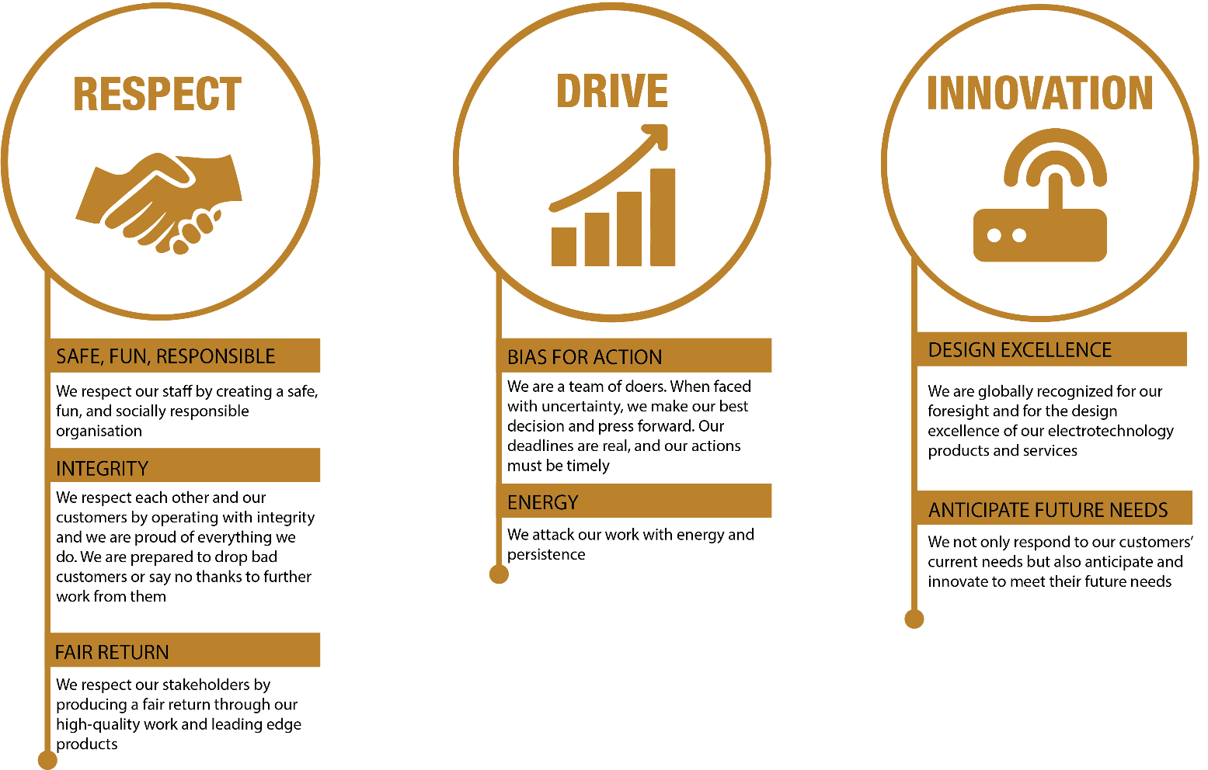

|  |  |  |  |  |
| --- | --- | --- | --- | --- |
| **REVIEWED BY:** |  |  | **DATE:** |  |
|  |  |  |  |  |
| **Last updated by:** | People and Culture |  | **Date/Time:** | Nov 23 |