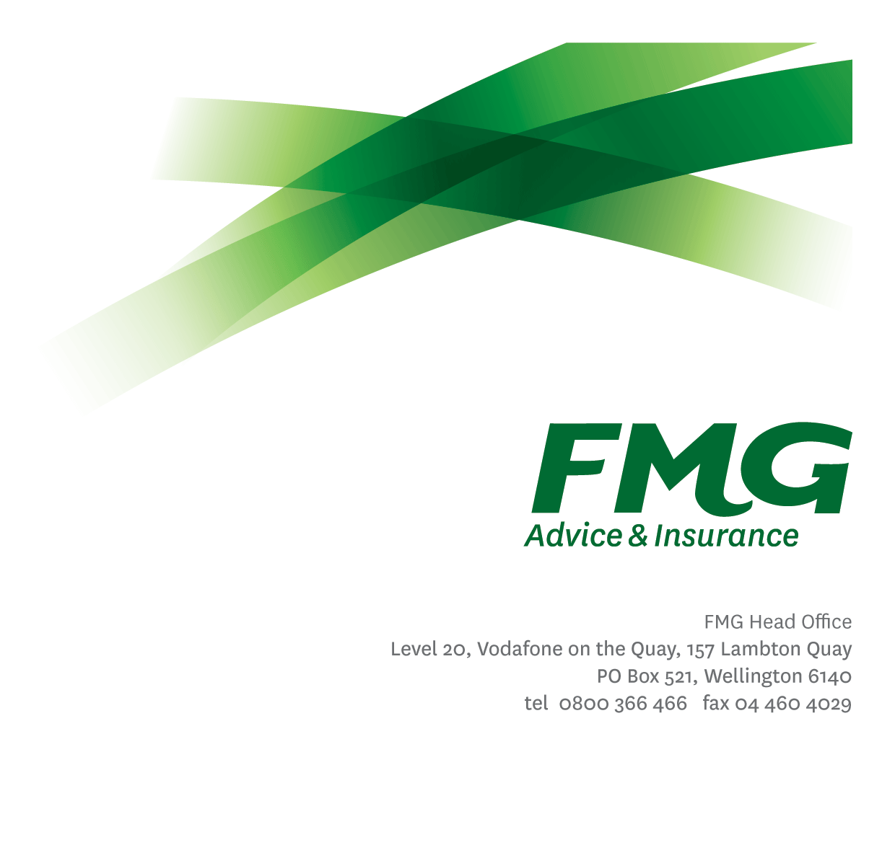Senior Business Optimisation Analyst

*Position Description*

*Location:* Wellington or Palmerston North

*Reporting to:* Head of Business Optimisation

*Business Unit:* Marketing and Propositions

*Direct Reports:* Nil

*Date Last Reviewed:* January 2025

### *About FMG*

***Formed by farmers for farmers over a century ago, FMG is New Zealand’s leading rural insurer providing risk advice and insurance solutions for farmers, growers, commercial businesses, the lifestyle sector and residential clients.***

***We’re proudly 100% New Zealand owned and operated and our focus is on helping our clients to achieve their goals.  As a mutual organisation, we’re all about giving rural New Zealanders a better deal, and part of this involves reinvesting all profits back into the business to keep premiums low and ensure the future sustainability of the organisation.***

### *FMG’s Values*

The FMG brand represents promises about what customers can expect from us and each of us is responsible for delivering on these promises. Living our company values means we deliver the best brand experience for our clients. Our company values are:

|  |  |
| --- | --- |
| * Do what’s right - Whāia te ara tika | * Make it happen - Whakatutukitia |
| * We’re in it together - Ko tātau tātau | * Proud of who we are Whakahīhī i te whakapapa |

### *Work Environment*

We strive to provide an environment that promotes and fosters achievement. We place importance on career development and training to give our people the tools they need to succeed. Fostering a culture of Wellbeing and Safety is also a critical element.

FMG’s Head Office is located in Wellington and accommodates FMG’s Leadership Team, Marketing & Propositions, People and Culture, Financial Management, Underwriting and Risk Quality, Reinsurance, Business Information and Analysis, and Legal and Compliance.

FMG’s largest regional office is located in Palmerston North accommodating our National Service Centre, Insurance Consultants, Information Technology, Claims, Operations and Payment functions. Approximately 300 employees are located there. FMG’s largest office in the South Island is Christchurch. In addition to the offices in Wellington, Palmerston North and Christchurch – FMG has smaller offices in 30 regional locations throughout New Zealand.

### *Purpose of the role*

The Senior Business Optimisation Analyst will bring strong business analysis and stakeholder management skills with a future focus and the ability to challenge the status quo. This role will support the Business Optimisation function, including Programme Shepherd; a multi-year, strategic programme of work focussed on delivering organisational improvements and driving an organisational culture change of bringing an owners’ mindset to ensure the financial resilience and sustainability of the mutual.

### *Key Responsibilities*

| Area | Responsibilities |
| --- | --- |
| Opportunity analysis and assessment | * Identify and evaluate opportunities to assist with prioritisation * Develop business cases, epic value statements, and recommendations as required * Coordinate business optimisation activities for specific initiatives * Work with key stakeholders to define, measure, manage, and report initiative benefits |
| Stakeholder Engagement and Management | * Build and maintain strong relationships with key stakeholders to ensure the successful delivery of business optimisation initiatives * Collaborate with senior leaders and key stakeholders to understand their needs and challenges * Effectively communicate opportunities to ensure alignment and active participation across the business * Champion and practise strong collaboration by fostering a culture of teamwork and open communication, ensuring cohesion and engagement across all stakeholders to drive successful business optimization initiatives |
| Data Analysis and Business Process Analysis | * Conduct data analysis and business process analysis to identify inefficiencies and areas for improvement * Challenge assumptions and the status quo to drive transformational change |
| Benefit identification, measurement, and tracking | * Assist with benefit identification, measurement, tracking, and ensuring the benefits are realised * Work with key stakeholders to assist with benefit management as required |
| Reporting | * Prepare and maintain initiative tracking and reporting * Assist with the preparation of monthly reports as required |
| FMG Values | * To promote the “FMG Way” through displaying the values of FMG which are do what’s right, make it happen, we’re in it together and proud of who we are |
| Health and Safety | * Complies with safety and wellbeing policy and procedures, including accident and incident reporting and hazard management requirements * Works in a safe manner at all times and does not undertake activities without appropriate training |
| Other Duties | * Complete tasks in agreed timeframe and provision of appropriate progress reports to the satisfaction of the Programme Manager and/or the General Manager Business Information Systems. |

|  |  |
| --- | --- |
| **COMPETENCIES** | |
| *\*see competency framework for behaviours expected at each level* | *Expected Level* |
| **Customer Driven (Internal & External)**  A commitment to understanding the needs and best interests of both internal and external customers, in order to provide them with outstanding customer service and help them to make informed decisions. | Advanced* |
| **Accountability**  Taking personal ownership of decisions, behaviour, and development, and being responsible for how these actions impact on the wider organisation and customers. | Advanced* |
| **Adaptability**  Demonstrating a willingness to engage in a changing environment and being flexible and comfortable working with change. | Intermediate* |
| **Motivation and Drive**  The determination to achieve goals and strive for excellence. | Intermediate* |
| **Relationship Building**  Developing and maintaining positive, professional relationships that are built on mutual trust and respect. | Intermediate* |
| **Team Work**  Making a positive contribution to the FMG team and collaborating effectively with others to achieve objectives. | Advanced* |
| **Critical Analysis**  The capability to identify key issues, trends, or important facts from information and to question and probe. | Advanced* |

|  |  |
| --- | --- |
| **KNOWLEDGE** | |
| **Qualifications** | A tertiary or industry qualification is desirable. |
| **Business Awareness** | The ideal candidate will possess a strong understanding of financial services organizations, with a preference for experience in the insurance sector. They should demonstrate the ability to quickly develop a comprehensive understanding of how FMG operates. |
| **Specialist Knowledge** | Understands business analysis best practices and understand the processes for planning and monitoring, defining business need, assessing capability gaps and determine appropriate solution approaches, requirements elicitation and analysis, requirements management and communication and solution assessment and validation. |

|  |  |
| --- | --- |
| **SKILLS** | |
| **Written Communication Skills** | Able to write clear, concise and persuasive proposals and reports. |
| **Verbal Communications Skills** | Communicates clearly in order to present information to persuade and influence others. |
| **Listening Skills** | Demonstrates active listening skills through eye contact, paraphrasing, appropriate body language and checking understanding. |
| **Risk Assessment Skills** | Identifies, understands and mitigates the risks that may impact on FMG's strategy, initiatives and reputation. |
| **Collaboration and Stakeholder Management** | Strong direction and stakeholder management skills |
| **Business analysis** | Proven experience in business analysis and business process analysis |
| **Benefit Management** | Experience and benefit identification, measurement, and tracking |
| **Transformational Focus** | Transformational focus with the ability to articulate opportunities effectively and to challenge assumptions in the status quo |

### *Relationship*

|  |  |  |
| --- | --- | --- |
| External | Internal | Committees/Groups |
| * External vendors & consultants | * Programme Shepherd Team and Business Unit Leads * Strategic and Mutual Leaders * Subject Matter Experts * Finance Team * Operational Excellence Team | * Enterprise Portfolio Management Committee |

### *Financial Authority Levels*

* None

### *Human Resources Authority Levels*

* None

### *Agreement*

I agree to the outline of the role as contained in this document and recognise that the contents may need to be amended from time to time to reflect changing business requirements.

I as Job holder, allow my Manager to gather information from third parties where necessary for the purposes of performance management.

*Agreement will be via electronic signature as evidenced on the acceptance form.*