Job description
Title | Mechanical Technician Maintenance and Fabrication (Shift Worker).
Location | Tasman Mill
Start Date
Reports To | Site Manager
Reviewed By | Don Grainger | Date: | January 2026
Last Updated By | People & Culture | Date: | January 2026
Purpose:
To participate in machinery maintenance and fabrication (Routine and Corrective), machinery condition monitoring and reporting, to best practice standards. To improve overall equipment efficiency and ensure machinery maintenance activities are carried out to directed specifications and standards. Ensure welding procedures are completed as per the required specification and testing. Improve asset data quality (SAP) and PM and SOP document improvement recommendations
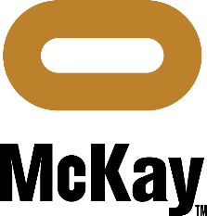
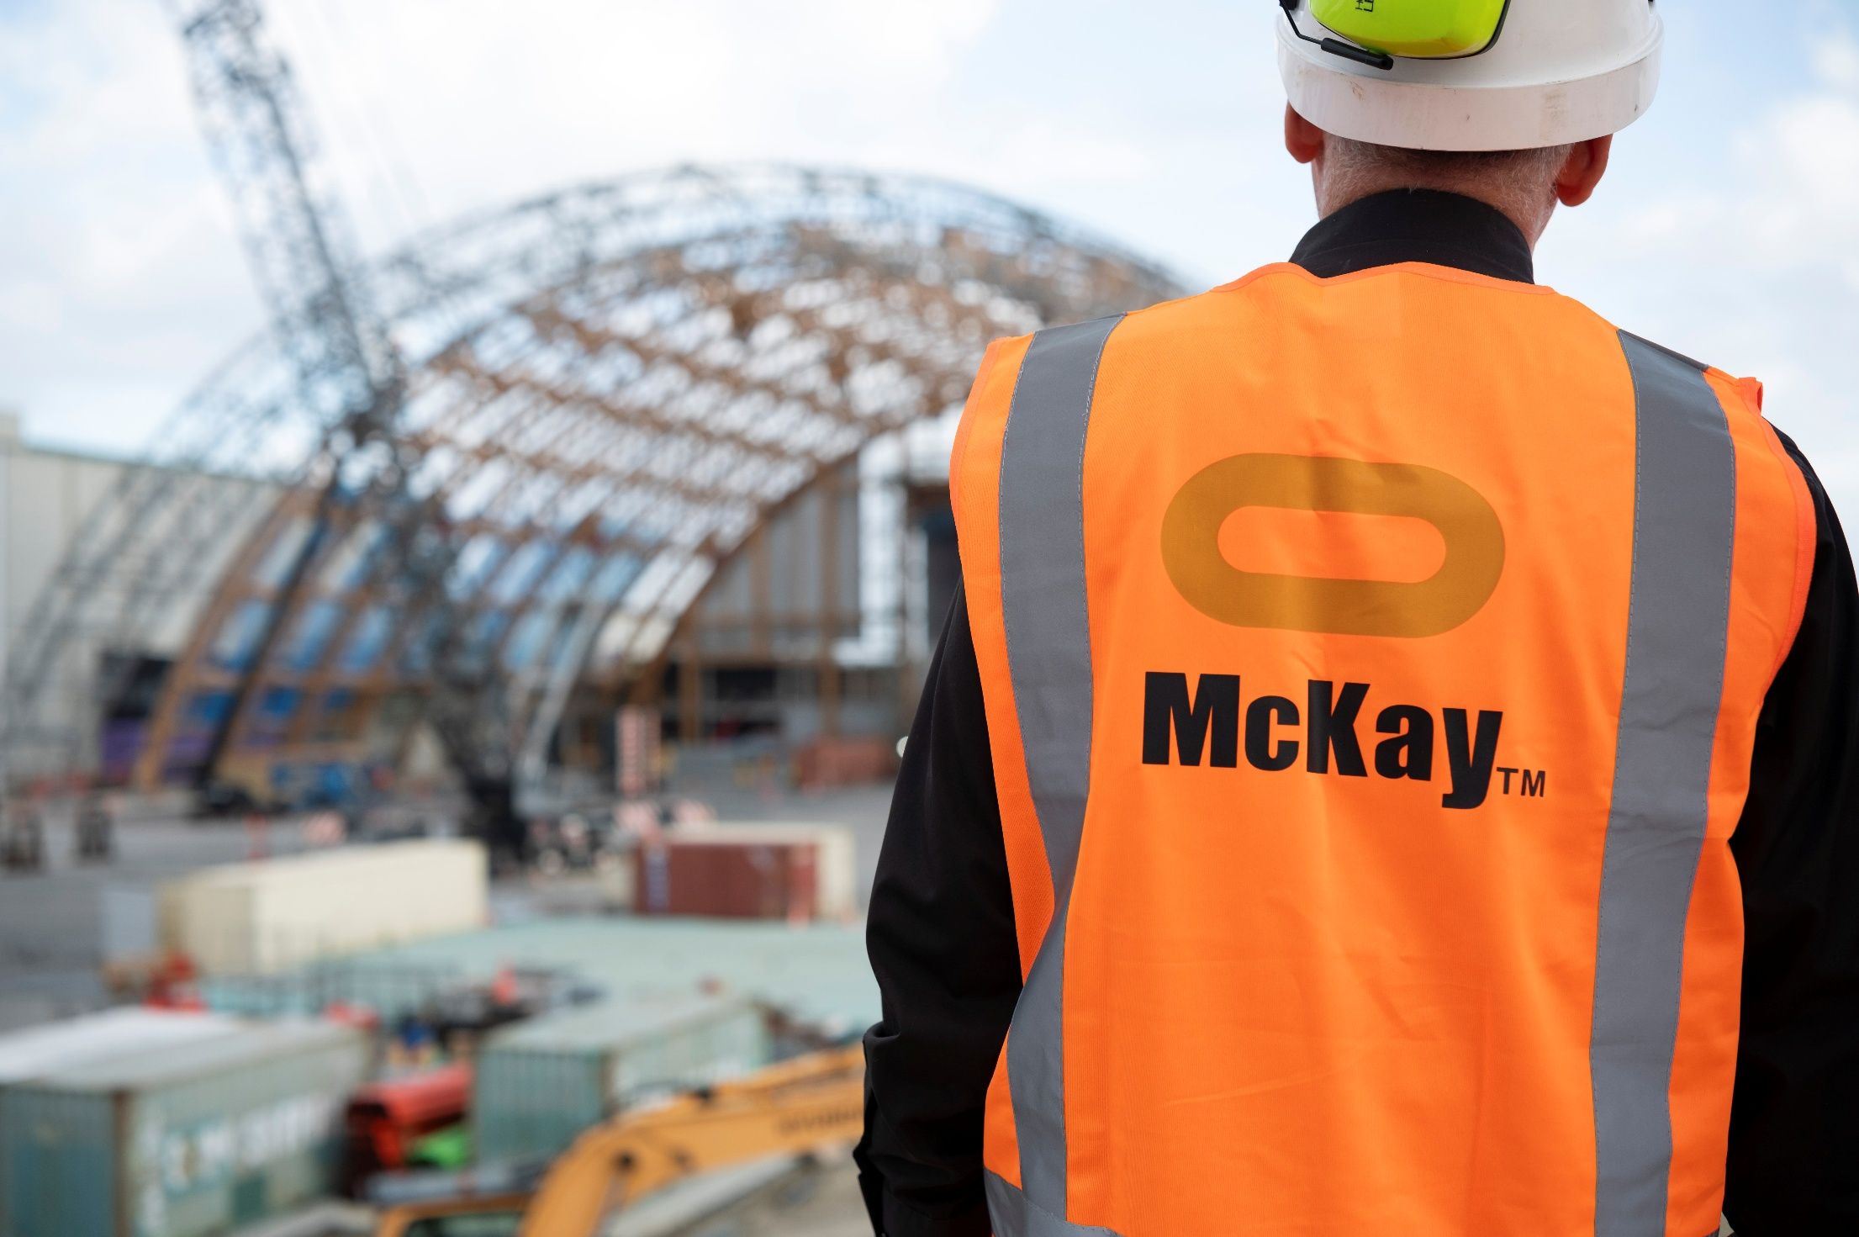


Role Summary

McKay is proud to stand as Aotearoa, New Zealand’s largest privately owned electrotechnology provider, offering innovative engineering and construction services nationwide
Having started providing electrotechnology services in 1936, McKay is a historic New Zealand electrical company with a depth of experience in providing end to end electrical solutions for a wide range of industries and sectors. McKay is the parent brand and has acquired and started a range of companies under the McKay Group name to serve all electrical needs.
As part of our engagement with our key customer OJI Fibre Solutions at the Kinleith and Tasman mills we offer a full range of maintenance services both electrical and mechanical as one combined and coordinated team.
As a Mechanical Technician Maintenance and Fabrication (Shift worker) at McKay Ltd., you are a skilled professional who is responsible for: -
- Self-leadership.
- Day to day machinery maintenance and condition monitoring, reporting and analysis
- Update SAP/ CMMS data. Update online data and records.
- Provide job status reporting Revise and mark up hard copy information systems. I.E Drawings, Data sheets, Bills of material, installation drawings E.T.C.
- Participate in equipment maintenance practice review.
- Preparation of equipment work plans and packs.
- Completion of equipment work plans and packs.
- Oversee machinery maintenance
- Review and improvement recommendation to equipment spares and asset data

Responsibilities
Technical Knowledge
- High level understanding of machinery maintenance and fabrication best practice.
- Understand technical drawing and specification data
- High level understanding of welding codes of practice
Communication & Customer Service
- Able to communicate confidently to one level up within the organisation
- Written and digital communication skills, including ability to compile reports and other correspondence. Complete forms and communicate through digital platforms.
- Competent in ensuring the customer's stated needs are recognized and working towards achieving them.
- Able to represent customer service ethic in approach
- Customer engagement for technical clarification, corrective action or emerging work.
- Be cordial and cooperative with customer representatives.
- Deliver services (the Job, or Job lot) in the time allowance agreed.
- Notify of any emerging risk to agreed deliverables
- Maintain cohesive relationships with all appropriate customer stake holders
- Embrace the concept of overall plant reliability. “It is my job’ ‘’I can make a difference’’
Safety Compliance
- Engage with our health and safety process, be a proactive H&S leader.
- Not knowingly breach any Act, Regulation or code of practice or allow others to do so.
- Adhere to all applicable health and safety systems, procedures and requirements
- Ensure operational procedures are adopted and practiced
- Actively participate in regular pre-start, toolbox, health and safety and safety committee meetings as required
- Participate in any incident investigation as required

Upgrades and Improvements
- Actively participate in the development and implementation of new technology
- Liaise with relevant personnel on all aspect’s machinery maintenance
- All machinery maintenance and fabrication activities are carried out in a safe, efficient and timely manner, according to OEM and Customer specifications.
Collaboration
- Participate as a positive member of the maintenance team and in the wider McKay.
- Actively participate in designated maintenance teams and provide a positive contribution
- Provides task related and wider learning opportunities for apprentices and trainees. Facilitates the attainment of new skills by strong feedback and coaching.
Documentation
- All documentation and reports completed accurately and on time.
Upkeep of Tools and Equipment
- Maintain up to date knowledge of changes to OEM recommendations
- Carry out preventative and corrective maintenance

Continuous Learning
- Participate in training as required
- Take a proactive approach to ensuring all required competencies are current
- Provide mentoring to other staff
- Assist in the growth of maintenance techniques and knowledge within the team

Qualifications & Knowledge
- NZ Cert Engineering fabrication Trade / Level 4, NZ Cert Mechanical Engineering Trade / Level 4, Maintenance Engineering, or equivalent.
- Competency to ASME BPV code section IX.

Or
- Apprenticed in Mechanical or Allied trade, unqualified. Extensive Relevant Industry and machinery experience. Or equivalent.
- Competency to ASME BPV code section IX.
- 3 years’ experience with maintenance and fabrication in industrial manufacturing environments preferred.
- Familiarity and understanding of digital tools and diagnostic systems is desirable.
- Can perform complex weld procedures, in a range of configurations.
- Strong English language and numeracy
- Office software, word, Excel preferred.
- Have ability to operate smart devices and data collection systems or be prepared to upskill with them.

Role Profile
As an Mechanical Technician Maintenance and Fabrication (Shift Worker).at McKay Electrical Ltd., you must hold the following capabilities;
- Understands mechanical maintenance best practice and can interpret technical drawings and machine components accurately.
- Confidently provides clear updates and technical information to supervisors or managers.
- Produces accurate maintenance documentation, reports, and digital records.
- Identifies customer needs and engages professionally to clarify technical issues and support operational outcomes.
- Builds strong, respectful working relationships with colleagues, contractors, and customers.
- Takes ownership of assigned tasks and consistently delivers safe, high-quality work on time.
- Maintains high accuracy in maintenance tasks and contributes to quality and root-cause investigations.
- Supports apprentices and trainees with coaching and shares knowledge to build team capability.

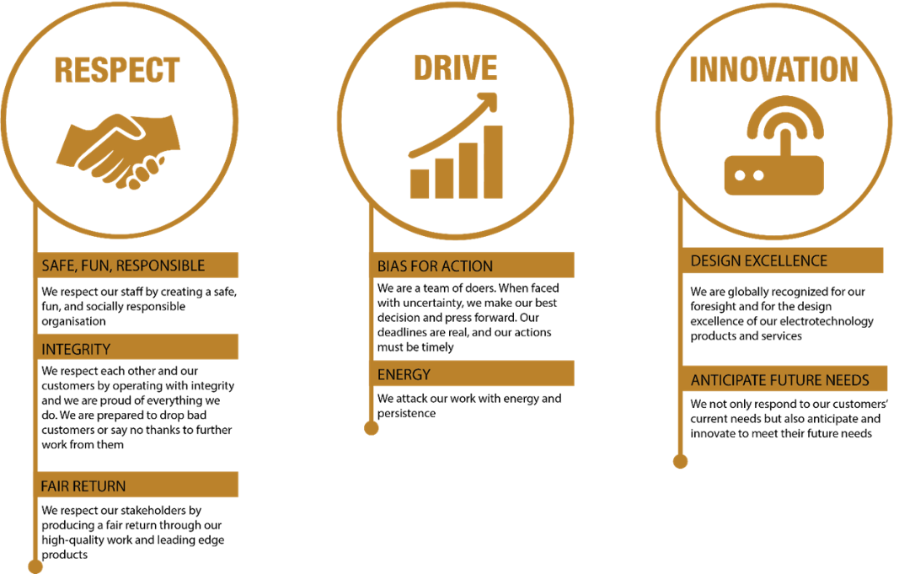
McKay Guiding Values

