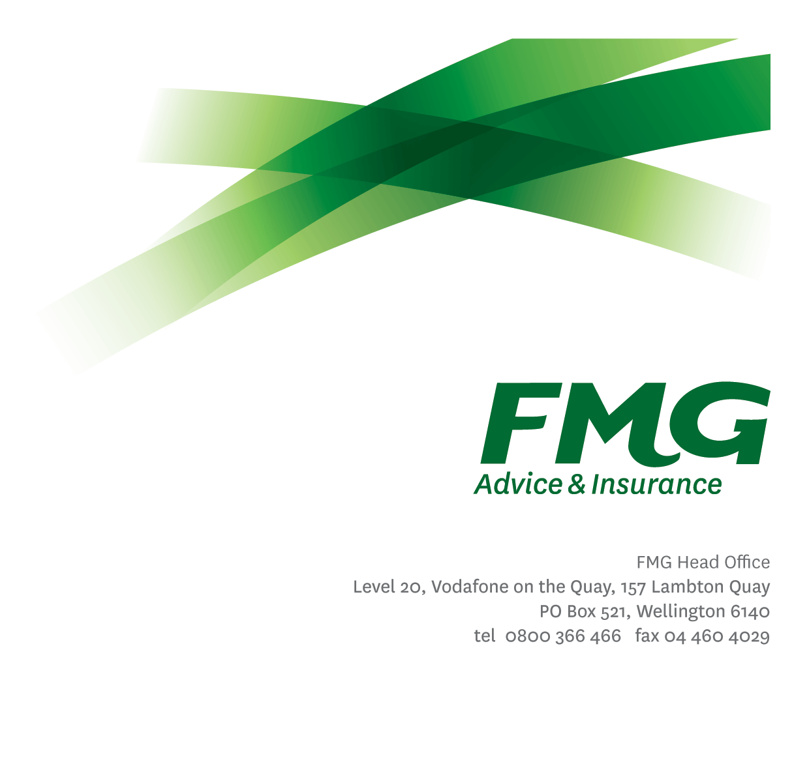
Workforce Analyst
Position Description
Location: As per Personal Terms
Reporting to: Resource Planning Manager
Business Unit: Sales, Advice & Service
Direct Reports: 0
Date Last Reviewed: November 2026

About FMG
Formed by farmers for farmers over a century ago, FMG is New Zealand’s leading rural insurer providing risk advice and insurance solutions for farmers, growers, commercial businesses, the lifestyle sector and domestic clients.
We’re proudly 100% New Zealand owned and operated and our focus is on helping our clients to achieve their goals. As a mutual organisation, we’re all about giving rural New Zealanders a better deal, and part of this involves reinvesting all profits back into the business to keep premiums low and ensure the future sustainability of the organisation.

FMG’s Values
The FMG brand represents promises about what clients can expect from us and each of us is responsible for delivering on these promises. Living our company values means we deliver the best brand experience for our clients. Our company values are:
- Do what's right - Whāia te ara tika | - Make it happen - Whakatutukitia
- We're in it together - Ko tātau tātau | - Proud of who we are - Whakahīhī i te whakapapa

Work Environment
We strive to provide an environment that promotes and fosters achievement. We place importance on career development and training to give our people the tools they need to succeed.
FMG’s Corporate Office is in Wellington and accommodates FMG’s Executive Leadership Team (ELT), Client Propositions & Online Services, People & Culture and Communications, Financial Management, Product & Pricing and Underwriting, Reinsurance, Business Information and Analysis, Legal and Compliance.
FMG’s largest regional office is in Palmerston North accommodating our National Sales & Advice Centre, Information Technology, Claims, Operations and Payments functions. In addition to the offices in Wellington, Palmerston North and Christchurch FMG has offices in 30 regional locations throughout New Zealand.

Purpose of the role
The Workforce Analyst is jointly responsible for the resource management of FMG’s phone and field-based channels, enabling FMG to achieve efficiency and service level performance standards, with the overall aim of optimising staffing levels to mitigate cost, maximise performance to deliver on demand and improve client satisfaction and experience

Key Responsibilities
Area | Responsibilities
Real-Time Queue Management | - Analyse real-time call trends and adjust FTE to ensure service levels are met.  - Manage intra-day performance to ensure on the day resource is managed with optimal efficiency against forecasts.  - Drive schedule adherence, compliance, activity and reports on exceptions and trends.  - Manage daily shrinkage, utilizing Workforce Management tools to maintain information on team activity and statistics, including schedule maintenance, meetings, absence, and other shrinkage activities.  - Enter and report on Consultant schedule and exception/out of adherence activity.  - Record daily trending, Consultant absence, outages, and other performance insights.  - Provide regular updates to Team Leaders & and Centre Managers detailing performance.  - Lead daily insight meetings providing Team Leaders with daily performance reports and optimal time to conduct unplanned activities with a focus on improving from the prior day.  - Ensure Consultant skills and priorities are accurate and reflective of Client demand.
Scheduling & Forecasting | - Develop staffing rosters for phone-based teams and resource plans for field-based channels that align available capacity with demand and agreed service requirements.  - Alongside the Resource Planning Manager, create, review, publish and optimise rolling schedules and resource plans for phone- and field-based channels.  - Balance annual leave, training, meetings and other non-Client-facing activities against staffing and coverage requirements for the planning period.  - Alongside the Resource Planning Manager, produce demand and capacity forecasts for phone- and field-based channels at intervals appropriate to each channel’s operating needs.  - Work with the Resource Planning Manager and relevant leaders to schedule planned non-Client-facing activities while maintaining appropriate service coverage across channels.  - Analyse capacity utilisation and recommend improvements to resource allocation across phone- and field-based channels.  - General support tasks as assigned on an ad-hoc basis
Field-Based Channel Support | - Analyse demand, workload and available capacity across field-based channels to identify resource requirements, coverage gaps and emerging trends.  - Support the Resource Planning Manager and regional leaders to develop and maintain resource plans that align field-based capacity with Client demand and agreed service requirements.  - Work with field-based leaders to incorporate planned leave, training, meetings and other non-Client-facing activities into capacity forecasts and resource recommendations.  - Monitor workload, utilisation and service trends against plans, providing timely insights and escalating capacity or coverage risks to the Resource Planning Manager and relevant leaders.  - Recommend adjustments to resource allocation as demand and priorities change, balancing Client experience, service requirements and efficient use of available capacity.
Reporting | - Provide accurate, timely reporting on demand, capacity, utilisation, service levels and resource risks across phone- and field-based channels, highlighting trends and recommending actions.
Personal Proficiency | - Proactively acquire and develop appropriate skills, knowledge and techniques in relation to fulfilling the core functions of the role.
Team Membership | - Work collaboratively with phone- and field-based leaders, providing regular resource planning updates and insights to the BIRO Leadership Team, regional leaders and wider stakeholders as required.
Compliance | - Ensure overall compliance with legislation regulations and FMG policies using established systems.
FMG Values | - Promote the “FMG Way” through displaying the values of FMG which are: Do what’s right, Make it happen, We’re in it together, Proud of who we are.
Wellbeing & Safety | - Demonstrate leadership and commitment to workplace wellbeing and safety practices.  - Promote and support initiatives that contribute to a healthy and safe working environment for employees, visitors, and contractors.  - Ensure compliance with safety and wellbeing policy and procedures, including accident and incident reporting and investigation, hazard management, induction, training and supervision, employee participation and contractor management.

COMPETENCIES
*see competency framework for behaviours expected at each level | Expected Level
Customer Driven (Internal & External)  A commitment to understanding the needs and best interests of both internal and external customers, in order to provide them with outstanding customer service and help them to make informed decisions. | Intermediate*
Accountability  Taking personal ownership of decisions, behaviour, and development, and being responsible for how these actions impact on the wider organisation and customers. | Intermediate*
Adaptability  Demonstrating a willingness to engage in a changing environment and being flexible and comfortable working with change. | Intermediate*
Motivation and Drive  The determination to achieve goals and strive for excellence. | Intermediate*
Relationship Building  Developing and maintaining positive, professional relationships that are built on mutual trust and respect. | Intermediate*
Teamwork  Making a positive contribution to the FMG team and collaborating effectively with others to achieve objectives. | Intermediate*
Critical Analysis  The capability to identify key issues, trends, or important facts from information and to question and probe. | Intermediate*

KNOWLEDGE
Qualifications | Relevant study or training in workforce planning, data analysis or business operations, or equivalent practical knowledge gained through experience.
Business Awareness | Understands demand forecasting, capacity planning, scheduling, utilisation and service-level management across phone- and field-based channels.  Understands how workforce availability, skills, planned leave, training and other non-Client-facing activities affect resource requirements, service coverage and Client experience.
Rural Knowledge | Understands the rural Client context and how seasonal demand and regional differences may affect workload and resource planning for phone- and field-based channels.
Legal Knowledge | Understands the privacy, confidentiality, employment and wellbeing and safety obligations relevant to workforce data, scheduling and resource planning, and applies FMG policies and established procedures.

EXPERIENCE
Work Experience | Experience in workforce planning, scheduling, resource coordination or operational analysis in a service-based environment, with an understanding of phone- and field-based service delivery.

SKILLS
Written Communication Skills | Produces clear, accurate reports and resource recommendations, explaining trends, assumptions, service impacts and proposed actions for operational leaders.
Verbal Communications Skills | Communicates timely operational updates and explains workforce insights clearly, working collaboratively with phone- and field-based leaders to support resource decisions.
Listening Skills | Listens actively, checks understanding and incorporates operational priorities and regional perspectives into forecasts, resource plans and recommendations.
Technology Skills | Uses workforce management, telephony, spreadsheet and reporting tools effectively to maintain accurate schedules and workforce data, analyse demand and capacity, and produce reliable reporting.
Data Analysis & Forecasting Skills | Analyses demand, workload, capacity and utilisation data; identifies patterns and exceptions; tests assumptions and scenarios; and translates findings into practical forecasts and resource recommendations.
Planning & Organisation Skills | Coordinates schedules, forecasts and resource planning activities, prioritises competing demands and responds to changing workloads while meeting agreed deadlines.
Risk Assessment Skills | Identifies capacity, coverage, data quality and service risks, assesses their likely impact, recommends practical mitigations and escalates issues to the Resource Planning Manager and relevant leaders.

Relationships
External | Internal | Committees/Groups
No regular external relationships specified. | Resource Planning Manager  Phone-based Team Leaders and Centre Managers, including NCC, Claims and Payment Services  Regional leaders and field-based channel leaders  Phone- and field-based Consultants  SAS Coaching & Training Team  Digital & Data

Financial Authority Levels
- No authority to approve or commit expenditure

People Advisory Authority Levels
- Not applicable

Agreement
I agree to the outline of the role as contained in this document and recognise that the contents may need to be amended from time to time to reflect changing business requirements.

I as Job holder, allow my Manager to gather information from third parties where necessary for the purposes of performance management.

Agreement will be via electronic signature as evidenced on the acceptance form.

