Job description
Title | Engineering Manager
Location | Auckland or Whangarei
Start Date | September 2026
Reports To | Executive General Manager Technology
Reviewed By | Fiona Bycroft | Date: | September 2026
Last Updated By | People & Culture | Date: | September 2026
Purpose:

To lead and grow McKay’s Engineering function in alignment with the company’s overarching strategy, ensuring the team has the capability, capacity and technical leadership required to deliver safe, high-quality and commercially successful outcomes. The role is accountable for translating strategic priorities into disciplined execution, strengthening engineering performance and developing a collaborative, high-performing team that supports sustainable business growth.



Role Summary
McKay is Aotearoa New Zealand’s largest privately owned electrotechnology provider, delivering integrated electrical engineering and construction solutions across a diverse range of industries and sectors.
The Engineering Manager leads the performance, development and growth of McKay’s Engineering function. Reporting to the Executive General Manager Technology, the role develops and implements the Engineering strategy in line with McKay’s overarching company strategy and converts that direction into clear priorities, investment and resource requirements, capability plans and measurable outcomes.
The role is accountable for the function’s people leadership, technical assurance, project delivery, resource planning, financial performance and continuous improvement. Working closely with operational leaders, customers and other stakeholders, the Engineering Manager ensures engineering work is delivered safely, to the required quality, on time and within budget, while identifying opportunities for innovation, market growth and stronger organisational capability.

Responsibilities

Strategy and Growth
- Develop and implement an Engineering growth strategy aligned with McKay’s overarching company strategy, translating strategic priorities into clear initiatives, capability and resource requirements, market opportunities, and measurable outcomes.

Client Relationships and Business Development
- Build trusted, long-term relationships with clients by understanding their priorities, providing credible technical leadership and ensuring McKay delivers on its commitments.
- Identify and develop opportunities to grow engineering services with existing and prospective clients, in line with McKay’s strategy and agreed target markets.
- Work with operational and commercial leaders to shape client solutions, bids and proposals that are technically sound, commercially viable and responsive to client needs.
- Represent McKay professionally in client and industry forums, using market insight and client feedback to inform service development, investment priorities and the Engineering growth strategy.

Leading and Growing Our People
- Build and lead a capable, high-performing engineering team by setting clear expectations and providing regular coaching, mentoring, feedback and development opportunities that help people grow and succeed.
- Create an environment where people feel trusted, supported and accountable, work well together, share knowledge and contribute ideas that improve engineering performance and support McKay’s future growth.

Project Management
- Establish clear project outcomes, scope, responsibilities and success measures with stakeholders before delivery begins, ensuring alignment with client commitments and McKay’s commercial and operational objectives.
- Develop project plans, schedules, and budgets, and ensure projects are completed on time and within budget.
- Monitor project progress, identify issues, and take corrective actions as needed.

Technical Guidance
- Provide technical expertise and guidance to the engineering team, helping them solve complex technical challenges and make informed decisions.
- Stay updated on industry trends and emerging technologies to ensure the team’s skills and knowledge are current.

Resource Allocation
- Allocate resources effectively, including personnel, equipment, and budget, to meet project requirements and deadlines.
- Collaborate with HR to recruit, onboard, and train new team members as needed.

Quality Assurance
- Ensure that engineering projects meet quality standards and regulatory requirements.
- Implement best practices and processes to maintain high-quality deliverables.

Risk Management
- Identify and mitigate risks associated with engineering projects, such as technical challenges, resource constraints, and external dependencies.

Communication
- Communicate project status, challenges, and progress to stakeholders, including executives and non-technical team members.
- Foster effective communication within the engineering team to promote collaboration.

Budget Management
- Manage the engineering department’s budget, including resource allocation, expenses, and cost control.

Qualifications & Knowledge
- Bachelor’s or Master’s degree in engineering discipline or related field.
- Proven experience in engineering, with a strong understanding of engineering principles and practices.
- Previous experience in a leadership or management role, demonstrating the ability to lead and inspire a team.

Role Profile
As an Engineering Manager at McKay Electrical Ltd., you must hold the following capabilities;
- Growth and strategic mindset
- Able to operate comfortably with ambiguity
- Excellent relationship and business development skills
- Innovative thinker
- Strong project management skills, including the ability to plan, organise, and oversee complex projects.
- Excellent communication skills, both technical and non-technical, to effectively convey information and ideas.
- Knowledge of industry-specific regulations and standards relevant to the organisation.
- Proficiency in using project management and collaboration tools.
- Leadership and interpersonal skills.
- Problem-solving and critical thinking.
- Decision-making abilities.
- Adaptability and the ability to handle change.
- Conflict resolution and negotiation skills.
- Time management and organisational skills.

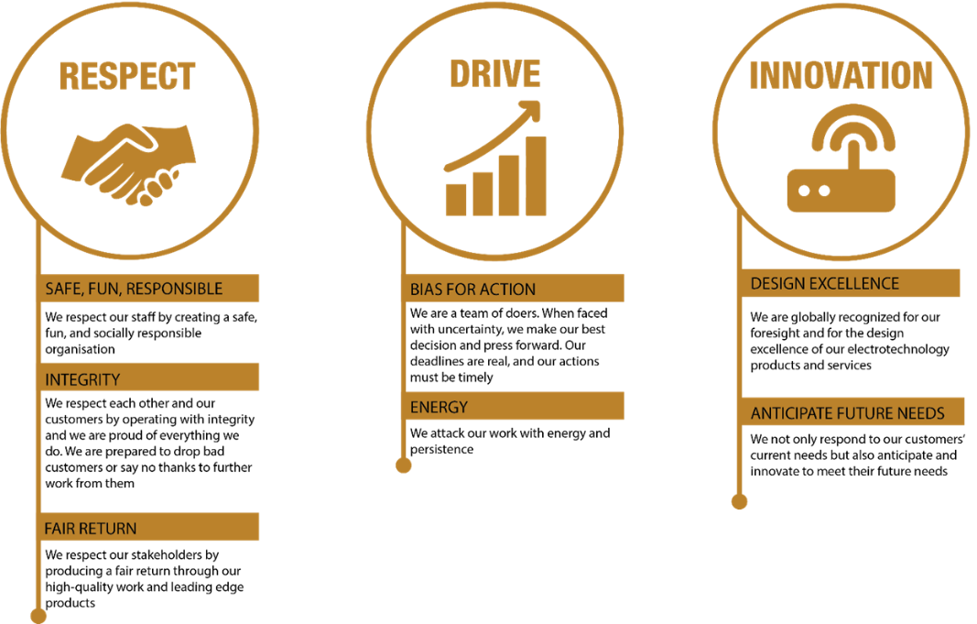
McKay Guiding Values

